Simple Nature

8. Atoms and Electromagnetism
Table of Contents

Contents
Section 8.1 - The Electric Glue
Section 8.2 - The Nucleus

Chapter 8. Atoms and Electromagnetism
\inlinefignocaption{lightning}

8.1 The Electric Glue
Where the telescope ends, the microscope begins. Which of the two has the grander view? -- Victor Hugo
His father died during his mother's pregnancy. Rejected by her as a boy, he was packed off to boarding school when she remarried. He himself never married, but in middle age he formed an intense relationship with a much younger man, a relationship that he terminated when he underwent a psychotic break. Following his early scientific successes, he spent the rest of his professional life mostly in frustration over his inability to unlock the secrets of alchemy.
The man being described is Isaac Newton, but not the triumphant Newton of the standard textbook hagiography. Why dwell on the sad side of his life? To the modern science educator, Newton's lifelong obsession with alchemy may seem an embarrassment, a distraction from his main achievement, the creation the modern science of mechanics. To Newton, however, his alchemical researches were naturally related to his investigations of force and motion. What was radical about Newton's analysis of motion was its universality: it succeeded in describing both the heavens and the earth with the same equations, whereas previously it had been assumed that the sun, moon, stars, and planets were fundamentally different from earthly objects. But Newton realized that if science was to describe all of nature in a unified way, it was not enough to unite the human scale with the scale of the universe: he would not be satisfied until he fit the microscopic universe into the picture as well.
It should not surprise us that Newton failed. Although he was a firm believer in the existence of atoms, there was no more experimental evidence for their existence than there had been when the ancient Greeks first posited them on purely philosophical grounds. Alchemy labored under a tradition of secrecy and mysticism. Newton had already almost single-handedly transformed the fuzzyheaded field of “natural philosophy” into something we would recognize as the modern science of physics, and it would be unjust to criticize him for failing to change alchemy into modern chemistry as well. The time was not ripe. The microscope was a new invention, and it was cutting-edge science when Newton's contemporary Hooke discovered that living things were made out of cells.
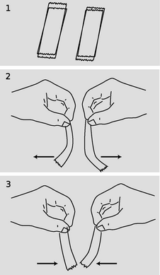
a / Four pieces of tape are prepared, 1, as described in the text. Depending on which combination is tested, the interaction can be either repulsive, 2, or attractive, 3.

The quest for the atomic force
Newton was not the first of the age of reason. He was the last of the magicians. -- John Maynard Keynes

Newton's quest
Nevertheless it will be instructive to pick up Newton's train of thought and see where it leads us with the benefit of modern hindsight. In uniting the human and cosmic scales of existence, he had reimagined both as stages on which the actors were objects (trees and houses, planets and stars) that interacted through attractions and repulsions. He was already convinced that the objects inhabiting the microworld were atoms, so it remained only to determine what kinds of forces they exerted on each other.
His next insight was no less brilliant for his inability to bring it to fruition. He realized that the many human-scale forces --- friction, sticky forces, the normal forces that keep objects from occupying the same space, and so on --- must all simply be expressions of a more fundamental force acting between atoms. Tape sticks to paper because the atoms in the tape attract the atoms in the paper. My house doesn't fall to the center of the earth because its atoms repel the atoms of the dirt under it.
Here he got stuck. It was tempting to think that the atomic force was a form of gravity, which he knew to be universal, fundamental, and mathematically simple. Gravity, however, is always attractive, so how could he use it to explain the existence of both attractive and repulsive atomic forces? The gravitational force between objects of ordinary size is also extremely small, which is why we never notice cars and houses attracting us gravitationally. It would be hard to understand how gravity could be responsible for anything as vigorous as the beating of a heart or the explosion of gunpowder. Newton went on to write a million words of alchemical notes filled with speculation about some other force, perhaps a “divine force” or “vegetative force” that would for example be carried by the sperm to the egg.
Luckily, we now know enough to investigate a different suspect as a candidate for the atomic force: electricity. Electric forces are often observed between objects that have been prepared by rubbing (or other surface interactions), for instance when clothes rub against each other in the dryer. A useful example is shown in figure a/1: stick two pieces of tape on a tabletop, and then put two more pieces on top of them. Lift each pair from the table, and then separate them. The two top pieces will then repel each other, a/2, as will the two bottom pieces. A bottom piece will attract a top piece, however, a/3. Electrical forces like these are similar in certain ways to gravity, the other force that we already know to be fundamental:
- Electrical forces are universal. Although some substances, such as fur, rubber, and plastic, respond more strongly to electrical preparation than others, all matter participates in electrical forces to some degree. There is no such thing as a “nonelectric” substance. Matter is both inherently gravitational and inherently electrical.
- Experiments show that the electrical force, like the gravitational force, is an inverse square force. That is, the electrical force between two spheres is proportional to 1/r², where r is the center-to-center distance between them.
Furthermore, electrical forces make more sense than gravity as candidates for the fundamental force between atoms, because we have observed that they can be either attractive or repulsive.
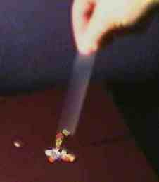
b / A charged piece of tape attracts uncharged pieces of paper from a distance, and they leap up to it.
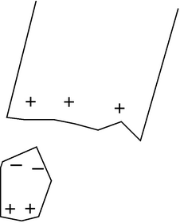
c / The paper has zero total charge, but it does have charged particles in it that can move.

Charge, electricity and magnetism

Charge
“Charge” is the technical term used to indicate that an object has been prepared so as to participate in electrical forces. This is to be distinguished from the common usage, in which the term is used indiscriminately for anything electrical. For example, although we speak colloquially of “charging” a battery, you may easily verify that a battery has no charge in the technical sense, e.g. it does not exert any electrical force on a piece of tape that has been prepared as described in the previous section.

Two types of charge
We can easily collect reams of data on electrical forces between different substances that have been charged in different ways. We find for example that cat fur prepared by rubbing against rabbit fur will attract glass that has been rubbed on silk. How can we make any sense of all this information? A vast simplification is achieved by noting that there are really only two types of charge. Suppose we pick cat fur rubbed on rabbit fur as a representative of type A, and glass rubbed on silk for type B. We will now find that there is no “type C.” Any object electrified by any method is either A-like, attracting things A attracts and repelling those it repels, or B-like, displaying the same attractions and repulsions as B. The two types, A and B, always display opposite interactions. If A displays an attraction with some charged object, then B is guaranteed to undergo repulsion with it, and vice-versa.

The coulomb
Although there are only two types of charge, each type can come in different amounts. The metric unit of charge is the coulomb (rhymes with “drool on”), defined as follows:
\lessimportant{One Coulomb (C) is the amount of charge such that a force of 9.0×10⁹ N occurs between two pointlike objects with charges of 1 C separated by a distance of 1 m.}
The notation for an amount of charge is q. The numerical factor in the definition is historical in origin, and is not worth memorizing. The definition is stated for pointlike, i.e. very small, objects, because otherwise different parts of them would be at different distances from each other.

A model of two types of charged particles
Experiments show that all the methods of rubbing or otherwise charging objects involve two objects, and both of them end up getting charged. If one object acquires a certain amount of one type of charge, then the other ends up with an equal amount of the other type. Various interpretations of this are possible, but the simplest is that the basic building blocks of matter come in two flavors, one with each type of charge. Rubbing objects together results in the transfer of some of these particles from one object to the other. In this model, an object that has not been electrically prepared may actually possesses a great deal of both types of charge, but the amounts are equal and they are distributed in the same way throughout it. Since type A repels anything that type B attracts, and vice versa, the object will make a total force of zero on any other object. The rest of this chapter fleshes out this model and discusses how these mysterious particles can be understood as being internal parts of atoms.

Use of positive and negative signs for charge
Because the two types of charge tend to cancel out each other's forces, it makes sense to label them using positive and negative signs, and to discuss the total charge of an object. It is entirely arbitrary which type of charge to call negative and which to call positive. Benjamin Franklin decided to describe the one we've been calling “A” as negative, but it really doesn't matter as long as everyone is consistent with everyone else. An object with a total charge of zero (equal amounts of both types) is referred to as electrically neutral.
self-check: Criticize the following statement: “There are two types of charge, attractive and repulsive.” (answer in the back of the PDF version of the book)
A large body of experimental observations can be summarized as follows:
Coulomb's law: The magnitude of the force acting between pointlike charged objects at a center-to-center distance r is given by the equation
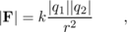
where the constant k equals 9.0×10⁹ N⋅m²/C². The force is attractive if the charges are of different signs, and repulsive if they have the same sign.
Clever modern techniques have allowed the 1/r² form of Coulomb's law to be tested to incredible accuracy, showing that the exponent is in the range from 1.9999999999999998 to 2.0000000000000002.
Note that Coulomb's law is closely analogous to Newton's law of gravity, where the magnitude of the force is Gm₁m₂/r², except that there is only one type of mass, not two, and gravitational forces are never repulsive. Because of this close analogy between the two types of forces, we can recycle a great deal of our knowledge of gravitational forces. For instance, there is an electrical equivalent of the shell theorem: the electrical forces exerted externally by a uniformly charged spherical shell are the same as if all the charge was concentrated at its center, and the forces exerted internally are zero.

Conservation of charge
An even more fundamental reason for using positive and negative signs for electrical charge is that experiments show that charge is conserved according to this definition: in any closed system, the total amount of charge is a constant. This is why we observe that rubbing initially uncharged substances together always has the result that one gains a certain amount of one type of charge, while the other acquires an equal amount of the other type. Conservation of charge seems natural in our model in which matter is made of positive and negative particles. If the charge on each particle is a fixed property of that type of particle, and if the particles themselves can be neither created nor destroyed, then conservation of charge is inevitable.

Electrical forces involving neutral objects
As shown in figure b, an electrically charged object can attract objects that are uncharged. How is this possible? The key is that even though each piece of paper has a total charge of zero, it has at least some charged particles in it that have some freedom to move. Suppose that the tape is positively charged, c. Mobile particles in the paper will respond to the tape's forces, causing one end of the paper to become negatively charged and the other to become positive. The attraction is between the paper and the tape is now stronger than the repulsion, because the negatively charged end is closer to the tape.
self-check: What would have happened if the tape was negatively charged? (answer in the back of the PDF version of the book)

The path ahead
We have begun to encounter complex electrical behavior that we would never have realized was occurring just from the evidence of our eyes. Unlike the pulleys, blocks, and inclined planes of mechanics, the actors on the stage of electricity and magnetism are invisible phenomena alien to our everyday experience. For this reason, the flavor of the second half of your physics education is dramatically different, focusing much more on experiments and techniques. Even though you will never actually see charge moving through a wire, you can learn to use an ammeter to measure the flow.
Students also tend to get the impression from their first semester of physics that it is a dead science. Not so! We are about to pick up the historical trail that leads directly to the cutting-edge physics research you read about in the newspaper. The atom-smashing experiments that began around 1900, which we will be studying in this chapter, were not that different from the ones of the year 2000 --- just smaller, simpler, and much cheaper.

Magnetic forces
A detailed mathematical treatment of magnetism won't come until much later in this book, but we need to develop a few simple ideas about magnetism now because magnetic forces are used in the experiments and techniques we come to next. Everyday magnets come in two general types. Permanent magnets, such as the ones on your refrigerator, are made of iron or substances like steel that contain iron atoms. (Certain other substances also work, but iron is the cheapest and most common.) The other type of magnet, an example of which is the ones that make your stereo speakers vibrate, consist of coils of wire through which electric charge flows. Both types of magnets are able to attract iron that has not been magnetically prepared, for instance the door of the refrigerator.
A single insight makes these apparently complex phenomena much simpler to understand: magnetic forces are interactions between moving charges, occurring in addition to the electric forces. Suppose a permanent magnet is brought near a magnet of the coiled-wire type. The coiled wire has moving charges in it because we force charge to flow. The permanent magnet also has moving charges in it, but in this case the charges that naturally swirl around inside the iron. (What makes a magnetized piece of iron different from a block of wood is that the motion of the charge in the wood is random rather than organized.) The moving charges in the coiled-wire magnet exert a force on the moving charges in the permanent magnet, and vice-versa.
The mathematics of magnetism is significantly more complex than the Coulomb force law for electricity, which is why we will wait until chapter 11 before delving deeply into it. Two simple facts will suffice for now:
(1) If a charged particle is moving in a region of space near where other charged particles are also moving, their magnetic force on it is directly proportional to its velocity.
(2) The magnetic force on a moving charged particle is always perpendicular to the direction the particle is moving.

Example 1: A magnetic compass
The Earth is molten inside, and like a pot of boiling water, it roils and churns. To make a drastic oversimplification, electric charge can get carried along with the churning motion, so the Earth contains moving charge. The needle of a magnetic compass is itself a small permanent magnet. The moving charge inside the earth interacts magnetically with the moving charge inside the compass needle, causing the compass needle to twist around and point north.

Example 2: A television tube
A TV picture is painted by a stream of electrons coming from the back of the tube to the front. The beam scans across the whole surface of the tube like a reader scanning a page of a book. Magnetic forces are used to steer the beam. As the beam comes from the back of the tube to the front, up-down and left-right forces are needed for steering. But magnetic forces cannot be used to get the beam up to speed in the first place, since they can only push perpendicular to the electrons' direction of motion, not forward along it.

Discussion Questions
◊ If the electrical attraction between two pointlike objects at a distance of 1 m is 9×10⁹ N, why can't we infer that their charges are +1 and -1 C? What further observations would we need to do in order to prove this?
◊ An electrically charged piece of tape will be attracted to your hand. Does that allow us to tell whether the mobile charged particles in your hand are positive or negative, or both?
Examples of masses of atoms compared to that of hydrogen. Note how some, but not all, are close to integers.

Atoms
I was brought up to look at the atom as a nice, hard fellow, red or grey in color according to taste. -- Rutherford

Atomism
The Greeks have been kicked around a lot in the last couple of millennia: dominated by the Romans, bullied during the crusades by warlords going to and from the Holy Land, and occupied by Turkey until recently. It's no wonder they prefer to remember their salad days, when their best thinkers came up with concepts like democracy and atoms. Greece is democratic again after a period of military dictatorship, and an atom is proudly pictured on one of their coins. That's why it hurts me to have to say that the ancient Greek hypothesis that matter is made of atoms was pure guesswork. There was no real experimental evidence for atoms, and the 18th-century revival of the atom concept by Dalton owed little to the Greeks other than the name, which means “unsplittable.” Subtracting even more cruelly from Greek glory, the name was shown to be inappropriate in 1899 when physicist J.J. Thomson proved experimentally that atoms had even smaller things inside them, which could be extracted. (Thomson called them “electrons.”) The “unsplittable” was splittable after all.
But that's getting ahead of our story. What happened to the atom concept in the intervening two thousand years? Educated people continued to discuss the idea, and those who were in favor of it could often use it to give plausible explanations for various facts and phenomena. One fact that was readily explained was conservation of mass. For example, if you mix 1 kg of water with 1 kg of dirt, you get exactly 2 kg of mud, no more and no less. The same is true for the a variety of processes such as freezing of water, fermenting beer, or pulverizing sandstone. If you believed in atoms, conservation of mass made perfect sense, because all these processes could be interpreted as mixing and rearranging atoms, without changing the total number of atoms. Still, this is nothing like a proof that atoms exist.
If atoms did exist, what types of atoms were there, and what distinguished the different types from each other? Was it their sizes, their shapes, their weights, or some other quality? The chasm between the ancient and modern atomisms becomes evident when we consider the wild speculations that existed on these issues until the present century. The ancients decided that there were four types of atoms, earth, water, air and fire; the most popular view was that they were distinguished by their shapes. Water atoms were spherical, hence water's ability to flow smoothly. Fire atoms had sharp points, which was why fire hurt when it touched one's skin. (There was no concept of temperature until thousands of years later.) The drastically different modern understanding of the structure of atoms was achieved in the course of the revolutionary decade stretching 1895 to 1905. The main purpose of this chapter is to describe those momentous experiments.

Atoms, light, and everything else
Although I tend to ridicule ancient Greek philosophers like Aristotle, let's take a moment to praise him for something. If you read Aristotle's writings on physics (or just skim them, which is all I've done), the most striking thing is how careful he is about classifying phenomena and analyzing relationships among phenomena. The human brain seems to naturally make a distinction between two types of physical phenomena: objects and motion of objects. When a phenomenon occurs that does not immediately present itself as one of these, there is a strong tendency to conceptualize it as one or the other, or even to ignore its existence completely. For instance, physics teachers shudder at students' statements that “the dynamite exploded, and force came out of it in all directions.” In these examples, the nonmaterial concept of force is being mentally categorized as if it was a physical substance. The statement that “winding the clock stores motion in the spring” is a miscategorization of electrical energy as a form of motion. An example of ignoring the existence of a phenomenon altogether can be elicited by asking people why we need lamps. The typical response that “the lamp illuminates the room so we can see things,” ignores the necessary role of light coming into our eyes from the things being illuminated.
If you ask someone to tell you briefly about atoms, the likely response is that “everything is made of atoms,” but we've now seen that it's far from obvious which “everything” this statement would properly refer to. For the scientists of the early 1900s who were trying to investigate atoms, this was not a trivial issue of definitions. There was a new gizmo called the vacuum tube, of which the only familiar example today is the picture tube of a TV. In short order, electrical tinkerers had discovered a whole flock of new phenomena that occurred in and around vacuum tubes, and given them picturesque names like “x-rays,” “cathode rays,” “Hertzian waves,” and “N-rays.” These were the types of observations that ended up telling us that we know about matter, but fierce controversies ensued over whether these were themselves forms of matter.
Let's bring ourselves up to the level of classification of phenomena employed by physicists in the year 1900. They recognized three categories:
- Matter has mass, can have kinetic energy, and can travel through a vacuum, transporting its mass and kinetic energy with it. Matter is conserved, both in the sense of conservation of mass and conservation of the number of atoms of each element. Atoms can't occupy the same space as other atoms, so a convenient way to prove something is not a form of matter is to show that it can pass through a solid material, in which the atoms are packed together closely.
- Light has no mass, always has energy, and can travel through a vacuum, transporting its energy with it. Two light beams can penetrate through each other and emerge from the collision without being weakened, deflected, or affected in any other way. Light can penetrate certain kinds of matter, e.g. glass.
- The third category is everything that doesn't fit the definition of light or matter. This catch-all category includes, for example, time, velocity, heat, and force.

The chemical elements
How would one find out what types of atoms there were? Today, it doesn't seem like it should have been very difficult to work out an experimental program to classify the types of atoms. For each type of atom, there should be a corresponding element, i.e. a pure substance made out of nothing but that type of atom. Atoms are supposed to be unsplittable, so a substance like milk could not possibly be elemental, since churning it vigorously causes it to split up into two separate substances: butter and whey. Similarly, rust could not be an element, because it can be made by combining two substances: iron and oxygen. Despite its apparent reasonableness, no such program was carried out until the eighteenth century. The ancients presumably did not do it because observation was not universally agreed on as the right way to answer questions about nature, and also because they lacked the necessary techniques or the techniques were the province of laborers with low social status, such as smiths and miners. Alchemists were hindered by atomism's reputation for subversiveness, and by a tendency toward mysticism and secrecy. (The most celebrated challenge facing the alchemists, that of converting lead into gold, is one we now know to be impossible, since lead and gold are both elements.)
By 1900, however, chemists had done a reasonably good job of finding out what the elements were. They also had determined the ratios of the different atoms' masses fairly accurately. A typical technique would be to measure how many grams of sodium (Na) would combine with one gram of chlorine (Cl) to make salt (NaCl). (This assumes you've already decided based on other evidence that salt consisted of equal numbers of Na and Cl atoms.) The masses of individual atoms, as opposed to the mass ratios, were known only to within a few orders of magnitude based on indirect evidence, and plenty of physicists and chemists denied that individual atoms were anything more than convenient symbols.

Making sense of the elements
As the information accumulated, the challenge was to find a way of systematizing it; the modern scientist's aesthetic sense rebels against complication. This hodgepodge of elements was an embarrassment. One contemporary observer, William Crookes, described the elements as extending “before us as stretched the wide Atlantic before the gaze of Columbus, mocking, taunting and murmuring strange riddles, which no man has yet been able to solve.” It wasn't long before people started recognizing that many atoms' masses were nearly integer multiples of the mass of hydrogen, the lightest element. A few excitable types began speculating that hydrogen was the basic building block, and that the heavier elements were made of clusters of hydrogen. It wasn't long, however, before their parade was rained on by more accurate measurements, which showed that not all of the elements had atomic masses that were near integer multiples of hydrogen, and even the ones that were close to being integer multiples were off by one percent or so.
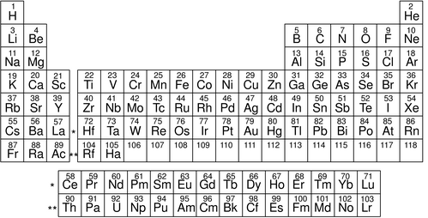
e / A modern periodic table. Elements in the same column have similar chemical properties. The modern atomic numbers, discussed in section 8.2, were not known in Mendeleev's time, since the table could be flipped in various ways.
Chemistry professor Dmitri Mendeleev, preparing his lectures in 1869, wanted to find some way to organize his knowledge for his students to make it more understandable. He wrote the names of all the elements on cards and began arranging them in different ways on his desk, trying to find an arrangement that would make sense of the muddle. The row-and-column scheme he came up with is essentially our modern periodic table. The columns of the modern version represent groups of elements with similar chemical properties, and each row is more massive than the one above it. Going across each row, this almost always resulted in placing the atoms in sequence by weight as well. What made the system significant was its predictive value. There were three places where Mendeleev had to leave gaps in his checkerboard to keep chemically similar elements in the same column. He predicted that elements would exist to fill these gaps, and extrapolated or interpolated from other elements in the same column to predict their numerical properties, such as masses, boiling points, and densities. Mendeleev's professional stock skyrocketed when his three elements (later named gallium, scandium and germanium) were discovered and found to have very nearly the properties he had predicted.
One thing that Mendeleev's table made clear was that mass was not the basic property that distinguished atoms of different elements. To make his table work, he had to deviate from ordering the elements strictly by mass. For instance, iodine atoms are lighter than tellurium, but Mendeleev had to put iodine after tellurium so that it would lie in a column with chemically similar elements.

Direct proof that atoms existed
The success of the kinetic theory of heat was taken as strong evidence that, in addition to the motion of any object as a whole, there is an invisible type of motion all around us: the random motion of atoms within each object. But many conservatives were not convinced that atoms really existed. Nobody had ever seen one, after all. It wasn't until generations after the kinetic theory of heat was developed that it was demonstrated conclusively that atoms really existed and that they participated in continuous motion that never died out.
The smoking gun to prove atoms were more than mathematical abstractions came when some old, obscure observations were reexamined by an unknown Swiss patent clerk named Albert Einstein. A botanist named Brown, using a microscope that was state of the art in 1827, observed tiny grains of pollen in a drop of water on a microscope slide, and found that they jumped around randomly for no apparent reason. Wondering at first if the pollen he'd assumed to be dead was actually alive, he tried looking at particles of soot, and found that the soot particles also moved around. The same results would occur with any small grain or particle suspended in a liquid. The phenomenon came to be referred to as Brownian motion, and its existence was filed away as a quaint and thoroughly unimportant fact, really just a nuisance for the microscopist.
It wasn't until 1906 that Einstein found the correct interpretation for Brown's observation: the water molecules were in continuous random motion, and were colliding with the particle all the time, kicking it in random directions. After all the millennia of speculation about atoms, at last there was solid proof. Einstein's calculations dispelled all doubt, since he was able to make accurate predictions of things like the average distance traveled by the particle in a certain amount of time. (Einstein received the Nobel Prize not for his theory of relativity but for his papers on Brownian motion and the photoelectric effect.)

Discussion Questions
◊ How could knowledge of the size of an individual aluminum atom be used to infer an estimate of its mass, or vice versa?
◊ How could one test Einstein's interpretation of Brownian motion by observing it at different temperatures?
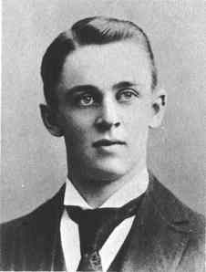
f / A young Robert Millikan. (Contemporary)
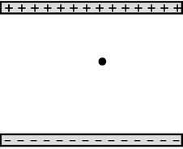
g / A simplified diagram of Millikan's apparatus.
 | q
 | / (1.64
q (C) | times1019 zuC
− 1.970×10 ⁻ ¹⁸ | − 12.02
− 0.987×10 ⁻ ¹⁸ | − 6.02
− 2.773×10 ⁻ ¹⁸ | − 16.93
A few samples of Millikan's data.

Quantization of charge
Proving that atoms actually existed was a big accomplishment, but demonstrating their existence was different from understanding their properties. Note that the Brown-Einstein observations had nothing at all to do with electricity, and yet we know that matter is inherently electrical, and we have been successful in interpreting certain electrical phenomena in terms of mobile positively and negatively charged particles. Are these particles atoms? Parts of atoms? Particles that are entirely separate from atoms? It is perhaps premature to attempt to answer these questions without any conclusive evidence in favor of the charged-particle model of electricity.
Strong support for the charged-particle model came from a 1911 experiment by physicist Robert Millikan at the University of Chicago. Consider a jet of droplets of perfume or some other liquid made by blowing it through a tiny pinhole. The droplets emerging from the pinhole must be smaller than the pinhole, and in fact most of them are even more microscopic than that, since the turbulent flow of air tends to break them up. Millikan reasoned that the droplets would acquire a little bit of electric charge as they rubbed against the channel through which they emerged, and if the charged-particle model of electricity was right, the charge might be split up among so many minuscule liquid drops that a single drop might have a total charge amounting to an excess of only a few charged particles --- perhaps an excess of one positive particle on a certain drop, or an excess of two negative ones on another.
Millikan's ingenious apparatus, g, consisted of two metal plates, which could be electrically charged as needed. He sprayed a cloud of oil droplets into the space between the plates, and selected one drop through a microscope for study. First, with no charge on the plates, he would determine the drop's mass by letting it fall through the air and measuring its terminal velocity, i.e. the velocity at which the force of air friction canceled out the force of gravity. The force of air drag on a slowly moving sphere had already been found by experiment to be bvr², where b was a constant. Setting the total force equal to zero when the drop is at terminal velocity gives
bvr² - mg = 0 ,
and setting the known density of oil equal to the drop's mass divided by its volume gives a second equation,
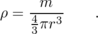
Everything in these equations can be measured directly except for m and r, so these are two equations in two unknowns, which can be solved in order to determine how big the drop is.
Next Millikan charged the metal plates, adjusting the amount of charge so as to exactly counteract gravity and levitate the drop. If, for instance, the drop being examined happened to have a total charge that was negative, then positive charge put on the top plate would attract it, pulling it up, and negative charge on the bottom plate would repel it, pushing it up. (Theoretically only one plate would be necessary, but in practice a two-plate arrangement like this gave electrical forces that were more uniform in strength throughout the space where the oil drops were.) The amount of charge on the plates required to levitate the charged drop gave Millikan a handle on the amount of charge the drop carried. The more charge the drop had, the stronger the electrical forces on it would be, and the less charge would have to be put on the plates to do the trick. Unfortunately, expressing this relationship using Coulomb's law would have been impractical, because it would require a perfect knowledge of how the charge was distributed on each plate, plus the ability to perform vector addition of all the forces being exerted on the drop by all the charges on the plate. Instead, Millikan made use of the fact that the electrical force experienced by a pointlike charged object at a certain point in space is proportional to its charge,
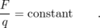
With a given amount of charge on the plates, this constant could be determined for instance by discarding the oil drop, inserting between the plates a larger and more easily handled object with a known charge on it, and measuring the force with conventional methods. (Millikan actually used a slightly different set of techniques for determining the constant, but the concept is the same.) The amount of force on the actual oil drop had to equal mg, since it was just enough to levitate it, and once the calibration constant had been determined, the charge of the drop could then be found based on its previously determined mass.
The table on the left shows a few of the results from Millikan's 1911 paper. (Millikan took data on both negatively and positively charged drops, but in his paper he gave only a sample of his data on negatively charged drops, so these numbers are all negative.) Even a quick look at the data leads to the suspicion that the charges are not simply a series of random numbers. For instance, the second charge is almost exactly equal to half the first one. Millikan explained the observed charges as all being integer multiples of a single number, 1.64×10⁻¹⁹ C. In the second column, dividing by this constant gives numbers that are essentially integers, allowing for the random errors present in the experiment. Millikan states in his paper that these results were a
... direct and tangible demonstration ... of the correctness of the view advanced many years ago and supported by evidence from many sources that all electrical charges, however produced, are exact multiples of one definite, elementary electrical charge, or in other words, that an electrical charge instead of being spread uniformly over the charged surface has a definite granular structure, consisting, in fact, of ... specks, or atoms of electricity, all precisely alike, peppered over the surface of the charged body.
In other words, he had provided direct evidence for the charged-particle model of electricity and against models in which electricity was described as some sort of fluid. The basic charge is notated e, and the modern value is e=1.60×10⁻¹⁹ C. The word “quantized” is used in physics to describe a quantity that can only have certain numerical values, and cannot have any of the values between those. In this language, we would say that Millikan discovered that charge is quantized. The charge e is referred to as the quantum of charge.

A historical note on Millikan's fraud
Very few undergraduate physics textbooks mention the well-documented fact that although Millikan's conclusions were correct, he was guilty of scientific fraud. His technique was difficult and painstaking to perform, and his original notebooks, which have been preserved, show that the data were far less perfect than he claimed in his published scientific papers. In his publications, he stated categorically that every single oil drop observed had had a charge that was a multiple of e, with no exceptions or omissions. But his notebooks are replete with notations such as “beautiful data, keep,” and “bad run, throw out.” Millikan, then, appears to have earned his Nobel Prize by advocating a correct position with dishonest descriptions of his data.
Why do textbook authors fail to mention Millikan's fraud? It may be that they think students are too unsophisticated to correctly evaluate the implications of the fact that scientific fraud has sometimes existed and even been rewarded by the scientific establishment. Maybe they are afraid students will reason that fudging data is OK, since Millikan got the Nobel Prize for it. But falsifying history in the name of encouraging truthfulness is more than a little ironic. English teachers don't edit Shakespeare's tragedies so that the bad characters are always punished and the good ones never suffer!
self-check: Is money quantized? What is the quantum of money? (answer in the back of the PDF version of the book)
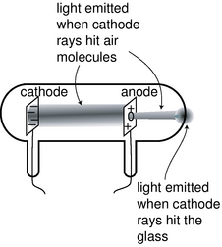
i / Cathode rays observed in a vacuum tube.
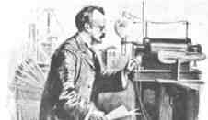
j / J.J. Thomson in the lab.

The electron

Cathode rays
Nineteenth-century physicists spent a lot of time trying to come up with wild, random ways to play with electricity. The best experiments of this kind were the ones that made big sparks or pretty colors of light.
One such parlor trick was the cathode ray. To produce it, you first had to hire a good glassblower and find a good vacuum pump. The glassblower would create a hollow tube and embed two pieces of metal in it, called the electrodes, which were connected to the outside via metal wires passing through the glass. Before letting him seal up the whole tube, you would hook it up to a vacuum pump, and spend several hours huffing and puffing away at the pump's hand crank to get a good vacuum inside. Then, while you were still pumping on the tube, the glassblower would melt the glass and seal the whole thing shut. Finally, you would put a large amount of positive charge on one wire and a large amount of negative charge on the other. Metals have the property of letting charge move through them easily, so the charge deposited on one of the wires would quickly spread out because of the repulsion of each part of it for every other part. This spreading-out process would result in nearly all the charge ending up in the electrodes, where there is more room to spread out than there is in the wire. For obscure historical reasons a negative electrode is called a cathode and a positive one is an anode.
Figure i shows the light-emitting stream that was observed. If, as shown in this figure, a hole was made in the anode, the beam would extend on through the hole until it hit the glass. Drilling a hole in the cathode, however would not result in any beam coming out on the left side, and this indicated that the stuff, whatever it was, was coming from the cathode. The rays were therefore christened “cathode rays.” (The terminology is still used today in the term “cathode ray tube” or “CRT” for the picture tube of a TV or computer monitor.)

Were cathode rays a form of light, or of matter?
Were cathode rays a form of light, or matter? At first no one really cared what they were, but as their scientific importance became more apparent, the light-versus-matter issue turned into a controversy along nationalistic lines, with the Germans advocating light and the English holding out for matter. The supporters of the material interpretation imagined the rays as consisting of a stream of atoms ripped from the substance of the cathode.
One of our defining characteristics of matter is that material objects cannot pass through each other. Experiments showed that cathode rays could penetrate at least some small thickness of matter, such as a metal foil a tenth of a millimeter thick, implying that they were a form of light.
Other experiments, however, pointed to the contrary conclusion. Light is a wave phenomenon, and one distinguishing property of waves is demonstrated by speaking into one end of a paper towel roll. The sound waves do not emerge from the other end of the tube as a focused beam. Instead, they begin spreading out in all directions as soon as they emerge. This shows that waves do not necessarily travel in straight lines. If a piece of metal foil in the shape of a star or a cross was placed in the way of the cathode ray, then a “shadow” of the same shape would appear on the glass, showing that the rays traveled in straight lines. This straight-line motion suggested that they were a stream of small particles of matter.
These observations were inconclusive, so what was really needed was a determination of whether the rays had mass and weight. The trouble was that cathode rays could not simply be collected in a cup and put on a scale. When the cathode ray tube is in operation, one does not observe any loss of material from the cathode, or any crust being deposited on the anode.
Nobody could think of a good way to weigh cathode rays, so the next most obvious way of settling the light/matter debate was to check whether the cathode rays possessed electrical charge. Light was known to be uncharged. If the cathode rays carried charge, they were definitely matter and not light, and they were presumably being made to jump the gap by the simultaneous repulsion of the negative charge in the cathode and attraction of the positive charge in the anode. The rays would overshoot the anode because of their momentum. (Although electrically charged particles do not normally leap across a gap of vacuum, very large amounts of charge were being used, so the forces were unusually intense.)

Thomson's experiments
Physicist J.J. Thomson at Cambridge carried out a series of definitive experiments on cathode rays around the year 1897. By turning them slightly off course with electrical forces, k, he showed that they were indeed electrically charged, which was strong evidence that they were material. Not only that, but he proved that they had mass, and measured the ratio of their mass to their charge, m/q. Since their mass was not zero, he concluded that they were a form of matter, and presumably made up of a stream of microscopic, negatively charged particles. When Millikan published his results fourteen years later, it was reasonable to assume that the charge of one such particle equaled minus one fundamental charge, q=-e, and from the combination of Thomson's and Millikan's results one could therefore determine the mass of a single cathode ray particle.
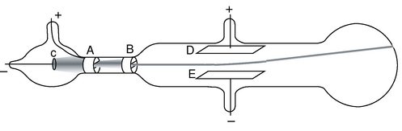
k / Thomson's experiment proving cathode rays had electric charge (redrawn from his original paper). The cathode, C, and anode, A, are as in any cathode ray tube. The rays pass through a slit in the anode, and a second slit, B, is interposed in order to make the beam thinner and eliminate rays that were not going straight. Charging plates D and E shows that cathode rays have charge: they are attracted toward the positive plate D and repelled by the negative plate E.
The basic technique for determining m/q was simply to measure the angle through which the charged plates bent the beam. The electric force acting on a cathode ray particle while it was between the plates would be proportional to its charge,
Application of Newton's second law, a=F/m, would allow m/q to be determined:
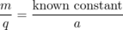
There was just one catch. Thomson needed to know the cathode ray particles' velocity in order to figure out their acceleration. At that point, however, nobody had even an educated guess as to the speed of the cathode rays produced in a given vacuum tube. The beam appeared to leap across the vacuum tube practically instantaneously, so it was no simple matter of timing it with a stopwatch!
Thomson's clever solution was to observe the effect of both electric and magnetic forces on the beam. The magnetic force exerted by a particular magnet would depend on both the cathode ray's charge and its velocity:
Thomson played with the electric and magnetic forces until either one would produce an equal effect on the beam, allowing him to solve for the velocity,
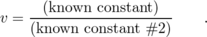
Knowing the velocity (which was on the order of 10% of the speed of light for his setup), he was able to find the acceleration and thus the mass-to-charge ratio m/q. Thomson's techniques were relatively crude (or perhaps more charitably we could say that they stretched the state of the art of the time), so with various methods he came up with m/q values that ranged over about a factor of two, even for cathode rays extracted from a cathode made of a single material. The best modern value is m/q=5.69×10⁻¹² kg/C, which is consistent with the low end of Thomson's range.

The cathode ray as a subatomic particle: the electron
What was significant about Thomson's experiment was not the actual numerical value of m/q, however, so much as the fact that, combined with Millikan's value of the fundamental charge, it gave a mass for the cathode ray particles that was thousands of times smaller than the mass of even the lightest atoms. Even without Millikan's results, which were 14 years in the future, Thomson recognized that the cathode rays' m/q was thousands of times smaller than the m/q ratios that had been measured for electrically charged atoms in chemical solutions. He correctly interpreted this as evidence that the cathode rays were smaller building blocks --- he called them electrons --- out of which atoms themselves were formed. This was an extremely radical claim, coming at a time when atoms had not yet been proven to exist! Even those who used the word “atom” often considered them no more than mathematical abstractions, not literal objects. The idea of searching for structure inside of “unsplittable” atoms was seen by some as lunacy, but within ten years Thomson's ideas had been amply verified by many more detailed experiments.

Discussion Questions
◊ Thomson started to become convinced during his experiments that the “cathode rays” observed coming from the cathodes of vacuum tubes were building blocks of atoms --- what we now call electrons. He then carried out observations with cathodes made of a variety of metals, and found that m/q was roughly the same in every case, considering his limited accuracy. Given his suspicion, why did it make sense to try different metals? How would the consistent values of m/q serve to test his hypothesis?
◊ My students have frequently asked whether the m/q that Thomson measured was the value for a single electron, or for the whole beam. Can you answer this question?
◊ Thomson found that the m/q of an electron was thousands of times smaller than that of charged atoms in chemical solutions. Would this imply that the electrons had more charge? Less mass? Would there be no way to tell? Explain. Remember that Millikan's results were still many years in the future, so q was unknown.
◊ Can you guess any practical reason why Thomson couldn't just let one electron fly across the gap before disconnecting the battery and turning off the beam, and then measure the amount of charge deposited on the anode, thus allowing him to measure the charge of a single electron directly?
◊ Why is it not possible to determine m and q themselves, rather than just their ratio, by observing electrons' motion in electric and magnetic fields?
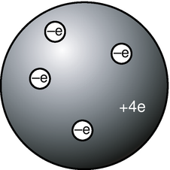
l / The raisin cookie model of the atom with four units of charge, which we now know to be beryllium.

The raisin cookie model of the atom
Based on his experiments, Thomson proposed a picture of the atom which became known as the raisin cookie model. In the neutral atom, l, there are four electrons with a total charge of -4e, sitting in a sphere (the “cookie”) with a charge of +4e spread throughout it. It was known that chemical reactions could not change one element into another, so in Thomson's scenario, each element's cookie sphere had a permanently fixed radius, mass, and positive charge, different from those of other elements. The electrons, however, were not a permanent feature of the atom, and could be tacked on or pulled out to make charged ions. Although we now know, for instance, that a neutral atom with four electrons is the element beryllium, scientists at the time did not know how many electrons the various neutral atoms possessed.
This model is clearly different from the one you've learned in grade school or through popular culture, where the positive charge is concentrated in a tiny nucleus at the atom's center. An equally important change in ideas about the atom has been the realization that atoms and their constituent subatomic particles behave entirely differently from objects on the human scale. For instance, we'll see later that an electron can be in more than one place at one time. The raisin cookie model was part of a long tradition of attempts to make mechanical models of phenomena, and Thomson and his contemporaries never questioned the appropriateness of building a mental model of an atom as a machine with little parts inside. Today, mechanical models of atoms are still used (for instance the tinker-toy-style molecular modeling kits like the ones used by Watson and Crick to figure out the double helix structure of DNA), but scientists realize that the physical objects are only aids to help our brains' symbolic and visual processes think about atoms.
Although there was no clear-cut experimental evidence for many of the details of the raisin cookie model, physicists went ahead and started working out its implications. For instance, suppose you had a four-electron atom. All four electrons would be repelling each other, but they would also all be attracted toward the center of the “cookie” sphere. The result should be some kind of stable, symmetric arrangement in which all the forces canceled out. People sufficiently clever with math soon showed that the electrons in a four-electron atom should settle down at the vertices of a pyramid with one less side than the Egyptian kind, i.e. a regular tetrahedron. This deduction turns out to be wrong because it was based on incorrect features of the model, but the model also had many successes, a few of which we will now discuss.

Example 3: Flow of electrical charge in wires
One of my former students was the son of an electrician, and had become an electrician himself. He related to me how his father had remained refused to believe all his life that electrons really flowed through wires. If they had, he reasoned, the metal would have gradually become more and more damaged, eventually crumbling to dust.
His opinion is not at all unreasonable based on the fact that electrons are material particles, and that matter cannot normally pass through matter without making a hole through it. Nineteenth-century physicists would have shared his objection to a charged-particle model of the flow of electrical charge. In the raisin-cookie model, however, the electrons are very low in mass, and therefore presumably very small in size as well. It is not surprising that they can slip between the atoms without damaging them.

Example 4: Flow of electrical charge across cell membranes
Your nervous system is based on signals carried by charge moving from nerve cell to nerve cell. Your body is essentially all liquid, and atoms in a liquid are mobile. This means that, unlike the case of charge flowing in a solid wire, entire charged atoms can flow in your nervous system

Example 5: Emission of electrons in a cathode ray tube
Why do electrons detach themselves from the cathode of a vacuum tube? Certainly they are encouraged to do so by the repulsion of the negative charge placed on the cathode and the attraction from the net positive charge of the anode, but these are not strong enough to rip electrons out of atoms by main force --- if they were, then the entire apparatus would have been instantly vaporized as every atom was simultaneously ripped apart!
The raisin cookie model leads to a simple explanation. We know that heat is the energy of random motion of atoms. The atoms in any object are therefore violently jostling each other all the time, and a few of these collisions are violent enough to knock electrons out of atoms. If this occurs near the surface of a solid object, the electron may can come loose. Ordinarily, however, this loss of electrons is a self-limiting process; the loss of electrons leaves the object with a net positive charge, which attracts the lost sheep home to the fold. (For objects immersed in air rather than vacuum, there will also be a balanced exchange of electrons between the air and the object.)
This interpretation explains the warm and friendly yellow glow of the vacuum tubes in an antique radio. To encourage the emission of electrons from the vacuum tubes' cathodes, the cathodes are intentionally warmed up with little heater coils.

Discussion Questions
◊ Today many people would define an ion as an atom (or molecule) with missing electrons or extra electrons added on. How would people have defined the word “ion” before the discovery of the electron?
◊ Since electrically neutral atoms were known to exist, there had to be positively charged subatomic stuff to cancel out the negatively charged electrons in an atom. Based on the state of knowledge immediately after the Millikan and Thomson experiments, was it possible that the positively charged stuff had an unquantized amount of charge? Could it be quantized in units of +e? In units of +2e? In units of +5/7e?

8.2 The Nucleus
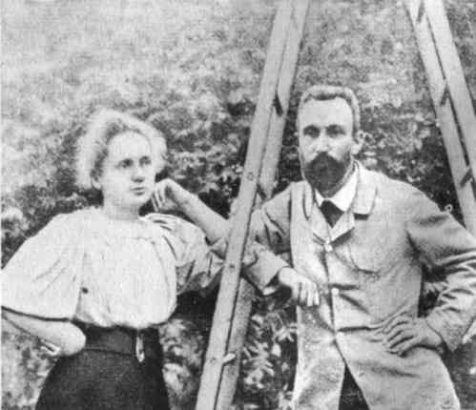
a / Marie and Pierre Curie were the first to purify radium in significant quantities. Radium's intense radioactivity made possible the experiments that led to the modern planetary model of the atom, in which electrons orbit a nucleus made of protons and neutrons.
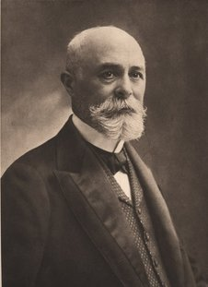
b / Henri Becquerel (1852-1908).
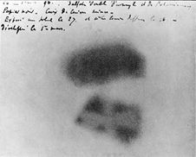
c / Becquerel's photographic plate. In the exposure at the bottom of the image, he has found that he could absorb the radiations, casting the shadow of a Maltese cross that was placed between the plate and the uranium salts.
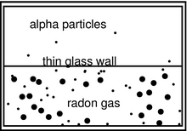
d / A simplified version of Rutherford's 1908 experiment, showing that alpha particles were doubly ionized helium atoms.
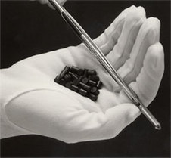
e / These pellets of uranium fuel will be inserted into the metal fuel rod and used in a nuclear reactor. The pellets emit alpha and beta radiation, which the gloves are thick enough to stop.

Radioactivity

Becquerel's discovery of radioactivity
How did physicists figure out that the raisin cookie model was incorrect, and that the atom's positive charge was concentrated in a tiny, central nucleus? The story begins with the discovery of radioactivity by the French chemist Becquerel. Up until radioactivity was discovered, all the processes of nature were thought to be based on chemical reactions, which were rearrangements of combinations of atoms. Atoms exert forces on each other when they are close together, so sticking or unsticking them would either release or store electrical energy. That energy could be converted to and from other forms, as when a plant uses the energy in sunlight to make sugars and carbohydrates, or when a child eats sugar, releasing the energy in the form of kinetic energy.
Becquerel discovered a process that seemed to release energy from an unknown new source that was not chemical. Becquerel, whose father and grandfather had also been physicists, spent the first twenty years of his professional life as a successful civil engineer, teaching physics on a part-time basis. He was awarded the chair of physics at the Musée d'Histoire Naturelle in Paris after the death of his father, who had previously occupied it. Having now a significant amount of time to devote to physics, he began studying the interaction of light and matter. He became interested in the phenomenon of phosphorescence, in which a substance absorbs energy from light, then releases the energy via a glow that only gradually goes away. One of the substances he investigated was a uranium compound, the salt UKSO₅. One day in 1896, cloudy weather interfered with his plan to expose this substance to sunlight in order to observe its fluorescence. He stuck it in a drawer, coincidentally on top of a blank photographic plate --- the old-fashioned glass-backed counterpart of the modern plastic roll of film. The plate had been carefully wrapped, but several days later when Becquerel checked it in the darkroom before using it, he found that it was ruined, as if it had been completely exposed to light.
History provides many examples of scientific discoveries that happened this way: an alert and inquisitive mind decides to investigate a phenomenon that most people would not have worried about explaining. Becquerel first determined by further experiments that the effect was produced by the uranium salt, despite a thick wrapping of paper around the plate that blocked out all light. He tried a variety of compounds, and found that it was the uranium that did it: the effect was produced by any uranium compound, but not by any compound that didn't include uranium atoms. The effect could be at least partially blocked by a sufficient thickness of metal, and he was able to produce silhouettes of coins by interposing them between the uranium and the plate. This indicated that the effect traveled in a straight line., so that it must have been some kind of ray rather than, e.g., the seepage of chemicals through the paper. He used the word “radiations,” since the effect radiated out from the uranium salt.
At this point Becquerel still believed that the uranium atoms were absorbing energy from light and then gradually releasing the energy in the form of the mysterious rays, and this was how he presented it in his first published lecture describing his experiments. Interesting, but not earth-shattering. But he then tried to determine how long it took for the uranium to use up all the energy that had supposedly been stored in it by light, and he found that it never seemed to become inactive, no matter how long he waited. Not only that, but a sample that had been exposed to intense sunlight for a whole afternoon was no more or less effective than a sample that had always been kept inside. Was this a violation of conservation of energy? If the energy didn't come from exposure to light, where did it come from?

Three kinds of “radiations”
Unable to determine the source of the energy directly, turn-of-the-century physicists instead studied the behavior of the “radiations” once they had been emitted. Becquerel had already shown that the radioactivity could penetrate through cloth and paper, so the first obvious thing to do was to investigate in more detail what thickness of material the radioactivity could get through. They soon learned that a certain fraction of the radioactivity's intensity would be eliminated by even a few inches of air, but the remainder was not eliminated by passing through more air. Apparently, then, the radioactivity was a mixture of more than one type, of which one was blocked by air. They then found that of the part that could penetrate air, a further fraction could be eliminated by a piece of paper or a very thin metal foil. What was left after that, however, was a third, extremely penetrating type, some of whose intensity would still remain even after passing through a brick wall. They decided that this showed there were three types of radioactivity, and without having the faintest idea of what they really were, they made up names for them. The least penetrating type was arbitrarily labeled α (alpha), the first letter of the Greek alphabet, and so on through β (beta) and finally γ (gamma) for the most penetrating type.

Radium: a more intense source of radioactivity
The measuring devices used to detect radioactivity were crude: photographic plates or even human eyeballs (radioactivity makes flashes of light in the jelly-like fluid inside the eye, which can be seen by the eyeball's owner if it is otherwise very dark). Because the ways of detecting radioactivity were so crude and insensitive, further progress was hindered by the fact that the amount of radioactivity emitted by uranium was not really very great. The vital contribution of physicist/chemist Marie Curie and her husband Pierre was to discover the element radium, and to purify and isolate significant quantities it. Radium emits about a million times more radioactivity per unit mass than uranium, making it possible to do the experiments that were needed to learn the true nature of radioactivity. The dangers of radioactivity to human health were then unknown, and Marie died of leukemia thirty years later. (Pierre was run over and killed by a horsecart.)

Tracking down the nature of alphas, betas, and gammas
As radium was becoming available, an apprentice scientist named Ernest Rutherford arrived in England from his native New Zealand and began studying radioactivity at the Cavendish Laboratory. The young colonial's first success was to measure the mass-to-charge ratio of beta rays. The technique was essentially the same as the one Thomson had used to measure the mass-to-charge ratio of cathode rays by measuring their deflections in electric and magnetic fields. The only difference was that instead of the cathode of a vacuum tube, a nugget of radium was used to supply the beta rays. Not only was the technique the same, but so was the result. Beta rays had the same m/q ratio as cathode rays, which suggested they were one and the same. Nowadays, it would make sense simply to use the term “electron,” and avoid the archaic “cathode ray” and “beta particle,” but the old labels are still widely used, and it is unfortunately necessary for physics students to memorize all three names for the same thing.
At first, it seemed that neither alphas or gammas could be deflected in electric or magnetic fields, making it appear that neither was electrically charged. But soon Rutherford obtained a much more powerful magnet, and was able to use it to deflect the alphas but not the gammas. The alphas had a much larger value of m/q than the betas (about 4000 times greater), which was why they had been so hard to deflect. Gammas are uncharged, and were later found to be a form of light.
The m/q ratio of alpha particles turned out to be the same as those of two different types of ions, He⁺⁺ (a helium atom with two missing electrons) and H₂⁺ (two hydrogen atoms bonded into a molecule, with one electron missing) , so it seemed likely that they were one or the other of those. The diagram shows a simplified version of Rutherford's ingenious experiment proving that they were He⁺⁺ ions. The gaseous element radon, an alpha emitter, was introduced into one half of a double glass chamber. The glass wall dividing the chamber was made extremely thin, so that some of the rapidly moving alpha particles were able to penetrate it. The other chamber, which was initially evacuated, gradually began to accumulate a population of alpha particles (which would quickly pick up electrons from their surroundings and become electrically neutral). Rutherford then determined that it was helium gas that had appeared in the second chamber. Thus alpha particles were proved to be He⁺⁺ ions. The nucleus was yet to be discovered, but in modern terms, we would describe a He⁺⁺ ion as the nucleus of a He atom.
To summarize, here are the three types of radiation emitted by radioactive elements, and their descriptions in modern terms:
α particle | stopped by a few inches of air | He nucleus
β particle | stopped by a piece of paper | electron
γ ray | penetrates thick shielding | a type of light

Discussion Questions
◊ Most sources of radioactivity emit alphas, betas, and gammas, not just one of the three. In the radon experiment, how did Rutherford know that he was studying the alphas?
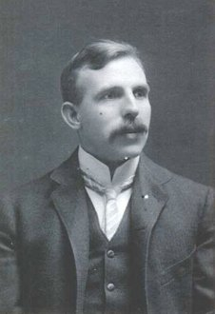
f / Ernest Rutherford (1871-1937).
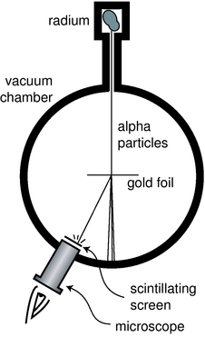
g / Rutherford and Marsden's apparatus.
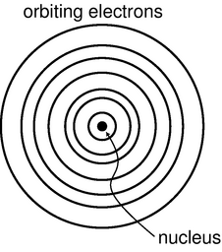
i / The planetary model of the atom.
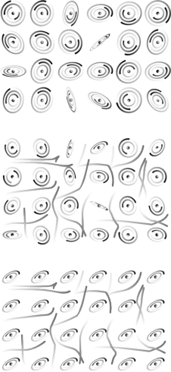
j / The planetary model applied to a nonmetal, 1, an unmagnetized metal, 2, and a magnetized metal, 3. Note that these figures are all simplified in several ways. For one thing, the electrons of an individual atom do not all revolve around the nucleus in the same plane. It is also very unusual for a metal to become so strongly magnetized that 100% of its atoms have their rotations aligned as shown in this figure.

The planetary model of the atom
The stage was now set for the unexpected discovery that the positively charged part of the atom was a tiny, dense lump at the atom's center rather than the “cookie dough” of the raisin cookie model. By 1909, Rutherford was an established professor, and had students working under him. For a raw undergraduate named Marsden, he picked a research project he thought would be tedious but straightforward.
It was already known that although alpha particles would be stopped completely by a sheet of paper, they could pass through a sufficiently thin metal foil. Marsden was to work with a gold foil only 1000 atoms thick. (The foil was probably made by evaporating a little gold in a vacuum chamber so that a thin layer would be deposited on a glass microscope slide. The foil would then be lifted off the slide by submerging the slide in water.)
Rutherford had already determined in his previous experiments the speed of the alpha particles emitted by radium, a fantastic 1.5×10⁷ m/s. The experimenters in Rutherford's group visualized them as very small, very fast cannonballs penetrating the “cookie dough” part of the big gold atoms. A piece of paper has a thickness of a hundred thousand atoms or so, which would be sufficient to stop them completely, but crashing through a thousand would only slow them a little and turn them slightly off of their original paths.
Marsden's supposedly ho-hum assignment was to use the apparatus shown in figure g to measure how often alpha particles were deflected at various angles. A tiny lump of radium in a box emitted alpha particles, and a thin beam was created by blocking all the alphas except those that happened to pass out through a tube. Typically deflected in the gold by only a small amount, they would reach a screen very much like the screen of a TV's picture tube, which would make a flash of light when it was hit. Here is the first example we have encountered of an experiment in which a beam of particles is detected one at a time. This was possible because each alpha particle carried so much kinetic energy; they were moving at about the same speed as the electrons in the Thomson experiment, but had ten thousand times more mass.
Marsden sat in a dark room, watching the apparatus hour after hour and recording the number of flashes with the screen moved to various angles. The rate of the flashes was highest when he set the screen at an angle close to the line of the alphas' original path, but if he watched an area farther off to the side, he would also occasionally see an alpha that had been deflected through a larger angle. After seeing a few of these, he got the crazy idea of moving the screen to see if even larger angles ever occurred, perhaps even angles larger than 90 degrees.
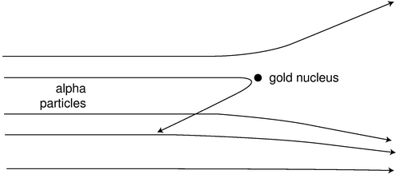
h / Alpha particles being scattered by a gold nucleus. On this scale, the gold atom is the size of a car, so all the alpha particles shown here are ones that just happened to come unusually close to the nucleus. For these exceptional alpha particles, the forces from the electrons are unimportant, because they are so much more distant than the nucleus.
The crazy idea worked: a few alpha particles were deflected through angles of up to 180 degrees, and the routine experiment had become an epoch-making one. Rutherford said, “We have been able to get some of the alpha particles coming backwards. It was almost as incredible as if you fired a 15-inch shell at a piece of tissue paper and it came back and hit you.” Explanations were hard to come by in the raisin cookie model. What intense electrical forces could have caused some of the alpha particles, moving at such astronomical speeds, to change direction so drastically? Since each gold atom was electrically neutral, it would not exert much force on an alpha particle outside it. True, if the alpha particle was very near to or inside of a particular atom, then the forces would not necessarily cancel out perfectly; if the alpha particle happened to come very close to a particular electron, the 1/r² form of the Coulomb force law would make for a very strong force. But Marsden and Rutherford knew that an alpha particle was 8000 times more massive than an electron, and it is simply not possible for a more massive object to rebound backwards from a collision with a less massive object while conserving momentum and energy. It might be possible in principle for a particular alpha to follow a path that took it very close to one electron, and then very close to another electron, and so on, with the net result of a large deflection, but careful calculations showed that such multiple “close encounters” with electrons would be millions of times too rare to explain what was actually observed.
At this point, Rutherford and Marsden dusted off an unpopular and neglected model of the atom, in which all the electrons orbited around a small, positively charged core or “nucleus,” just like the planets orbiting around the sun. All the positive charge and nearly all the mass of the atom would be concentrated in the nucleus, rather than spread throughout the atom as in the raisin cookie model. The positively charged alpha particles would be repelled by the gold atom's nucleus, but most of the alphas would not come close enough to any nucleus to have their paths drastically altered. The few that did come close to a nucleus, however, could rebound backwards from a single such encounter, since the nucleus of a heavy gold atom would be fifty times more massive than an alpha particle. It turned out that it was not even too difficult to derive a formula giving the relative frequency of deflections through various angles, and this calculation agreed with the data well enough (to within 15%), considering the difficulty in getting good experimental statistics on the rare, very large angles.
What had started out as a tedious exercise to get a student started in science had ended as a revolution in our understanding of nature. Indeed, the whole thing may sound a little too much like a moralistic fable of the scientific method with overtones of the Horatio Alger genre. The skeptical reader may wonder why the planetary model was ignored so thoroughly until Marsden and Rutherford's discovery. Is science really more of a sociological enterprise, in which certain ideas become accepted by the establishment, and other, equally plausible explanations are arbitrarily discarded? Some social scientists are currently ruffling a lot of scientists' feathers with critiques very much like this, but in this particular case, there were very sound reasons for rejecting the planetary model. As you'll learn in more detail later in this course, any charged particle that undergoes an acceleration dissipate energy in the form of light. In the planetary model, the electrons were orbiting the nucleus in circles or ellipses, which meant they were undergoing acceleration, just like the acceleration you feel in a car going around a curve. They should have dissipated energy as light, and eventually they should have lost all their energy. Atoms don't spontaneously collapse like that, which was why the raisin cookie model, with its stationary electrons, was originally preferred. There were other problems as well. In the planetary model, the one-electron atom would have to be flat, which would be inconsistent with the success of molecular modeling with spherical balls representing hydrogen and atoms. These molecular models also seemed to work best if specific sizes were used for different atoms, but there is no obvious reason in the planetary model why the radius of an electron's orbit should be a fixed number. In view of the conclusive Marsden-Rutherford results, however, these became fresh puzzles in atomic physics, not reasons for disbelieving the planetary model.

Some phenomena explained with the planetary model
The planetary model may not be the ultimate, perfect model of the atom, but don't underestimate its power. It already allows us to visualize correctly a great many phenomena.
As an example, let's consider the distinctions among nonmetals, metals that are magnetic, and metals that are nonmagnetic. As shown in figure j, a metal differs from a nonmetal because its outermost electrons are free to wander rather than owing their allegiance to a particular atom. A metal that can be magnetized is one that is willing to line up the rotations of some of its electrons so that their axes are parallel. Recall that magnetic forces are forces made by moving charges; we have not yet discussed the mathematics and geometry of magnetic forces, but it is easy to see how random orientations of the atoms in the nonmagnetic substance would lead to cancellation of the forces.
Even if the planetary model does not immediately answer such questions as why one element would be a metal and another a nonmetal, these ideas would be difficult or impossible to conceptualize in the raisin cookie model.

Discussion Questions
◊ In reality, charges of the same type repel one another and charges of different types are attracted. Suppose the rules were the other way around, giving repulsion between opposite charges and attraction between similar ones. What would the universe be like?

Atomic number
As alluded to in a discussion question in the previous section, scientists of this period had only a very approximate idea of how many units of charge resided in the nuclei of the various chemical elements. Although we now associate the number of units of nuclear charge with the element's position on the periodic table, and call it the atomic number, they had no idea that such a relationship existed. Mendeleev's table just seemed like an organizational tool, not something with any necessary physical significance. And everything Mendeleev had done seemed equally valid if you turned the table upside-down or reversed its left and right sides, so even if you wanted to number the elements sequentially with integers, there was an ambiguity as to how to do it. Mendeleev's original table was in fact upside-down compared to the modern one.
k / A modern periodic table, labeled with atomic numbers. Mendeleev's original table was upside-down compared to this one.
In the period immediately following the discovery of the nucleus, physicists only had rough estimates of the charges of the various nuclei. In the case of the very lightest nuclei, they simply found the maximum number of electrons they could strip off by various methods: chemical reactions, electric sparks, ultraviolet light, and so on. For example they could easily strip of one or two electrons from helium, making He⁺ or He⁺⁺, but nobody could make He⁺⁺⁺, presumably because the nuclear charge of helium was only +2e. Unfortunately only a few of the lightest elements could be stripped completely, because the more electrons were stripped off, the greater the positive net charge remaining, and the more strongly the rest of the negatively charged electrons would be held on. The heavy elements' atomic numbers could only be roughly extrapolated from the light elements, where the atomic number was about half the atom's mass expressed in units of the mass of a hydrogen atom. Gold, for example, had a mass about 197 times that of hydrogen, so its atomic number was estimated to be about half that, or somewhere around 100. We now know it to be 79.
How did we finally find out? The riddle of the nuclear charges was at last successfully attacked using two different techniques, which gave consistent results. One set of experiments, involving x-rays, was performed by the young Henry Mosely, whose scientific brilliance was soon to be sacrificed in a battle between European imperialists over who would own the Dardanelles, during that pointless conflict then known as the War to End All Wars, and now referred to as World War I.
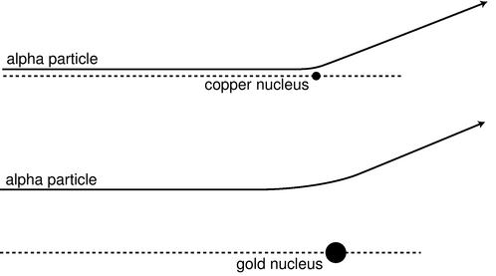
l / An alpha particle has to come much closer to the low-charged copper nucleus in order to be deflected through the same angle.
Since Mosely's analysis requires several concepts with which you are not yet familiar, we will instead describe the technique used by James Chadwick at around the same time. An added bonus of describing Chadwick's experiments is that they presaged the important modern technique of studying collisions of subatomic particles. In grad school, I worked with a professor whose thesis adviser's thesis adviser was Chadwick, and he related some interesting stories about the man. Chadwick was apparently a little nutty and a complete fanatic about science, to the extent that when he was held in a German prison camp during World War II, he managed to cajole his captors into allowing him to scrounge up parts from broken radios so that he could attempt to do physics experiments.
Chadwick's experiment worked like this. Suppose you perform two Rutherford-type alpha scattering measurements, first one with a gold foil as a target as in Rutherford's original experiment, and then one with a copper foil. It is possible to get large angles of deflection in both cases, but as shown in figure m, the alpha particle must be heading almost straight for the copper nucleus to get the same angle of deflection that would have occurred with an alpha that was much farther off the mark; the gold nucleus' charge is so much greater than the copper's that it exerts a strong force on the alpha particle even from far off. The situation is very much like that of a blindfolded person playing darts. Just as it is impossible to aim an alpha particle at an individual nucleus in the target, the blindfolded person cannot really aim the darts. Achieving a very close encounter with the copper atom would be akin to hitting an inner circle on the dartboard. It's much more likely that one would have the luck to hit the outer circle, which covers a greater number of square inches. By analogy, if you measure the frequency with which alphas are scattered by copper at some particular angle, say between 19 and 20 degrees, and then perform the same measurement at the same angle with gold, you get a much higher percentage for gold than for copper.
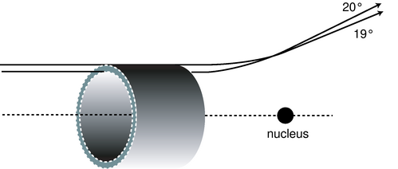
m / An alpha particle must be headed for the ring on the front of the imaginary cylindrical pipe in order to produce scattering at an angle between 19 and 20 degrees. The area of this ring is called the “cross-section” for scattering at 19-20° because it is the cross-sectional area of a cut through the pipe.
In fact, the numerical ratio of the two nuclei's charges can be derived from this same experimentally determined ratio. Using the standard notation Z for the atomic number (charge of the nucleus divided by e), the following equation can be proved (example 6):
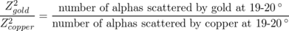
By making such measurements for targets constructed from all the elements, one can infer the ratios of all the atomic numbers, and since the atomic numbers of the light elements were already known, atomic numbers could be assigned to the entire periodic table. According to Mosely, the atomic numbers of copper, silver and platinum were 29, 47, and 78, which corresponded well with their positions on the periodic table. Chadwick's figures for the same elements were 29.3, 46.3, and 77.4, with error bars of about 1.5 times the fundamental charge, so the two experiments were in good agreement.
The point here is absolutely not that you should be ready to plug numbers into the above equation for a homework or exam question! My overall goal in this chapter is to explain how we know what we know about atoms. An added bonus of describing Chadwick's experiment is that the approach is very similar to that used in modern particle physics experiments, and the ideas used in the analysis are closely related to the now-ubiquitous concept of a “cross-section.” In the dartboard analogy, the cross-section would be the area of the circular ring you have to hit. The reasoning behind the invention of the term “cross-section” can be visualized as shown in figure m. In this language, Rutherford's invention of the planetary model came from his unexpected discovery that there was a nonzero cross-section for alpha scattering from gold at large angles, and Chadwick confirmed Mosely's determinations of the atomic numbers by measuring cross-sections for alpha scattering.

Example 6: Proof of the relationship between Z and scattering
The equation above can be derived by the following not very rigorous proof. To deflect the alpha particle by a certain angle requires that it acquire a certain momentum component in the direction perpendicular to its original momentum. Although the nucleus's force on the alpha particle is not constant, we can pretend that it is approximately constant during the time when the alpha is within a distance equal to, say, 150% of its distance of closest approach, and that the force is zero before and after that part of the motion. (If we chose 120% or 200%, it shouldn't make any difference in the final result, because the final result is a ratio, and the effects on the numerator and denominator should cancel each other.) In the approximation of constant force, the change in the alpha's perpendicular momentum component is then equal to FΔ t. The Coulomb force law says the force is proportional to Z/ r². Although r does change somewhat during the time interval of interest, it's good enough to treat it as a constant number, since we're only computing the ratio between the two experiments' results. Since we are approximating the force as acting over the time during which the distance is not too much greater than the distance of closest approach, the time interval Δ t must be proportional to r, and the sideways momentum imparted to the alpha, FΔ t, is proportional to ( Z/ r²) r, or Z/ r. If we're comparing alphas scattered at the same angle from gold and from copper, then Δ p is the same in both cases, and the proportionality Δ p∝ Z/ r tells us that the ones scattered from copper at that angle had to be headed in along a line closer to the central axis by a factor equaling Z_{T}EXTu0004gold/ Z_{T}EXTu0006copper. If you imagine a “dartboard ring” that the alphas have to hit, then the ring for the gold experiment has the same proportions as the one for copper, but it is enlarged by a factor equal to Z_{T}EXTu0004gold/ Z_{T}EXTu0006copper. That is, not only is the radius of the ring greater by that factor, but unlike the rings on a normal dartboard, the thickness of the outer ring is also greater in proportion to its radius. When you take a geometric shape and scale it up in size like a photographic enlargement, its area is increased in proportion to the square of the enlargement factor, so the area of the dartboard ring in the gold experiment is greater by a factor equal to ( Z_{T}EXTu0004gold/ Z_{T}EXTu0006copper)². Since the alphas are aimed entirely randomly, the chances of an alpha hitting the ring are in proportion to the area of the ring, which proves the equation given above.
As an example of the modern use of scattering experiments and cross-section measurements, you may have heard of the recent experimental evidence for the existence of a particle called the top quark. Of the twelve subatomic particles currently believed to be the smallest constituents of matter, six form a family called the quarks, distinguished from the other six by the intense attractive forces that make the quarks stick to each other. (The other six consist of the electron plus five other, more exotic particles.) The only two types of quarks found in naturally occurring matter are the “up quark” and “down quark,” which are what protons and neutrons are made of, but four other types were theoretically predicted to exist, for a total of six. (The whimsical term “quark” comes from a line by James Joyce reading “Three quarks for master Mark.”) Until recently, only five types of quarks had been proven to exist via experiments, and the sixth, the top quark, was only theorized. There was no hope of ever detecting a top quark directly, since it is radioactive, and only exists for a zillionth of a second before evaporating. Instead, the researchers searching for it at the Fermi National Accelerator Laboratory near Chicago measured cross-sections for scattering of nuclei off of other nuclei. The experiment was much like those of Rutherford and Chadwick, except that the incoming nuclei had to be boosted to much higher speeds in a particle accelerator. The resulting encounter with a target nucleus was so violent that both nuclei were completely demolished, but, as Einstein proved, energy can be converted into matter, and the energy of the collision creates a spray of exotic, radioactive particles, like the deadly shower of wood fragments produced by a cannon ball in an old naval battle. Among those particles were some top quarks. The cross-sections being measured were the cross-sections for the production of certain combinations of these secondary particles. However different the details, the principle was the same as that employed at the turn of the century: you smash things together and look at the fragments that fly off to see what was inside them. The approach has been compared to shooting a clock with a rifle and then studying the pieces that fly off to figure out how the clock worked.

Discussion Questions
◊ The diagram, showing alpha particles being deflected by a gold nucleus, was drawn with the assumption that alpha particles came in on lines at many different distances from the nucleus. Why wouldn't they all come in along the same line, since they all came out through the same tube?
◊ Why does it make sense that, as shown in the figure, the trajectories that result in 19° and 20° scattering cross each other?
◊ Rutherford knew the velocity of the alpha particles emitted by radium, and guessed that the positively charged part of a gold atom had a charge of about +100e (we now know it is +79e). Considering the fact that some alpha particles were deflected by 180°, how could he then use conservation of energy to derive an upper limit on the size of a gold nucleus? (For simplicity, assume the size of the alpha particle is negligible compared to that of the gold nucleus, and ignore the fact that the gold nucleus recoils a little from the collision, picking up a little kinetic energy.)
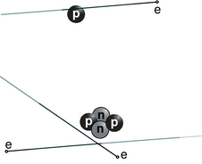
n / Examples of the construction of atoms: hydrogen (top) and helium (bottom). On this scale, the electrons' orbits would be the size of a college campus.
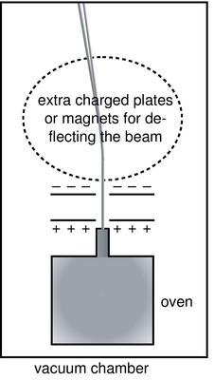
o / A version of the Thomson apparatus modified for measuring the mass-to-charge ratios of ions rather than electrons. A small sample of the element in question, copper in our example, is boiled in the oven to create a thin vapor. (A vacuum pump is continuously sucking on the main chamber to keep it from accumulating enough gas to stop the beam of ions.) Some of the atoms of the vapor are ionized by a spark or by ultraviolet light. Ions that wander out of the nozzle and into the region between the charged plates are then accelerated toward the top of the figure. As in the Thomson experiment, mass-to-charge ratios are inferred from the deflection of the beam.

The structure of nuclei

The proton
The fact that the nuclear charges were all integer multiples of e suggested to many physicists that rather than being a pointlike object, the nucleus might contain smaller particles having individual charges of +e. Evidence in favor of this idea was not long in arriving. Rutherford reasoned that if he bombarded the atoms of a very light element with alpha particles, the small charge of the target nuclei would give a very weak repulsion. Perhaps those few alpha particles that happened to arrive on head-on collision courses would get so close that they would physically crash into some of the target nuclei. An alpha particle is itself a nucleus, so this would be a collision between two nuclei, and a violent one due to the high speeds involved. Rutherford hit pay dirt in an experiment with alpha particles striking a target containing nitrogen atoms. Charged particles were detected flying out of the target like parts flying off of cars in a high-speed crash. Measurements of the deflection of these particles in electric and magnetic fields showed that they had the same charge-to-mass ratio as singly-ionized hydrogen atoms. Rutherford concluded that these were the conjectured singly-charged particles that held the charge of the nucleus, and they were later named protons. The hydrogen nucleus consists of a single proton, and in general, an element's atomic number gives the number of protons contained in each of its nuclei. The mass of the proton is about 1800 times greater than the mass of the electron.

The neutron
It would have been nice and simple if all the nuclei could have been built only from protons, but that couldn't be the case. If you spend a little time looking at a periodic table, you will soon notice that although some of the atomic masses are very nearly integer multiples of hydrogen's mass, many others are not. Even where the masses are close whole numbers, the masses of an element other than hydrogen is always greater than its atomic number, not equal to it. Helium, for instance, has two protons, but its mass is four times greater than that of hydrogen.
Chadwick cleared up the confusion by proving the existence of a new subatomic particle. Unlike the electron and proton, which are electrically charged, this particle is electrically neutral, and he named it the neutron. Chadwick's experiment has been described in detail in chapter 4 of book 2 of this series, but briefly the method was to expose a sample of the light element beryllium to a stream of alpha particles from a lump of radium. Beryllium has only four protons, so an alpha that happens to be aimed directly at a beryllium nucleus can actually hit it rather than being stopped short of a collision by electrical repulsion. Neutrons were observed as a new form of radiation emerging from the collisions, and Chadwick correctly inferred that they were previously unsuspected components of the nucleus that had been knocked out. As described in 3, Chadwick also determined the mass of the neutron; it is very nearly the same as that of the proton.
To summarize, atoms are made of three types of particles:
 | charge | mass in units of the proton’s mass | location in atom
proton | + e | 1 | in nucleus
neutron | 0 | 1.001 | in nucleus
electron | − e | 1/1836 | orbiting nucleus
The existence of neutrons explained the mysterious masses of the elements. Helium, for instance, has a mass very close to four times greater than that of hydrogen. This is because it contains two neutrons in addition to its two protons. The mass of an atom is essentially determined by the total number of neutrons and protons. The total number of neutrons plus protons is therefore referred to as the atom's mass number.

Isotopes
We now have a clear interpretation of the fact that helium is close to four times more massive than hydrogen, and similarly for all the atomic masses that are close to an integer multiple of the mass of hydrogen. But what about copper, for instance, which had an atomic mass 63.5 times that of hydrogen? It didn't seem reasonable to think that it possessed an extra half of a neutron! The solution was found by measuring the mass-to-charge ratios of singly-ionized atoms (atoms with one electron removed). The technique is essentially that same as the one used by Thomson for cathode rays, except that whole atoms do not spontaneously leap out of the surface of an object as electrons sometimes do. Figure o shows an example of how the ions can be created and injected between the charged plates for acceleration.
Injecting a stream of copper ions into the device, we find a surprise --- the beam splits into two parts! Chemists had elevated to dogma the assumption that all the atoms of a given element were identical, but we find that 69% of copper atoms have one mass, and 31% have another. Not only that, but both masses are very nearly integer multiples of the mass of hydrogen (63 and 65, respectively). Copper gets its chemical identity from the number of protons in its nucleus, 29, since chemical reactions work by electric forces. But apparently some copper atoms have 63-29=34 neutrons while others have 65-29=36. The atomic mass of copper, 63.5, reflects the proportions of the mixture of the mass-63 and mass-65 varieties. The different mass varieties of a given element are called isotopes of that element.
Isotopes can be named by giving the mass number as a subscript to the left of the chemical symbol, e.g. ⁶⁵Cu. Examples:
 | protons | neutrons | mass number
1zuH | 1 | 0 | 0+1 = 1
4zuHe | 2 | 2 | 2+2 = 4
12zuC | 6 | 6 | 6+6 = 12
14zuC | 6 | 8 | 6+8 = 14
262zuHa | 105 | 157 | 105+157 = 262
self-check: Why are the positive and negative charges of the accelerating plates reversed in the isotope-separating apparatus compared to the Thomson apparatus? (answer in the back of the PDF version of the book)
Chemical reactions are all about the exchange and sharing of electrons: the nuclei have to sit out this dance because the forces of electrical repulsion prevent them from ever getting close enough to make contact with each other. Although the protons do have a vitally important effect on chemical processes because of their electrical forces, the neutrons can have no effect on the atom's chemical reactions. It is not possible, for instance, to separate ⁶³Cu from ⁶⁵Cu by chemical reactions. This is why chemists had never realized that different isotopes existed. (To be perfectly accurate, different isotopes do behave slightly differently because the more massive atoms move more sluggishly and therefore react with a tiny bit less intensity. This tiny difference is used, for instance, to separate out the isotopes of uranium needed to build a nuclear bomb. The smallness of this effect makes the separation process a slow and difficult one, which is what we have to thank for the fact that nuclear weapons have not been built by every terrorist cabal on the planet.)

Sizes and shapes of nuclei
Matter is nearly all nuclei if you count by weight, but in terms of volume nuclei don't amount to much. The radius of an individual neutron or proton is very close to 1 fm (1 fm=10⁻¹⁵ m), so even a big lead nucleus with a mass number of 208 still has a diameter of only about 13 fm, which is ten thousand times smaller than the diameter of a typical atom. Contrary to the usual imagery of the nucleus as a small sphere, it turns out that many nuclei are somewhat elongated, like an American football, and a few have exotic asymmetric shapes like pears or kiwi fruits.

Discussion Questions
◊ Suppose the entire universe was in a (very large) cereal box, and the nutritional labeling was supposed to tell a godlike consumer what percentage of the contents was nuclei. Roughly what would the percentage be like if the labeling was according to mass? What if it was by volume?
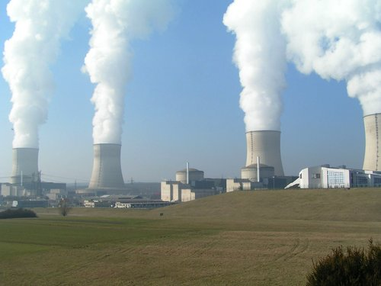
p / A nuclear power plant at Cattenom, France. Unlike the coal and oil plants that supply most of the U.S.'s electrical power, a nuclear power plant like this one releases no pollution or greenhouse gases into the Earth's atmosphere, and therefore doesn't contribute to global warming. The white stuff puffing out of this plant is non-radioactive water vapor. Although nuclear power plants generate long-lived nuclear waste, this waste arguably poses much less of a threat to the biosphere than greenhouse gases would.
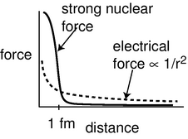
q / The strong nuclear force cuts off very sharply at a range of about 1 fm.

The strong nuclear force, alpha decay and fission
Once physicists realized that nuclei consisted of positively charged protons and uncharged neutrons, they had a problem on their hands. The electrical forces among the protons are all repulsive, so the nucleus should simply fly apart! The reason all the nuclei in your body are not spontaneously exploding at this moment is that there is another force acting. This force, called the strong nuclear force, is always attractive, and acts between neutrons and neutrons, neutrons and protons, and protons and protons with roughly equal strength. The strong nuclear force does not have any effect on electrons, which is why it does not influence chemical reactions.
Unlike electric forces, whose strengths are given by the simple Coulomb force law, there is no simple formula for how the strong nuclear force depends on distance. Roughly speaking, it is effective over ranges of ∼1 fm, but falls off extremely quickly at larger distances (much faster than 1/r²). Since the radius of a neutron or proton is about 1 fm, that means that when a bunch of neutrons and protons are packed together to form a nucleus, the strong nuclear force is effective only between neighbors.
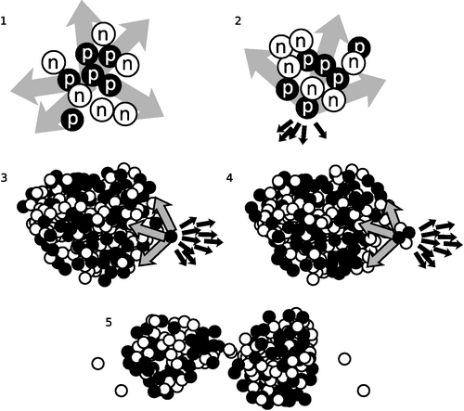
r / 1. The forces on the proton cancel. 2. The forces don't cancel. 3. In a heavy nucleus, the large number of electrical repulsions can add up to a force that is comparable to the strong nuclear attraction. 4. Alpha emission. 5. Fission.
Figure r illustrates how the strong nuclear force acts to keep ordinary nuclei together, but is not able to keep very heavy nuclei from breaking apart. In r/1, a proton in the middle of a carbon nucleus feels an attractive strong nuclear force (arrows) from each of its nearest neighbors. The forces are all in different directions, and tend to cancel out. The same is true for the repulsive electrical forces (not shown). In figure r/2, a proton at the edge of the nucleus has neighbors only on one side, and therefore all the strong nuclear forces acting on it are tending to pull it back in. Although all the electrical forces from the other five protons (dark arrows) are all pushing it out of the nucleus, they are not sufficient to overcome the strong nuclear forces.
In a very heavy nucleus, r/3, a proton that finds itself near the edge has only a few neighbors close enough to attract it significantly via the strong nuclear force, but every other proton in the nucleus exerts a repulsive electrical force on it. If the nucleus is large enough, the total electrical repulsion may be sufficient to overcome the attraction of the strong force, and the nucleus may spit out a proton. Proton emission is fairly rare, however; a more common type of radioactive decay¹ in heavy nuclei is alpha decay, shown in r/4. The imbalance of the forces is similar, but the chunk that is ejected is an alpha particle (two protons and two neutrons) rather than a single proton.
It is also possible for the nucleus to split into two pieces of roughly equal size, r/5, a process known as fission. Note that in addition to the two large fragments, there is a spray of individual neutrons. In a nuclear fission bomb or a nuclear fission reactor, some of these neutrons fly off and hit other nuclei, causing them to undergo fission as well. The result is a chain reaction.
When a nucleus is able to undergo one of these processes, it is said to be radioactive, and to undergo radioactive decay. Some of the naturally occurring nuclei on earth are radioactive. The term “radioactive” comes from Becquerel's image of rays radiating out from something, not from radio waves, which are a whole different phenomenon. The term “decay” can also be a little misleading, since it implies that the nucleus turns to dust or simply disappears -- actually it is splitting into two new nuclei with an the same total number of neutrons and protons, so the term “radioactive transformation” would have been more appropriate. Although the original atom's electrons are mere spectators in the process of weak radioactive decay, we often speak loosely of “radioactive atoms” rather than “radioactive nuclei.”

Randomness in physics
How does an atom decide when to decay? We might imagine that it is like a termite-infested house that gets weaker and weaker, until finally it reaches the day on which it is destined to fall apart. Experiments, however, have not succeeded in detecting such “ticking clock” hidden below the surface; the evidence is that all atoms of a given isotope are absolutely identical. Why, then, would one uranium atom decay today while another lives for another million years? The answer appears to be that it is entirely random. We can make general statements about the average time required for a certain isotope to decay, or how long it will take for half the atoms in a sample to decay (its half-life), but we can never predict the behavior of a particular atom.
This is the first example we have encountered of an inescapable randomness in the laws of physics. If this kind of randomness makes you uneasy, you're in good company. Einstein's famous quote is “...I am convinced that He [God] does not play dice.“ Einstein's distaste for randomness, and his association of determinism with divinity, goes back to the Enlightenment conception of the universe as a gigantic piece of clockwork that only had to be set in motion initially by the Builder. Physics had to be entirely rebuilt in the 20th century to incorporate the fundamental randomness of physics, and this modern revolution is the topic of chapter 12. In particular, we will delay the mathematical development of the half-life concept until then.
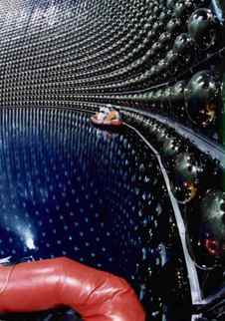
s / This neutrino detector is in the process of being filled with ultrapure water.

The weak nuclear force; beta decay
All the nuclear processes we've discussed so far have involved rearrangements of neutrons and protons, with no change in the total number of neutrons or the total number of protons. Now consider the proportions of neutrons and protons in your body and in the planet earth: neutrons and protons are roughly equally numerous in your body's carbon and oxygen nuclei, and also in the nickel and iron that make up most of the earth. The proportions are about 50-50. But the only chemical elements produced in any significant quantities by the big bang were hydrogen (about 90%) and helium (about 10%). If the early universe was almost nothing but hydrogen atoms, whose nuclei are protons, where did all those neutrons come from?
The answer is that there is another nuclear force, the weak nuclear force, that is capable of transforming neutrons into protons and vice-versa. Two possible reactions are
and
p → n + e⁺ + ν .
(There is also a third type called electron capture, in which a proton grabs one of the atom's electrons and they produce a neutron and a neutrino.)
Whereas alpha decay and fission are just a redivision of the previously existing particles, these reactions involve the destruction of one particle and the creation of three new particles that did not exist before.
There are three new particles here that you have never previously encountered. The symbol e⁺ stands for an antielectron, which is a particle just like the electron in every way, except that its electric charge is positive rather than negative. Antielectrons are also known as positrons. Nobody knows why electrons are so common in the universe and antielectrons are scarce. When an antielectron encounters an electron, they annihilate each other, producing gamma rays, and this is the fate of all the antielectrons that are produced by natural radioactivity on earth. Antielectrons are an example of antimatter. A complete atom of antimatter would consist of antiprotons, antielectrons, and antineutrons. Although individual particles of antimatter occur commonly in nature due to natural radioactivity and cosmic rays, only a few complete atoms of antihydrogen have ever been produced artificially.
The notation ν stands for a particle called a neutrino, and means an antineutrino. Neutrinos and antineutrinos have no electric charge (hence the name).
We can now list all four of the known fundamental forces of physics:
- gravity
- electromagnetism
- strong nuclear force
- weak nuclear force
The other forces we have learned about, such as friction and the normal force, all arise from electromagnetic interactions between atoms, and therefore are not considered to be fundamental forces of physics.

Example 7: Decay of ²¹²Pb
\zu{Pb}}^{212}\zu{Pb}. It contains 82 protons and 130 neutrons. Itn\rightarrow p + e^- + \bar{\nu}. The newly^{212}\zu{Bi}$.
In a reaction like this one, the electron flies off at high speed (typically close to the speed of light), and the escaping electrons are the things that make large amounts of this type of radioactivity dangerous. The outgoing electron was the first thing that tipped off scientists in the early 1900s to the existence of this type of radioactivity. Since they didn't know that the outgoing particles were electrons, they called them beta particles, and this type of radioactive decay was therefore known as beta decay. A clearer but less common terminology is to call the two processes electron decay and positron decay.
The neutrino or antineutrino emitted in such a reaction pretty much ignores all matter, because its lack of charge makes it immune to electrical forces, and it also remains aloof from strong nuclear interactions. Even if it happens to fly off going straight down, it is almost certain to make it through the entire earth without interacting with any atoms in any way. It ends up flying through outer space forever. The neutrino's behavior makes it exceedingly difficult to detect, and when beta decay was first discovered nobody realized that neutrinos even existed. We now know that the neutrino carries off some of the energy produced in the reaction, but at the time it seemed that the total energy afterwards (not counting the unsuspected neutrino's energy) was greater than the total energy before the reaction, violating conservation of energy. Physicists were getting ready to throw conservation of energy out the window as a basic law of physics when indirect evidence led them to the conclusion that neutrinos existed.

The solar neutrino problem
What about these neutrinos? Why haven't you heard of them before? It's not because they're rare --- a billion neutrinos pass through your body every microsecond, but until recently almost nothing was known about them. Produced as a side-effect of the nuclear reactions that power our sun and other stars, these ghostlike bits of matter are believed to be the most numerous particles in the universe. But they interact so weakly with ordinary matter that nearly all the neutrinos that enter the earth on one side will emerge from the other side of our planet without even slowing down.
Our first real peek at the properties of the elusive neutrino has come from a huge detector in a played-out Japanese zinc mine, s. An international team of physicists outfitted the mineshaft with wall-to-wall light sensors, and then filled the whole thing with water so pure that you can see through it for a hundred meters, compared to only a few meters for typical tap water. Neutrinos stream through the 50 million liters of water continually, just as they flood everything else around us, and the vast majority never interact with a water molecule. A very small percentage, however, do annihilate themselves in the water, and the tiny flashes of light they produce can be detected by the beachball-sized vacuum tubes that line the darkened mineshaft. Most of the neutrinos around us come from the sun, but for technical reasons this type of water-based detector is more sensitive to the less common but more energetic neutrinos produced when cosmic ray particles strike the earthճ atmosphere.
Neutrinos were already known to come in three “flavors,” which can be distinguished from each other by the particles created when they collide with matter. An “electron-flavored neutrino” creates an ordinary electron when it is annihilated, while the two other types create more exotic particles called mu and tau particles. Think of the three types of neutrinos as chocolate, vanilla, and strawberry. When you buy a chocolate ice cream cone, you expect that it will keep being chocolate as you eat it. The unexpected finding from the Japanese experiment is that some of the neutrinos are changing flavor between the time when they are produced by a cosmic ray and the moment when they wink out of existence in the water. Itճ as though your chocolate ice cream cone transformed itself magically into strawberry while your back was turned.
How did the physicists figure out the change in flavor? The experiment detects some neutrinos originating in the atmosphere above Japan, and also many neutrinos coming from distant parts of the earth. A neutrino created above the Atlantic Ocean arrives in Japan from underneath, and the experiment can distinguish these upward-traveling neutrinos from the downward-moving local variety. They found that the mixture of neutrinos coming from below was different from the mixture arriving from above, with some of the electron-flavored and tau-flavored neutrinos having apparently changed into mu-flavored neutrinos during their voyage through the earth. The ones coming from above didn't have time to change flavors on their much shorter journey.
This is interpreted as evidence that the neutrinos are constantly changing back and forth among the three flavors. On theoretical grounds, it is believed that such a vibration can only occur if neutrinos have mass. Only a rough estimate of the mass is possible at this point: it appears that neutrinos have a mass somewhere in the neighborhood of one billionth of the mass of an electron, or about 10⁻³⁹ kg.
If the neutrino's mass is so tiny, does it even matter? It matters to astronomers. Neutrinos are the only particles that can be used to probe certain phenomena. For example, they are the only direct probes we have for testing our models of the core of our own sun, which is the source of energy for all life on earth.
◊ In the reactions and p → n + e⁺ + ν, verify that charge is conserved. In beta decay, when one of these reactions happens to a neutron or proton within a nucleus, one or more gamma rays may also be emitted. Does this affect conservation of charge? Would it be possible for some extra electrons to be released without violating charge conservation?
◊ When an antielectron and an electron annihilate each other, they produce two gamma rays. Is charge conserved in this reaction?

Fusion
As we have seen, heavy nuclei tend to fly apart because each proton is being repelled by every other proton in the nucleus, but is only attracted by its nearest neighbors. The nucleus splits up into two parts, and as soon as those two parts are more than about 1 fm apart, the strong nuclear force no longer causes the two fragments to attract each other. The electrical repulsion then accelerates them, causing them to gain a large amount of kinetic energy. This release of kinetic energy is what powers nuclear reactors and fission bombs.
It might seem, then, that the lightest nuclei would be the most stable, but that is not the case. Let's compare an extremely light nucleus like ⁴He with a somewhat heavier one, ¹⁶O. A neutron or proton in ⁴He can be attracted by the three others, but in ¹⁶O, it might have five or six neighbors attracting it. The ¹⁶O nucleus is therefore more stable.
It turns out that the most stable nuclei of all are those around nickel and iron, having about 30 protons and 30 neutrons. Just as a nucleus that is too heavy to be stable can release energy by splitting apart into pieces that are closer to the most stable size, light nuclei can release energy if you stick them together to make bigger nuclei that are closer to the most stable size. Fusing one nucleus with another is called nuclear fusion. Nuclear fusion is what powers our sun and other stars. 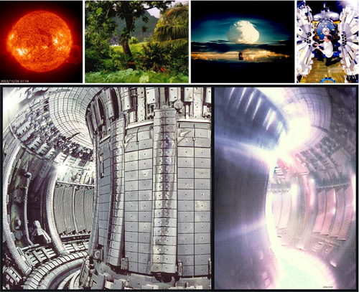
t / 1. Our sun's source of energy is nuclear fusion, so nuclear fusion is also the source of power for all life on earth, including, 2, this rain forest in Fatu-Hiva. 3. The first release of energy by nuclear fusion through human technology was the 1952 Ivy Mike test at the Enewetak Atoll. 4. This array of gamma-ray detectors is called GAMMASPHERE. During operation, the array is closed up, and a beam of ions produced by a particle accelerator strikes a target at its center, producing nuclear fusion reactions. The gamma rays can be studied for information about the structure of the fused nuclei, which are typically varieties not found in nature. 5. Nuclear fusion promises to be a clean, inexhaustible source of energy. However, the goal of commercially viable nuclear fusion power has remained elusive, due to the engineering difficulties involved in magnetically containing a plasma (ionized gas) at a sufficiently high temperature and density. This photo shows the experimental JET reactor, with the device opened up on the left, and in action on the right.

Nuclear energy and binding energies
In the same way that chemical reactions can be classified as exothermic (releasing energy) or endothermic (requiring energy to react), so nuclear reactions may either release or use up energy. The energies involved in nuclear reactions are greater by a huge factor. Thousands of tons of coal would have to be burned to produce as much energy as would be produced in a nuclear power plant by one kg of fuel.
Although nuclear reactions that use up energy (endothermic reactions) can be initiated in accelerators, where one nucleus is rammed into another at high speed, they do not occur in nature, not even in the sun. The amount of kinetic energy required is simply not available.
To find the amount of energy consumed or released in a nuclear reaction, you need to know how much nuclear interaction energy, U_{nuc}, was stored or released. Experimentalists have determined the amount of nuclear energy stored in the nucleus of every stable element, as well as many unstable elements. This is the amount of mechanical work that would be required to pull the nucleus apart into its individual neutrons and protons, and is known as the nuclear binding energy.

Example 8: A reaction occurring in the sun
The sun produces its energy through a series of nuclear fusion reactions. One of the reactions is
¹H + ²H→ ³He + γ
The excess energy is almost all carried off by the gamma ray (not by the kinetic energy of the helium-3 atom). The binding energies in units of pJ (picojoules) are:
1zuH | 0 J
2zuH | 0.35593 pJ
3zuHe | 1.23489 pJ
The total initial nuclear energy is 0 pJ+0.35593 pJ, and the final nuclear energy is 1.23489 pJ, so by conservation of energy, the gamma ray must carry off 0.87896 pJ of energy. The gamma ray is then absorbed by the sun and converted to heat.
self-check: Why is the binding energy of ¹H exactly equal to zero? (answer in the back of the PDF version of the book)
By the way, if you add up the masses of the three particles produced in the reaction , you will find that they do not equal the mass of the neutron, so mass is not conserved. An even more blatant example is the annihilation of an electron with a positron, e⁻ + e⁺ →γ, in which the original mass is completely destroyed, since gamma rays have no mass. Nonconservation of mass is not just a property of nuclear reactions. It also occurs in chemical reactions, but the change in mass is too small to detect with ordinary laboratory balances. The reason why mass is not being conserved is that mass is being converted to energy, according to Einstein's celebrated equation E=mc². This was discussed briefly in section 1.4, and in more depth in section 7.3.
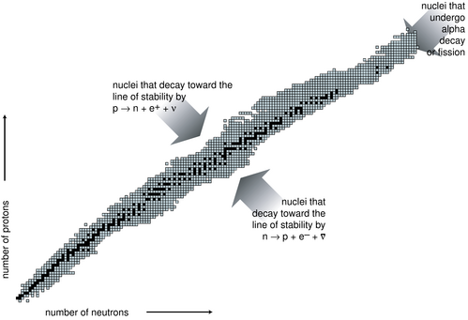
u / The known nuclei, represented on a chart of proton number versus neutron number. Note the two nuclei in the bottom row with zero protons. One is simply a single neutron. The other is a cluster of four neutrons. This “tetraneutron” was reported, unexpectedly, to be a bound system in results from a 2002 experiment. The result is controversial. If correct, it implies the existence of a heretofore unsuspected type of matter, the neutron droplet, which we can think of as an atom with no protons or electrons.
Figure u is a compact way of showing the vast variety of the nuclei. Each box represents a particular number of neutrons and protons. The black boxes are nuclei that are stable, i.e. that would require an input of energy in order to change into another. The gray boxes show all the unstable nuclei that have been studied experimentally. Some of these last for billions of years on the average before decaying and are found in nature, but most have much shorter average lifetimes, and can only be created and studied in the laboratory.
The curve along which the stable nuclei lie is called the line of stability. Nuclei along this line have the most stable proportion of neutrons to protons. For light nuclei the most stable mixture is about 50-50, but we can see that stable heavy nuclei have two or three times more neutrons than protons. This is because the electrical repulsions of all the protons in a heavy nucleus add up to a powerful force that would tend to tear it apart. The presence of a large number of neutrons increases the distances among the protons, and also increases the number of attractions due to the strong nuclear force.
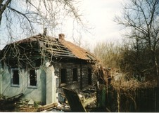
v / An abandoned village near Chernobyl.
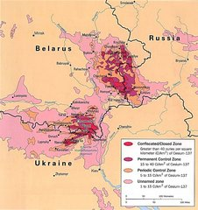
w / A map showing levels of radiation near the site of the Chernobyl disaster. At the boundary of the most highly contaminated (bright red) areas, people would be exposed to about 1300 millirem per year, or about four times the natural background level. In the pink areas, which are still densely populated, the exposure is comparable to the natural level found in a high-altitude city such as Denver.

Biological effects of ionizing radiation
As a science educator, I find it frustrating that nowhere in the massive amount of journalism devoted to the Chernobyl disaster does one ever find any numerical statements about the amount of radiation to which people have been exposed. Anyone mentally capable of understanding sports statistics or weather reports ought to be able to understand such measurements, as long as something like the following explanatory text was inserted somewhere in the article:
Radiation exposure is measured in units of millirems. The average person is exposed to about 200 millirems each year from natural background sources.
With this context, people would be able to come to informed conclusions based on statements such as, ”Children in Finland received an average dose of \_\_\_\_\_\_\_\_\_\_\_ millirems above natural background levels because of the Chernobyl disaster.“
A millirem, or mrem, is, of course, a thousandth of a rem, but what is a rem? It measures the amount of energy per kilogram deposited in the body by ionizing radiation, multiplied by a ”quality factor" to account for the different health hazards posed by alphas, betas, gammas, neutrons, and other types of radiation. Only ionizing radiation is counted, since nonionizing radiation simply heats one's body rather than killing cells or altering DNA. For instance, alpha particles are typically moving so fast that their kinetic energy is sufficient to ionize thousands of atoms, but it is possible for an alpha particle to be moving so slowly that it would not have enough kinetic energy to ionize even one atom.
Notwithstanding the pop culture images of the Incredible Hulk and Godzilla, it is not possible for a multicellular animal to become “mutated” as a whole. In most cases, a particle of ionizing radiation will not even hit the DNA, and even if it does, it will only affect the DNA of a single cell, not every cell in the animal's body. Typically, that cell is simply killed, because the DNA becomes unable to function properly. Once in a while, however, the DNA may be altered so as to make that cell cancerous. For instance, skin cancer can be caused by UV light hitting a single skin cell in the body of a sunbather. If that cell becomes cancerous and begins reproducing uncontrollably, she will end up with a tumor twenty years later.
Other than cancer, the only other dramatic effect that can result from altering a single cell's DNA is if that cell happens to be a sperm or ovum, which can result in nonviable or mutated offspring. Men are relatively immune to reproductive harm from radiation, because their sperm cells are replaced frequently. Women are more vulnerable because they keep the same set of ova as long as they live.
A whole-body exposure of 500,000 mrem will kill a person within a week or so. Luckily, only a small number of humans have ever been exposed to such levels: one scientist working on the Manhattan Project, some victims of the Nagasaki and Hiroshima explosions, and 31 workers at Chernobyl. Death occurs by massive killing of cells, especially in the blood-producing cells of the bone marrow.
Lower levels, on the order of 100,000 mrem, were inflicted on some people at Nagasaki and Hiroshima. No acute symptoms result from this level of exposure, but certain types of cancer are significantly more common among these people. It was originally expected that the radiation would cause many mutations resulting in birth defects, but very few such inherited effects have been observed.
A great deal of time has been spent debating the effects of very low levels of ionizing radiation. A medical x-ray, for instance, may result in a dose on the order of 100 mrem above background, i.e. a doubling of the normal background level. Similar doses in excess of the average background level may be received by people living at high altitudes or people with high concentrations of radon gas in their houses. Unfortunately (or fortunately, depending on how you look at it), the added risks of cancer or birth defects resulting from these levels of exposure are extremely small, and therefore nearly impossible to measure. As with many suspected carcinogenic chemicals, the only practical method of estimating risks is to give laboratory animals doses many orders of magnitude greater, and then assume that the health risk is directly proportional to the dose. Under these assumptions, the added risk posed by a dental x-ray or radon in one's basement is negligible on a personal level, and is only significant in terms of a slight increase in cancer throughout the population. As a matter of social policy, excess radiation exposure is not a significant public health problem compared to car accidents or tobacco smoking.

Discussion Questions
◊ Should the quality factor for neutrinos be very small, because they mostly don't interact with your body?
◊ Would an alpha source be likely to cause different types of cancer depending on whether the source was external to the body or swallowed in contaminated food? What about a gamma source?

x / The Crab Nebula is a remnant of a supernova explosion. Almost all the elements our planet is made of originated in such explosions.
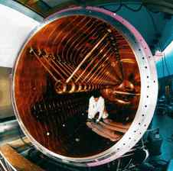
y / Construction of the UNILAC accelerator in Germany, one of whose uses is for experiments to create very heavy artificial elements. In such an experiment, fusion products recoil through a device called SHIP (not shown) that separates them based on their charge-to-mass ratios --- it is essentially just a scaled-up version of Thomson's apparatus. A typical experiment runs for several months, and out of the billions of fusion reactions induced during this time, only one or two may result in the production of superheavy atoms. In all the rest, the fused nucleus breaks up immediately. SHIP is used to identify the small number of “good” reactions and separate them from this intense background.

The creation of the elements

Creation of hydrogen and helium in the Big Bang
We have discussed in chapter 6 the evidence for the Big Bang theory of the origin of the universe. Did all the chemical elements we're made of come into being in the Big Bang? Temperatures in the first microseconds after the Big Bang were so high that atoms and nuclei could not hold together at all. After things had cooled down enough for nuclei and atoms to exist, there was a period of about three minutes during which the temperature and density were high enough for fusion to occur, but not so high that atoms could hold together. We have a good, detailed understanding of the laws of physics that apply under these conditions, so theorists are able to say with confidence that the only element heavier than hydrogen that was created in significant quantities was helium.

We are stardust
In that case, where did all the other elements come from? Astronomers came up with the answer. By studying the combinations of wavelengths of light, called spectra, emitted by various stars, they had been able to determine what kinds of atoms they contained. (We will have more to say about spectra at the end of this book.) They found that the stars fell into two groups. One type was nearly 100% hydrogen and helium, while the other contained 99% hydrogen and helium and 1% other elements. They interpreted these as two generations of stars. The first generation had formed out of clouds of gas that came fresh from the big bang, and their composition reflected that of the early universe. The nuclear fusion reactions by which they shine have mainly just increased the proportion of helium relative to hydrogen, without making any heavier elements.
The members of the first generation that we see today, however, are only those that lived a long time. Small stars are more miserly with their fuel than large stars, which have short lives. The large stars of the first generation have already finished their lives. Near the end of its lifetime, a star runs out of hydrogen fuel and undergoes a series of violent and spectacular reorganizations as it fuses heavier and heavier elements. Very large stars finish this sequence of events by undergoing supernova explosions, in which some of their material is flung off into the void while the rest collapses into an exotic object such as a black hole or neutron star.
The second generation of stars, of which our own sun is an example, condensed out of clouds of gas that had been enriched in heavy elements due to supernova explosions. It is those heavy elements that make up our planet and our bodies.

Artificial synthesis of heavy elements
Elements up to uranium, atomic number 92, were created by these astronomical processes. Beyond that, the increasing electrical repulsion of the protons leads to shorter and shorter half-lives. Even if a supernova a billion years ago did create some quantity of an element such as Berkelium, number 97, there would be none left in the Earth's crust today. The heaviest elements have all been created by artificial fusion reactions in accelerators. As of 2006, the heaviest element that has been created is 116 -- two atoms of it!²
Although the creation of a new element, i.e. an atom with a novel number of protons, has historically been considered a glamorous accomplishment, to the nuclear physicist the creation of an atom with a hitherto unobserved number of neutrons is equally important. The greatest neutron number reached so far is 179. One tantalizing goal of this type of research is the theoretical prediction that there might be an island of stability beyond the previously explored tip of the chart of the nuclei shown in section 8.2.8. Just as certain numbers of electrons lead to the chemical stability of the noble gases (helium, neon, argon, ...), certain numbers of neutrons and protons lead to a particularly stable packing of orbits. Calculations dating back to the 1960's have hinted that there might be relatively stable nuclei having approximately 114 protons and 184 neutrons. The isotopes of elements 114 and 116 that have been produced so far have had half-lives in the second or millosecond range. This may not seem like very long, but lifetimes in the microsecond range are more typical for the superheavy elements that have previously been discovered. There is even speculation that certain superheavy isotopes would be stable enough to be produced in quantities that could for instance be weighed and used in chemical reactions.
\backofchapterboilerplate{atomem}

Homework Problems
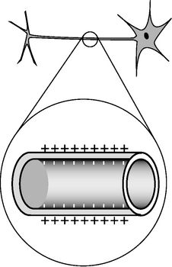
a / Problem 1. Top: A realistic picture of a neuron. Bottom: A simplified diagram of one segment of the tail (axon).
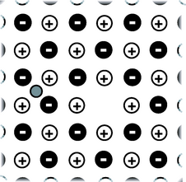
b / Problem 6.
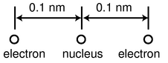
c / Problem 8.
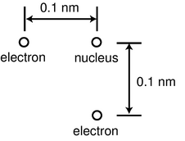
d / Problem 9.
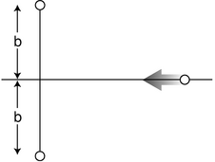
e / Problem 14.
1. [0]{neuron} The figure shows a neuron, which is the type of cell your nerves are made of. Neurons serve to transmit sensory information to the brain, and commands from the brain to the muscles. All this data is transmitted electrically, but even when the cell is resting and not transmitting any information, there is a layer of negative electrical charge on the inside of the cell membrane, and a layer of positive charge just outside it. This charge is in the form of various ions dissolved in the interior and exterior fluids. Why would the negative charge remain plastered against the inside surface of the membrane, and likewise why doesn't the positive charge wander away from the outside surface?
2. Use the nutritional information on some packaged food to make an order-of-magnitude estimate of the amount of chemical energy stored in one atom of food, in units of joules. Assume that a typical atom has a mass of 10⁻²⁶ kg. This constitutes a rough estimate of the amounts of energy there are on the atomic scale. [See chapter 1 of my book Newtonian Physics, at http://www.lightandmatter.com, for help on how to do order-of-magnitude estimates. Note that a nutritional “calorie” is really a kilocalorie; see page 768.](answer check available at lightandmatter.com)
3. (a) Recall that the gravitational energy of two gravitationally interacting spheres is given by U_{g}=-Gm₁m₂/r, where r is the center-to-center distance. What would be the analogous equation for two electrically interacting spheres? Justify your choice of a plus or minus sign on physical grounds, considering attraction and repulsion.(answer check available at lightandmatter.com)
(b) Use this expression to estimate the energy required to pull apart a raisin-cookie atom of the one-electron type, assuming a radius of 10⁻¹⁰ m.(answer check available at lightandmatter.com)
(c) Compare this with the result of problem 2.
4. A neon light consists of a long glass tube full of neon, with metal caps on the ends. Positive charge is placed on one end of the tube, and negative charge on the other. The electric forces generated can be strong enough to strip electrons off of a certain number of neon atoms. Assume for simplicity that only one electron is ever stripped off of any neon atom. When an electron is stripped off of an atom, both the electron and the neon atom (now an ion) have electric charge, and they are accelerated by the forces exerted by the charged ends of the tube. (They do not feel any significant forces from the other ions and electrons within the tube, because only a tiny minority of neon atoms ever gets ionized.) Light is finally produced when ions are reunited with electrons. Give a numerical comparison of the magnitudes and directions of the accelerations of the electrons and ions. [You may need some data from appendix 5.] (answer check available at lightandmatter.com)
5. If you put two hydrogen atoms near each other, they will feel an attractive force, and they will pull together to form a molecule. (Molecules consisting of two hydrogen atoms are the normal form of hydrogen gas.) Why do they feel a force if they are near each other, since each is electrically neutral? Shouldn't the attractive and repulsive forces all cancel out exactly? Use the raisin cookie model. (Students who have taken chemistry often try to use fancier models to explain this, but if you can't explain it using a simple model, you probably don't understand the fancy model as well as you thought you did!)
6. [2]{nacl} The figure shows one layer of the three-dimensional structure of a salt crystal. The atoms extend much farther off in all directions, but only a six-by-six square is shown here. The larger circles are the chlorine ions, which have charges of -e. The smaller circles are sodium ions, with charges of +e. The distance between neighboring ions is about 0.3 nm. Real crystals are never perfect, and the crystal shown here has two defects: a missing atom at one location, and an extra lithium atom, shown as a grey circle, inserted in one of the small gaps. If the lithium atom has a charge of +e, what is the direction and magnitude of the total force on it? Assume there are no other defects nearby in the crystal besides the two shown here. \hwhint{hwhint:nacl}(answer check available at lightandmatter.com)
7. [0]{earthmoonelec} The Earth and Moon are bound together by gravity. If, instead, the force of attraction were the result of each having a charge of the same magnitude but opposite in sign, find the quantity of charge that would have to be placed on each to produce the required force.(answer check available at lightandmatter.com)
8. A helium atom finds itself momentarily in this arrangement. Find the direction and magnitude of the force acting on the right-hand electron. The two protons in the nucleus are so close together (∼1 fm) that you can consider them as being right on top of each other.(answer check available at lightandmatter.com)
9. The helium atom of problem 8 has some new experiences, goes through some life changes, and later on finds itself in the configuration shown here. What are the direction and magnitude of the force acting on the bottom electron? (Draw a sketch to make clear the definition you are using for the angle that gives direction.)(answer check available at lightandmatter.com)
10. Suppose you are holding your hands in front of you, 10 cm apart.
(a) Estimate the total number of electrons in each hand.(answer check available at lightandmatter.com)
(b) Estimate the total repulsive force of all the electrons in one hand on all the electrons in the other.(answer check available at lightandmatter.com)
(c) Why don't you feel your hands repelling each other?
(d) Estimate how much the charge of a proton could differ in magnitude from the charge of an electron without creating a noticeable force between your hands.
11. Suppose that a proton in a lead nucleus wanders out to the surface of the nucleus, and experiences a strong nuclear force of about 8 kN from the nearby neutrons and protons pulling it back in. Compare this numerically to the repulsive electrical force from the other protons, and verify that the net force is attractive. A lead nucleus is very nearly spherical, and is about 6.5 fm in radius.(answer check available at lightandmatter.com)
12. [0]{muonic} The subatomic particles called muons behave exactly like electrons, except that a muon's mass is greater by a factor of 206.77. Muons are continually bombarding the Earth as part of the stream of particles from space known as cosmic rays. When a muon strikes an atom, it can displace one of its electrons. If the atom happens to be a hydrogen atom, then the muon takes up an orbit that is on the average 206.77 times closer to the proton than the orbit of the ejected electron. How many times greater is the electric force experienced by the muon than that previously felt by the electron?(answer check available at lightandmatter.com)
13. The nuclear process of beta decay by electron capture is described parenthetically on page 416. The reaction is p+e⁻ → n+ν.
(a) Show that charge is conserved in this reaction.
(b) Conversion between energy and mass is discussed in chapter 7. Based on these ideas, explain why electron capture doesn't occur in hydrogen atoms. (If it did, matter wouldn't exist!)
14. In the semifinals of an electrostatic croquet tournament, Jessica hits her positively charged ball, sending it across the playing field, rolling to the left along the x axis. It is repelled by two other positive charges. These two charges are fixed on the y axis at the locations shown in the figure. The two fixed charges are equal to each other, but not to the charge of the ball.
(a) Express the force on the ball in terms of the ball's position, x.
(b) At what value of x does the ball experience the greatest deceleration? Express you answer in terms of b. (Assume the ball has enough energy to continue through, so you don't have to worry about whether it actually gets as far as this particular value of x.) (Based on a problem by Halliday and Resnick.)
15. Suppose that at some instant in time, a wire extending from x=0 to x=∞ holds a charge density, in units of coulombs per meter, given by ae^{-bx}. This type of charge density, d q/d x, is typically notated as λ (Greek letter lambda). Find the total charge on the wire.(answer check available at lightandmatter.com)

Footnotes
[1] Alpha decay is more common for statistical reasons. An alpha particle happens to be a very stable arrangement, with an unusually low interaction energy due to the strong nuclear interactions within it. This leaves a lot of spare energy for its center of mass motion, which gives it a greater selection of possible momentum vectors. The idea of a “greater selection” can be made more precise using the concept of phase space, discussed in section 5.4.
[2] An earlier claim of the creation of element 116 by a group at Berkeley turned out to be a case of scientific fraud, but the element was later produced by a different group, at Dubna, Russia.

9. Circuits
Table of Contents

Contents
Section 9.1 - Current and Voltage
Section 9.2 - Parallel and Series Circuits
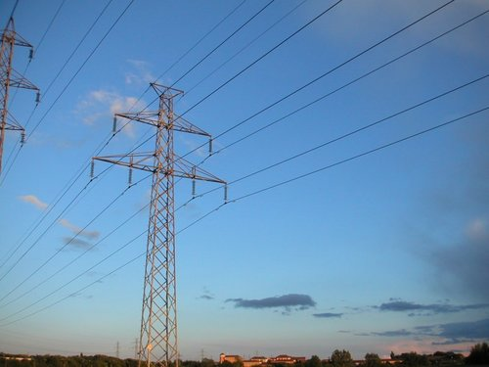

Chapter 9. Circuits
Madam, what good is a baby? -- Michael Faraday, when asked by Queen Victoria what the electrical devices in his lab were good for
A few years ago, my wife and I bought a house with Character, Character being a survival mechanism that houses have evolved in order to convince humans to agree to much larger mortgage payments than they'd originally envisioned. Anyway, one of the features that gives our house Character is that it possesses, built into the wall of the family room, a set of three pachinko machines. These are Japanese gambling devices sort of like vertical pinball machines. (The legal papers we got from the sellers hastened to tell us that they were “for amusement purposes only.”) Unfortunately, only one of the three machines was working when we moved in, and it soon died on us. Having become a pachinko addict, I decided to fix it, but that was easier said than done. The inside is a veritable Rube Goldberg mechanism of levers, hooks, springs, and chutes. My hormonal pride, combined with my Ph.D. in physics, made me certain of success, and rendered my eventual utter failure all the more demoralizing.
Contemplating my defeat, I realized how few complex mechanical devices I used from day to day. Apart from our cars and my saxophone, every technological tool in our modern life-support system was electronic rather than mechanical.

9.1 Current and Voltage

a / Gymnotus carapo, a knifefish, uses electrical signals to sense its environment and to communicate with others of its species. (Greg DeGreef)

Current

Unity of all types of electricity
We are surrounded by things we have been told are “electrical,” but it's far from obvious what they have in common to justify being grouped together. What relationship is there between the way socks cling together and the way a battery lights a lightbulb? We have been told that both an electric eel and our own brains are somehow electrical in nature, but what do they have in common?
British physicist Michael Faraday (1791-1867) set out to address this problem. He investigated electricity from a variety of sources --- including electric eels! --- to see whether they could all produce the same effects, such as shocks and sparks, attraction and repulsion. “Heating” refers, for example, to the way a lightbulb filament gets hot enough to glow and emit light. Magnetic induction is an effect discovered by Faraday himself that connects electricity and magnetism. We will not study this effect, which is the basis for the electric generator, in detail until later in the book.
 |  |  | attraction and
 | shocks | sparks | repulsion | heating
rubbing | surd | surd | surd | surd
battery | surd | surd | surd | surd
animal | surd | surd | surd) | surd
magnetically induced | surd | surd | surd | surd
The table shows a summary of some of Faraday's results. Check marks indicate that Faraday or his close contemporaries were able to verify that a particular source of electricity was capable of producing a certain effect. (They evidently failed to demonstrate attraction and repulsion between objects charged by electric eels, although modern workers have studied these species in detail and been able to understand all their electrical characteristics on the same footing as other forms of electricity.)
Faraday's results indicate that there is nothing fundamentally different about the types of electricity supplied by the various sources. They are all able to produce a wide variety of identical effects. Wrote Faraday, “The general conclusion which must be drawn from this collection of facts is that electricity, whatever may be its source, is identical in its nature.”
If the types of electricity are the same thing, what thing is that? The answer is provided by the fact that all the sources of electricity can cause objects to repel or attract each other. We use the word “charge” to describe the property of an object that allows it to participate in such electrical forces, and we have learned that charge is present in matter in the form of nuclei and electrons. Evidently all these electrical phenomena boil down to the motion of charged particles in matter.

Electric current
If the fundamental phenomenon is the motion of charged particles, then how can we define a useful numerical measurement of it? We might describe the flow of a river simply by the velocity of the water, but velocity will not be appropriate for electrical purposes because we need to take into account how much charge the moving particles have, and in any case there are no practical devices sold at Radio Shack that can tell us the velocity of charged particles. Experiments show that the intensity of various electrical effects is related to a different quantity: the number of coulombs of charge that pass by a certain point per second. By analogy with the flow of water, this quantity is called the electric current , I. Its units of coulombs/second are more conveniently abbreviated as amperes, 1 A=1 C/s. (In informal speech, one usually says “amps.”)
The main subtlety involved in this definition is how to account for the two types of charge. The stream of water coming from a hose is made of atoms containing charged particles, but it produces none of the effects we associate with electric currents. For example, you do not get an electrical shock when you are sprayed by a hose. This type of experiment shows that the effect created by the motion of one type of charged particle can be canceled out by the motion of the opposite type of charge in the same direction. In water, every oxygen atom with a charge of +8e is surrounded by eight electrons with charges of -e, and likewise for the hydrogen atoms.
We therefore refine our definition of current as follows:
When charged particles are exchanged between regions of space A and B, the electric current flowing from A to B is defined as
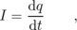
where d q is the change in region B's total charge occurring over a period of time d t.
In the garden hose example, your body picks up equal amounts of positive and negative charge, resulting in no change in your total charge, so the electrical current flowing into you is zero.
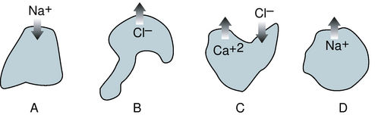
b / Example 1

Example 1: Ions moving across a cell membrane
◊ Figure b shows ions, labeled with their charges, moving in or out through the membranes of three cells. If the ions all cross the membranes during the same interval of time, how would the currents into the cells compare with each other?
◊ We're just assuming the rate of flow is constant, so we can talk about Δ q instead of d q.
Cell A has positive current going into it because its charge is increased, i.e. has a positive value of Δ q.
Cell B has the same current as cell A, because by losing one unit of negative charge it also ends up increasing its own total charge by one unit.
Cell C's total charge is reduced by three units, so it has a large negative current going into it.
Cell D loses one unit of charge, so it has a small negative current into it.

Example 2: Finding current given charge
◊ A charged balloon falls to the ground, and its charge begins leaking off to the Earth. Suppose that the charge on the balloon is given by q=ae^{-bt}. Find the current as a function of time, and interpret the answer.
◊ Taking the derivative, we have
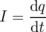
= - abe^{- bt}
An exponential function approaches zero as the exponent gets more and more negative. This means that both the charge and the current are decreasing in magnitude with time. It makes sense that the charge approaches zero, since the balloon is losing its charge. It also makes sense that the current is decreasing in magnitude, since charge cannot flow at the same rate forever without overshooting zero.
The reverse of differentiation is integration, so if we know the current as a function of time, we can find the charge by integrating. Example 8 on page 444 shows such a calculation.
It may seem strange to say that a negatively charged particle going one way creates a current going the other way, but this is quite ordinary. As we will see, currents flow through metal wires via the motion of electrons, which are negatively charged, so the direction of motion of the electrons in a circuit is always opposite to the direction of the current. Of course it would have been convenient of Benjamin Franklin had defined the positive and negative signs of charge the opposite way, since so many electrical devices are based on metal wires.

Example 3: Number of electrons flowing through a lightbulb
◊ If a lightbulb has 1.0 A flowing through it, how many electrons will pass through the filament in 1.0 s?
◊ We are only calculating the number of electrons that flow, so we can ignore the positive and negative signs. Also, since the rate of flow is constant, we don't really need to think in terms of calculus; the derivative d q/d t that defines current is the same as Δ q/Δ t in this situation. Solving for Δ q= I Δ t gives a charge of 1.0 C flowing in this time interval. The number of electrons is
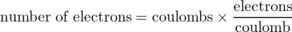
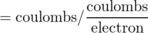
= 1.0 C / e
= 6.2×10¹⁸
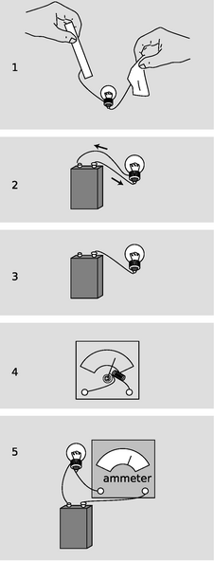
c / 1. Static electricity runs out quickly. 2. A practical circuit. 3. An open circuit. 4. How an ammeter works. 5. Measuring the current with an ammeter.

Circuits
How can we put electric currents to work? The only method of controlling electric charge we have studied so far is to charge different substances, e.g. rubber and fur, by rubbing them against each other. Figure c/1 shows an attempt to use this technique to light a lightbulb. This method is unsatisfactory. True, current will flow through the bulb, since electrons can move through metal wires, and the excess electrons on the rubber rod will therefore come through the wires and bulb due to the attraction of the positively charged fur and the repulsion of the other electrons. The problem is that after a zillionth of a second of current, the rod and fur will both have run out of charge. No more current will flow, and the lightbulb will go out.
Figure c/2 shows a setup that works. The battery pushes charge through the circuit, and recycles it over and over again. (We will have more to say later in this chapter about how batteries work.) This is called a complete circuit. Today, the electrical use of the word “circuit” is the only one that springs to mind for most people, but the original meaning was to travel around and make a round trip, as when a circuit court judge would ride around the boondocks, dispensing justice in each town on a certain date.
Note that an example like c/3 does not work. The wire will quickly begin acquiring a net charge, because it has no way to get rid of the charge flowing into it. The repulsion of this charge will make it more and more difficult to send any more charge in, and soon the electrical forces exerted by the battery will be canceled out completely. The whole process would be over so quickly that the filament would not even have enough time to get hot and glow. This is known as an open circuit. Exactly the same thing would happen if the complete circuit of figure c/2 was cut somewhere with a pair of scissors, and in fact that is essentially how an ordinary light switch works: by opening up a gap in the circuit.
The definition of electric current we have developed has the great virtue that it is easy to measure. In practical electrical work, one almost always measures current, not charge. The instrument used to measure current is called an ammeter. A simplified ammeter, c/4, simply consists of a coiled-wire magnet whose force twists an iron needle against the resistance of a spring. The greater the current, the greater the force. Although the construction of ammeters may differ, their use is always the same. We break into the path of the electric current and interpose the meter like a tollbooth on a road, c/5. There is still a complete circuit, and as far as the battery and bulb are concerned, the ammeter is just another segment of wire.
Does it matter where in the circuit we place the ammeter? Could we, for instance, have put it in the left side of the circuit instead of the right? Conservation of charge tells us that this can make no difference. Charge is not destroyed or “used up” by the lightbulb, so we will get the same current reading on either side of it. What is “used up” is energy stored in the battery, which is being converted into heat and light energy.

d / Example 4.

Voltage

The volt unit
Electrical circuits can be used for sending signals, storing information, or doing calculations, but their most common purpose by far is to manipulate energy, as in the battery-and-bulb example of the previous section. We know that lightbulbs are rated in units of watts, i.e. how many joules per second of energy they can convert into heat and light, but how would this relate to the flow of charge as measured in amperes? By way of analogy, suppose your friend, who didn't take physics, can't find any job better than pitching bales of hay. The number of calories he burns per hour will certainly depend on how many bales he pitches per minute, but it will also be proportional to how much mechanical work he has to do on each bale. If his job is to toss them up into a hayloft, he will got tired a lot more quickly than someone who merely tips bales off a loading dock into trucks. In metric units,
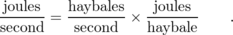
Similarly, the rate of energy transformation by a battery will not just depend on how many coulombs per second it pushes through a circuit but also on how much mechanical work it has to do on each coulomb of charge:
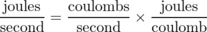
or
Units of joules per coulomb are abbreviated as volts, 1 V=1 J/C, named after the Italian physicist Alessandro Volta. Everyone knows that batteries are rated in units of volts, but the voltage concept is more general than that; it turns out that voltage is a property of every point in space. To gain more insight, let's think more carefully about what goes on in the battery and bulb circuit.

The voltage concept in general
To do work on a charged particle, the battery apparently must be exerting forces on it. How does it do this? Well, the only thing that can exert an electrical force on a charged particle is another charged particle. It's as though the haybales were pushing and pulling each other into the hayloft! This is potentially a horribly complicated situation. Even if we knew how much excess positive or negative charge there was at every point in the circuit (which realistically we don't) we would have to calculate zillions of forces using Coulomb's law, perform all the vector additions, and finally calculate how much work was being done on the charges as they moved along. To make things even more scary, there is more than one type of charged particle that moves: electrons are what move in the wires and the bulb's filament, but ions are the moving charge carriers inside the battery. Luckily, there are two ways in which we can simplify things:
The situation is unchanging. Unlike the imaginary setup in which we attempted to light a bulb using a rubber rod and a piece of fur, this circuit maintains itself in a steady state (after perhaps a microsecond-long period of settling down after the circuit is first assembled). The current is steady, and as charge flows out of any area of the circuit it is replaced by the same amount of charge flowing in. The amount of excess positive or negative charge in any part of the circuit therefore stays constant. Similarly, when we watch a river flowing, the water goes by but the river doesn't disappear.
Force depends only on position. Since the charge distribution is not changing, the total electrical force on a charged particle depends only on its own charge and on its location. If another charged particle of the same type visits the same location later on, it will feel exactly the same force.
The second observation tells us that there is nothing all that different about the experience of one charged particle as compared to another's. If we single out one particle to pay attention to, and figure out the amount of work done on it by electrical forces as it goes from point A to point B along a certain path, then this is the same amount of work that will be done on any other charged particles of the same type as it follows the same path. For the sake of visualization, let's think about the path that starts at one terminal of the battery, goes through the light bulb's filament, and ends at the other terminal. When an object experiences a force that depends only on its position (and when certain other, technical conditions are satisfied), we can define an electrical energy associated with the position of that object. The amount of work done on the particle by electrical forces as it moves from A to B equals the drop in electrical energy between A and B. This electrical energy is what is being converted into other forms of energy such as heat and light. We therefore define voltage in general as electrical energy per unit charge:
The difference in voltage between two points in space is defined as
Δ V=Δ U_{elec}/q ,
where Δ U_{elec} is the change in the electrical energy of a particle with charge q as it moves from the initial point to the final point.
The amount of power dissipated (i.e., rate at which energy is transformed by the flow of electricity) is then given by the equation
P = I Δ V .

Example 4: Energy stored in a battery
◊ The 1.2 V rechargeable battery in figure d is labeled 1800 milliamp-hours. What is the maximum amount of energy the battery can store?
◊ An ampere-hour is a unit of current multiplied by a unit of time. Current is charge per unit time, so an ampere-hour is in fact a funny unit of charge:
1800 milliamp-hours is therefore 1800×10⁻³× 3600 C=6.5×10³ C. That's a huge number of charged particles, but the total loss of electrical energy will just be their total charge multiplied by the voltage difference across which they move:
Δ U_{elec} = q Δ V
= (6.5×10³ C)(1.2 V)
= 7.8 kJ

Example 5: Units of volt-amps
◊ Doorbells are often rated in volt-amps. What does this combination of units mean?
◊ Current times voltage gives units of power, P= IΔ V, so volt-amps are really just a nonstandard way of writing watts. They are telling you how much power the doorbell requires.

Example 6: Power dissipated by a battery and bulb
◊ If a 9.0-volt battery causes 1.0 A to flow through a lightbulb, how much power is dissipated?
◊ The voltage rating of a battery tells us what voltage difference Δ V it is designed to maintain between its terminals.
P = I Δ V
= 9.0 A⋅V
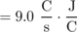
= 9.0 W
The only nontrivial thing in this problem was dealing with the units. One quickly gets used to translating common combinations like A⋅V into simpler terms.
Here are a few questions and answers about the voltage concept.
{}Question: OK, so what is voltage, really?
{}Answer: A device like a battery has positive and negative charges inside it that push other charges around the outside circuit. A higher-voltage battery has denser charges in it, which will do more work on each charged particle that moves through the outside circuit.
To use a gravitational analogy, we can put a paddlewheel at the bottom of either a tall waterfall or a short one, but a kg of water that falls through the greater gravitational energy difference will have more energy to give up to the paddlewheel at the bottom.
{}Question: Why do we define voltage as electrical energy divided by charge, instead of just defining it as electrical energy?
{}Answer: One answer is that it's the only definition that makes the equation P=I Δ V work. A more general answer is that we want to be able to define a voltage difference between any two points in space without having to know in advance how much charge the particles moving between them will have. If you put a nine-volt battery on your tongue, then the charged particles that move across your tongue and give you that tingly sensation are not electrons but ions, which may have charges of +e, -2e, or practically anything. The manufacturer probably expected the battery to be used mostly in circuits with metal wires, where the charged particles that flowed would be electrons with charges of -e. If the ones flowing across your tongue happen to have charges of -2e, the electrical energy difference for them will be twice as much, but dividing by their charge of -2e in the definition of voltage will still give a result of 9 V.
{}Question: Are there two separate roles for the charged particles in the circuit, a type that sits still and exerts the forces, and another that moves under the influence of those forces?
{}Answer: No. Every charged particle simultaneously plays both roles. Newton's third law says that any particle that has an electrical forces acting on it must also be exerting an electrical force back on the other particle. There are no “designated movers” or “designated force-makers.”
{}Question: Why does the definition of voltage only refer to voltage differences?
{}Answer: It's perfectly OK to define voltage as V=U_{elec}/q. But recall that it is only differences in interaction energy, U, that have direct physical meaning in physics. Similarly, voltage differences are really more useful than absolute voltages. A voltmeter measures voltage differences, not absolute voltages.

Discussion Questions
◊ A roller coaster is sort of like an electric circuit, but it uses gravitational forces on the cars instead of electric ones. What would a high-voltage roller coaster be like? What would a high-current roller coaster be like?
◊ Criticize the following statements:
- “He touched the wire, and 10000 volts went through him.”
- “That battery has a charge of 9 volts.”
- “You used up the charge of the battery.”
◊ When you touch a 9-volt battery to your tongue, both positive and negative ions move through your saliva. Which ions go which way?
◊ I once touched a piece of physics apparatus that had been wired incorrectly, and got a several-thousand-volt voltage difference across my hand. I was not injured. For what possible reason would the shock have had insufficient power to hurt me?
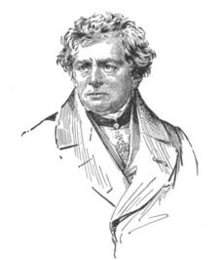
e / Georg Simon Ohm (1787-1854).
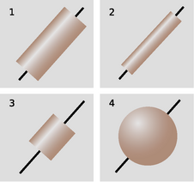
f / Four objects made of the same substance have different resistances.
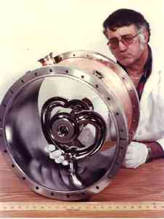
g / A superconducting segment of the ATLAS accelerator at Argonne National Laboratory near Chicago. It is used to accelerate beams of ions to a few percent of the speed of light for nuclear physics research. The shiny silver-colored surfaces are made of the element niobium, which is a superconductor at relatively high temperatures compared to other metals --- relatively high meaning the temperature of liquid helium! The beam of ions passes through the holes in the two small cylinders on the ends of the curved rods. Charge is shuffled back and forth between them at a frequency of 12 million cycles per second, so that they take turns being positive and negative. The positively charged beam consists of short spurts, each timed so that when it is in one of the segments it will be pulled forward by negative charge on the cylinder in front of it and pushed forward by the positively charged one behind. The huge currents involved would quickly melt any metal that was not superconducting, but in a superconductor they produce no heat at all.
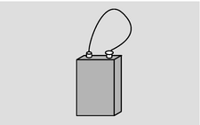
h / Short-circuiting a battery. Warning: you can burn yourself this way or start a fire! If you want to try this, try making the connection only very briefly, use a low-voltage battery, and avoid touching the battery or the wire, both of which will get hot.
color | meaning
black | 0
brown | 1
red | 2
orange | 3
yellow | 4
green | 5
blue | 6
violet | 7
gray | 8
white | 9
silver | ±10%
gold | ±5%
Color codes used on resistors.
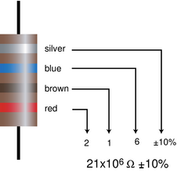
j / An example of a resistor with a color code.
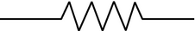
k / The symbol used in schematics to represent a resistor.
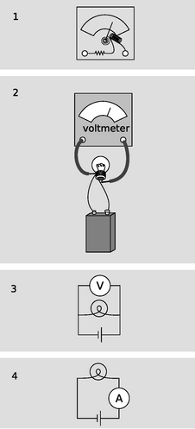
l / 1. A simplified diagram of how a voltmeter works. 2. Measuring the voltage difference across a lightbulb. 3. The same setup drawn in schematic form. 4. The setup for measuring current is different.

Resistance

Resistance
So far we have simply presented it as an observed fact that a battery-and-bulb circuit quickly settles down to a steady flow, but why should it? Newton's second law, a=F/m, would seem to predict that the steady forces on the charged particles should make them whip around the circuit faster and faster. The answer is that as charged particles move through matter, there are always forces, analogous to frictional forces, that resist the motion. These forces need to be included in Newton's second law, which is really a=F_{total}/m, not a=F/m. If, by analogy, you push a crate across the floor at constant speed, i.e. with zero acceleration, the total force on it must be zero. After you get the crate going, the floor's frictional force is exactly canceling out your force. The chemical energy stored in your body is being transformed into heat in the crate and the floor, and no longer into an increase in the crate's kinetic energy. Similarly, the battery's internal chemical energy is converted into heat, not into perpetually increasing the charged particles' kinetic energy. Changing energy into heat may be a nuisance in some circuits, such as a computer chip, but it is vital in a lightbulb, which must get hot enough to glow. Whether we like it or not, this kind of heating effect is going to occur any time charged particles move through matter.
What determines the amount of heating? One flashlight bulb designed to work with a 9-volt battery might be labeled 1.0 watts, another 5.0. How does this work? Even without knowing the details of this type of friction at the atomic level, we can relate the heat dissipation to the amount of current that flows via the equation P=IΔV. If the two flashlight bulbs can have two different values of P when used with a battery that maintains the same Δ V, it must be that the 5.0-watt bulb allows five times more current to flow through it.
For many substances, including the tungsten from which lightbulb filaments are made, experiments show that the amount of current that will flow through it is directly proportional to the voltage difference placed across it. For an object made of such a substance, we define its electrical resistance as follows:
If an object inserted in a circuit displays a current flow which is proportional to the voltage difference across it, then we define its resistance as the constant ratio
R = Δ V / I .
The units of resistance are volts/ampere, usually abbreviated as ohms, symbolized with the capital Greek letter omega, Ω.

Example 7: Resistance of a lightbulb
◊ A flashlight bulb powered by a 9-volt battery has a resistance of 10 Ω. How much current will it draw?
◊ Solving the definition of resistance for I, we find
I = Δ V/ R
= 0.9 V/Ω
= 0.9 V/(V/A)
Ohm's law states that many substances, including many solids and some liquids, display this kind of behavior, at least for voltages that are not too large. The fact that Ohm's law is called a “law” should not be taken to mean that all materials obey it, or that it has the same fundamental importance as Newton's laws, for example. Materials are called ohmic or nonohmic, depending on whether they obey Ohm's law.
If objects of the same size and shape made from two different ohmic materials have different resistances, we can say that one material is more resistive than the other, or equivalently that it is less conductive. Materials, such as metals, that are very conductive are said to be good conductors. Those that are extremely poor conductors, for example wood or rubber, are classified as insulators. There is no sharp distinction between the two classes of materials. Some, such as silicon, lie midway between the two extremes, and are called semiconductors.
On an intuitive level, we can understand the idea of resistance by making the sounds “hhhhhh” and “ffffff.” To make air flow out of your mouth, you use your diaphragm to compress the air in your chest. The pressure difference between your chest and the air outside your mouth is analogous to a voltage difference. When you make the “h” sound, you form your mouth and throat in a way that allows air to flow easily. The large flow of air is like a large current. Dividing by a large current in the definition of resistance means that we get a small resistance. We say that the small resistance of your mouth and throat allows a large current to flow. When you make the “f” sound, you increase the resistance and cause a smaller current to flow.
Note that although the resistance of an object depends on the substance it is made of, we cannot speak simply of the “resistance of gold” or the “resistance of wood.” Figure f shows four examples of objects that have had wires attached at the ends as electrical connections. If they were made of the same substance, they would all nevertheless have different resistances because of their different sizes and shapes. A more detailed discussion will be more natural in the context of the following chapter, but it should not be too surprising that the resistance of f/2 will be greater than that of f/1 --- the image of water flowing through a pipe, however incorrect, gives us the right intuition. Object f/3 will have a smaller resistance than f/1 because the charged particles have less of it to get through.

Superconductors
All materials display some variation in resistance according to temperature (a fact that is used in thermostats to make a thermometer that can be easily interfaced to an electric circuit). More spectacularly, most metals have been found to exhibit a sudden change to zero resistance when cooled to a certain critical temperature. They are then said to be superconductors. Theoretically, superconductors should make a great many exciting devices possible, for example coiled-wire magnets that could be used to levitate trains. In practice, the critical temperatures of all metals are very low, and the resulting need for extreme refrigeration has made their use uneconomical except for such specialized applications as particle accelerators for physics research.
But scientists have recently made the surprising discovery that certain ceramics are superconductors at less extreme temperatures. The technological barrier is now in finding practical methods for making wire out of these brittle materials. Wall Street is currently investing billions of dollars in developing superconducting devices for cellular phone relay stations based on these materials. In 2001, the city of Copenhagen replaced a short section of its electrical power trunks with superconducing cables, and they are now in operation and supplying power to customers.
There is currently no satisfactory theory of superconductivity in general, although superconductivity in metals is understood fairly well. Unfortunately I have yet to find a fundamental explanation of superconductivity in metals that works at the introductory level.

Example 8: Finding charge given current
◊ In the segment of the ATLAS accelerator shown in figure g, the current flowing back and forth between the two cylinders is given by I= a cos bt. What is the charge on one of the cylinders as a function of time? ◊ We are given the current and want to find the charge, i.e. we are given the derivative and we want to find the original function that would give that derivative. This means we need to integrate:
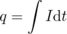
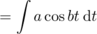
where q_{o} is a constant of integration.
We can interpret this in order to explain why a superconductor needs to be used. The constant b must be very large, since the current is supposed to oscillate back and forth millions of times a second. Looking at the final result, we see that if b is a very large number, and q is to be a significant amount of charge, then a must be a very large number as well. If a is numerically large, then the current must be very large, so it would heat the accelerator too much if it was flowing through an ordinary conductor.

Constant voltage throughout a conductor
The idea of a superconductor leads us to the question of how we should expect an object to behave if it is made of a very good conductor. Superconductors are an extreme case, but often a metal wire can be thought of as a perfect conductor, for example if the parts of the circuit other than the wire are made of much less conductive materials. What happens if R equals zero in the equation R=Δ V/I? The result of dividing two numbers can only be zero if the number on top equals zero. This tells us that if we pick any two points in a perfect conductor, the voltage difference between them must be zero. In other words, the entire conductor must be at the same voltage.
Constant voltage means that no work would be done on a charge as it moved from one point in the conductor to another. If zero work was done only along a certain path between two specific points, it might mean that positive work was done along part of the path and negative work along the rest, resulting in a cancellation. But there is no way that the work could come out to be zero for all possible paths unless the electrical force on a charge was in fact zero at every point. Suppose, for example, that you build up a static charge by scuffing your feet on a carpet, and then you deposit some of that charge onto a doorknob, which is a good conductor. How can all that charge be in the doorknob without creating any electrical force at any point inside it? The only possible answer is that the charge moves around until it has spread itself into just the right configuration so that the forces exerted by all the little bits of excess surface charge on any charged particle within the doorknob exactly canceled out.
We can explain this behavior if we assume that the charge placed on the doorknob eventually settles down into a stable equilibrium. Since the doorknob is a conductor, the charge is free to move through it. If it was free to move and any part of it did experience a nonzero total force from the rest of the charge, then it would move, and we would not have an equilibrium.
It also turns out that charge placed on a conductor, once it reaches its equilibrium configuration, is entirely on the surface, not on the interior. We will not prove this fact formally, but it is intuitively reasonable. Suppose, for instance, that the net charge on the conductor is negative, i.e. it has an excess of electrons. These electrons all repel each other, and this repulsion will tend to push them onto the surface, since being on the surface allows them to be as far apart as possible.

Short circuits
So far we have been assuming a perfect conductor. What if it is a good conductor, but not a perfect one? Then we can solve for Δ V=IR. An ordinary-sized current will make a very small result when we multiply it by the resistance of a good conductor such as a metal wire. The voltage throughout the wire will then be nearly constant. If, on the other hand, the current is extremely large, we can have a significant voltage difference. This is what happens in a short-circuit: a circuit in which a low-resistance pathway connects the two sides of a voltage source. Note that this is much more specific than the popular use of the term to indicate any electrical malfunction at all. If, for example, you short-circuit a 9-volt battery as shown in figure h, you will produce perhaps a thousand amperes of current, leading to a very large value of P=IΔ V. The wire gets hot!
self-check: What would happen to the battery in this kind of short circuit? (answer in the back of the PDF version of the book)

Resistors
Inside any electronic gadget you will see quite a few little circuit elements like the one shown below. These resistors are simply a cylinder of ohmic material with wires attached to the end.
At this stage, most students have a hard time understanding why resistors would be used inside a radio or a computer. We obviously want a lightbulb or an electric stove to have a circuit element that resists the flow of electricity and heats up, but heating is undesirable in radios and computers. Without going too far afield, let's use a mechanical analogy to get a general idea of why a resistor would be used in a radio.
The main parts of a radio receiver are an antenna, a tuner for selecting the frequency, and an amplifier to strengthen the signal sufficiently to drive a speaker. The tuner resonates at the selected frequency, just as in the examples of mechanical resonance discussed in 3. The behavior of a mechanical resonator depends on three things: its inertia, its stiffness, and the amount of friction or damping. The first two parameters locate the peak of the resonance curve, while the damping determines the width of the resonance. In the radio tuner we have an electrically vibrating system that resonates at a particular frequency. Instead of a physical object moving back and forth, these vibrations consist of electrical currents that flow first in one direction and then in the other. In a mechanical system, damping means taking energy out of the vibration in the form of heat, and exactly the same idea applies to an electrical system: the resistor supplies the damping, and therefore controls the width of the resonance. If we set out to eliminate all resistance in the tuner circuit, by not building in a resistor and by somehow getting rid of all the inherent electrical resistance of the wires, we would have a useless radio. The tuner's resonance would be so narrow that we could never get close enough to the right frequency to bring in the station. The roles of inertia and stiffness are played by other circuit elements we have not discusses (a capacitor and a coil).
Many electrical devices are based on electrical resistance and Ohm's law, even if they do not have little components in them that look like the usual resistor. The following are some examples.

Lightbulb
There is nothing special about a lightbulb filament --- you can easily make a lightbulb by cutting a narrow waist into a metallic gum wrapper and connecting the wrapper across the terminals of a 9-volt battery. The trouble is that it will instantly burn out. Edison solved this technical challenge by encasing the filament in an evacuated bulb, which prevented burning, since burning requires oxygen.

Polygraph
The polygraph, or “lie detector,” is really just a set of meters for recording physical measures of the subject's psychological stress, such as sweating and quickened heartbeat. The real-time sweat measurement works on the principle that dry skin is a good insulator, but sweaty skin is a conductor. Of course a truthful subject may become nervous simply because of the situation, and a practiced liar may not even break a sweat. The method's practitioners claim that they can tell the difference, but you should think twice before allowing yourself to be polygraph tested. Most U.S. courts exclude all polygraph evidence, but some employers attempt to screen out dishonest employees by polygraph testing job applicants, an abuse that ranks with such pseudoscience as handwriting analysis.

Fuse
A fuse is a device inserted in a circuit tollbooth-style in the same manner as an ammeter. It is simply a piece of wire made of metals having a relatively low melting point. If too much current passes through the fuse, it melts, opening the circuit. The purpose is to make sure that the building's wires do not carry so much current that they themselves will get hot enough to start a fire. Most modern houses use circuit breakers instead of fuses, although fuses are still common in cars and small devices. A circuit breaker is a switch operated by a coiled-wire magnet, which opens the circuit when enough current flows. The advantage is that once you turn off some of the appliances that were sucking up too much current, you can immediately flip the switch closed. In the days of fuses, one might get caught without a replacement fuse, or even be tempted to stuff aluminum foil in as a replacement, defeating the safety feature.

Voltmeter
A voltmeter is nothing more than an ammeter with an additional high-value resistor through which the current is also forced to flow. Ohm's law relates the current through the resistor is related directly to the voltage difference across it, so the meter can be calibrated in units of volts based on the known value of the resistor. The voltmeter's two probes are touched to the two locations in a circuit between which we wish to measure the voltage difference, l/2. Note how cumbersome this type of drawing is, and how difficult it can be to tell what is connected to what. This is why electrical drawing are usually shown in schematic form. Figure l/3 is a schematic representation of figure l/2.
The setups for measuring current and voltage are different. When we are measuring current, we are finding “how much stuff goes through,” so we place the ammeter where all the current is forced to go through it. Voltage, however, is not “stuff that goes through,” it is a measure of electrical energy. If an ammeter is like the meter that measures your water use, a voltmeter is like a measuring stick that tells you how high a waterfall is, so that you can determine how much energy will be released by each kilogram of falling water. We do not want to force the water to go through the measuring stick! The arrangement in figure l/3 is a parallel circuit: one in there are “forks in the road” where some of the current will flow one way and some will flow the other. Figure l/4 is said to be wired in series: all the current will visit all the circuit elements one after the other. We will deal with series and parallel circuits in more detail in the following chapter.
If you inserted a voltmeter incorrectly, in series with the bulb and battery, its large internal resistance would cut the current down so low that the bulb would go out. You would have severely disturbed the behavior of the circuit by trying to measure something about it.
Incorrectly placing an ammeter in parallel is likely to be even more disconcerting. The ammeter has nothing but wire inside it to provide resistance, so given the choice, most of the current will flow through it rather than through the bulb. So much current will flow through the ammeter, in fact, that there is a danger of burning out the battery or the meter or both! For this reason, most ammeters have fuses or circuit breakers inside. Some models will trip their circuit breakers and make an audible alarm in this situation, while others will simply blow a fuse and stop working until you replace it.

Discussion Questions
◊ In figure l/1, would it make any difference in the voltage measurement if we touched the voltmeter's probes to different points along the same segments of wire?
◊ Explain why it would be incorrect to define resistance as the amount of charge the resistor allows to flow.

Current-conducting properties of materials
Ohm's law has a remarkable property, which is that current will flow even in response to a voltage difference that is as small as we care to make it. In the analogy of pushing a crate across a floor, it is as though even a flea could slide the crate across the floor, albeit at some very low speed. The flea cannot do this because of static friction, which we can think of as an effect arising from the tendency of the microscopic bumps and valleys in the crate and floor to lock together. The fact that Ohm's law holds for nearly all solids has an interesting interpretation: at least some of the electrons are not “locked down” at all to any specific atom.
More generally we can ask how charge actually flows in various solids, liquids, and gases. This will lead us to the explanations of many interesting phenomena, including lightning, the bluish crust that builds up on the terminals of car batteries, and the need for electrolytes in sports drinks.

Solids
In atomic terms, the defining characteristic of a solid is that its atoms are packed together, and the nuclei cannot move very far from their equilibrium positions. It makes sense, then, that electrons, not ions, would be the charge carriers when currents flow in solids. This fact was established experimentally by Tolman and Stewart, in an experiment in which they spun a large coil of wire and then abruptly stopped it. They observed a current in the wire immediately after the coil was stopped, which indicated that charged particles that were not permanently locked to a specific atom had continued to move because of their own inertia, even after the material of the wire in general stopped. The direction of the current showed that it was negatively charged particles that kept moving. The current only lasted for an instant, however; as the negatively charged particles collected at the downstream end of the wire, farther particles were prevented joining them due to their electrical repulsion, as well as the attraction from the upstream end, which was left with a net positive charge. Tolman and Stewart were even able to determine the mass-to-charge ratio of the particles. We need not go into the details of the analysis here, but particles with high mass would be difficult to decelerate, leading to a stronger and longer pulse of current, while particles with high charge would feel stronger electrical forces decelerating them, which would cause a weaker and shorter pulse. The mass-to-charge ratio thus determined was consistent with the m/q of the electron to within the accuracy of the experiment, which essentially established that the particles were electrons.
The fact that only electrons carry current in solids, not ions, has many important implications. For one thing, it explains why wires don't fray or turn to dust after carrying current for a long time. Electrons are very small (perhaps even pointlike), and it is easy to imagine them passing between the cracks among the atoms without creating holes or fractures in the atomic framework. For those who know a little chemistry, it also explains why all the best conductors are on the left side of the periodic table. The elements in that area are the ones that have only a very loose hold on their outermost electrons.

Gases
The molecules in a gas spend most of their time separated from each other by significant distances, so it is not possible for them to conduct electricity the way solids do, by handing off electrons from atom to atom. It is therefore not surprising that gases are good insulators.
Gases are also usually nonohmic. As opposite charges build up on a stormcloud and the ground below, the voltage difference becomes greater and greater. Zero current flows, however, until finally the voltage reaches a certain threshold and we have an impressive example of what is known as a spark or electrical discharge. If air was ohmic, the current between the cloud and the ground would simply increase steadily as the voltage difference increased, rather than being zero until a threshold was reached. This behavior can be explained as follows. At some point, the electrical forces on the air electrons and nuclei of the air molecules become so strong that electrons are ripped right off of some of the molecules. The electrons then accelerate toward either the cloud or the ground, whichever is positively charged, and the positive ions accelerate the opposite way. As these charge carriers accelerate, they strike and ionize other molecules, which produces a rapidly growing cascade.

Liquids
Molecules in a liquid are able to slide past each other, so ions as well as electrons can carry currents. Pure water is a poor conductor because the water molecules tend to hold onto their electrons strongly, and there are therefore not many electrons or ions available to move. Water can become quite a good conductor, however, with the addition of even a small amount of certain substances called electrolytes, which are typically salts. For example, if we add table salt, NaCl, to water, the NaCl molecules dissolve into Na⁺ and Cl⁻ ions, which can then move and create currents. This is why electric currents can flow among the cells in our bodies: cellular fluid is quite salty. When we sweat, we lose not just water but electrolytes, so dehydration plays havoc with our cells' electrical systems. It is for this reason that electrolytes are included in sports drinks and formulas for rehydrating infants who have diarrhea.
Since current flow in liquids involves entire ions, it is not surprising that we can see physical evidence when it has occurred. For example, after a car battery has been in use for a while, the H₂SO₄ battery acid becomes depleted of hydrogen ions, which are the main charge carriers that complete the circuit on the inside of the battery. The leftover SO₄ then forms a visible blue crust on the battery posts.

Speed of currents and electrical signals
When I talk on the phone to my mother in law two thousand miles away, I do not notice any delay while the signal makes its way back and forth. Electrical signals therefore must travel very quickly, but how fast exactly? The answer is rather subtle. For the sake of concreteness, let's restrict ourselves to currents in metals, which consist of electrons.
The electrons themselves are only moving at speeds of perhaps a few thousand miles per hour, and their motion is mostly random thermal motion. This shows that the electrons in my phone cannot possibly be zipping back and forth between California and New York fast enough to carry the signals. Even if their thousand-mile-an-hour motion was organized rather than random, it would still take them many minutes to get there. Realistically, it will take the average electron even longer than that to make the trip. The current in the wire consists only of a slow overall drift, at a speed on the order of a few centimeters per second, superimposed on the more rapid random motion. We can compare this with the slow westward drift in the population of the U.S. If we could make a movie of the motion of all the people in the U.S. from outer space, and could watch it at high speed so that the people appeared to be scurrying around like ants, we would think that the motion was fairly random, and we would not immediately notice the westward drift. Only after many years would we realize that the number of people heading west over the Sierras had exceeded the number going east, so that California increased its share of the country's population.
So why are electrical signals so fast if the average drift speed of electrons is so slow? The answer is that a disturbance in an electrical system can move much more quickly than the charges themselves. It is as though we filled a pipe with golf balls and then inserted an extra ball at one end, causing a ball to fall out at the other end. The force propagated to the other end in a fraction of a second, but the balls themselves only traveled a few centimeters in that time.
Because the reality of current conduction is so complex, we often describe things using mental shortcuts that are technically incorrect. This is OK as long as we know that they are just shortcuts. For example, suppose the presidents of France and Russia shake hands, and the French politician has inadvertently picked up a positive electrical charge, which shocks the Russian. We may say that the excess positively charged particles in the French leader's body, which all repel each other, take the handshake as an opportunity to get farther apart by spreading out into two bodies rather than one. In reality, it would be a matter of minutes before the ions in one person's body could actually drift deep into the other's. What really happens is that throughout the body of the recipient of the shock there are already various positive and negative ions which are free to move. Even before the perpetrator's charged hand touches the victim's sweaty palm, the charges in the shocker's body begin to repel the positive ions and attract the negative ions in the other person. The split-second sensation of shock is caused by the sudden jumping of the victim's ions by distances of perhaps a micrometer, this effect occurring simultaneously throughout the whole body, although more violently in the hand and arm, which are closer to the other person.

9.2 Parallel and Series Circuits
In section 9.1, we limited ourselves to relatively simple circuits, essentially nothing more than a battery and a single lightbulb. The purpose of this chapter is to introduce you to more complex circuits, containing multiple resistors or voltage sources in series, in parallel, or both.
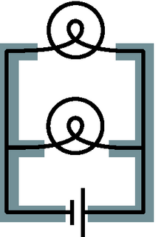
b / The two shaded areas shaped like the letter “E” are both regions of constant voltage.

Schematics
I see a chess position; Kasparov sees an interesting Ruy Lopez variation. To the uninitiated a schematic may look as unintelligible as Mayan hieroglyphs, but even a little bit of eye training can go a long way toward making its meaning leap off the page. A schematic is a stylized and simplified drawing of a circuit. The purpose is to eliminate as many irrelevant features as possible, so that the relevant ones are easier to pick out.
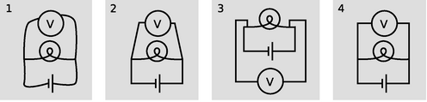
a / 1. Wrong: The shapes of the wires are irrelevant. 2. Wrong: Right angles should be used. 3. Wrong: A simple pattern is made to look unfamiliar and complicated. 4. Right.
An example of an irrelevant feature is the physical shape, length, and diameter of a wire. In nearly all circuits, it is a good approximation to assume that the wires are perfect conductors, so that any piece of wire uninterrupted by other components has constant voltage throughout it. Changing the length of the wire, for instance, does not change this fact. (Of course if we used miles and miles of wire, as in a telephone line, the wire's resistance would start to add up, and its length would start to matter.) The shapes of the wires are likewise irrelevant, so we draw them with standardized, stylized shapes made only of vertical and horizontal lines with right-angle bends in them. This has the effect of making similar circuits look more alike and helping us to recognize familiar patterns, just as words in a newspaper are easier to recognize than handwritten ones. Figure a shows some examples of these concepts.
The most important first step in learning to read schematics is to learn to recognize contiguous pieces of wire which must have constant voltage throughout. In figure b, for example, the two shaded E-shaped pieces of wire must each have constant voltage. This focuses our attention on two of the main unknowns we'd like to be able to predict: the voltage of the left-hand E and the voltage of the one on the right.
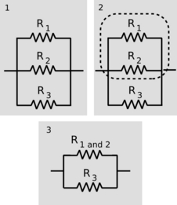
d / Three resistors in parallel.
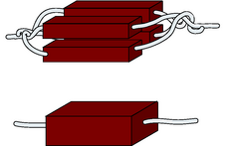
e / Uniting four resistors in parallel is equivalent to making a single resistor with the same length but four times the cross-sectional area. The result is to make a resistor with one quarter the resistance.
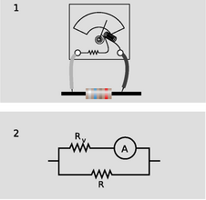
g / A voltmeter is really an ammeter with an internal resistor. When we measure the voltage difference across a resistor, 1, we are really constructing a parallel resistance circuit, 2.

Parallel resistances and the junction rule
One of the simplest examples to analyze is the parallel resistance circuit, of which figure b was an example. In general we may have unequal resistances R₁ and R₂, as in c/1. Since there are only two constant-voltage areas in the circuit, c/2, all three components have the same voltage difference across them. A battery normally succeeds in maintaining the voltage differences across itself for which it was designed, so the voltage drops Δ V₁ and Δ V₂ across the resistors must both equal the voltage of the battery:
Δ V₁=Δ V₂=Δ V_{battery} .
Each resistance thus feels the same voltage difference as if it was the only one in the circuit, and Ohm's law tells us that the amount of current flowing through each one is also the same as it would have been in a one-resistor circuit. This is why household electrical circuits are wired in parallel. We want every appliance to work the same, regardless of whether other appliances are plugged in or unplugged, turned on or switched off. (The electric company doesn't use batteries of course, but our analysis would be the same for any device that maintains a constant voltage.)
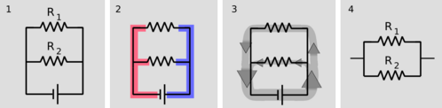
c / 1. Two resistors in parallel. 2. There are two constant-voltage areas. 3. The current that comes out of the battery splits between the two resistors, and later reunites. 4. The two resistors in parallel can be treated as a single resistor with a smaller resistance value.
Of course the electric company can tell when we turn on every light in the house. How do they know? The answer is that we draw more current. Each resistance draws a certain amount of current, and the amount that has to be supplied is the sum of the two individual currents. The current is like a river that splits in half, c/3, and then reunites. The total current is
I_{total} = I₁ + I₂ .
This is an example of a general fact called the junction rule:
In any circuit that is not storing or releasing charge, conservation of charge implies that the total current flowing out of any junction must be the same as the total flowing in.
Coming back to the analysis of our circuit, we apply Ohm's law to each resistance, resulting in
I_{total} = Δ V/R₁+ Δ V/R₂
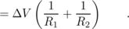
As far as the electric company is concerned, your whole house is just one resistor with some resistance R, called the equivalent resistance. They would write Ohm's law as
I_{total} = Δ V/R ,
from which we can determine the equivalent resistance by comparison with the previous expression:
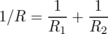
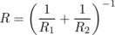
[equivalent resistance of two resistors in parallel]
Two resistors in parallel, c/4, are equivalent to a single resistor with a value given by the above equation.

Example 9: Two lamps on the same household circuit
◊ You turn on two lamps that are on the same household circuit. Each one has a resistance of 1 ohm. What is the equivalent resistance, and how does the power dissipation compare with the case of a single lamp?
◊ The equivalent resistance of the two lamps in parallel is
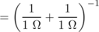
The voltage difference across the whole circuit is always the 110 V set by the electric company (it's alternating current, but that's irrelevant). The resistance of the whole circuit has been cut in half by turning on the second lamp, so a fixed amount of voltage will produce twice as much current. Twice the current flowing across the same voltage difference means twice as much power dissipation, which makes sense.
The cutting in half of the resistance surprises many students, since we are “adding more resistance” to the circuit by putting in the second lamp. Why does the equivalent resistance come out to be less than the resistance of a single lamp? This is a case where purely verbal reasoning can be misleading. A resistive circuit element, such as the filament of a lightbulb, is neither a perfect insulator nor a perfect conductor. Instead of analyzing this type of circuit in terms of “resistors,” i.e. partial insulators, we could have spoken of “conductors.” This example would then seem reasonable, since we “added more conductance,” but one would then have the incorrect expectation about the case of resistors in series, discussed in the following section.
Perhaps a more productive way of thinking about it is to use mechanical intuition. By analogy, your nostrils resist the flow of air through them, but having two nostrils makes it twice as easy to breathe.

Example 10: Three resistors in parallel
◊ What happens if we have three or more resistors in parallel?
◊ This is an important example, because the solution involves an important technique for understanding circuits: breaking them down into smaller parts and them simplifying those parts. In the circuit d/1, with three resistors in parallel, we can think of two of the resistors as forming a single big resistor, d/2, with equivalent resistance
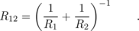
We can then simplify the circuit as shown in d/3, so that it contains only two resistances. The equivalent resistance of the whole circuit is then given by
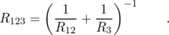
Substituting for R₁₂ and simplifying, we find the result
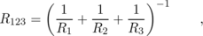
which you probably could have guessed. The interesting point here is the divide-and-conquer concept, not the mathematical result.

Example 11: An arbitrary number of identical resistors in parallel
◊ What is the resistance of N identical resistors in parallel?
◊ Generalizing the results for two and three resistors, we have
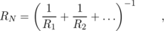
where “...” means that the sum includes all the resistors. If all the resistors are identical, this becomes
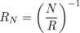

Example 12: Dependence of resistance on cross-sectional area
We have alluded briefly to the fact that an object's electrical resistance depends on its size and shape, but now we are ready to begin making more mathematical statements about it. As suggested by figure e, increasing a resistors's cross-sectional area is equivalent to adding more resistors in parallel, which will lead to an overall decrease in resistance. Any real resistor with straight, parallel sides can be sliced up into a large number of pieces, each with cross-sectional area of, say, 1 μ m². The number, N, of such slices is proportional to the total cross-sectional area of the resistor, and by application of the result of the previous example we therefore find that the resistance of an object is inversely proportional to its cross-sectional area.
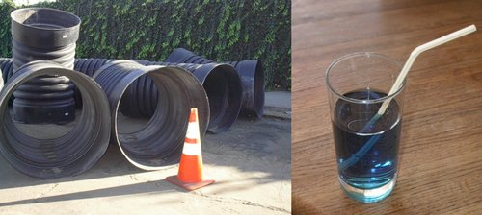
f / A fat pipe has less resistance than a skinny pipe.
An analogous relationship holds for water pipes, which is why high-flow trunk lines have to have large cross-sectional areas. To make lots of water (current) flow through a skinny pipe, we'd need an impractically large pressure (voltage) difference.

Example 13: Incorrect readings from a voltmeter
A voltmeter is really just an ammeter with an internal resistor, and we use a voltmeter in parallel with the thing that we're trying to measure the voltage difference across. This means that any time we measure the voltage drop across a resistor, we're essentially putting two resistors in parallel. The ammeter inside the voltmeter can be ignored for the purpose of analyzing what how current flows in the circuit, since it is essentially just some coiled-up wire with a very low resistance.
Now if we are carrying out this measurement on a resistor that is part of a larger circuit, we have changed the behavior of the circuit through our act of measuring. It is as though we had modified the circuit by replacing the resistance R with the smaller equivalent resistance of R and R_{v} in parallel. It is for this reason that voltmeters are built with the largest possible internal resistance. As a numerical example, if we use a voltmeter with an internal resistance of 1 MΩ to measure the voltage drop across a one-ohm resistor, the equivalent resistance is 0.999999 Ω, which is not different enough to make any difference. But if we tried to use the same voltmeter to measure the voltage drop across a 2-MΩ resistor, we would be reducing the resistance of that part of the circuit by a factor of three, which would produce a drastic change in the behavior of the whole circuit.
This is the reason why you can't use a voltmeter to measure the voltage difference between two different points in mid-air, or between the ends of a piece of wood. This is by no means a stupid thing to want to do, since the world around us is not a constant-voltage environment, the most extreme example being when an electrical storm is brewing. But it will not work with an ordinary voltmeter because the resistance of the air or the wood is many gigaohms. The effect of waving a pair of voltmeter probes around in the air is that we provide a reuniting path for the positive and negative charges that have been separated --- through the voltmeter itself, which is a good conductor compared to the air. This reduces to zero the voltage difference we were trying to measure.
In general, a voltmeter that has been set up with an open circuit (or a very large resistance) between its probes is said to be “floating.” An old-fashioned analog voltmeter of the type described here will read zero when left floating, the same as when it was sitting on the shelf. A floating digital voltmeter usually shows an error message.
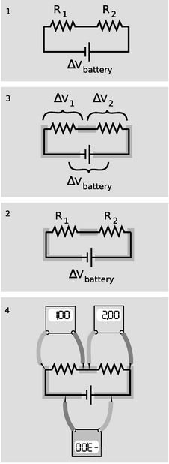
h / 1. A battery drives current through two resistors in series. 2. There are three constant-voltage regions. 3. The three voltage differences are related. 4. If the meter crab-walks around the circuit without flipping over or crossing its legs, the resulting voltages have plus and minus signs that make them add up to zero.
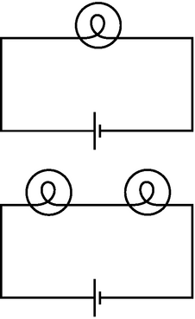
i / Example 14.
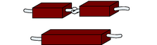
j / Doubling the length of a resistor is like putting two resistors in series. The resistance is doubled.

Series resistances
The two basic circuit layouts are parallel and series, so a pair of resistors in series, h/1, is another of the most basic circuits we can make. By conservation of charge, all the current that flows through one resistor must also flow through the other (as well as through the battery):
I₁ = I₂ .
The only way the information about the two resistance values is going to be useful is if we can apply Ohm's law, which will relate the resistance of each resistor to the current flowing through it and the voltage difference across it. Figure h/2 shows the three constant-voltage areas. Voltage differences are more physically significant than voltages, so we define symbols for the voltage differences across the two resistors in figure h/3.
We have three constant-voltage areas, with symbols for the difference in voltage between every possible pair of them. These three voltage differences must be related to each other. It is as though I tell you that Fred is a foot taller than Ginger, Ginger is a foot taller than Sally, and Fred is two feet taller than Sally. The information is redundant, and you really only needed two of the three pieces of data to infer the third. In the case of our voltage differences, we have
|Δ V₁| + |Δ V₂| = |Δ V_{battery}| .
The absolute value signs are because of the ambiguity in how we define our voltage differences. If we reversed the two probes of the voltmeter, we would get a result with the opposite sign. Digital voltmeters will actually provide a minus sign on the screen if the wire connected to the “V” plug is lower in voltage than the one connected to the “COM” plug. Analog voltmeters pin the needle against a peg if you try to use them to measure negative voltages, so you have to fiddle to get the leads connected the right way, and then supply any necessary minus sign yourself.
Figure h/4 shows a standard way of taking care of the ambiguity in signs. For each of the three voltage measurements around the loop, we keep the same probe (the darker one) on the clockwise side. It is as though the voltmeter was sidling around the circuit like a crab, without ever “crossing its legs.” With this convention, the relationship among the voltage drops becomes
Δ V₁ + Δ V₂ = -Δ V_{battery} ,
or, in more symmetrical form,
Δ V₁ + Δ V₂ + Δ V_{battery} = 0 .
More generally, this is known as the loop rule for analyzing circuits:
Assuming the standard convention for plus and minus signs, the sum of the voltage drops around any closed loop in a circuit must be zero.
Looking for an exception to the loop rule would be like asking for a hike that would be downhill all the way and that would come back to its starting point!
For the circuit we set out to analyze, the equation
Δ V₁ + Δ V₂ + Δ V_{battery} = 0
can now be rewritten by applying Ohm's law to each resistor:
I₁R₁ + I₂R₂ + Δ V_{battery} = 0 .
The currents are the same, so we can factor them out:
and this is the same result we would have gotten if we had been analyzing a one-resistor circuit with resistance R₁+R₂. Thus the equivalent resistance of resistors in series equals the sum of their resistances.

Example 14: Two lightbulbs in series
◊ If two identical lightbulbs are placed in series, how do their brightnesses compare with the brightness of a single bulb?
◊ Taken as a whole, the pair of bulbs act like a doubled resistance, so they will draw half as much current from the wall. Each bulb will be dimmer than a single bulb would have been.
The total power dissipated by the circuit is IΔ V. The voltage drop across the whole circuit is the same as before, but the current is halved, so the two-bulb circuit draws half as much total power as the one-bulb circuit. Each bulb draws one-quarter of the normal power.
Roughly speaking, we might expect this to result in one quarter the light being produced by each bulb, but in reality lightbulbs waste quite a high percentage of their power in the form of heat and wavelengths of light that are not visible (infrared and ultraviolet). Less light will be produced, but it's hard to predict exactly how much less, since the efficiency of the bulbs will be changed by operating them under different conditions.

Example 15: More than two equal resistances in series
By straightforward application of the divide-and-conquer technique discussed in the previous section, we find that the equivalent resistance of N identical resistances R in series will be NR.

Example 16: Dependence of resistance on length
In the previous section, we proved that resistance is inversely proportional to cross-sectional area. By equivalent reason about resistances in series, we find that resistance is proportional to length. Analogously, it is harder to blow through a long straw than through a short one.
Putting the two arguments together, we find that the resistance of an object with straight, parallel sides is given by
The proportionality constant is called the resistivity, and it depends only on the substance of which the object is made. A resistivity measurement could be used, for instance, to help identify a sample of an unknown substance.

Example 17: Choice of high voltage for power lines
Thomas Edison got involved in a famous technological controversy over the voltage difference that should be used for electrical power lines. At this time, the public was unfamiliar with electricity, and easily scared by it. The president of the United States, for instance, refused to have electrical lighting in the White House when it first became commercially available because he considered it unsafe, preferring the known fire hazard of oil lamps to the mysterious dangers of electricity. Mainly as a way to overcome public fear, Edison believed that power should be transmitted using small voltages, and he publicized his opinion by giving demonstrations at which a dog was lured into position to be killed by a large voltage difference between two sheets of metal on the ground. (Edison's opponents also advocated alternating current rather than direct current, and AC is more dangerous than DC as well. As we will discuss later, AC can be easily stepped up and down to the desired voltage level using a device called a transformer.)
Now if we want to deliver a certain amount of power P_{L} to a load such as an electric lightbulb, we are constrained only by the equation P_{L} = IΔ V_{L}. We can deliver any amount of power we wish, even with a low voltage, if we are willing to use large currents. Modern electrical distribution networks, however, use dangerously high voltage differences of tens of thousands of volts. Why did Edison lose the debate?
It boils down to money. The electric company must deliver the amount of power P_{L} desired by the customer through a transmission line whose resistance R_{T} is fixed by economics and geography. The same current flows through both the load and the transmission line, dissipating power usefully in the former and wastefully in the latter. The efficiency of the system is
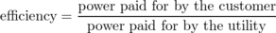
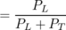
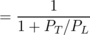
Putting ourselves in the shoes of the electric company, we wish to get rid of the variable P_{T}, since it is something we control only indirectly by our choice of Δ V_{T} and I. Substituting P_{T}= IΔ V_{T}, we find
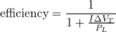
We assume the transmission line (but not necessarily the load) is ohmic, so substituting Δ V_{T}=IR_{T} gives
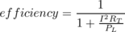
This quantity can clearly be maximized by making I as small as possible, since we will then be dividing by the smallest possible quantity on the bottom of the fraction. A low-current circuit can only deliver significant amounts of power if it uses high voltages, which is why electrical transmission systems use dangerous high voltages.

Example 18: Getting killed by your ammeter
As with a voltmeter, an ammeter can give erroneous readings if it is used in such a way that it changes the behavior the circuit. An ammeter is used in series, so if it is used to measure the current through a resistor, the resistor's value will effectively be changed to R+ R_{a}, where R_{a} is the resistance of the ammeter. Ammeters are designed with very low resistances in order to make it unlikely that R+ R_{a} will be significantly different from R.
In fact, the real hazard is death, not a wrong reading! Virtually the only circuits whose resistances are significantly less than that of an ammeter are those designed to carry huge currents. An ammeter inserted in such a circuit can easily melt. When I was working at a laboratory funded by the Department of Energy, we got periodic bulletins from the DOE safety office about serious accidents at other sites, and they held a certain ghoulish fascination. One of these was about a DOE worker who was completely incinerated by the explosion created when he inserted an ordinary Radio Shack ammeter into a high-current circuit. Later estimates showed that the heat was probably so intense that the explosion was a ball of plasma --- a gas so hot that its atoms have been ionized.
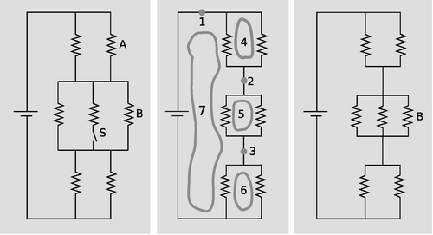
k / Example 19.

Example 19: A complicated circuit
◊ All seven resistors in the left-hand panel of figure k are identical. Initially, the switch S is open as shown in the figure, and the current through resistor A is I_{o}. The switch is then closed. Find the current through resistor B, after the switch is closed, in terms of I_{o}.
◊ The second panel shows the circuit redrawn for simplicity, in the initial condition with the switch open. When the switch is open, no current can flow through the central resistor, so we may as well ignore it. I've also redrawn the junctions, without changing what's connected to what. This is the kind of mental rearranging that you'll eventually learn to do automatically from experience with analyzing circuits. The redrawn version makes it easier to see what's happening with the current. Charge is conserved, so any charge that flows past point 1 in the circuit must also flow past points 2 and 3. This would have been harder to reason about by applying the junction rule to the original version, which appears to have nine separate junctions.
In the new version, it's also clear that the circuit has a great deal of symmetry. We could flip over each parallel pair of identical resistors without changing what's connected to what, so that makes it clear that the voltage drops and currents must be equal for the members of each pair. We can also prove this by using the loop rule. The loop rule says that the two voltage drops in loop 4 must be equal, and similarly for loops 5 and 6. Since the resistors obey Ohm's law, equal voltage drops across them also imply equal currents. That means that when the current at point 1 comes to the top junction, exactly half of it goes through each resistor. Then the current reunites at 2, splits between the next pair, and so on. We conclude that each of the six resistors in the circuit experiences the same voltage drop and the same current. Applying the loop rule to loop 7, we find that the sum of the three voltage drops across the three left-hand resistors equals the battery's voltage, V, so each resistor in the circuit experiences a voltage drop V/3. Letting R stand for the resistance of one of the resistors, we find that the current through resistor B, which is the same as the currents through all the others, is given by I_{o}=V/3R.
We now pass to the case where the switch is closed, as shown in the third panel. The battery's voltage is the same as before, and each resistor's resistance is the same, so we can still use the same symbols V and R for them. It is no longer true, however, that each resistor feels a voltage drop V/3. The equivalent resistance of the whole circuit is R/2+R/3+R/2=4R/3, so the total current drawn from the battery is 3V/4R. In the middle group of resistors, this current is split three ways, so the new current through B is (1/3)(3V/4R)=V/4R=3I_{o}/4.
Interpreting this result, we see that it comes from two effects that partially cancel. Closing the switch reduces the equivalent resistance of the circuit by giving charge another way to flow, and increases the amount of current drawn from the battery. Resistor B, however, only gets a 1/3 share of this greater current, not 1/2. The second effect turns out to be bigger than the second effect, and therefore the current through resistor B is lessened over all.

Discussion Questions
◊ We have stated the loop rule in a symmetric form where a series of voltage drops adds up to zero. To do this, we had to define a standard way of connecting the voltmeter to the circuit so that the plus and minus signs would come out right. Suppose we wish to restate the junction rule in a similar symmetric way, so that instead of equating the current coming in to the current going out, it simply states that a certain sum of currents at a junction adds up to zero. What standard way of inserting the ammeter would we have to use to make this work?
\backofchapterboilerplate{dccircuits}

Homework Problems
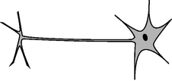
a / Problem 2.
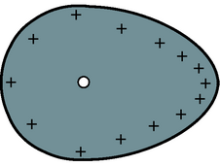
b / Problem 8.
c / Problem 10.
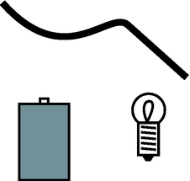
d / Problem 14.
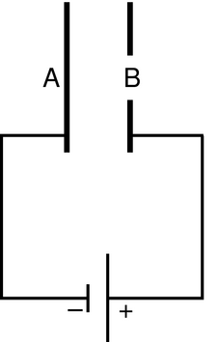
e / Problem 15.
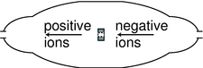
f / Problem 16.
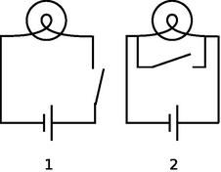
g / Problem 22.
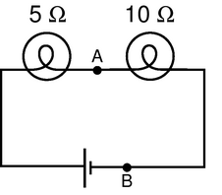
h / Problem 23.
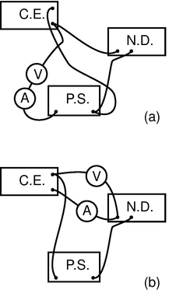
i / Problem 25.
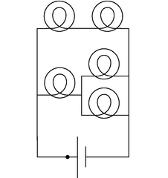
j / Problems 29 and 30.

k / A printed circuit board, like the kind referred to in problem 31.
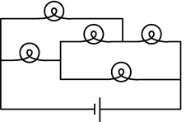
l / Problem 32.
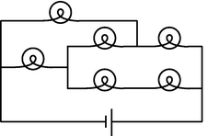
m / Problem 33.
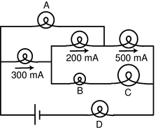
n / Problem 34.
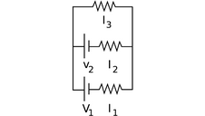
o / Problem 35.
1. In a wire carrying a current of 1.0 pA, how long do you have to wait, on the average, for the next electron to pass a given point? Express your answer in units of microseconds. (solution in the pdf version of the book){hwsoln:timebetweenelectrons}
2. Referring back to our old friend the neuron from problem 1 on page 427, let's now consider what happens when the nerve is stimulated to transmit information. When the blob at the top (the cell body) is stimulated, it causes Na⁺ ions to rush into the top of the tail (axon). This electrical pulse will then travel down the axon, like a flame burning down from the end of a fuse, with the Na⁺ ions at each point first going out and then coming back in. If 10¹⁰ Na⁺ ions cross the cell membrane in 0.5 ms, what amount of current is created? (answer check available at lightandmatter.com)
3. [0]{bulbresistance} If a typical light bulb draws about 900 mA from a 110-V household circuit, what is its resistance? (Don't worry about the fact that it's alternating current.) (answer check available at lightandmatter.com)
4. A resistor has a voltage difference Δ V across it, causing a current I to flow.
(a) Find an equation for the power it dissipates as heat in terms of the variables I and R only, eliminating Δ V. (answer check available at lightandmatter.com)
(b) If an electrical line coming to your house is to carry a given amount of current, interpret your equation from part a to explain whether the wire's resistance should be small, or large. (answer check available at lightandmatter.com)
5. (a) Express the power dissipated by a resistor in terms of R and Δ V only, eliminating I. (answer check available at lightandmatter.com)
(b) Electrical receptacles in your home are mostly 110 V, but circuits for electric stoves, air conditioners, and washers and driers are usually 220 V. The two types of circuits have differently shaped receptacles. Suppose you rewire the plug of a drier so that it can be plugged in to a 110 V receptacle. The resistor that forms the heating element of the drier would normally draw 200 W. How much power does it actually draw now? (answer check available at lightandmatter.com)
6. [0]{lightningcurrent} Lightning discharges a cloud during an electrical storm. Suppose that the current in the lightning bolt varies with time as I=bt, where b is a constant. Find the cloud's charge as a function of time. (answer check available at lightandmatter.com)
7. In AM (amplitude-modulated) radio, an audio signal f(t) is multiplied by a sine wave sin ω t in the megahertz frequency range. For simplicity, let's imagine that the transmitting antenna is a whip, and that charge goes back and forth between the top and bottom. Suppose that, during a certain time interval, the audio signal varies linearly with time, giving a charge q=(a+bt)sin ω t at the top of the whip and -q at the bottom. Find the current as a function of time. (answer check available at lightandmatter.com)
8. As discussed in the text, when a conductor reaches an equilibrium where its charge is at rest, there is always zero electric force on a charge in its interior, and any excess charge concentrates itself on the surface. The surface layer of charge arranges itself so as to produce zero total force at any point in the interior. (Otherwise the free charge in the interior could not be at rest.) Suppose you have a teardrop-shaped conductor like the one shown in the figure. Since the teardrop is a conductor, there are free charges everywhere inside it, but consider a free charged particle at the location shown with a white circle. Explain why, in order to produce zero force on this particle, the surface layer of charge must be denser in the pointed part of the teardrop. (Similar reasoning shows why lightning rods are made with points. The charged stormclouds induce positive and negative charges to move to opposite ends of the rod. At the pointed upper end of the rod, the charge tends to concentrate at the point, and this charge attracts the lightning.)
9. [0]{pointchargevoltage} Use the result of problem 3 on page 427 to find an equation for the voltage at a point in space at a distance r from a point charge Q. (Take your V=0 distance to be anywhere you like.) (answer check available at lightandmatter.com)
10. Referring back to problem 6 on page 428 about the sodium chloride crystal, suppose the lithium ion is going to jump from the gap it is occupying to one of the four closest neighboring gaps. Which one will it jump to, and if it starts from rest, how fast will it be going by the time it gets there? (It will keep on moving and accelerating after that, but that does not concern us.) [Hint: The approach is similar to the one used for the other problem, but you want to work with voltage and electrical energy rather than force.] (answer check available at lightandmatter.com)
11. Today, even a big luxury car like a Cadillac can have an electrical system that is relatively low in power, since it doesn't need to do much more than run headlights, power windows, etc. In the near future, however, manufacturers plan to start making cars with electrical systems about five times more powerful. This will allow certain energy-wasting parts like the water pump to be run on electrical motors and turned off when they're not needed --- currently they're run directly on shafts from the motor, so they can't be shut off. It may even be possible to make an engine that can shut off at a stoplight and then turn back on again without cranking, since the valves can be electrically powered. Current cars' electrical systems have 12-volt batteries (with 14-volt chargers), but the new systems will have 36-volt batteries (with 42-volt chargers).
(a) Suppose the battery in a new car is used to run a device that requires the same amount of power as the corresponding device in the old car. Based on the sample figures above, how would the currents handled by the wires in one of the new cars compare with the currents in the old ones?
(b) The real purpose of the greater voltage is to handle devices that need more power. Can you guess why they decided to change to 36-volt batteries rather than increasing the power without increasing the voltage? (answer check available at lightandmatter.com)
12. (a) You take an LP record out of its sleeve, and it acquires a static charge of 1 nC. You play it at the normal speed of r.p.m., and the charge moving in a circle creates an electric current. What is the current, in amperes? (answer check available at lightandmatter.com)
(b) Although the planetary model of the atom can be made to work with any value for the radius of the electrons' orbits, more advanced models that we will study later in this course predict definite radii. If the electron is imagined as circling around the proton at a speed of 2.2×10⁶ m/s, in an orbit with a radius of 0.05 nm, what electric current is created? (answer check available at lightandmatter.com)
13. We have referred to resistors dissipating heat, i.e. we have assumed that P=IΔ V is always greater than zero. Could IΔ V come out to be negative for a resistor? If so, could one make a refrigerator by hooking up a resistor in such a way that it absorbed heat instead of dissipating it?
14. You are given a battery, a flashlight bulb, and a single piece of wire. Draw at least two configurations of these items that would result in lighting up the bulb, and at least two that would not light it. (Don't draw schematics.) If you're not sure what's going on, borrow the materials from your instructor and try it. Note that the bulb has two electrical contacts: one is the threaded metal jacket, and the other is the tip. [Problem by Arnold Arons.]
15. The figure shows a simplified diagram of an electron gun such as the one that creates the electron beam in a TV tube. Electrons that spontaneously emerge from the negative electrode (cathode) are then accelerated to the positive electrode, which has a hole in it. (Once they emerge through the hole, they will slow down. However, if the two electrodes are fairly close together, this slowing down is a small effect, because the attractive and repulsive forces experienced by the electron tend to cancel.)
(a) If the voltage difference between the electrodes is Δ V, what is the velocity of an electron as it emerges at B? Assume that its initial velocity, at A, is negligible, and that the velocity is nonrelativistic. (If you haven't read ch.~7 yet, don't worry about the remark about relativity.) (answer check available at lightandmatter.com)
(b) Evaluate your expression numerically for the case where Δ V=10 kV, and compare to the speed of light. If you've read ch.~7 already, comment on whether the assumption of nonrelativistic motion was justified. (solution in the pdf version of the book){hwsoln:electrongun}(answer check available at lightandmatter.com)
16. The figure shows a simplified diagram of a device called a tandem accelerator, used for accelerating beams of ions up to speeds on the order of 1% of the speed of light. The nuclei of these ions collide with the nuclei of atoms in a target, producing nuclear reactions for experiments studying the structure of nuclei. The outer shell of the accelerator is a conductor at zero voltage (i.e. the same voltage as the Earth). The electrode at the center, known as the “terminal,” is at a high positive voltage, perhaps millions of volts. Negative ions with a charge of -1 unit (i.e. atoms with one extra electron) are produced offstage on the right, typically by chemical reactions with cesium, which is a chemical element that has a strong tendency to give away electrons. Relatively weak electric and magnetic forces are used to transport these -1 ions into the accelerator, where they are attracted to the terminal. Although the center of the terminal has a hole in it to let the ions pass through, there is a very thin carbon foil there that they must physically penetrate. Passing through the foil strips off some number of electrons, changing the atom into a positive ion, with a charge of +n times the fundamental charge. Now that the atom is positive, it is repelled by the terminal, and accelerates some more on its way out of the accelerator.
(a) Find the velocity, v, of the emerging beam of positive ions, in terms of n, their mass m, the terminal voltage V, and fundamental constants. Neglect the small change in mass caused by the loss of electrons in the stripper foil.
(b) To fuse protons with protons, a minimum beam velocity of about 11% of the speed of light is required. What terminal voltage would be needed in this case? (answer check available at lightandmatter.com)
(c) In the setup described in part b, we need a target containing atoms whose nuclei are single protons, i.e., a target made of hydrogen. Since hydrogen is a gas, and we want a foil for our target, we have to use a hydrogen compound, such as a plastic. Discuss what effect this would have on the experiment. (answer check available at lightandmatter.com)
17. [0]{tenkohmonekohm} What resistance values can be created by combining a 1 kΩ resistor and a 10 kΩ resistor? (solution in the pdf version of the book){hwsoln:tenkohmonekohm}
18. (a) Many battery-operated devices take more than one battery. If you look closely in the battery compartment, you will see that the batteries are wired in series. Consider a flashlight circuit. What does the loop rule tell you about the effect of putting several batteries in series in this way?
(b) The cells of an electric eel's nervous system are not that different from ours --- each cell can develop a voltage difference across it of somewhere on the order of one volt. How, then, do you think an electric eel can create voltages of thousands of volts between different parts of its body?
19. A 1.0 Ω toaster and a 2.0 Ω lamp are connected in parallel with the 110-V supply of your house. (Ignore the fact that the voltage is AC rather than DC.)
(a) Draw a schematic of the circuit.
(b) For each of the three components in the circuit, find the current passing through it and the voltage drop across it.
(c) Suppose they were instead hooked up in series. Draw a schematic and calculate the same things.
20. The heating element of an electric stove is connected in series with a switch that opens and closes many times per second. When you turn the knob up for more power, the fraction of the time that the switch is closed increases. Suppose someone suggests a simpler alternative for controlling the power by putting the heating element in series with a variable resistor controlled by the knob. (With the knob turned all the way clockwise, the variable resistor's resistance is nearly zero, and when it's all the way counterclockwise, its resistance is essentially infinite.) (a) Draw schematics. (b) Why would the simpler design be undesirable?
21. Wire is sold in a series of standard diameters, called “gauges.” The difference in diameter between one gauge and the next in the series is about 20%. How would the resistance of a given length of wire compare with the resistance of the same length of wire in the next gauge in the series? (answer check available at lightandmatter.com)
22. The figure shows two possible ways of wiring a flashlight with a switch. Both will serve to turn the bulb on and off, although the switch functions in the opposite sense. Why is method (1) preferable?
23. In the figure, the battery is 9 V.
(a) What are the voltage differences across each light bulb?
(b) What current flows through each of the three components of the circuit?
(c) If a new wire is added to connect points A and B, how will the appearances of the bulbs change? What will be the new voltages and currents?
(d) Suppose no wire is connected from A to B, but the two bulbs are switched. How will the results compare with the results from the original setup as drawn?
24. You have a circuit consisting of two unknown resistors in series, and a second circuit consisting of two unknown resistors in parallel.
(a) What, if anything, would you learn about the resistors in the series circuit by finding that the currents through them were equal?
(b) What if you found out the voltage differences across the resistors in the series circuit were equal?
(c) What would you learn about the resistors in the parallel circuit from knowing that the currents were equal?
(d) What if the voltages in the parallel circuit were equal?
25. A student in a biology lab is given the following instructions: “Connect the cerebral eraser (C.E.) and the neural depolarizer (N.D.) in parallel with the power supply (P.S.). (Under no circumstances should you ever allow the cerebral eraser to come within 20 cm of your head.) Connect a voltmeter to measure the voltage across the cerebral eraser, and also insert an ammeter in the circuit so that you can make sure you don't put more than 100 mA through the neural depolarizer.” The diagrams show two lab groups' attempts to follow the instructions.
(a) Translate diagram 1 into a standard-style schematic. What is correct and incorrect about this group's setup?
(b) Do the same for diagram 2.
26. How many different resistance values can be created by combining three unequal resistors? (Don't count possibilities in which not all the resistors are used, i.e. ones in which there is zero current in one or more of them.)
27. [2]{tetrahedron} Suppose six identical resistors, each with resistance R, are connected so that they form the edges of a tetrahedron (a pyramid with three sides in addition to the base, i.e. one less side than an Egyptian pyramid). What resistance value or values can be obtained by making connections onto any two points on this arrangement? (solution in the pdf version of the book){hwsoln:tetrahedron}
28. A person in a rural area who has no electricity runs an extremely long extension cord to a friend's house down the road so she can run an electric light. The cord is so long that its resistance, x, is not negligible. Show that the lamp's brightness is greatest if its resistance, y, is equal to x. Explain physically why the lamp is dim for values of y that are too small or too large.
29. The figure shows a circuit containing five lightbulbs connected to a battery. Suppose you're going to connect one probe of a voltmeter to the circuit at the point marked with a dot. How many unique, nonzero voltage differences could you measure by connecting the other probe to other wires in the circuit?
30. The lightbulbs in the figure are all identical. If you were inserting an ammeter at various places in the circuit, how many unique currents could you measure? If you know that the current measurement will give the same number in more than one place, only count that as one unique current.
31. You have to do different things with a circuit to measure current than to measure a voltage difference. Which would be more practical for a printed circuit board, in which the wires are actually strips of metal embedded inside the board? (solution in the pdf version of the book){hwsoln:measure-on-printed-circuit}
32. [2]{tricky-unlit-bulb} The bulbs are all identical. Which one doesn't light up?
33. [2]{network} Each bulb has a resistance of one ohm. How much power is drawn from the one-volt battery?
34. The bulbs all have unequal resistances. Given the three currents shown in the figure, find the currents through bulbs A, B, C, and D.
35. All three resistors have the same resistance, R. Find the three unknown currents in terms of V₁, V₂, and R. (answer check available at lightandmatter.com)
\begin{exsection}
\extitle{A}{Voltage and Current}
1. How many different currents could you measure in this circuit? Make a prediction, and then try it.
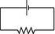
What do you notice? How does this make sense in terms of the roller coaster metaphor introduced in discussion question 9.1.3A on page 441?
What is being used up in the resistor?
2. By connecting probes to these points, how many ways could you measure a voltage? How many of them would be different numbers? Make a prediction, and then do it.
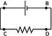
What do you notice? Interpret this using the roller coaster metaphor, and color in parts of the circuit that represent constant voltages.
3. The resistors are unequal. How many different voltages and currents can you measure? Make a prediction, and then try it.
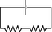
What do you notice? Interpret this using the roller coaster metaphor, and color in parts of the circuit that represent constant voltages.
\extitle{B}{The Loop and Junction Rules}
Apparatus:
DC power supply
multimeter
resistors
1. The junction rule
Construct a circuit like this one, using the power supply as your voltage source. To make things more interesting, don't use equal resistors. Use nice big resistors (say 100 kΩ to 1 MΩ) --- this will ensure that you don't burn up the resistors, and that the multimeter's small internal resistance when used as an ammeter is negligible in comparison.
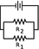
Insert your multimeter in the circuit to measure all three currents that you need in order to test the junction rule.
2. The loop rule
Now come up with a circuit to test the loop rule. Since the loop rule is always supposed to be true, it's hard to go wrong here! Make sure you have at least three resistors in a loop, and make sure you hook in the power supply in a way that creates non-zero voltage differences across all the resistors. Measure the voltage differences you need to measure to test the loop rule. Here it is best to use fairly small resistances, so that the multimeter's large internal resistance when used in parallel as a voltmeter will not significantly reduce the resistance of the circuit. Do not use resistances of less than about 100 Ω, however, or you may blow a fuse or burn up a resistor.
\extitle{C}{Reasoning About Circuits}
The questions in this exercise can all be solved using some combination of the following approaches:
a) There is constant voltage throughout any conductor.
b) Ohm's law can be applied to any part of a circuit.
c) Apply the loop rule.
d) Apply the junction rule.
In each case, discuss the question, decide what you think is the right answer, and then try the experiment.
1. A wire is added in parallel with one bulb.
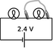
Which reasoning is correct?
- Each bulb still has 1.2 V across it, so both bulbs are still lit up.
- All parts of a wire are at the same voltage, and there is now a wire connection from one side of the right-hand bulb to the other. The right-hand bulb has no voltage difference across it, so it goes out.
2. The series circuit is changed as shown.
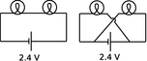
Which reasoning is correct?
- Each bulb now has its sides connected to the two terminals of the battery, so each now has 2.4 V across it instead of 1.2 V. They get brighter.
- Just as in the original circuit, the current goes through one bulb, then the other. It's just that now the current goes in a figure-8 pattern. The bulbs glow the same as before.
3. A wire is added as shown to the original circuit.
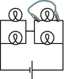
What is wrong with the following reasoning?
The top right bulb will go out, because its two sides are now connected with wire, so there will be no voltage difference across it. The other three bulbs will not be affected.
4. A wire is added as shown to the original circuit.
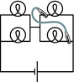
What is wrong with the following reasoning?
The current flows out of the right side of the battery. When it hits the first junction, some of it will go left and some will keep going up The part that goes up lights the top right bulb. The part that turns left then follows the path of least resistance, going through the new wire instead of the bottom bulb. The top bulb stays lit, the bottom one goes out, and others stay the same.
5. What happens when one bulb is unscrewed, leaving an air gap?
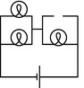
\end{exsection}
10. Fields
Table of Contents

Contents
Section 10.1 - Fields of Force
Section 10.2 - Voltage Related to Field
Section 10.3 - Fields by Superposition
Section 10.4 - Energy in Fields
Section 10.5 - LRC Circuits
Section 10.6 - Fields by Gauss' Law
Section 10.7 - Gauss' Law in Differential Form

Chapter 10. Fields
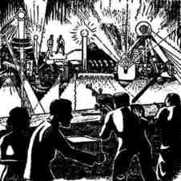
“Okay. Your duties are as follows: Get Breen. I don't care how you get him, but get him soon. That faker! He posed for twenty years as a scientist without ever being apprehended. Well, I'm going to do some apprehending that'll make all previous apprehending look like no apprehension at all. You with me?”
“Yes,” said Battle, very much confused. “What's that thing you have?”
“Piggy-back heat-ray. You transpose the air in its path into an unstable isotope which tends to carry all energy as heat. Then you shoot your juice light, or whatever along the isotopic path and you burn whatever's on the receiving end. You want a few?”
“No,” said Battle. “I have my gats. What else have you got for offense and defense?” Underbottam opened a cabinet and proudly waved an arm. “Everything,” he said.
“Disintegraters, heat-rays, bombs of every type. And impenetrable shields of energy, massive and portable. What more do I need?”
From THE REVERSIBLE REVOLUTIONS by Cecil Corwin, Cosmic Stories, March 1941. Art by Morey, Bok, Kyle, Hunt, Forte. Copyright expired. }

10.1 Fields of Force
Cutting-edge science readily infiltrates popular culture, though sometimes in garbled form. The Newtonian imagination populated the universe mostly with that nice solid stuff called matter, which was made of little hard balls called atoms. In the early twentieth century, consumers of pulp fiction and popularized science began to hear of a new image of the universe, full of x-rays, N-rays, and Hertzian waves. What they were beginning to soak up through their skins was a drastic revision of Newton's concept of a universe made of chunks of matter which happened to interact via forces. In the newly emerging picture, the universe was made of force, or, to be more technically accurate, of ripples in universal fields of force. Unlike the average reader of Cosmic Stories in 1941, you now possess enough technical background to understand what a “force field” really is.
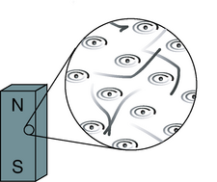
a / A bar magnet's atoms are (partially) aligned.
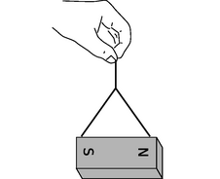
b / A bar magnet interacts with our magnetic planet.
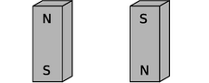
c / Magnets aligned north-south.
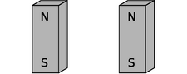
d / The second magnet is reversed.
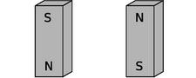
e / Both magnets are reversed.

Why fields?

Time delays in forces exerted at a distance
What convinced physicists that they needed this new concept of a field of force? Although we have been dealing mostly with electrical forces, let's start with a magnetic example. (In fact the main reason I've delayed a detailed discussion of magnetism for so long is that mathematical calculations of magnetic effects are handled much more easily with the concept of a field of force.) First a little background leading up to our example. A bar magnet, a, has an axis about which many of the electrons' orbits are oriented. The earth itself is also a magnet, although not a bar-shaped one. The interaction between the earth-magnet and the bar magnet, b, makes them want to line up their axes in opposing directions (in other words such that their electrons rotate in parallel planes, but with one set rotating clockwise and the other counterclockwise as seen looking along the axes). On a smaller scale, any two bar magnets placed near each other will try to align themselves head-to-tail, c.
Now we get to the relevant example. It is clear that two people separated by a paper-thin wall could use a pair of bar magnets to signal to each other. Each person would feel her own magnet trying to twist around in response to any rotation performed by the other person's magnet. The practical range of communication would be very short for this setup, but a sensitive electrical apparatus could pick up magnetic signals from much farther away. In fact, this is not so different from what a radio does: the electrons racing up and down the transmitting antenna create forces on the electrons in the distant receiving antenna. (Both magnetic and electric forces are involved in real radio signals, but we don't need to worry about that yet.)
A question now naturally arises as to whether there is any time delay in this kind of communication via magnetic (and electric) forces. Newton would have thought not, since he conceived of physics in terms of instantaneous action at a distance. We now know, however, that there is such a time delay. If you make a long-distance phone call that is routed through a communications satellite, you should easily be able to detect a delay of about half a second over the signal's round trip of 50,000 miles. Modern measurements have shown that electric, magnetic, and gravitational forces all travel at the speed of light, 3×10⁸ m/s.¹ (In fact, we will soon discuss how light itself is made of electricity and magnetism.)
If it takes some time for forces to be transmitted through space, then apparently there is some thing that travels through space. The fact that the phenomenon travels outward at the same speed in all directions strongly evokes wave metaphors such as ripples on a pond.

More evidence that fields of force are real: they carry energy.
The smoking-gun argument for this strange notion of traveling force ripples comes from the fact that they carry energy.
First suppose that the person holding the bar magnet on the right decides to reverse hers, resulting in configuration d. She had to do mechanical work to twist it, and if she releases the magnet, energy will be released as it flips back to c. She has apparently stored energy by going from c to d. So far everything is easily explained without the concept of a field of force.
But now imagine that the two people start in position c and then simultaneously flip their magnets extremely quickly to position e, keeping them lined up with each other the whole time. Imagine, for the sake of argument, that they can do this so quickly that each magnet is reversed while the force signal from the other is still in transit. (For a more realistic example, we'd have to have two radio antennas, not two magnets, but the magnets are easier to visualize.) During the flipping, each magnet is still feeling the forces arising from the way the other magnet used to be oriented. Even though the two magnets stay aligned during the flip, the time delay causes each person to feel resistance as she twists her magnet around. How can this be? Both of them are apparently doing mechanical work, so they must be storing magnetic energy somehow. But in the traditional Newtonian conception of matter interacting via instantaneous forces at a distance, interaction energy arises from the relative positions of objects that are interacting via forces. If the magnets never changed their orientations relative to each other, how can any magnetic energy have been stored?
The only possible answer is that the energy must have gone into the magnetic force ripples crisscrossing the space between the magnets. Fields of force apparently carry energy across space, which is strong evidence that they are real things.
This is perhaps not as radical an idea to us as it was to our ancestors. We are used to the idea that a radio transmitting antenna consumes a great deal of power, and somehow spews it out into the universe. A person working around such an antenna needs to be careful not to get too close to it, since all that energy can easily cook flesh (a painful phenomenon known as an “RF burn”).
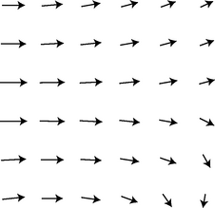
f / The wind patterns in a certain area of the ocean could be charted in a “sea of arrows” representation like this. Each arrow represents both the wind's strength and its direction at a certain location.
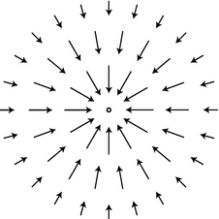
g / The gravitational field surrounding a clump of mass such as the earth.
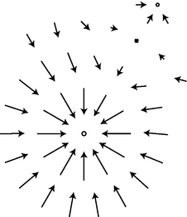
h / The gravitational fields of the earth and moon superpose. Note how the fields cancel at one point, and how there is no boundary between the interpenetrating fields surrounding the two bodies.

The gravitational field
Given that fields of force are real, how do we define, measure, and calculate them? A fruitful metaphor will be the wind patterns experienced by a sailing ship. Wherever the ship goes, it will feel a certain amount of force from the wind, and that force will be in a certain direction. The weather is ever-changing, of course, but for now let's just imagine steady wind patterns. Definitions in physics are operational, i.e. they describe how to measure the thing being defined. The ship's captain can measure the wind's “field of force” by going to the location of interest and determining both the direction of the wind and the strength with which it is blowing. Charting all these measurements on a map leads to a depiction of the field of wind force like the one shown in the figure. This is known as the “sea of arrows” method of visualizing a field.
Now let's see how these concepts are applied to the fundamental force fields of the universe. We'll start with the gravitational field, which is the easiest to understand. As with the wind patterns, we'll start by imagining gravity as a static field, even though the existence of the tides proves that there are continual changes in the gravity field in our region of space. When the gravitational field was introduced in chapter 2, I avoided discussing its direction explicitly, but defining it is easy enough: we simply go to the location of interest and measure the direction of the gravitational force on an object, such as a weight tied to the end of a string.
In chapter 2, I defined the gravitational field in terms of the energy required to raise a unit mass through a unit distance. However, I'm going to give a different definition now, using an approach that will be more easily adapted to electric and magnetic fields. This approach is based on force rather than energy. We couldn't carry out the energy-based definition without dividing by the mass of the object involved, and the same is true for the force-based definition. For example, gravitational forces are weaker on the moon than on the earth, but we cannot specify the strength of gravity simply by giving a certain number of newtons. The number of newtons of gravitational force depends not just on the strength of the local gravitational field but also on the mass of the object on which we're testing gravity, our “test mass.” A boulder on the moon feels a stronger gravitational force than a pebble on the earth. We can get around this problem by defining the strength of the gravitational field as the force acting on an object, divided by the object's mass:
The gravitational field vector, g, at any location in space is found by placing a test mass m_{t} at that point. The field vector is then given by g=F/m_{t}, where F is the gravitational force on the test mass.
We now have three ways of representing a gravitational field. The magnitude of the gravitational field near the surface of the earth, for instance, could be written as 9.8 N/kg, 9.8 J/kg⋅m, or 9.8 m/s². If we already had two names for it, why invent a third? The main reason is that it prepares us with the right approach for defining other fields.
The most subtle point about all this is that the gravitational field tells us about what forces would be exerted on a test mass by the earth, sun, moon, and the rest of the universe, if we inserted a test mass at the point in question. The field still exists at all the places where we didn't measure it.

Example 1: Gravitational field of the earth
◊ What is the magnitude of the earth's gravitational field, in terms of its mass, M, and the distance r from its center?
◊ Substituting |F|= GMm_{t}/ r² into the definition of the gravitational field, we find |g|= GM/ r². This expression could be used for the field of any spherically symmetric mass distribution, since the equation we assumed for the gravitational force would apply in any such case.

Sources and sinks
If we make a sea-of-arrows picture of the gravitational fields surrounding the earth, g, the result is evocative of water going down a drain. For this reason, anything that creates an inward-pointing field around itself is called a sink. The earth is a gravitational sink. The term “source” can refer specifically to things that make outward fields, or it can be used as a more general term for both “outies” and “innies.” However confusing the terminology, we know that gravitational fields are only attractive, so we will never find a region of space with an outward-pointing field pattern.
Knowledge of the field is interchangeable with knowledge of its sources (at least in the case of a static, unchanging field). If aliens saw the earth's gravitational field pattern they could immediately infer the existence of the planet, and conversely if they knew the mass of the earth they could predict its influence on the surrounding gravitational field.

Superposition of fields
A very important fact about all fields of force is that when there is more than one source (or sink), the fields add according to the rules of vector addition. The gravitational field certainly will have this property, since it is defined in terms of the force on a test mass, and forces add like vectors. Superposition is an important characteristics of waves, so the superposition property of fields is consistent with the idea that disturbances can propagate outward as waves in a field.

Example 2: Reduction in gravity on Io due to Jupiter's gravity
◊ The average gravitational field on Jupiter's moon Io is 1.81 N/kg. By how much is this reduced when Jupiter is directly overhead? Io's orbit has a radius of 4.22×10⁸ m, and Jupiter's mass is 1.899×10²⁷ kg.
◊ By the shell theorem, we can treat the Jupiter as if its mass was all concentrated at its center, and likewise for Io. If we visit Io and land at the point where Jupiter is overhead, we are on the same line as these two centers, so the whole problem can be treated one-dimensionally, and vector addition is just like scalar addition. Let's use positive numbers for downward fields (toward the center of Io) and negative for upward ones. Plugging the appropriate data into the expression derived in example 1, we find that the Jupiter's contribution to the field is - 0.71 N/kg. Superposition says that we can find the actual gravitational field by adding up the fields created by Io and Jupiter: 1.81-0.71 N/kg = 1.1 N/kg. You might think that this reduction would create some spectacular effects, and make Io an exciting tourist destination. Actually you would not detect any difference if you flew from one side of Io to the other. This is because your body and Io both experience Jupiter's gravity, so you follow the same orbital curve through the space around Jupiter.
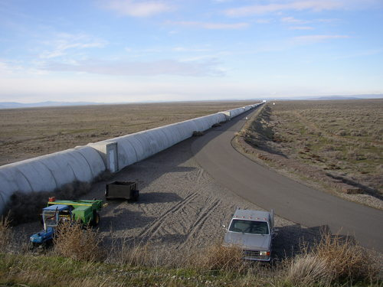
i / The part of the LIGO gravity wave detector at Hanford Nuclear Reservation, near Richland, Washington. The other half of the detector is in Louisiana.

Gravitational waves
A source that sits still will create a static field pattern, like a steel ball sitting peacefully on a sheet of rubber. A moving source will create a spreading wave pattern in the field, like a bug thrashing on the surface of a pond. Although we have started with the gravitational field as the simplest example of a static field, stars and planets do more stately gliding than thrashing, so gravitational waves are not easy to detect. Newton's theory of gravity does not describe gravitational waves, but they are predicted by Einstein's general theory of relativity. J.H. Taylor and R.A. Hulse were awarded the Nobel Prize in 1993 for giving indirect evidence that Einstein's waves actually exist. They discovered a pair of exotic, ultra-dense stars called neutron stars orbiting one another very closely, and showed that they were losing orbital energy at the rate predicted by Einstein's theory.
A Caltech-MIT collaboration has built a pair of gravitational wave detectors called LIGO to search for more direct evidence of gravitational waves. Since they are essentially the most sensitive vibration detectors ever made, they are located in quiet rural areas, and signals will be compared between them to make sure that they were not due to passing trucks. The project began operating at full sensitivity in 2005, and is now able to detect a vibration that causes a change of 10⁻¹⁸ m in the distance between the mirrors at the ends of the 4-km vacuum tunnels. This is a thousand times less than the size of an atomic nucleus! There is only enough funding to keep the detectors operating for a few more years, so the physicists can only hope that during that time, somewhere in the universe, a sufficiently violent cataclysm will occur to make a detectable gravitational wave. (More accurately, they want the wave to arrive in our solar system during that time, although it will have been produced millions of years before.)
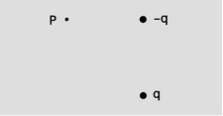
j / Example 3.
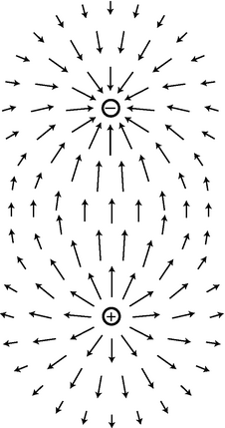
k / A dipole field. Electric fields diverge from a positive charge and converge on a negative charge.
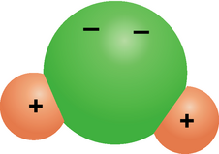
l / A water molecule is a dipole.
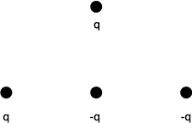
n / Example 5.
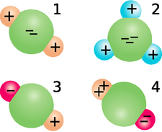
o / Discussion question H.

The electric field

Definition
The definition of the electric field is directly analogous to, and has the same motivation as, the definition of the gravitational field:
The electric field vector, E, at any location in space is found by placing a test charge q_{t} at that point. The electric field vector is then given by E=F/q_{t}, where F is the electric force on the test charge.
Charges are what create electric fields. Unlike gravity, which is always attractive, electricity displays both attraction and repulsion. A positive charge is a source of electric fields, and a negative one is a sink.
The most difficult point about the definition of the electric field is that the force on a negative charge is in the opposite direction compared to the field. This follows from the definition, since dividing a vector by a negative number reverses its direction. It's as though we had some objects that fell upward instead of down.
self-check: Find an equation for the magnitude of the field of a single point charge Q. (answer in the back of the PDF version of the book)

Example 3: Superposition of electric fields
◊ Charges q and - q are at a distance b from each other, as shown in the figure. What is the electric field at the point P, which lies at a third corner of the square?
◊ The field at P is the vector sum of the fields that would have been created by the two charges independently. Let positive x be to the right and let positive y be up.
Negative charges have fields that point at them, so the charge -q makes a field that points to the right, i.e. has a positive x component. Using the answer to the self-check, we have
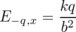
E_{-q,y} = 0 .
Note that if we had blindly ignored the absolute value signs and plugged in - q to the equation, we would have incorrectly concluded that the field went to the left.
By the Pythagorean theorem, the positive charge is at a distance from P, so the magnitude of its contribution to the field is E= kq/2 b². Positive charges have fields that point away from them, so the field vector is at an angle of 135° counterclockwise from the x axis.
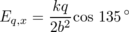
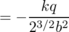
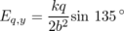
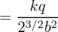
The total field is
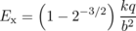
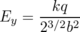

Dipoles
The simplest set of sources that can occur with electricity but not with gravity is the dipole, consisting of a positive charge and a negative charge with equal magnitudes. More generally, an electric dipole can be any object with an imbalance of positive charge on one side and negative on the other. A water molecule, l, is a dipole because the electrons tend to shift away from the hydrogen atoms and onto the oxygen atom.
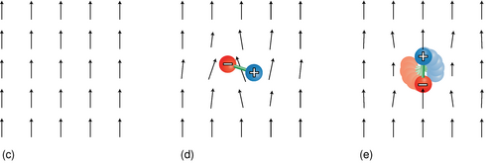
m / 1. A uniform electric field created by some charges “off-stage.” 2. A dipole is placed in the field. 3. The dipole aligns with the field.
Your microwave oven acts on water molecules with electric fields. Let us imagine what happens if we start with a uniform electric field, m/1, made by some external charges, and then insert a dipole, m/2, consisting of two charges connected by a rigid rod. The dipole disturbs the field pattern, but more important for our present purposes is that it experiences a torque. In this example, the positive charge feels an upward force, but the negative charge is pulled down. The result is that the dipole wants to align itself with the field, m/3. The microwave oven heats food with electrical (and magnetic) waves. The alternation of the torque causes the molecules to wiggle and increase the amount of random motion. The slightly vague definition of a dipole given above can be improved by saying that a dipole is any object that experiences a torque in an electric field.
What determines the torque on a dipole placed in an externally created field? Torque depends on the force, the distance from the axis at which the force is applied, and the angle between the force and the line from the axis to the point of application. Let a dipole consisting of charges +q and -q separated by a distance be placed in an external field of magnitude |E|, at an angle θ with respect to the field. The total torque on the dipole is
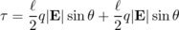
(Note that even though the two forces are in opposite directions, the torques do not cancel, because they are both trying to twist the dipole in the same direction.) The quantity is called the dipole moment, notated D. (More complex dipoles can also be assigned a dipole moment --- they are defined as having the same dipole moment as the two-charge dipole that would experience the same torque.)
Employing a little more mathematical elegance, we can define a dipole moment vector,
where r_{i} is the position vector of the charge labeled by the index i. We can then write the torque in terms of a vector cross product (page 226),
No matter how we notate it, the definition of the dipole moment requires that we choose point from which we measure all the position vectors of the charges. However, in the commonly encountered special case where the total charge of the object is zero, the dipole moment is the same regardless of this choice.

Example 4: Dipole moment of a molecule of NaCl gas
◊ In a molecule of NaCl gas, the center-to-center distance between the two atoms is about 0.6 nm. Assuming that the chlorine completely steals one of the sodium's electrons, compute the magnitude of this molecule's dipole moment.
◊ The total charge is zero, so it doesn't matter where we choose the origin of our coordinate system. For convenience, let's choose it to be at one of the atoms, so that the charge on that atom doesn't contribute to the dipole moment. The magnitude of the dipole moment is then
D = (6×10⁻¹⁰ m)( e)
= (6×10⁻¹⁰ m)( 1.6×10⁻¹⁹ C)
= 1×10⁻²⁸ C⋅m

Example 5: Dipole moments as vectors
◊ The horizontal and vertical spacing between the charges in the figure is b. Find the dipole moment.
◊ Let the origin of the coordinate system be at the leftmost charge.

Alternative definition of the electric field
The behavior of a dipole in an externally created field leads us to an alternative definition of the electric field:
The electric field vector, E, at any location in space is defined by observing the torque exerted on a test dipole D_{t} placed there. The direction of the field is the direction in which the field tends to align a dipole (from - to +), and the field's magnitude is |E|=τ/D_{t}sinθ. In other words, the field vector is the vector that satisfies the equation for any test dipole D_{t} placed at that point in space.
The main reason for introducing a second definition for the same concept is that the magnetic field is most easily defined using a similar approach.

Discussion Questions
◊ In the definition of the electric field, does the test charge need to be 1 coulomb? Does it need to be positive?
◊ Does a charged particle such as an electron or proton feel a force from its own electric field?
◊ Is there an electric field surrounding a wall socket that has nothing plugged into it, or a battery that is just sitting on a table?
◊ In a flashlight powered by a battery, which way do the electric fields point? What would the fields be like inside the wires? Inside the filament of the bulb?
◊ Criticize the following statement: “An electric field can be represented by a sea of arrows showing how current is flowing.”
◊ The field of a point charge, |E|=kQ/r², was derived in a self-check. How would the field pattern of a uniformly charged sphere compare with the field of a point charge?
◊ The interior of a perfect electrical conductor in equilibrium must have zero electric field, since otherwise the free charges within it would be drifting in response to the field, and it would not be in equilibrium. What about the field right at the surface of a perfect conductor? Consider the possibility of a field perpendicular to the surface or parallel to it.
◊ Compare the dipole moments of the molecules and molecular ions shown in the figure.
◊ Small pieces of paper that have not been electrically prepared in any way can be picked up with a charged object such as a charged piece of tape. In our new terminology, we could describe the tape's charge as inducing a dipole moment in the paper. Can a similar technique be used to induce not just a dipole moment but a charge?

10.2 Voltage Related to Field

One dimension
Voltage is electrical energy per unit charge, and electric field is force per unit charge. For a particle moving in one dimension, along the x axis, we can therefore relate voltage and field if we start from the relationship between interaction energy and force,
d U = -F_{x}d x ,
and divide by charge,
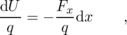
giving
d V = -E_{x} d x ,
or
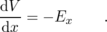
The interpretation is that a strong electric field occurs in a region of space where the voltage is rapidly changing. By analogy, a steep hillside is a place on the map where the altitude is rapidly changing.

Example 6: Field generated by an electric eel
◊ Suppose an electric eel is 1 m long, and generates a voltage difference of 1000 volts between its head and tail. What is the electric field in the water around it?
◊ We are only calculating the amount of field, not its direction, so we ignore positive and negative signs. Subject to the possibly inaccurate assumption of a constant field parallel to the eel's body, we have
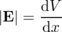
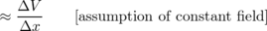

Example 7: Relating the units of electric field and voltage
From our original definition of the electric field, we expect it to have units of newtons per coulomb, N/C. The example above, however, came out in volts per meter, V/m. Are these inconsistent? Let's reassure ourselves that this all works. In this kind of situation, the best strategy is usually to simplify the more complex units so that they involve only mks units and coulombs. Since voltage is defined as electrical energy per unit charge, it has units of J/C:
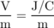
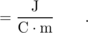
To connect joules to newtons, we recall that work equals force times distance, so J=N⋅m, so
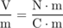
As with other such difficulties with electrical units, one quickly begins to recognize frequently occurring combinations.

Example 8: Voltage associated with a point charge
◊ What is the voltage associated with a point charge?
◊ As derived previously in self-check A on page 483, the field is
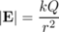
The difference in voltage between two points on the same radius line is
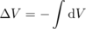
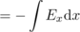
In the general discussion above, x was just a generic name for distance traveled along the line from one point to the other, so in this case x really means r.
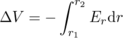
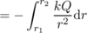
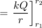
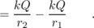
The standard convention is to use r₁=∞ as a reference point, so that the voltage at any distance r from the charge is
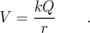
The interpretation is that if you bring a positive test charge closer to a positive charge, its electrical energy is increased; if it was released, it would spring away, releasing this as kinetic energy.
self-check: Show that you can recover the expression for the field of a point charge by evaluating the derivative E_{x}=-d V/d x. (answer in the back of the PDF version of the book)

a / A topographical map of Shelburne Falls, Mass. (USGS)
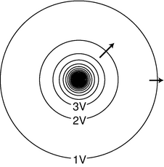
b / The constant-voltage curves surrounding a point charge. Near the charge, the curves are so closely spaced that they blend together on this drawing due to the finite width with which they were drawn. Some electric fields are shown as arrows.

Two or three dimensions
The topographical map in figure a suggests a good way to visualize the relationship between field and voltage in two dimensions. Each contour on the map is a line of constant height; some of these are labeled with their elevations in units of feet. Height is related to gravitational energy, so in a gravitational analogy, we can think of height as representing voltage. Where the contour lines are far apart, as in the town, the slope is gentle. Lines close together indicate a steep slope.
If we walk along a straight line, say straight east from the town, then height (voltage) is a function of the east-west coordinate x. Using the usual mathematical definition of the slope, and writing V for the height in order to remind us of the electrical analogy, the slope along such a line is d V/d x (the rise over the run).
What if everything isn't confined to a straight line? Water flows downhill. Notice how the streams on the map cut perpendicularly through the lines of constant height.
It is possible to map voltages in the same way, as shown in figure b. The electric field is strongest where the constant-voltage curves are closest together, and the electric field vectors always point perpendicular to the constant-voltage curves.
The one-dimensional relationship E=-d V/d x generalizes to three dimensions as follows:
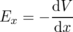
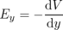
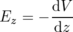
This can be notated as a gradient (page 171),
E = ∇ V ,
and if we know the field and want to find the voltage, we can use a line integral,
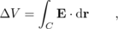
where the quantity inside the integral is a vector dot product.
self-check: Imagine that figure a represents voltage rather than height. (a) Consider the stream the starts near the center of the map. Determine the positive and negative signs of d V/d x and d V/d y, and relate these to the direction of the force that is pushing the current forward against the resistance of friction. (b) If you wanted to find a lot of electric charge on this map, where would you look? (answer in the back of the PDF version of the book)
Figure c shows some examples of ways to visualize field and voltage patterns.
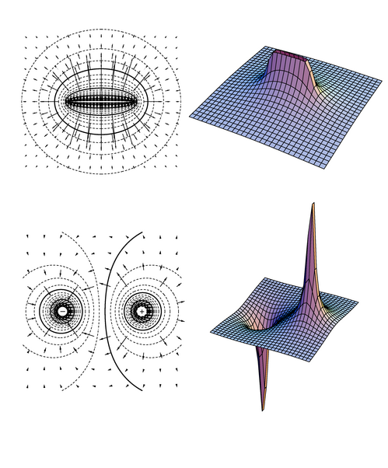
c / Two-dimensional field and voltage patterns. Top: A uniformly charged rod. Bottom: A dipole. In each case, the diagram on the left shows the field vectors and constant-voltage curves, while the one on the right shows the voltage (up-down coordinate) as a function of x and y. Interpreting the field diagrams: Each arrow represents the field at the point where its tail has been positioned. For clarity, some of the arrows in regions of very strong field strength are not shown Ѡthey would be too long to show. Interpreting the constant-voltage curves: In regions of very strong fields, the curves are not shown because they would merge together to make solid black regions. Interpreting the perspective plots: Keep in mind that even though we're visualizing things in three dimensions, these are really two-dimensional voltage patterns being represented. The third (up-down) dimension represents voltage, not position.

10.3 Fields by Superposition
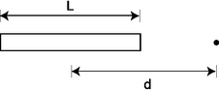
a / Example 9.
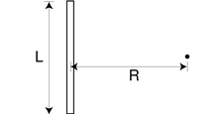
b / Example 10.
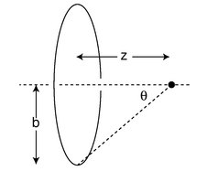
c / Example 11.
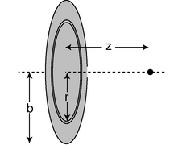
d / Example 12: geometry.
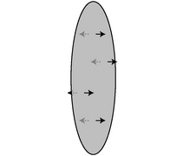
e / Example 12: the field on both sides (for σ>0).
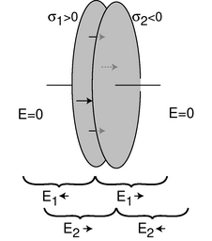
f / A capacitor consisting of two disks with opposite charges.

Electric field of a continuous charge distribution
Charge really comes in discrete chunks, but often it is mathematically convenient to treat a set of charges as if they were like a continuous fluid spread throughout a region of space. For example, a charged metal ball will have charge spread nearly uniformly all over its surface, and for most purposes it will make sense to ignore the fact that this uniformity is broken at the atomic level. The electric field made by such a continuous charge distribution is the sum of the fields created by every part of it. If we let the “parts” become infinitesimally small, we have a sum of an infinitely many infinitesimal numbers: an integral. If it was a discrete sum, as in example 3 on page 485, we would have a total electric field in the x direction that was the sum of all the x components of the individual fields, and similarly we'd have sums for the y and z components. In the continuous case, we have three integrals. Let's keep it simple by starting with a one-dimensional example.

Example 9: Field of a uniformly charged rod
◊ A rod of length L has charge Q spread uniformly along it. Find the electric field at a point a distance d from the center of the rod, along the rod's axis.
◊ This is a one-dimensional situation, so we really only need to do a single integral representing the total field along the axis. We imagine breaking the rod down into short pieces of length d z, each with charge d q. Since charge is uniformly spread along the rod, we have d q=λd z, where λ= Q/ L (Greek lambda) is the charge per unit length, in units of coulombs per meter. Since the pieces are infinitesimally short, we can treat them as point charges and use the expression kd q/ r² for their contributions to the field, where r= d- z is the distance from the charge at z to the point in which we are interested.
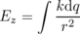
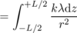
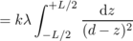
The integral can be looked up in a table, or reduced to an elementary form by substituting a new variable for d- z. The result is
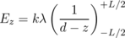
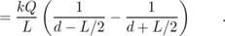
For large values of d, this expression gets smaller for two reasons: (1) the denominators of the fractions become large, and (2) the two fractions become nearly the same, and tend to cancel out. This makes sense, since the field should get weaker as we get farther away from the charge. In fact, the field at large distances must approach kQ/ d² (homework problem 17).
It's also interesting to note that the field becomes infinite at the ends of the rod, but is not infinite on the interior of the rod. Can you explain physically why this happens?
Example 9 was one-dimensional. In the general three-dimensional case, we might have to integrate all three components of the field. However, there is a trick that lets us avoid this much complication. The voltage is a scalar, so we can find the voltage by doing just a single integral, then use the voltage to find the field.

Example 10: Voltage, then field
◊ A rod of length L is uniformly charged with charge Q. Find the field at a point lying in the midplane of the rod at a distance R.
◊ By symmetry, the field has only a radial component, E_{R}, pointing directly away from the rod (or toward it for Q<0). The brute-force approach, then, would be to evaluate the integral 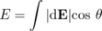, where dE is the contribution to the field from a charge d q at some point along the rod, and θ is the angle dE makes with the radial line.
It's easier, however, to find the voltage first, and then find the field from the voltage. Since the voltage is a scalar, we simply integrate the contribution d V from each charge d q, without even worrying about angles and directions. Let z be the coordinate that measures distance up and down along the rod, with z=0 at the center of the rod. Then the distance between a point z on the rod and the point of interest is , and we have
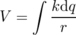
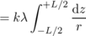
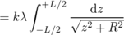
The integral can be looked up in a table, or evaluated using computer software:
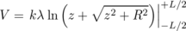
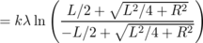
The expression inside the parentheses can be simplified a little. Leaving out some tedious algebra, the result is
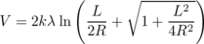
This can readily be differentiated to find the field:
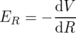
+(1/2)(1+ L²/4 R²)^{-1/2}(- L²/2 R³)
or, after some simplification,
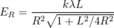
For large values of R, the square root approaches one, and we have simply E_{R}≈ kλ L/ R²= k Q/ R². In other words, the field very far away is the same regardless of whether the charge is a point charge or some other shape like a rod. This is intuitively appealing, and doing this kind of check also helps to reassure one that the final result is correct.
The preceding example, although it involved some messy algebra, required only straightforward calculus, and no vector operations at all, because we only had to integrate a scalar function to find the voltage. The next example is one in which we can integrate either the field or the voltage without too much complication.

Example 11: On-axis field of a ring of charge
◊ Find the voltage and field along the axis of a uniformly charged ring.
◊ Integrating the voltage is straightforward.
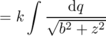
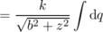
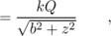
where Q is the total charge of the ring. This result could have been derived without calculus, since the distance r is the same for every point around the ring, i.e. the integrand is a constant. It would also be straightforward to find the field by differentiating this expression with respect to z (homework problem 18).
Instead, let's see how to find the field by direct integration. By symmetry, the field at the point of interest can have only a component along the axis of symmetry, the z axis:
E_{x} = 0
E_{y} = 0
To find the field in the z direction, we integrate the z components contributed to the field by each infinitesimal part of the ring.
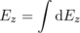
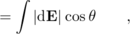
where θ is the angle shown in the figure.
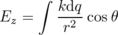
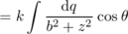
Everything inside the integral is a constant, so we have
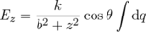
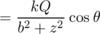
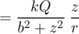
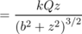
In all the examples presented so far, the charge has been confined to a one-dimensional line or curve. Although it is possible, for example, to put charge on a piece of wire, it is more common to encounter practical devices in which the charge is distributed over a two-dimensional surface, as in the flat metal plates used in Thomson's experiments. Mathematically, we can approach this type of calculation with the divide-and-conquer technique: slice the surface into lines or curves whose fields we know how to calculate, and then add up the contributions to the field from all these slices. In the limit where the slices are imagined to be infinitesimally thin, we have an integral.

Example 12: Field of a uniformly charged disk
◊ A circular disk is uniformly charged. (The disk must be an insulator; if it was a conductor, then the repulsion of all the charge would cause it to collect more densely near the edge.) Find the field at a point on the axis, at a distance z from the plane of the disk.
◊ We're given that every part of the disk has the same charge per unit area, so rather than working with Q, the total charge, it will be easier to use the charge per unit area, conventionally notated σ (Greek sigma), σ= Q/π b².
Since we already know the field due to a ring of charge, we can solve the problem by slicing the disk into rings, with each ring extending from r to r+d r. The area of such a ring equals its circumference multiplied by its width, i.e. 2π rd r, so its charge is d q=2πσ rd r, and from the result of example 11, its contribution to the field is
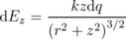
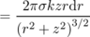
The total field is
= 2πσ kz
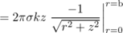
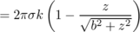
The result of example 12 has some interesting properties. First, we note that it was derived on the unspoken assumption of z>0. By symmetry, the field on the other side of the disk must be equally strong, but in the opposite direction, as shown in figures e and g. Thus there is a discontinuity in the field at z=0. In reality, the disk will have some finite thickness, and the switching over of the field will be rapid, but not discontinuous.
At large values of z, i.e. z>> b, the field rapidly approaches the 1/r² variation that we expect when we are so far from the disk that the disk's size and shape cannot matter (homework problem 17).
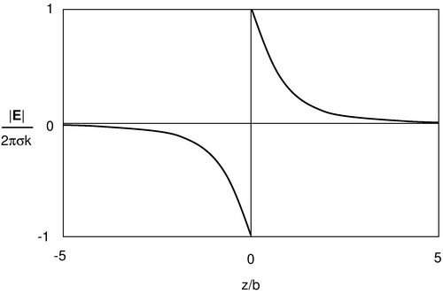
g / Example 12: variation of the field (σ>0).
A practical application is the case of a capacitor, f, having two parallel circular plates very close together. In normal operation, the charges on the plates are opposite, so one plate has fields pointing into it and the other one has fields pointing out. In a real capacitor, the plates are a metal conductor, not an insulator, so the charge will tend to arrange itself more densely near the edges, rather than spreading itself uniformly on each plate. Furthermore, we have only calculated the on-axis field in example 12; in the off-axis region, each disk's contribution to the field will be weaker, and it will also point away from the axis a little. But if we are willing to ignore these complications for the sake of a rough analysis, then the fields superimpose as shown in figure f: the fields cancel the outside of the capacitor, but between the plates its value is double that contributed by a single plate. This cancellation on the outside is a very useful property for a practical capacitor. For instance, if you look at the printed circuit board in a typical piece of consumer electronics, there are many capacitors, often placed fairly close together. If their exterior fields didn't cancel out nicely, then each capacitor would interact with its neighbors in a complicated way, and the behavior of the circuit would depend on the exact physical layout, since the interaction would be stronger or weaker depending on distance. In reality, a capacitor does create weak external electric fields, but their effects are often negligible, and we can then use the lumped-circuit approximation, which states that each component's behavior depends only on the currents that flow in and out of it, not on the interaction of its fields with the other components.
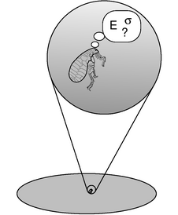
h / Close to the surface, the relationship between E and σ is a fixed one, regardless of the geometry. The flea can't determine the size or shape of her world by comparing E and σ.
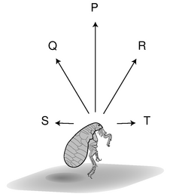
i / Fields contributed by nearby parts of the surface, P, Q, and R, contribute to E⊥. Fields due to distant charges, S, and T, have very small contributions to E⊥ because of their shallow angles.
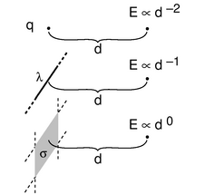
j / Example 13.

The field near a charged surface
From a theoretical point of view, there is something even more intriguing about example 12: the magnitude of the field for small values of z (z<< b) is E=2π kσ, which doesn't depend on b at all for a fixed value of σ. If we made a disk with twice the radius, and covered it with the same number of coulombs per square meter (resulting in a total charge four times as great), the field close to the disk would be unchanged! That is, a flea living near the center of the disk, h, would have no way of determining the size of her flat “planet” by measuring the local field and charge density. (Only by leaping off the surface into outer space would she be able to measure fields that were dependent on b. If she traveled very far, to z>> b, she would be in the region where the field is well approximated by |E|≈ kQ/z²=kπ b²σ/z², which she could solve for b.)
What is the reason for this surprisingly simple behavior of the field? Is it a piece of mathematical trivia, true only in this particular case? What if the shape was a square rather than a circle? In other words, the flea gets no information about the size of the disk from measuring E, since E=2π kσ, independent of b, but what if she didn't know the shape, either? If the result for a square had some other geometrical factor in front instead of 2π, then she could tell which shape it was by measuring E. The surprising mathematical fact, however, is that the result for a square, indeed for any shape whatsoever, is E=2πσ k. It doesn't even matter whether the surface is flat or warped, or whether the density of charge is different at parts of the surface which are far away compared to the flea's distance above the surface.
This universal E⊥=2π kσ field perpendicular to a charged surface can be proved mathematically based on Gauss's law² (section 10.6), but we can understand what's happening on qualitative grounds. Suppose on night, while the flea is asleep, someone adds more surface area, also positively charged, around the outside edge of her disk-shaped world, doubling its radius. The added charge, however, has very little effect on the field in her environment, as long as she stays at low altitudes above the surface. As shown in figure i, the new charge to her west contributes a field, T, that is almost purely “horizontal” (i.e. parallel to the surface) and to the east. It has a negligible upward component, since the angle is so shallow. This new eastward contribution to the field is exactly canceled out by the westward field, S, created by the new charge to her east. There is likewise almost perfect cancellation between any other pair of opposite compass directions.
A similar argument can be made as to the shape-independence of the result, as long as the shape is symmetric. For example, suppose that the next night, the tricky real estate developers decide to add corners to the disk and transform it into a square. Each corner's contribution to the field measured at the center is canceled by the field due to the corner diagonally across from it.
What if the flea goes on a trip away from the center of the disk? The perfect cancellation of the “horizontal” fields contributed by distant charges will no longer occur, but the “vertical” field (i.e. the field perpendicular to the surface) will still be E⊥=2π kσ, where σ is the local charge density, since the distant charges can't contribute to the vertical field. The same result applies if the shape of the surface is asymmetric, and doesn't even have any well-defined geometric center: the component perpendicular to the surface is E⊥=2π kσ, but we may have E||≠q0. All of the above arguments can be made more rigorous by discussing mathematical limits rather than using words like “very small.” There is not much point in giving a rigorous proof here, however, since we will be able to demonstrate this fact as a corollary of Gauss' Law in section 10.6. The result is as follows:
At a point lying a distance z from a charged surface, the component of the electric field perpendicular to the surface obeys
where σ is the charge per unit area. This is true regardless of the shape or size of the surface.

Example 13: The field near a point, line, or surface charge
◊ Compare the variation of the electric field with distance, d, for small values of d in the case of a point charge, an infinite line of charge, and an infinite charged surface.
◊ For a point charge, we have already found E∝ d⁻² for the magnitude of the field, where we are now using d for the quantity we would ordinarily notate as r. This is true for all values of d, not just for small d --- it has to be that way, because the point charge has no size, so if E behaved differently for small and large d, there would be no way to decide what d had to be small or large relative to.
For a line of charge, the result of example 10 is
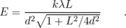
In the limit of d<< L, the quantity inside the square root is dominated by the second term, and we have E∝ d⁻¹.
Finally, in the case of a charged surface, the result is simply E=2πσ k, or E∝ d⁰.
Notice the lovely simplicity of the pattern, as shown in figure j. A point is zero-dimensional: it has no length, width, or breadth. A line is one-dimensional, and a surface is two-dimensional. As the dimensionality of the charged object changes from 0 to 1, and then to 2, the exponent in the near-field expression goes from 2 to 1 to 0.

10.4 Energy in Fields
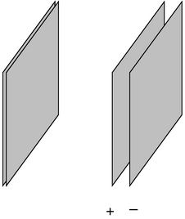
a / Two oppositely charged capacitor plates are pulled apart.
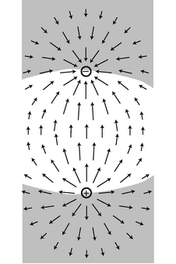
b / Example 16.
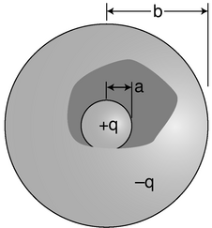
c / Example B. Part of the outside sphere has been drawn as if it is transparent, in order to show the inside sphere.
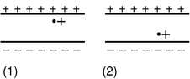
d / Discussion question A.
e / Discussion question B.

Electric field energy
Fields possess energy, as argued on page 479, but how much energy? The answer can be found using the following elegant approach. We assume that the electric energy contained in an infinitesimal volume of space d v is given by d U_{e}=f(E)d v, where f is some function, which we wish to determine, of the field E. It might seem that we would have no easy way to determine the function f, but many of the functions we could cook up would violate the symmetry of space. For instance, we could imagine f(E)=aE_{y}, where a is some constant with the appropriate units. However, this would violate the symmetry of space, because it would give the y axis a different status from x and z. As discussed on page 168, if we wish to calculate a scalar based on some vectors, the dot product is the only way to do it that has the correct symmetry properties. If all we have is one vector, E, then the only scalar we can form is E⋅E, which is the square of the magnitude of the electric field vector.
In principle, the energy function we are seeking could be proportional to E⋅E, or to any function computed from it, such as or (E⋅E)⁷. On physical grounds, however, the only possibility that works is E⋅E. Suppose, for instance, that we pull apart two oppositely charged capacitor plates, as shown in figure a. We are doing work by pulling them apart against the force of their electrical attraction, and this quantity of mechanical work equals the increase in electrical energy, U_{e}. Using our previous approach to energy, we would have thought of U_{e} as a quantity which depended on the distance of the positive and negative charges from each other, but now we're going to imagine U_{e} as being stored within the electric field that exists in the space between and around the charges. When the plates are touching, their fields cancel everywhere, and there is zero electrical energy. When they are separated, there is still approximately zero field on the outside, but the field between the plates is nonzero, and holds some energy. Now suppose we carry out the whole process, but with the plates carrying double their previous charges. Since Coulomb's law involves the product q₁q₂ of two charges, we have quadrupled the force between any given pair of charged particles, and the total attractive force is therefore also four times greater than before. This means that the work done in separating the plates is four times greater, and so is the energy U_{e} stored in the field. The field, however, has merely been doubled at any given location: the electric field E₊ due to the positively charged plate is doubled, and similarly for the contribution E₋ from the negative one, so the total electric field E₊+E₋ is also doubled. Thus doubling the field results in an electrical energy which is four times greater, i.e. the energy density must be proportional to the square of the field, d U_{e}∝(E⋅E)d v. For ease of notation, we write this as d U_{e}∝ E²d v, or d U_{e}=aE²d v, where a is a constant of proportionality. Note that we never really made use of any of the details of the geometry of figure a, so the reasoning is of general validity. In other words, not only is d U_{e}=aE²d v the function that works in this particular case, but there is every reason to believe that it would work in other cases as well.
It now remains only to find a. Since the constant must be the same in all situations, we only need to find one example in which we can compute the field and the energy, and then we can determine a. The situation shown in figure a is just about the easiest example to analyze. We let the square capacitor plates be uniformly covered with charge densities +σ and -σ, and we write b for the lengths of their sides. Let h be the gap between the plates after they have been separated. We choose h<< b, so that the field experienced by the negative plate due to the positive plate is E₊=2π kσ. The charge of the negative plate is -σ b², so the magnitude of the force attracting it back toward the positive plate is (force)=(charge)(field)=2π kσ² b². The amount of work done in separating the plates is (work)=(force)(distance)=2π kσ² b²h. This is the amount of energy that has been stored in the field between the two plates, U_{e}=2π kσ² b²h=2π kσ² v, where v is the volume of the region between the plates.
We want to equate this to U_{e}=aE²v. (We can write U_{e} and v rather than d U_{e} and d v, since the field is constant in the region between the plates.) The field between the plates has contributions from both plates, E=E₊+E₋=4π kσ. (We only used half this value in the computation of the work done on the moving plate, since the moving plate can't make a force on itself. Mathematically, each plate is in a region where its own field is reversing directions, so we can think of its own contribution to the field as being zero within itself.) We then have aE²v=a⋅ 16π²k²σ² ⋅ v, and setting this equal to U_{e}=2π kσ² v from the result of the work computation, we find a=1/8π k. Our final result is as follows:
The electric energy possessed by an electric field E occupying an infinitesimal volume of space d v is given by
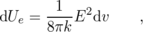
where E²=E⋅E is the square of the magnitude of the electric field.
This is reminiscent of how waves behave: the energy content of a wave is typically proportional to the square of its amplitude.
self-check: We can think of the quantity d U_{e}/d v as the energy density due to the electric field, i.e. the number of joules per cubic meter needed in order to create that field. (a) How does this quantity depend on the components of the field vector, E_{x}, E_{y}, and E_{z}? (b) Suppose we have a field with E_{x}≠q0, E_{y}=0, and E_{z}=0. What would happen to the energy density if we reversed the sign of E_{x}? (answer in the back of the PDF version of the book)

Example 14: A numerical example
◊ A capacitor has plates whose areas are 10⁻⁴ m², separated by a gap of 10⁻⁵ m. A 1.5-volt battery is connected across it. How much energy is sucked out of the battery and stored in the electric field between the plates? (A real capacitor typically has an insulating material between the plates whose molecules interact electrically with the charge in the plates. For this example, we'll assume that there is just a vacuum in between the plates. The plates are also typically rolled up rather than flat.)
◊ To connect this with our previous calculations, we need to find the charge density on the plates in terms of the voltage we were given. Our previous examples were based on the assumption that the gap between the plates was small compared to the size of the plates. Is this valid here? Well, if the plates were square, then the area of 10⁻⁴ m² would imply that their sides were 10⁻² m in length. This is indeed very large compared to the gap of 10⁻⁵ m, so this assumption appears to be valid (unless, perhaps, the plates have some very strange, long and skinny shape).
Based on this assumption, the field is relatively uniform in the whole volume between the plates, so we can use a single symbol, E, to represent its magnitude, and the relation E=d V/d x is equivalent to .
Since the field is uniform, we can dispense with the calculus, and replace d U_{e} = (1/8π k) E² d v with U_{e} = (1/8π k) E² v. The volume equals the area multiplied by the gap, so we have
U_{e} = (1/8π k) E²(area)(gap)
= 1×10⁻¹⁰ J
self-check: Show that the units in the preceding example really do work out to be joules. (answer in the back of the PDF version of the book)

Example 15: Why k is on the bottom
It may also seem strange that the constant k is in the denominator of the equation d U_{e} = (1/8π k) E² d v. The Coulomb constant k tells us how strong electric forces are, so shouldn't it be on top? No. Consider, for instance, an alternative universe in which electric forces are twice as strong as in ours. The numerical value of k is doubled. Because k is doubled, all the electric field strengths are doubled as well, which quadruples the quantity E². In the expression E²/8π k, we've quadrupled something on top and doubled something on the bottom, which makes the energy twice as big. That makes perfect sense.

Example 16: Potential energy of a pair of opposite charges
Imagine taking two opposite charges, b, that were initially far apart and allowing them to come together under the influence of their electrical attraction.
According to our old approach, electrical energy is lost because the electric force did positive work as it brought the charges together. (This makes sense because as they come together and accelerate it is their electrical energy that is being lost and converted to kinetic energy.)
By the new method, we must ask how the energy stored in the electric field has changed. In the region indicated approximately by the shading in the figure, the superposing fields of the two charges undergo partial cancellation because they are in opposing directions. The energy in the shaded region is reduced by this effect. In the unshaded region, the fields reinforce, and the energy is increased.
It would be quite a project to do an actual numerical calculation of the energy gained and lost in the two regions (this is a case where the old method of finding energy gives greater ease of computation), but it is fairly easy to convince oneself that the energy is less when the charges are closer. This is because bringing the charges together shrinks the high-energy unshaded region and enlarges the low-energy shaded region.

Example 17: A spherical capacitor
◊ A spherical capacitor, c, consists of two concentric spheres of radii a and b. Find the energy required to charge up the capacitor so that the plates hold charges + q and - q.
◊ On page 68, I proved that for gravitational forces, the interaction of a spherical shell of mass with other masses outside it is the same as if the shell's mass was concentrated at its center. On the interior of such a shell, the forces cancel out exactly. Since gravity and the electric force both vary as 1/ r², the same proof carries over immediately to electrical forces. The magnitude of the outward electric field contributed by the charge + q of the central sphere is therefore |E_+| = \left\{ \begin{array}{lr} 0, & r< a kq/ r^2, & r> a \end{array} \right. , where r is the distance from the center. Similarly, the magnitude of the inward field contributed by the outside sphere is |E_-| = \left\{ \begin{array}{lr} 0, & r< b kq/ r^2, & r> b \end{array} \right. . In the region outside the whole capacitor, the two fields are equal in magnitude, but opposite in direction, so they cancel. We then have for the total field |E| = \left\{ \begin{array}{lr} 0, & r< a
0, & r> b \end{array} \right. , so to calculate the energy, we only need to worry about the region a< r< b. The energy density in this region is
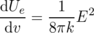
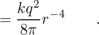
This expression only depends on r, so the energy density is constant across any sphere of radius r. We can slice the region a< r< b into concentric spherical layers, like an onion, and the energy within one such layer, extending from r to r+d r is
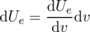
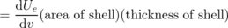
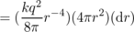
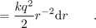
Integrating over all the layers to find the total energy, we have
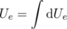
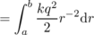
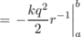
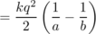

Discussion Questions
◊ The figure shows a positive charge in the gap between two capacitor plates. Compare the energy of the electric fields in the two cases. Does this agree with what you would have expected based on your knowledge of electrical forces?
◊ The figure shows a spherical capacitor. In the text, the energy stored in its electric field is shown to be
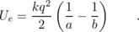
What happens if the difference between b and a is very small? Does this make sense in terms of the mechanical work needed in order to separate the charges? Does it make sense in terms of the energy stored in the electric field? Should these two energies be added together?
Similarly, discuss the cases of b→∞ and a→0.
◊ Criticize the following statement: “A solenoid makes a charge in the space surrounding it, which dissipates when you release the energy.”
◊ In example 16 on page 505, I argued that for the charges shown in the figure, the fields contain less energy when the charges are closer together, because the region of cancellation expanded, while the region of reinforcing fields shrank. Perhaps a simpler approach is to consider the two extreme possibilities: the case where the charges are infinitely far apart, and the one in which they are at zero distance from each other, i.e. right on top of each other. Carry out this reasoning for the case of (1) a positive charge and a negative charge of equal magnitude, (2) two positive charges of equal magnitude, (3) the gravitational energy of two equal masses.

Gravitational field energy
Example B depended on the close analogy between electric and gravitational forces. In fact, every argument, proof, and example discussed so far in this section is equally valid as a gravitational example, provided we take into account one fact: only positive mass exists, and the gravitational force between two masses is attractive. This is the opposite of what happens with electrical forces, which are repulsive in the case of two positive charges. As a consequence of this, we need to assign a negative energy density to the gravitational field! For a gravitational field, we have
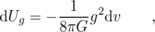
where g²=g⋅g is the square of the magnitude of the gravitational field.

Magnetic field energy
So far we've only touched in passing on the topic of magnetic fields, which will deal with in detail in chapter 11. Magnetism is an interaction between moving charge and moving charge, i.e. between currents and currents. Since a current has a direction in space,³ while charge doesn't, we can anticipate that the mathematical rule connecting a magnetic field to its source-currents will have to be completely different from the one relating the electric field to its source-charges. However, if you look carefully at the argument leading to the relation d U_{e}/d v = E²/8π k, you'll see that these mathematical details were only necessary to the part of the argument in which we fixed the constant of proportionality. To establish d U_{e}/d v ∝ E², we only had to use three simple facts:
- The field is proportional to the source.
- Forces are proportional to fields.
- Field contributed by multiple sources add like vectors.
All three of these statements are true for the magnetic field as well, so without knowing anything more specific about magnetic fields --- not even what units are used to measure them! --- we can state with certainty that the energy density in the magnetic field is proportional to the square of the magnitude of the magnetic field.

10.5 LRC Circuits
The long road leading from the light bulb to the computer started with one very important step: the introduction of feedback into electronic circuits. Although the principle of feedback has been understood and and applied to mechanical systems for centuries, and to electrical ones since the early twentieth century, for most of us the word evokes an image of Jimi Hendrix (or some more recent guitar hero) intentionally creating earsplitting screeches, or of the school principal doing the same inadvertently in the auditorium. In the guitar example, the musician stands in front of the amp and turns it up so high that the sound waves coming from the speaker come back to the guitar string and make it shake harder. This is an example of positive feedback: the harder the string vibrates, the stronger the sound waves, and the stronger the sound waves, the harder the string vibrates. The only limit is the power-handling ability of the amplifier.
Negative feedback is equally important. Your thermostat, for example, provides negative feedback by kicking the heater off when the house gets warm enough, and by firing it up again when it gets too cold. This causes the house's temperature to oscillate back and forth within a certain range. Just as out-of-control exponential freak-outs are a characteristic behavior of positive-feedback systems, oscillation is typical in cases of negative feedback. You have already studied negative feedback extensively in section 3.3 in the case of a mechanical system, although we didn't call it that.
a / The symbol for a capacitor.
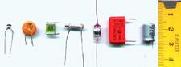
b / Some capacitors.
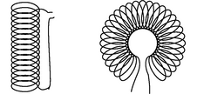
c / Two common geometries for inductors. The cylindrical shape on the left is called a solenoid.
d / The symbol for an inductor.
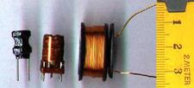
e / Some inductors.
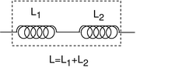
f / Inductances in series add.
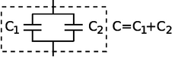
g / Capacitances in parallel add.
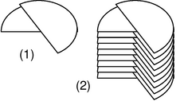
h / A variable capacitor.
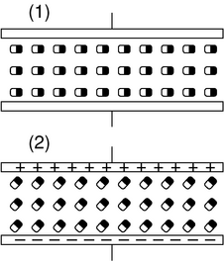
i / Discussion question B.

Capacitance and inductance
In a mechanical oscillation, energy is exchanged repetitively between potential and kinetic forms, and may also be siphoned off in the form of heat dissipated by friction. In an electrical circuit, resistors are the circuit elements that dissipate heat. What are the electrical analogs of storing and releasing the potential and kinetic energy of a vibrating object? When you think of energy storage in an electrical circuit, you are likely to imagine a battery, but even rechargeable batteries can only go through 10 or 100 cycles before they wear out. In addition, batteries are not able to exchange energy on a short enough time scale for most applications. The circuit in a musical synthesizer may be called upon to oscillate thousands of times a second, and your microwave oven operates at gigahertz frequencies. Instead of batteries, we generally use capacitors and inductors to store energy in oscillating circuits. Capacitors, which you've already encountered, store energy in electric fields. An inductor does the same with magnetic fields.

Capacitors
A capacitor's energy exists in its surrounding electric fields. It is proportional to the square of the field strength, which is proportional to the charges on the plates. If we assume the plates carry charges that are the same in magnitude, +q and -q, then the energy stored in the capacitor must be proportional to q². For historical reasons, we write the constant of proportionality as 1/2C,
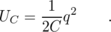
The constant C is a geometrical property of the capacitor, called its capacitance.
Based on this definition, the units of capacitance must be coulombs squared per joule, and this combination is more conveniently abbreviated as the farad, 1 F=1 C²/J. “Condenser” is a less formal term for a capacitor. Note that the labels printed on capacitors often use MF to mean μF, even though MF should really be the symbol for megafarads, not microfarads. Confusion doesn't result from this nonstandard notation, since picofarad and microfarad values are the most common, and it wasn't until the 1990's that even millifarad and farad values became available in practical physical sizes. Figure a shows the symbol used in schematics to represent a capacitor.

Example 18: A parallel-plate capacitor
◊ Suppose a capacitor consists of two parallel metal plates with area A, and the gap between them is h. The gap is small compared to the dimensions of the plates. What is the capacitance?
◊ Since the plates are metal, the charges on each plate are free to move, and will tend to cluster themselves more densely near the edges due to the mutual repulsion of the other charges in the same plate. However, it turns out that if the gap is small, this is a small effect, so we can get away with assuming uniform charge density on each plate. The result of example 14 then applies, and for the region between the plates, we have E=4π kσ=4π kq/ A and U_{e} = (1/8π k) E² Ah. Substituting the first expression into the second, we find U_{e}=2π kq² h/ A. Comparing this to the definition of capacitance, we end up with C= A/4π kh.

Inductors
Any current will create a magnetic field, so in fact every current-carrying wire in a circuit acts as an inductor! However, this type of “stray” inductance is typically negligible, just as we can usually ignore the stray resistance of our wires and only take into account the actual resistors. To store any appreciable amount of magnetic energy, one usually uses a coil of wire designed specifically to be an inductor. All the loops' contribution to the magnetic field add together to make a stronger field. Unlike capacitors and resistors, practical inductors are easy to make by hand. One can for instance spool some wire around a short wooden dowel. An inductor like this, in the form cylindrical coil of wire, is called a solenoid, c, and a stylized solenoid, d, is the symbol used to represent an inductor in a circuit regardless of its actual geometry.
How much energy does an inductor store? The energy density is proportional to the square of the magnetic field strength, which is in turn proportional to the current flowing through the coiled wire, so the energy stored in the inductor must be proportional to I². We write L/2 for the constant of proportionality, giving
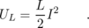
As in the definition of capacitance, we have a factor of 1/2, which is purely a matter of definition. The quantity L is called the inductance of the inductor, and we see that its units must be joules per ampere squared. This clumsy combination of units is more commonly abbreviated as the henry, 1 henry = 1 J/A². Rather than memorizing this definition, it makes more sense to derive it when needed from the definition of inductance. Many people know inductors simply as “coils,” or “chokes,” and will not understand you if you refer to an “inductor,” but they will still refer to L as the “inductance,” not the “coilance” or “chokeance!”
There is a lumped circuit approximation for inductors, just like the one for capacitors (p. 499). For a capacitor, this means assuming that the electric fields are completely internal, so that components only interact via currents that flow through wires, not due to the physical overlapping of their fields in space. Similarly for an inductor, the lumped circuit approximation is the assumption that the magnetic fields are completely internal.

Example 19: Identical inductances in series
If two inductors are placed in series, any current that passes through the combined double inductor must pass through both its parts. If we assume the lumped circuit approximation, the two inductors' fields don't interfere with each other, so the energy is doubled for a given current. Thus by the definition of inductance, the inductance is doubled as well. In general, inductances in series add, just like resistances. The same kind of reasoning also shows that the inductance of a solenoid is approximately proportional to its length, assuming the number of turns per unit length is kept constant. (This is only approximately true, because putting two solenoids end-to-end causes the fields just outside their mouths to overlap and add together in a complicated manner. In other words, the lumped-circuit approximation may not be very good.)

Example 20: Identical capacitances in parallel
When two identical capacitances are placed in parallel, any charge deposited at the terminals of the combined double capacitor will divide itself evenly between the two parts. The electric fields surrounding each capacitor will be half the intensity, and therefore store one quarter the energy. Two capacitors, each storing one quarter the energy, give half the total energy storage. Since capacitance is inversely related to energy storage, this implies that identical capacitances in parallel give double the capacitance. In general, capacitances in parallel add. This is unlike the behavior of inductors and resistors, for which series configurations give addition.
This is consistent with the result of example 18, which had the capacitance of a single parallel-plate capacitor proportional to the area of the plates. If we have two parallel-plate capacitors, and we combine them in parallel and bring them very close together side by side, we have produced a single capacitor with plates of double the area, and it has approximately double the capacitance, subject to any violation of the lumped-circuit approximation due to the interaction of the fields where the edges of the capacitors are joined together.
Inductances in parallel and capacitances in series are explored in homework problems 30 and 32.

Example 21: A variable capacitor
Figure h/1 shows the construction of a variable capacitor out of two parallel semicircles of metal. One plate is fixed, while the other can be rotated about their common axis with a knob. The opposite charges on the two plates are attracted to one another, and therefore tend to gather in the overlapping area. This overlapping area, then, is the only area that effectively contributes to the capacitance, and turning the knob changes the capacitance. The simple design can only provide very small capacitance values, so in practice one usually uses a bank of capacitors, wired in parallel, with all the moving parts on the same shaft.

Discussion Questions
◊ Suppose that two parallel-plate capacitors are wired in parallel, and are placed very close together, side by side, so that the lumped circuit approximation is not very accurate. Will the resulting capacitance be too small, or too big? Could you twist the circuit into a different shape and make the effect be the other way around, or make the effect vanish? How about the case of two inductors in series?
◊ Most practical capacitors do not have an air gap or vacuum gap between the plates; instead, they have an insulating substance called a dielectric. We can think of the molecules in this substance as dipoles that are free to rotate (at least a little), but that are not free to move around, since it is a solid. The figure shows a highly stylized and unrealistic way of visualizing this. We imagine that all the dipoles are intially turned sideways, (1), and that as the capacitor is charged, they all respond by turning through a certain angle, (2). (In reality, the scene might be much more random, and the alignment effect much weaker.)
For simplicity, imagine inserting just one electric dipole into the vacuum gap. For a given amount of charge on the plates, how does this affect the amount of energy stored in the electric field? How does this affect the capacitance?
Now redo the analysis in terms of the mechanical work needed in order to charge up the plates.
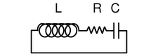
j / A series LRC circuit.
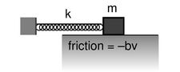
k / A mechanical analogy for the LRC circuit.

Oscillations
Figure j shows the simplest possible oscillating circuit. For any useful application it would actually need to include more components. For example, if it was a radio tuner, it would need to be connected to an antenna and an amplifier. Nevertheless, all the essential physics is there.
We can analyze it without any sweat or tears whatsoever, simply by constructing an analogy with a mechanical system. In a mechanical oscillator, k, we have two forms of stored energy,
In the case of a mechanical oscillator, we have usually assumed a friction force of the form that turns out to give the nicest mathematical results, F=-bv. In the circuit, the dissipation of energy into heat occurs via the resistor, with no mechanical force involved, so in order to make the analogy, we need to restate the role of the friction force in terms of energy. The power dissipated by friction equals the mechanical work it does in a time interval d t, divided by d t, P=W/d t=Fd x/d t=Fv=-bv², so
self-check: Equation (1) has x squared, and equations (2) and (3) have v squared. Because they're squared, the results don't depend on whether these variables are positive or negative. Does this make physical sense? (answer in the back of the PDF version of the book)
In the circuit, the stored forms of energy are
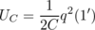
and the rate of heat dissipation in the resistor is
Comparing the two sets of equations, we first form analogies between quantities that represent the state of the system at some moment in time:
self-check: How is v related mathematically to x? How is I connected to q? Are the two relationships analogous? (answer in the back of the PDF version of the book)
Next we relate the ones that describe the system's permanent characteristics:
Since the mechanical system naturally oscillates with a frequency⁴ , we can immediately solve the electrical version by analogy, giving
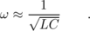
Since the resistance R is analogous to b in the mechanical case, we find that the Q (quality factor, not charge) of the resonance is inversely proportional to R, and the width of the resonance is directly proportional to R.

Example 22: Tuning a radio receiver
A radio receiver uses this kind of circuit to pick out the desired station. Since the receiver resonates at a particular frequency, stations whose frequencies are far off will not excite any response in the circuit. The value of R has to be small enough so that only one station at a time is picked up, but big enough so that the tuner isn't too touchy. The resonant frequency can be tuned by adjusting either L or C, but variable capacitors are easier to build than variable inductors.

Example 23: A numerical calculation
The phone company sends more than one conversation at a time over the same wire, which is accomplished by shifting each voice signal into different range of frequencies during transmission. The number of signals per wire can be maximized by making each range of frequencies (known as a bandwidth) as small as possible. It turns out that only a relatively narrow range of frequencies is necessary in order to make a human voice intelligible, so the phone company filters out all the extreme highs and lows. (This is why your phone voice sounds different from your normal voice.)
◊ If the filter consists of an LRC circuit with a broad resonance centered around 1.0 kHz, and the capacitor is 1 μF (microfarad), what inductance value must be used?
◊ Solving for L, we have
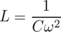
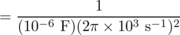
= 2.5×10⁻³ F⁻¹s²
Checking that these really are the same units as henries is a little tedious, but it builds character:
F⁻¹s² = (C²/J)⁻¹s²
= J⋅C⁻²s²
= J/A²
= H
The result is 25 mH (millihenries).
This is actually quite a large inductance value, and would require a big, heavy, expensive coil. In fact, there is a trick for making this kind of circuit small and cheap. There is a kind of silicon chip called an op-amp, which, among other things, can be used to simulate the behavior of an inductor. The main limitation of the op-amp is that it is restricted to low-power applications.
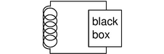
l / The inductor releases energy and gives it to the black box.
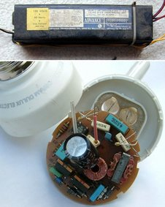
n / Ballasts for fluorescent lights. Top: a big, heavy inductor used as a ballast in an old-fashioned fluorescent bulb. Bottom: a small solid-state ballast, built into the base of a modern compact fluorescent bulb.

Voltage and current
What is physically happening in one of these oscillating circuits? Let's first look at the mechanical case, and then draw the analogy to the circuit. For simplicity, let's ignore the existence of damping, so there is no friction in the mechanical oscillator, and no resistance in the electrical one.
Suppose we take the mechanical oscillator and pull the mass away from equilibrium, then release it. Since friction tends to resist the spring's force, we might naively expect that having zero friction would allow the mass to leap instantaneously to the equilibrium position. This can't happen, however, because the mass would have to have infinite velocity in order to make such an instantaneous leap. Infinite velocity would require infinite kinetic energy, but the only kind of energy that is available for conversion to kinetic is the energy stored in the spring, and that is finite, not infinite. At each step on its way back to equilibrium, the mass's velocity is controlled exactly by the amount of the spring's energy that has so far been converted into kinetic energy. After the mass reaches equilibrium, it overshoots due to its own momentum. It performs identical oscillations on both sides of equilibrium, and it never loses amplitude because friction is not available to convert mechanical energy into heat.
Now with the electrical oscillator, the analog of position is charge. Pulling the mass away from equilibrium is like depositing charges +q and -q on the plates of the capacitor. Since resistance tends to resist the flow of charge, we might imagine that with no friction present, the charge would instantly flow through the inductor (which is, after all, just a piece of wire), and the capacitor would discharge instantly. However, such an instant discharge is impossible, because it would require infinite current for one instant. Infinite current would create infinite magnetic fields surrounding the inductor, and these fields would have infinite energy. Instead, the rate of flow of current is controlled at each instant by the relationship between the amount of energy stored in the magnetic field and the amount of current that must exist in order to have that strong a field. After the capacitor reaches q=0, it overshoots. The circuit has its own kind of electrical “inertia,” because if charge was to stop flowing, there would have to be zero current through the inductor. But the current in the inductor must be related to the amount of energy stored in its magnetic fields. When the capacitor is at q=0, all the circuit's energy is in the inductor, so it must therefore have strong magnetic fields surrounding it and quite a bit of current going through it.
The only thing that might seem spooky here is that we used to speak as if the current in the inductor caused the magnetic field, but now it sounds as if the field causes the current. Actually this is symptomatic of the elusive nature of cause and effect in physics. It's equally valid to think of the cause and effect relationship in either way. This may seem unsatisfying, however, and for example does not really get at the question of what brings about a voltage difference across the resistor (in the case where the resistance is finite); there must be such a voltage difference, because without one, Ohm's law would predict zero current through the resistor.
Voltage, then, is what is really missing from our story so far.
Let's start by studying the voltage across a capacitor. Voltage is electrical potential energy per unit charge, so the voltage difference between the two plates of the capacitor is related to the amount by which its energy would increase if we increased the absolute values of the charges on the plates from q to q+d q:
V_{C} = (U_{q+d q}-U_{q})/d q
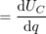
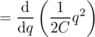
Many books use this as the definition of capacitance. This equation, by the way, probably explains the historical reason why C was defined so that the energy was inversely proportional to C for a given value of C: the people who invented the definition were thinking of a capacitor as a device for storing charge rather than energy, and the amount of charge stored for a fixed voltage (the charge “capacity”) is proportional to C.
In the case of an inductor, we know that if there is a steady, constant current flowing through it, then the magnetic field is constant, and so is the amount of energy stored; no energy is being exchanged between the inductor and any other circuit element. But what if the current is changing? The magnetic field is proportional to the current, so a change in one implies a change in the other. For concreteness, let's imagine that the magnetic field and the current are both decreasing. The energy stored in the magnetic field is therefore decreasing, and by conservation of energy, this energy can't just go away --- some other circuit element must be taking energy from the inductor. The simplest example, shown in figure l, is a series circuit consisting of the inductor plus one other circuit element. It doesn't matter what this other circuit element is, so we just call it a black box, but if you like, we can think of it as a resistor, in which case the energy lost by the inductor is being turned into heat by the resistor. The junction rule tells us that both circuit elements have the same current through them, so I could refer to either one, and likewise the loop rule tells us V_{inductor}+V_{black box}=0, so the two voltage drops have the same absolute value, which we can refer to as V. Whatever the black box is, the rate at which it is taking energy from the inductor is given by |P|=|IV|, so
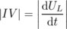
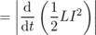
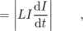
or
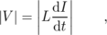
which in many books is taken to be the definition of inductance. The direction of the voltage drop (plus or minus sign) is such that the inductor resists the change in current.
There's one very intriguing thing about this result. Suppose, for concreteness, that the black box in figure l is a resistor, and that the inductor's energy is decreasing, and being converted into heat in the resistor. The voltage drop across the resistor indicates that it has an electric field across it, which is driving the current. But where is this electric field coming from? There are no charges anywhere that could be creating it! What we've discovered is one special case of a more general principle, the principle of induction: a changing magnetic field creates an electric field, which is in addition to any electric field created by charges. (The reverse is also true: any electric field that changes over time creates a magnetic field.) Induction forms the basis for such technologies as the generator and the transformer, and ultimately it leads to the existence of light, which is a wave pattern in the electric and magnetic fields. These are all topics for chapter 11, but it's truly remarkable that we could come to this conclusion without yet having learned any details about magnetism.
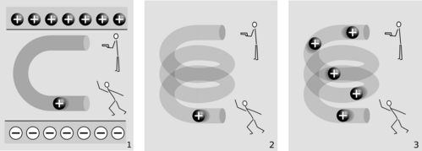
m / Electric fields made by charges, 1, and by changing magnetic fields, 2 and 3.
The cartoons in figure m compares electric fields made by charges, 1, to electric fields made by changing magnetic fields, 2-3. In m/1, two physicists are in a room whose ceiling is positively charged and whose floor is negatively charged. The physicist on the bottom throws a positively charged bowling ball into the curved pipe. The physicist at the top uses a radar gun to measure the speed of the ball as it comes out of the pipe. They find that the ball has slowed down by the time it gets to the top. By measuring the change in the ball's kinetic energy, the two physicists are acting just like a voltmeter. They conclude that the top of the tube is at a higher voltage than the bottom of the pipe. A difference in voltage indicates an electric field, and this field is clearly being caused by the charges in the floor and ceiling.
In m/2, there are no charges anywhere in the room except for the charged bowling ball. Moving charges make magnetic fields, so there is a magnetic field surrounding the helical pipe while the ball is moving through it. A magnetic field has been created where there was none before, and that field has energy. Where could the energy have come from? It can only have come from the ball itself, so the ball must be losing kinetic energy. The two physicists working together are again acting as a voltmeter, and again they conclude that there is a voltage difference between the top and bottom of the pipe. This indicates an electric field, but this electric field can't have been created by any charges, because there aren't any in the room. This electric field was created by the change in the magnetic field.
The bottom physicist keeps on throwing balls into the pipe, until the pipe is full of balls, m/3, and finally a steady current is established. While the pipe was filling up with balls, the energy in the magnetic field was steadily increasing, and that energy was being stolen from the balls' kinetic energy. But once a steady current is established, the energy in the magnetic field is no longer changing. The balls no longer have to give up energy in order to build up the field, and the physicist at the top finds that the balls are exiting the pipe at full speed again. There is no voltage difference any more. Although there is a current, d I/d t is zero.

Example 24: Ballasts
In a gas discharge tube, such as a neon sign, enough voltage is applied to a tube full of gas to ionize some of the atoms in the gas. Once ions have been created, the voltage accelerates them, and they strike other atoms, ionizing them as well and resulting in a chain reaction. This is a spark, like a bolt of lightning. But once the spark starts up, the device begins to act as though it has no resistance: more and more current flows, without the need to apply any more voltage. The power, P=IV, would grow without limit, and the tube would burn itself out.
The simplest solution is to connect an inductor, known as the “ballast,” in series with the tube, and run the whole thing on an AC voltage. During each cycle, as the voltage reaches the point where the chain reaction begins, there is a surge of current, but the inductor resists such a sudden change of current, and the energy that would otherwise have burned out the bulb is instead channeled into building a magnetic field.
A common household fluorescent lightbulb consists of a gas discharge tube in which the glass is coated with a fluorescent material. The gas in the tube emits ultraviolet light, which is absorbed by the coating, and the coating then glows in the visible spectrum.
Until recently, it was common for a fluroescent light's ballast to be a simple inductor, and for the whole device to be operated at the 60 Hz frequency of the electrical power lines. This caused the lights to flicker annoyingly at 120 Hz, and could also cause an audible hum, since the magnetic field surrounding the inductor could exert mechanical forces on things. These days, the trend is toward using a solid-state circuit that mimics the behavior of an inductor, but at a frequency in the kilohertz range, eliminating the flicker and hum. Modern compact fluorescent bulbs electronic have ballasts built into their bases, so they can be used as plug-in replacements for incandescent bulbs. A compact fluorescent bulb uses about 1/4 the electricity of an incandescent bulb, lasts ten times longer, and saves $30 worth of electricity over its lifetime.

Discussion Question
◊ What happens when the physicist at the bottom in figure m/3 starts getting tired, and decreases the current?

o / An RC circuit.
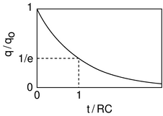
p / Over a time interval RC, the charge on the capacitor is reduced by a factor of e.
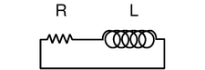
q / An RL circuit.
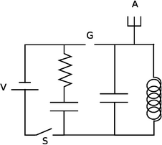
r / Example 26.

Decay
Up until now I've soft-pedaled the fact that by changing the characteristics of an oscillator, it is possible to produce non-oscillatory behavior. For example, imagine taking the mass-on-a-spring system and making the spring weaker and weaker. In the limit of small k, it's as though there was no spring whatsoever, and the behavior of the system is that if you kick the mass, it simply starts slowing down. For friction proportional to v, as we've been assuming, the result is that the velocity approaches zero, but never actually reaches zero. This is unrealistic for the mechanical oscillator, which will not have vanishing friction at low velocities, but it is quite realistic in the case of an electrical circuit, for which the voltage drop across the resistor really does approach zero as the current approaches zero.
We do not even have to reduce k to exactly zero in order to get non-oscillatory behavior. There is actually a finite, critical value below which the behavior changes, so that the mass never even makes it through one cycle. This is the case of overdamping, discussed on page 142.
Electrical circuits can exhibit all the same behavior. For simplicity we will analyze only the cases of LRC circuits with L=0 or C=0.

The RC circuit
We first analyze the RC circuit, o. In reality one would have to “kick” the circuit, for example by briefly inserting a battery, in order to get any interesting behavior. We start with Ohm's law and the equation for the voltage across a capacitor:
V_{R} = IR
V_{C} = q/C
The loop rule tells us
V_{R} + V_{C} = 0 ,
and combining the three equations results in a relationship between q and I:
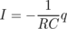
The negative sign tells us that the current tends to reduce the charge on the capacitor, i.e. to discharge it. It makes sense that the current is proportional to q : if q is large, then the attractive forces between the +q and -q charges on the plates of the capacitor are large, and charges will flow more quickly through the resistor in order to reunite. If there was zero charge on the capacitor plates, there would be no reason for current to flow. Since amperes, the unit of current, are the same as coulombs per second, it appears that the quantity RC must have units of seconds, and you can check for yourself that this is correct. RC is therefore referred to as the time constant of the circuit.
How exactly do I and q vary with time? Rewriting I as d q/d t, we have
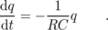
We need a function q(t) whose derivative equals itself, but multiplied by a negative constant. A function of the form ae^{t}, where e=2.718... is the base of natural logarithms, is the only one that has its derivative equal to itself, and ae^{bt} has its derivative equal to itself multiplied by b. Thus our solution is
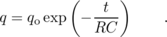

The RL circuit
The RL circuit, q, can be attacked by similar methods, and it can easily be shown that it gives
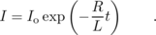
The RL time constant equals L/R.

Example 25: Death by solenoid; spark plugs
When we suddenly break an RL circuit, what will happen? It might seem that we're faced with a paradox, since we only have two forms of energy, magnetic energy and heat, and if the current stops suddenly, the magnetic field must collapse suddenly. But where does the lost magnetic energy go? It can't go into resistive heating of the resistor, because the circuit has now been broken, and current can't flow!
The way out of this conundrum is to recognize that the open gap in the circuit has a resistance which is large, but not infinite. This large resistance causes the RL time constant L/ R to be very small. The current thus continues to flow for a very brief time, and flows straight across the air gap where the circuit has been opened. In other words, there is a spark!
We can determine based on several different lines of reasoning that the voltage drop from one end of the spark to the other must be very large. First, the air's resistance is large, so V= IR requires a large voltage. We can also reason that all the energy in the magnetic field is being dissipated in a short time, so the power dissipated in the spark, P= IV, is large, and this requires a large value of V. (I isn't large --- it is decreasing from its initial value.) Yet a third way to reach the same result is to consider the equation V_{L}=d I/d t : since the time constant is short, the time derivative d I/d t is large.
This is exactly how a car's spark plugs work. Another application is to electrical safety: it can be dangerous to break an inductive circuit suddenly, because so much energy is released in a short time. There is also no guarantee that the spark will discharge across the air gap; it might go through your body instead, since your body might have a lower resistance.

Example 26: A spark-gap radio transmitter
Figure r shows a primitive type of radio transmitter, called a spark gap transmitter, used to send Morse code around the turn of the twentieth century. The high voltage source, V, is typically about 10,000 volts. When the telegraph switch, S, is closed, the RC circuit on the left starts charging up. An increasing voltage difference develops between the electrodes of the spark gap, G. When this voltage difference gets large enough, the electric field in the air between the electrodes causes a spark, partially discharging the RC circuit, but charging the LC circuit on the right. The LC circuit then oscillates at its resonant frequency (typically about 1 MHz), but the energy of these oscillations is rapidly radiated away by the antenna, A, which sends out radio waves (chapter 11).

Discussion Questions
◊ A gopher gnaws through one of the wires in the DC lighting system in your front yard, and the lights turn off. At the instant when the circuit becomes open, we can consider the bare ends of the wire to be like the plates of a capacitor, with an air gap (or gopher gap) between them. What kind of capacitance value are we talking about here? What would this tell you about the RC time constant?
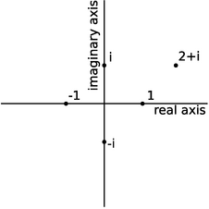
s / Visualizing complex numbers as points in a plane.
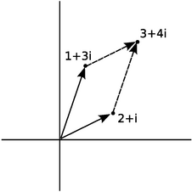
t / Addition of complex numbers is just like addition of vectors, although the real and imaginary axes don't actually represent directions in space.
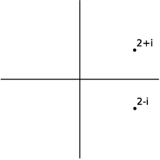
u / A complex number and its conjugate.
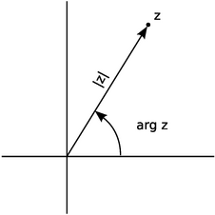
v / A complex number can be described in terms of its magnitude and argument.
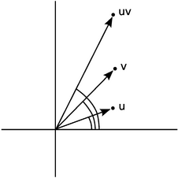
w / The argument of uv is the sum of the arguments of u and v.

Review of Complex Numbers
For a more detailed treatment of complex numbers, see ch. 3 of James Nearing's free book at
http://www.physics.miami.edu/nearing/mathmethods/.
We assume there is a number, i, such that i²=-1. The square roots of -1 are then i and -i. (In electrical engineering work, where i stands for current, j is sometimes used instead.) This gives rise to a number system, called the complex numbers, containing the real numbers as a subset. Any complex number z can be written in the form z=a+bi, where a and b are real, and a and b are then referred to as the real and imaginary parts of z. A number with a zero real part is called an imaginary number. The complex numbers can be visualized as a plane, with the real number line placed horizontally like the x axis of the familiar x-y plane, and the imaginary numbers running along the y axis. The complex numbers are complete in a way that the real numbers aren't: every nonzero complex number has two square roots. For example, 1 is a real number, so it is also a member of the complex numbers, and its square roots are -1 and 1. Likewise, -1 has square roots i and -i, and the number i has square roots and .
Complex numbers can be added and subtracted by adding or subtracting their real and imaginary parts. Geometrically, this is the same as vector addition.
The complex numbers a+bi and a-bi, lying at equal distances above and below the real axis, are called complex conjugates. The results of the quadratic formula are either both real, or complex conjugates of each other. The complex conjugate of a number z is notated as or .
The complex numbers obey all the same rules of arithmetic as the reals, except that they can't be ordered along a single line. That is, it's not possible to say whether one complex number is greater than another. We can compare them in terms of their magnitudes (their distances from the origin), but two distinct complex numbers may have the same magnitude, so, for example, we can't say whether 1 is greater than i or i is greater than 1.

Example 27: A square root of i
◊ Prove that is a square root of i.
◊ Our proof can use any ordinary rules of arithmetic, except for ordering.
= i
Example 27 showed one method of multiplying complex numbers. However, there is another nice interpretation of complex multiplication. We define the argument of a complex number as its angle in the complex plane, measured counterclockwise from the positive real axis. Multiplying two complex numbers then corresponds to multiplying their magnitudes, and adding their arguments.
self-check: Using this interpretation of multiplication, how could you find the square roots of a complex number? (answer in the back of the PDF version of the book)

Example 28: An identity
The magnitude |z| of a complex number z obeys the identity . To prove this, we first note that has the same magnitude as z, since flipping it to the other side of the real axis doesn't change its distance from the origin. Multiplying z by gives a result whose magnitude is found by multiplying their magnitudes, so the magnitude of must therefore equal |z|². Now we just have to prove that is a positive real number. But if, for example, z lies counterclockwise from the real axis, then lies clockwise from it. If z has a positive argument, then has a negative one, or vice-versa. The sum of their arguments is therefore zero, so the result has an argument of zero, and is on the positive real axis. ⁵
This whole system was built up in order to make every number have square roots. What about cube roots, fourth roots, and so on? Does it get even more weird when you want to do those as well? No. The complex number system we've already discussed is sufficient to handle all of them. The nicest way of thinking about it is in terms of roots of polynomials. In the real number system, the polynomial x²-1 has two roots, i.e., two values of x (plus and minus one) that we can plug in to the polynomial and get zero. Because it has these two real roots, we can rewrite the polynomial as (x-1)(x+1). However, the polynomial x²+1 has no real roots. It's ugly that in the real number system, some second-order polynomials have two roots, and can be factored, while others can't. In the complex number system, they all can. For instance, x²+1 has roots i and -i, and can be factored as (x-i)(x+i). In general, the fundamental theorem of algebra states that in the complex number system, any nth-order polynomial can be factored completely into n linear factors, and we can also say that it has n complex roots, with the understanding that some of the roots may be the same. For instance, the fourth-order polynomial x⁴+x² can be factored as (x-i)(x+i)(x-0)(x-0), and we say that it has four roots, i, -i, 0, and 0, two of which happen to be the same. This is a sensible way to think about it, because in real life, numbers are always approximations anyway, and if we make tiny, random changes to the coefficients of this polynomial, it will have four distinct roots, of which two just happen to be very close to zero.

Discussion Questions
◊ Find , , and , where denotes the argument of the complex number z.
◊ Visualize the following multiplications in the complex plane using the interpretation of multiplication in terms of multiplying magnitudes and adding arguments: (i)(i)=-1, (i)(-i)=1, (-i)(-i)=-1.
◊ If we visualize z as a point in the complex plane, how should we visualize -z? What does this mean in terms of arguments? Give similar interpretations for z² and .
◊ Find four different complex numbers z such that z⁴=1.
◊ Compute the following. Use the magnitude and argument, not the real and imaginary parts.
|1+i| ,
Based on the results above, compute the real and imaginary parts of 1/(1+i).
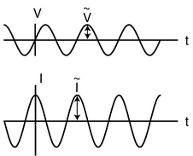
x / In a capacitor, the current is 90° ahead of the voltage in phase.
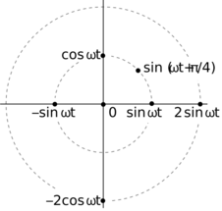
y / Representing functions with points in polar coordinates.
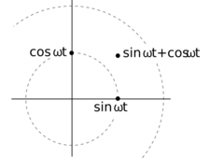
z / Adding two sinusoidal functions.
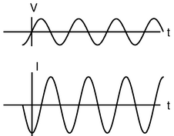
aa / The current through an inductor lags behind the voltage by a phase angle of 90°.

Impedance
So far we have been thinking in terms of the free oscillations of a circuit. This is like a mechanical oscillator that has been kicked but then left to oscillate on its own without any external force to keep the vibrations from dying out. Suppose an LRC circuit is driven with a sinusoidally varying voltage, such as will occur when a radio tuner is hooked up to a receiving antenna. We know that a current will flow in the circuit, and we know that there will be resonant behavior, but it is not necessarily simple to relate current to voltage in the most general case. Let's start instead with the special cases of LRC circuits consisting of only a resistance, only a capacitance, or only an inductance. We are interested only in the steady-state response.
The purely resistive case is easy. Ohm's law gives
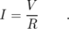
In the purely capacitive case, the relation V=q/C lets us calculate
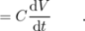
This is partly analogous to Ohm's law. For example, if we double the amplitude of a sinusoidally varying AC voltage, the derivative d V/d t will also double, and the amplitude of the sinusoidally varying current will also double. However, it is not true that I=V/R, because taking the derivative of a sinusoidal function shifts its phase by 90 degrees. If the voltage varies as, for example, V(t)=V_{o}sin (ω t), then the current will be I(t)=ω C V_{o}cos (ω t). The amplitude of the current is ω C V_{o}, which is proportional to V_{o}, but it's not true that I(t)=V(t)/R for some constant R.
A second problem that crops up is that our entire analysis of DC resistive circuits was built on the foundation of the loop rule and the junction rule, both of which are statements about sums. To apply the junction rule to an AC circuit, for exampe, we would say that the sum of the sine waves describing the currents coming into the junction is equal (at every moment in time) to the sum of the sine waves going out. Now sinusoidal functions have a remarkable property, which is that if you add two different sinusoidal functions having the same frequency, the result is also a sinusoid with that frequency. For example, , which can be proved using trig identities. The trig identities can get very cumbersome, however, and there is a much easier technique involving complex numbers.
Figure y shows a useful way to visualize what's going on. When a circuit is oscillating at a frequency ω, we use points in the plane to represent sinusoidal functions with various phases and amplitudes.
self-check: Which of the following functions can be represented in this way? cos(6t-4), cos²t, tan t (answer in the back of the PDF version of the book)
The simplest examples of how to visualize this in polar coordinates are ones like cos ω t+cos ω t=2cos ω t, where everything has the same phase, so all the points lie along a single line in the polar plot, and addition is just like adding numbers on the number line. The less trivial example , can be visualized as in figure z.
Figure z suggests that all of this can be tied together nicely if we identify our plane with the plane of complex numbers. For example, the complex numbers 1 and i represent the functions sinω t and cosω t. In figure x, for example, the voltage across the capacitor is a sine wave multiplied by a number that gives its amplitude, so we associate that function with a number lying on the real axis. Its magnitude, , gives the amplitude in units of volts, while its argument , gives its phase angle, which is zero. The current is a multiple of a sine wave, so we identify it with a number lying on the imaginary axis. We have , and is the amplitude of the current, in units of amperes. But comparing with our result above, we have . Bringing together the phase and magnitude information, we have . This looks very much like Ohm's law, so we write
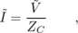
where the quantity
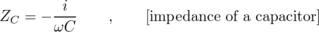
having units of ohms, is called the impedance of the capacitor at this frequency.
It makes sense that the impedance becomes infinite at zero frequency. Zero frequency means that it would take an infinite time before the voltage would change by any amount. In other words, this is like a situation where the capacitor has been connected across the terminals of a battery and been allowed to settle down to a state where there is constant charge on both terminals. Since the electric fields between the plates are constant, there is no energy being added to or taken out of the field. A capacitor that can't exchange energy with any other circuit component is nothing more than a broken (open) circuit.
Note that we have two types of complex numbers: those that represent sinusoidal functions of time, and those that represent impedances. The ones that represent sinusoidal functions have tildes on top, which look like little sine waves.
self-check: Why can't a capacitor have its impedance printed on it along with its capacitance? (answer in the back of the PDF version of the book)
Similar math (but this time with an integral instead of a derivative) gives
for an inductor. It makes sense that the inductor has lower impedance at lower frequencies, since at zero frequency there is no change in the magnetic field over time. No energy is added to or released from the magnetic field, so there are no induction effects, and the inductor acts just like a piece of wire with negligible resistance. The term “choke” for an inductor refers to its ability to “choke out” high frequencies.
The phase relationships shown in figures x and aa can be remembered using my own mnemonic, “eVIL,” which shows that the voltage (V) leads the current (I) in an inductive circuit, while the opposite is true in a capacitive one. A more traditional mnemonic is “ELI the ICE man,” which uses the notation E for emf, a concept closely related to voltage (see p. 612).
Summarizing, the impedances of resistors, capacitors, and inductors are
Z_{R} = R
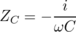
Z_{L} = iω L .

Example 29: Low-pass and high-pass filters
An LRC circuit only responds to a certain range (band) of frequencies centered around its resonant frequency. As a filter, this is known as a bandpass filter. If you turn down both the bass and the treble on your stereo, you have created a bandpass filter.
To create a high-pass or low-pass filter, we only need to insert a capacitor or inductor, respectively, in series. For instance, a very basic surge protector for a computer could be constructed by inserting an inductor in series with the computer. The desired 60 Hz power from the wall is relatively low in frequency, while the surges that can damage your computer show much more rapid time variation. Even if the surges are not sinusoidal signals, we can think of a rapid “spike” qualitatively as if it was very high in frequency --- like a high-frequency sine wave, it changes very rapidly.
Inductors tend to be big, heavy, expensive circuit elements, so a simple surge protector would be more likely to consist of a capacitor in parallel with the computer. (In fact one would normally just connect one side of the power circuit to ground via a capacitor.) The capacitor has a very high impedance at the low frequency of the desired 60 Hz signal, so it siphons off very little of the current. But for a high-frequency signal, the capacitor's impedance is very small, and it acts like a zero-impedance, easy path into which the current is diverted.
The main things to be careful about with impedance are that (1) the concept only applies to a circuit that is being driven sinusoidally, (2) the impedance of an inductor or capacitor is frequency-dependent.

Discussion Question
◊ Figure x on page 528 shows the voltage and current for a capacitor. Sketch the q-t graph, and use it to give a physical explanation of the phase relationship between the voltage and current. For example, why is the current zero when the voltage is at a maximum or minimum?
◊ Figure aa on page 530 shows the voltage and current for an inductor. The power is considered to be positive when energy is being put into the inductor's magnetic field. Sketch the graph of the power, and then the graph of U, the energy stored in the magnetic field, and use it to give a physical explanation of the P-t graph. In particular, discuss why the frequency is doubled on the P-t graph.
◊ Relate the features of the graph in figure aa on page 530 to the story told in cartoons in figure m/2-3 on page 519.
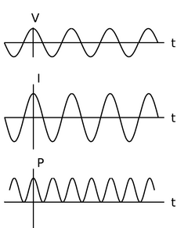
ab / Power in a resistor: the rate at which electrical energy is being converted into heat.
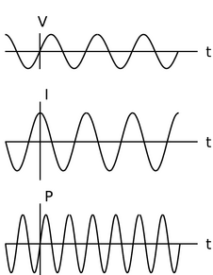
ac / Power in a capacitor: the rate at which energy is being stored in (+) or removed from (-) the electric field.

Power
How much power is delivered when an oscillating voltage is applied to an impedance? The equation P=IV is generally true, since voltage is defined as energy per unit charge, and current is defined as charge per unit time: multiplying them gives energy per unit time. In a DC circuit, all three quantities were constant, but in an oscillating (AC) circuit, all three display time variation.

A resistor
First let's examine the case of a resistor. For instance, you're probably reading this book from a piece of paper illuminated by a glowing lightbulb, which is driven by an oscillating voltage with amplitude V_{o}. In the special case of a resistor, we know that I and V are in phase. For example, if V varies as V_{o}cos ω t, then I will be a cosine as well, I_{o}cos ω t. The power is then I_{o}V_{o}cos²ω t, which is always positive,⁶ and varies between 0 and I_{o}V_{o}. Even if the time variation was cosω t or sin(ω t+π/4), we would still have a maximum power of I_{o}V_{o}, because both the voltage and the current would reach their maxima at the same time. In a lightbulb, the moment of maximum power is when the circuit is most rapidly heating the filament. At the instant when P=0, a quarter of a cycle later, no current is flowing, and no electrical energy is being turned into heat. Throughout the whole cycle, the filament is getting rid of energy by radiating light.⁷ Since the circuit oscillates at a frequency⁸ of 60 Hz, the temperature doesn't really have time to cycle up or down very much over the 1/60 s period of the oscillation, and we don't notice any significant variation in the brightness of the light, even with a short-exposure photograph.
Thus, what we really want to know is the average power, “average” meaning the average over one full cycle. Since we're covering a whole cycle with our average, it doesn't matter what phase we assume. Let's use a cosine. The total amount of energy transferred over one cycle is
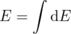
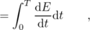
where T=2π/ω is the period.
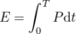
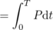
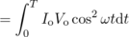
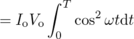
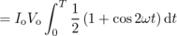
The reason for using the trig identity cos² x=(1+cos 2 x)/2 in the last step is that it lets us get the answer without doing a hard integral. Over the course of one full cycle, the quantity cos 2ω t goes positive, negative, positive, and negative again, so the integral of it is zero. We then have
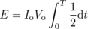
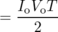
The average power is
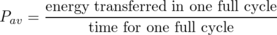
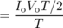
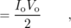
i.e., the average is half the maximum. The power varies from 0 to I_{o}V_{o}, and it spends equal amounts of time above and below the maximum, so it isn't surprising that the average power is half-way in between zero and the maximum. Summarizing, we have
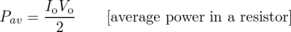
for a resistor.

RMS quantities
Suppose one day the electric company decided to start supplying your electricity as DC rather than AC. How would the DC voltage have to be related to the amplitude V_{o} of the AC voltage previously used if they wanted your lightbulbs to have the same brightness as before? The resistance of the bulb, R, is a fixed value, so we need to relate the power to the voltage and the resistance, eliminating the current. In the DC case, this gives P=IV=(V/R)V=V²/R. (For DC, P and P_{av} are the same.) In the AC case, P_{av} = I_{o}V_{o}/2=V_{o}²/2R. Since there is no factor of 1/2 in the DC case, the same power could be provided with a DC voltage that was smaller by a factor of . Although you will hear people say that household voltage in the U.S. is 110 V, its amplitude is actually . The reason for referring to as “the” voltage is that people who are naive about AC circuits can plug into a familiar DC equation like P=V²/R and get the right average answer. The quantity is called the “RMS” voltage, which stands for “root mean square.” The idea is that if you square the function V(t), take its average (mean) over one cycle, and then take the square root of that average, you get . Many digital meters provide RMS readouts for measuring AC voltages and currents.

A capacitor
For a capacitor, the calculation starts out the same, but ends up with a twist. If the voltage varies as a cosine, V_{o}cos ω t, then the relation I=Cd V/d t tells us that the current will be some constant multiplied by minus the sine, -V_{o}sin ω t. The integral we did in the case of a resistor now becomes
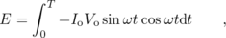
and based on figure ac, you can easily convince yourself that over the course of one full cycle, the power spends two quarter-cycles being negative and two being positive. In other words, the average power is zero!
Why is this? It makes sense if you think in terms of energy. A resistor converts electrical energy to heat, never the other way around. A capacitor, however, merely stores electrical energy in an electric field and then gives it back. For a capacitor,
Notice that although the average power is zero, the power at any given instant is not typically zero, as shown in figure ac. The capacitor does transfer energy: it's just that after borrowing some energy, it always pays it back in the next quarter-cycle.

An inductor
The analysis for an inductor is similar to that for a capacitor: the power averaged over one cycle is zero. Again, we're merely storing energy temporarily in a field (this time a magnetic field) and getting it back later.
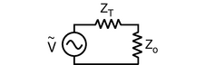
ad / We wish to maximize the power delivered to the load, Z_{o}, by adjusting its impedance.

Impedance Matching
Figure ad shows a commonly encountered situation: we wish to maximize the average power, P_{av}, delivered to the load for a fixed value of V_{o}, the amplitude of the oscillating driving voltage. We assume that the impedance of the transmission line, Z_{T} is a fixed value, over which we have no control, but we are able to design the load, Z_{o}, with any impedance we like. For now, we'll also assume that both impedances are resistive. For example, Z_{T} could be the resistance of a long extension cord, and Z_{o} could be a lamp at the end of it. Using the methods of subsection , however, it turns out that we can easily generalize our result to deal with any kind of impedance impedance. For example, the load could be a stereo speaker's magnet coil, which is displays both inductance and resistance. (For a purely inductive or capacitive load, P_{av} equals zero, so the problem isn't very interesting!)
Since we're assuming both the load and the transmission line are resistive, their impedances add in series, and the amplitude of the current is given by
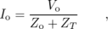
so
P_{av} = I_{o}V_{o}/2
= I_{o}²Z_{o}/2
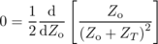
Z_{o} = Z_{T}
In other words, to maximize the power delivered to the load, we should make the load's impedance the same as the transmission line's. This result may seem surprising at first, but it makes sense if you think about it. If the load's impedance is too high, it's like opening a switch and breaking the circuit; no power is delivered. On the other hand, it doesn't pay to make the load's impedance too small. Making it smaller does give more current, but no matter how small we make it, the current will still be limited by the transmission line's impedance. As the load's impedance approaches zero, the current approaches this fixed value, and the the power delivered, I_{o}²Z_{o}, decreases in proportion to Z_{o}.
Maximizing the power transmission by matching Z_{T} to Z_{o} is called impedance matching. For example, an 8-ohm home stereo speaker will be correctly matched to a home stereo amplifier with an internal impedance of 8 ohms, and 4-ohm car speakers will be correctly matched to a car stereo with a 4-ohm internal impedance. You might think impedance matching would be unimportant because even if, for example, we used a car stereo to drive 8-ohm speakers, we could compensate for the mismatch simply by turning the volume knob higher. This is indeed one way to compensate for any impedance mismatch, but there is always a price to pay. When the impedances are matched, half the power is dissipated in the transmission line and half in the load. By connecting a 4-ohm amplifier to an 8-ohm speaker, however, you would be setting up a situation in two watts were being dissipated as heat inside the amp for every amp being delivered to the speaker. In other words, you would be wasting energy, and perhaps burning out your amp when you turned up the volume to compensate for the mismatch.
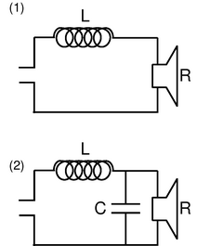
ae / Example 32.

Impedances in series and parallel
How do impedances combine in series and parallel? The beauty of treating them as complex numbers is that they simply combine according to the same rules you've already learned as resistances.

Example 30: Series impedance
◊ A capacitor and an inductor in series with each other are driven by a sinusoidally oscillating voltage. At what frequency is the current maximized?
◊ Impedances in series, like resistances in series, add. The capacitor and inductor act as if they were a single circuit element with an impedance
Z = Z_{L}+ Z_{C}
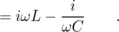
The current is then
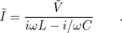
We don't care about the phase of the current, only its amplitude, which is represented by the absolute value of the complex number , and this can be maximized by making | iω L- i/ω C| as small as possible. But there is some frequency at which this quantity is zero ---
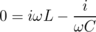
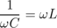
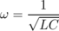
At this frequency, the current is infinite! What is going on physically? This is an LRC circuit with R=0. It has a resonance at this frequency, and because there is no damping, the response at resonance is infinite. Of course, any real LRC circuit will have some damping, however small (cf. figure g on page 135).

Example 31: Resonance with damping
◊ What is the amplitude of the current in a series LRC circuit?
◊ Generalizing from example 30, we add a third, real impedance:
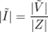
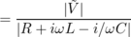
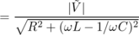
This result would have taken pages of algebra without the complex number technique!

Example 32: A second-order stereo crossover filter
A stereo crossover filter ensures that the high frequencies go to the tweeter and the lows to the woofer. This can be accomplished simply by putting a single capacitor in series with the tweeter and a single inductor in series with the woofer. However, such a filter does not cut off very sharply. Suppose we model the speakers as resistors. (They really have inductance as well, since they have coils in them that serve as electromagnets to move the diaphragm that makes the sound.) Then the power they draw is I² R. Putting an inductor in series with the woofer, ae/1, gives a total impedance that at high frequencies is dominated by the inductor's, so the current is proportional to ω⁻¹, and the power drawn by the woofer is proportional to ω⁻².
A second-order filter, like ae/2, is one that cuts off more sharply: at high frequencies, the power goes like ω⁻⁴. To analyze this circuit, we first calculate the total impedance:
Z = Z_{L}+( Z_{C}⁻¹+ Z_{R}⁻¹)⁻¹
All the current passes through the inductor, so if the driving voltage being supplied on the left is , we have
and we also have
The loop rule, applied to the outer perimeter of the circuit, gives
Straightforward algebra now results in
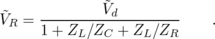
At high frequencies, the Z_{L}/ Z_{C} term, which varies as ω², dominates, so and are proportional to ω⁻², and the power is proportional to ω⁻⁴.

10.6 Fields by Gauss' Law
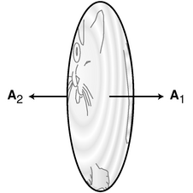
a / The area vector is defined to be perpendicular to the surface, in the outward direction. Its magnitude tells how much the area is.
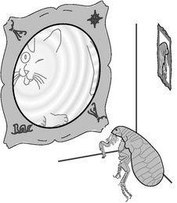
b / Gauss contemplates a map of the known world.
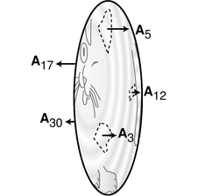
c / Each part of the surface has its own area vector. Note the differences in lengths of the vectors, corresponding to the unequal areas.
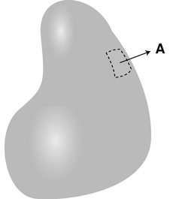
d / An area vector can be defined for a sufficiently small part of a curved surface.

Gauss' law
The flea of subsection 10.3.2 had a long and illustrious scientific career, and we're now going to pick up her story where we left off. This flea, whose name is Gauss⁹, has derived the equation E⊥=2π kσ for the electric field very close to a charged surface with charge density σ. Next we will describe two improvements she is going to make to that equation.
First, she realizes that the equation is not as useful as it could be, because it only gives the part of the field due to the surface. If other charges are nearby, then their fields will add to this field as vectors, and the equation will not be true unless we carefully subtract out the field from the other charges. This is especially problematic for her because the planet on which she lives, known for obscure reasons as planet Flatcat, is itself electrically charged, and so are all the fleas --- the only thing that keeps them from floating off into outer space is that they are negatively charged, while Flatcat carries a positive charge, so they are electrically attracted to it. When Gauss found the original version of her equation, she wanted to demonstrate it to her skeptical colleagues in the laboratory, using electric field meters and charged pieces of metal foil. Even if she set up the measurements by remote control, so that her the charge on her own body would be too far away to have any effect, they would be disrupted by the ambient field of planet Flatcat. Finally, however, she realized that she could improve her equation by rewriting it as follows:
E_{outward, on side 1}+E_{outward, on side 2} = 4π kσ .
The tricky thing here is that “outward” means a different thing, depending on which side of the foil we're on. On the left side, “outward” means to the left, while on the right side, “outward” is right. A positively charged piece of metal foil has a field that points leftward on the left side, and rightward on its right side, so the two contributions of 2π kσ are both positive, and we get 4π kσ. On the other hand, suppose there is a field created by other charges, not by the charged foil, that happens to point to the right. On the right side, this externally created field is in the same direction as the foil's field, but on the left side, the it reduces the strength of the leftward field created by the foil. The increase in one term of the equation balances the decrease in the other term. This new version of the equation is thus exactly correct regardless of what externally generated fields are present!
Her next innovation starts by multiplying the equation on both sides by the area, A, of one side of the foil:
or
E_{outward, on side 1}A+E_{outward, on side 2}A = 4π kq ,
where q is the charge of the foil. The reason for this modification is that she can now make the whole thing more attractive by defining a new vector, the area vector A. As shown in figure a, she defines an area vector for side 1 which has magnitude A and points outward from side 1, and an area vector for side 2 which has the same magnitude and points outward from that side, which is in the opposite direction. The dot product of two vectors, u⋅v, can be interpreted as u_{parallel to v}|v|, and she can therefore rewrite her equation as
E₁⋅A₁+E₂⋅A₂ = 4π k q .
The quantity on the left side of this equation is called the flux through the surface, written Φ.
Gauss now writes a grant proposal to her favorite funding agency, the BSGS (Blood-Suckers' Geological Survey), and it is quickly approved. Her audacious plan is to send out exploring teams to chart the electric fields of the whole planet of Flatcat, and thereby determine the total electric charge of the planet. The fleas' world is commonly assumed to be a flat disk, and its size is known to be finite, since the sun passes behind it at sunset and comes back around on the other side at dawn. The most daring part of the plan is that it requires surveying not just the known side of the planet but the uncharted Far Side as well. No flea has ever actually gone around the edge and returned to tell the tale, but Gauss assures them that they won't fall off --- their negatively charged bodies will be attracted to the disk no matter which side they are on.
Of course it is possible that the electric charge of planet Flatcat is not perfectly uniform, but that isn't a problem. As discussed in subsection 10.3.2, as long as one is very close to the surface, the field only depends on the local charge density. In fact, a side-benefit of Gauss's program of exploration is that any such local irregularities will be mapped out. But what the newspapers find exciting is the idea that once all the teams get back from their voyages and tabulate their data, the total charge of the planet will have been determined for the first time. Each surveying team is assigned to visit a certain list of republics, duchies, city-states, and so on. They are to record each territory's electric field vector, as well as its area. Because the electric field may be nonuniform, the final equation for determining the planet's electric charge will have many terms, not just one for each side of the planet:
Gauss herself leads one of the expeditions, which heads due east, toward the distant Tail Kingdom, known only from fables and the occasional account from a caravan of traders. A strange thing happens, however. Gauss embarks from her college town in the wetlands of the Tongue Republic, travels straight east, passes right through the Tail Kingdom, and one day finds herself right back at home, all without ever seeing the edge of the world! What can have happened? All at once she realizes that the world isn't flat.
Now what? The surveying teams all return, the data are tabulated, and the result for the total charge of Flatcat is (units of nanocoulombs). But the equation was derived under the assumption that Flatcat was a disk. If Flatcat is really round, then the result may be completely wrong. Gauss and two of her grad students go to their favorite bar, and decide to keep on ordering Bloody Marys until they either solve their problems or forget them. One student suggests that perhaps Flatcat really is a disk, but the edges are rounded. Maybe the surveying teams really did flip over the edge at some point, but just didn't realize it. Under this assumption, the original equation will be approximately valid, and 37 nC really is the total charge of Flatcat.
A second student, named Newton, suggests that they take seriously the possibility that Flatcat is a sphere. In this scenario, their planet's surface is really curved, but the surveying teams just didn't notice the curvature, since they were close to the surface, and the surface was so big compared to them. They divided up the surface into a patchwork, and each patch was fairly small compared to the whole planet, so each patch was nearly flat. Since the patch is nearly flat, it makes sense to define an area vector that is perpendicular to it. In general, this is how we define the direction of an area vector, as shown in figure d. This only works if the areas are small. For instance, there would be no way to define an area vector for an entire sphere, since “outward” is in more than one direction.
If Flatcat is a sphere, then the inside of the sphere must be vast, and there is no way of knowing exactly how the charge is arranged below the surface. However, the survey teams all found that the electric field was approximately perpendicular to the surface everywhere, and that its strength didn't change very much from one location to another. The simplest explanation is that the charge is all concentrated in one small lump at the center of the sphere. They have no way of knowing if this is really the case, but it's a hypothesis that allows them to see how much their 37 nC result would change if they assumed a different geometry. Making this assumption, Newton performs the following simple computation on a napkin. The field at the surface is related to the charge at the center by
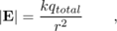
where r is the radius of Flatcat. The flux is then
and since the E_{j} and A_{j} vectors are parallel, the dot product equals |E_{j}||A_{j}|, so
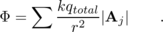
But the field strength is always the same, so we can take it outside the sum, giving
= 4π kq_{total} .
Not only have all the factors of r canceled out, but the result is the same as for a disk!
Everyone is pleasantly surprised by this apparent mathematical coincidence, but is it anything more than that? For instance, what if the charge wasn't concentrated at the center, but instead was evenly distributed throughout Flatcat's interior volume? Newton, however, is familiar with a result called the shell theorem (page 68), which states that the field of a uniformly charged sphere is the same as if all the charge had been concentrated at its center.¹⁰ We now have three different assumptions about the shape of Flatcat and the arrangement of the charges inside it, and all three lead to exactly the same mathematical result, Φ = 4π kq_{total}. This is starting to look like more than a coincidence. In fact, there is a general mathematical theorem, called Gauss' theorem, which states the following:
For any region of space, the flux through the surface equals 4π kq_{in}, where q_{in} is the total charge in that region.
Don't memorize the factor of 4π in front --- you can rederive it any time you need to, by considering a spherical surface centered on a point charge.
Note that although region and its surface had a definite physical existence in our story --- they are the planet Flatcat and the surface of planet Flatcat --- Gauss' law is true for any region and surface we choose, and in general, the Gaussian surface has no direct physical significance. It's simply a computational tool.
Rather than proving Gauss' theorem and then presenting some examples and applications, it turns out to be easier to show some examples that demonstrate its salient properties. Having understood these properties, the proof becomes quite simple.
self-check: Suppose we have a negative point charge, whose field points inward, and we pick a Gaussian surface which is a sphere centered on that charge. How does Gauss' theorem apply here? (answer in the back of the PDF version of the book)
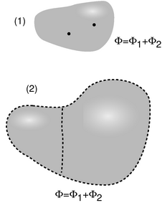
e / 1. The flux due to two charges equals the sum of the fluxes from each one. 2. When two regions are joined together, the flux through the new region equals the sum of the fluxes through the two parts.

Additivity of flux
Figure e shows two two different ways in which flux is additive. Figure e/1, additivity by charge, shows that we can break down a charge distribution into two or more parts, and the flux equals the sum of the fluxes due to the individual charges. This follows directly from the fact that the flux is defined in terms of a dot product, E⋅A, and the dot product has the additive property (a+b)⋅c=a⋅c+b⋅c.
To understand additivity of flux by region, e/2, we have to consider the parts of the two surfaces that were eliminated when they were joined together, like knocking out a wall to make two small apartments into one big one. Although the two regions shared this wall before it was removed, the area vectors were opposite: the direction that is outward from one region is inward with respect to the other. Thus if the field on the wall contributes positive flux to one region, it contributes an equal amount of negative flux to the other region, and we can therefore eliminate the wall to join the two regions, without changing the total flux.
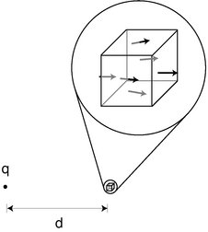
f / The flux through a tiny cube due to a point charge.

Zero flux from outside charges
A third important property of Gauss' theorem is that it only refers to the charge inside the region we choose to discuss. In other words, it asserts that any charge outside the region contributes zero to the flux. This makes at least some sense, because a charge outside the region will have field vectors pointing into the surface on one side, and out of the surface on the other. Certainly there should be at least partial cancellation between the negative (inward) flux on one side and the positive (outward) flux on the other. But why should this cancellation be exact?
To see the reason for this perfect cancellation, we can imagine space as being built out of tiny cubes, and we can think of any charge distribution as being composed of point charges. The additivity-by-charge property tells us that any charge distribution can be handled by considering its point charges individually, and the additivity-by-region property tells us that if we have a single point charge outside a big region, we can break the region down into tiny cubes. If we can prove that the flux through such a tiny cube really does cancel exactly, then the same must be true for any region, which we could build out of such cubes, and any charge distribution, which we can build out of point charges.
For simplicity, we will carry out this calculation only in the special case shown in figure f, where the charge lies along one axis of the cube. Let the sides of the cube have length 2b, so that the area of each side is (2b)²=4b². The cube extends a distance b above, below, in front of, and behind the horizontal x axis. There is a distance d-b from the charge to the left side, and d+b to the right side.
There will be one negative flux, through the left side, and five positive ones. Of these positive ones, the one through the right side is very nearly the same in magnitude as the negative flux through the left side, but just a little less because the field is weaker on the right, due to the greater distance from the charge. The fluxes through the other four sides are very small, since the field is nearly perpendicular to their area vectors, and the dot product E_{j}⋅A_{j} is zero if the two vectors are perpendicular. In the limit where b is very small, we can approximate the flux by evaluating the field at the center of each of the cube's six sides, giving
Φ = Φ_{left}+4Φ_{side}+Φ_{right}
= |E_{left}||A_{left}|cos 180°
and a little trig gives cosθ_{side}≈ b/d, so
Φ = -|E_{left}||A_{left}|
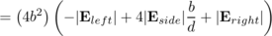
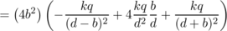
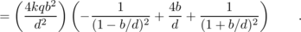
Using the approximation (1+ε)⁻²≈ 1-2ε for small ε, this becomes
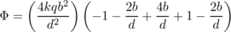
= 0 .
Thus in the limit of a very small cube, b<< d, we have proved that the flux due to this exterior charge is zero. The proof can be extended to the case where the charge is not along any axis of the cube,¹¹ and based on additivity we then have a proof that the flux due to an outside charge is always zero.

Discussion Questions
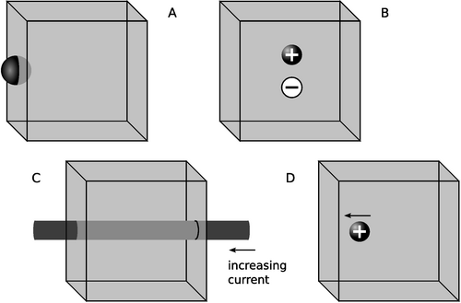
g / Discussion question A-D.
◊ One question that might naturally occur to you about Gauss's law is what happens for charge that is exactly on the surface --- should it be counted toward the enclosed charge, or not? If charges can be perfect, infinitesimal points, then this could be a physically meaningful question. Suppose we approach this question by way of a limit: start with charge q spread out over a sphere of finite size, and then make the size of the sphere approach zero. The figure shows a uniformly charged sphere that's exactly half-way in and half-way out of the cubical Gaussian surface. What is the flux through the cube, compared to what it would be if the charge was entirely enclosed? (There are at least three ways to find this flux: by direct integration, by Gauss's law, or by the additivity of flux by region.)
◊ The dipole is completely enclosed in the cube. What does Gauss's law say about the flux through the cube? If you imagine the dipole's field pattern, can you verify that this makes sense?
◊ The wire passes in through one side of the cube and out through the other. If the current through the wire is increasing, then the wire will act like an inductor, and there will be a voltage difference between its ends. (The inductance will be relatively small, since the wire isn't coiled up, and the Δ V will therefore also be fairly small, but still not zero.) The Δ V implies the existence of electric fields, and yet Gauss's law says the flux must be zero, since there is no charge inside the cube. Why isn't Gauss's law violated?
◊ The charge has been loitering near the edge of the cube, but is then suddenly hit with a mallet, causing it to fly off toward the left side of the cube. We haven't yet discussed in detail how disturbances in the electric and magnetic fields ripple outward through space, but it turns out that they do so at the speed of light. (In fact, that's what light is: ripples in the electric and magnetic fields.) Because the charge is closer to the left side of the cube, the change in the electric field occurs there before the information reaches the right side. This would seem certain to lead to a violation of Gauss's law. How can the ideas explored in discussion question C show the resolution to this paradox?
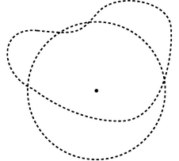
h / Completing the proof of Gauss' theorem.

Proof of Gauss' theorem
With the computational machinery we've developed, it is now simple to prove Gauss' theorem. Based on additivity by charge, it suffices to prove the law for a point charge. We have already proved Gauss' law for a point charge in the case where the point charge is outside the region. If we can prove it for the inside case, then we're all done.
If the charge is inside, we reason as follows. First, we forget about the actual Gaussian surface of interest, and instead construct a spherical one, centered on the charge. For the case of a sphere, we've already seen the proof written on a napkin by the flea named Newton (page 541). Now wherever the actual surface sticks out beyond the sphere, we glue appropriately shaped pieces onto the sphere. In the example shown in figure h, we have to add two Mickey Mouse ears. Since these added pieces do not contain the point charge, the flux through them is zero, and additivity of flux by region therefore tells us that the total flux is not changed when we make this alteration. Likewise, we need to chisel out any regions where the sphere sticks out beyond the actual surface. Again, there is no change in flux, since the region being altered doesn't contain the point charge. This proves that the flux through the Gaussian surface of interest is the same as the flux through the sphere, and since we've already proved that that flux equals 4π kq_{in}, our proof of Gauss' theorem is complete.

Discussion Questions
◊ A critical part of the proof of Gauss' theorem was the proof that a tiny cube has zero flux through it due to an external charge. Discuss qualitatively why this proof would fail if Coulomb's law was a 1/r or 1/r³ law.

Gauss' law as a fundamental law of physics
Note that the proof of Gauss' theorem depended on the computation on the napkin discussed on page 10.6.1. The crucial point in this computation was that the electric field of a point charge falls off like 1/r², and since the area of a sphere is proportional to r², the result is independent of r. The 1/r² variation of the field also came into play on page 544 in the proof that the flux due to an outside charge is zero. In other words, if we discover some other force of nature which is proportional to 1/r³ or r, then Gauss' theorem will not apply to that force. Gauss' theorem is not true for nuclear forces, which fall off exponentially with distance. However, this is the only assumption we had to make about the nature of the field. Since gravity, for instance, also has fields that fall off as 1/r², Gauss' theorem is equally valid for gravity --- we just have to replace mass with charge, change the Coulomb constant k to the gravitational constant G, and insert a minus sign because the gravitational fields around a (positive) mass point inward.
Gauss' theorem can only be proved if we assume a 1/r² field, and the converse is also true: any field that satisfies Gauss' theorem must be a 1/r² field. Thus although we previously thought of Coulomb's law as the fundamental law of nature describing electric forces, it is equally valid to think of Gauss' theorem as the basic law of nature for electricity. From this point of view, Gauss' theorem is not a mathematical fact but an experimentally testable statement about nature, so we'll refer to it as Gauss' law, just as we speak of Coulomb's law or Newton's law of gravity.
If Gauss' law is equivalent to Coulomb's law, why not just use Coulomb's law? First, there are some cases where calculating a field is easy with Gauss' law, and hard with Coulomb's law. More importantly, Gauss' law and Coulomb's law are only mathematically equivalent under the assumption that all our charges are standing still, and all our fields are constant over time, i.e. in the study of electrostatics, as opposed to electrodynamics. As we broaden our scope to study generators, inductors, transformers, and radio antennas, we will encounter cases where Gauss' law is valid, but Coulomb's law is not.
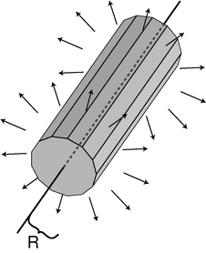
i / Applying Gauss' law to an infinite line of charge.
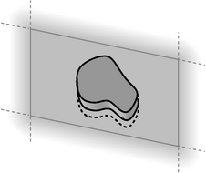
j / Applying Gauss' law to an infinite charged surface.

Applications
Often we encounter situations where we have a static charge distribution, and we wish to determine the field. Although superposition is a generic strategy for solving this type of problem, if the charge distribution is symmetric in some way, then Gauss' law is often a far easier way to carry out the computation.

Field of a long line of charge
Consider the field of an infinitely long line of charge, holding a uniform charge per unit length λ. Computing this field by brute-force superposition was fairly laborious (examples 10 on page 495 and 13 on page 501). With Gauss' law it becomes a very simple calculation.
The problem has two types of symmetry. The line of charge, and therefore the resulting field pattern, look the same if we rotate them about the line. The second symmetry occurs because the line is infinite: if we slide the line along its own length, nothing changes. This sliding symmetry, known as a translation symmetry, tells us that the field must point directly away from the line at any given point.
Based on these symmetries, we choose the Gaussian surface shown in figure i. If we want to know the field at a distance R from the line, then we choose this surface to have a radius R, as shown in the figure. The length, L, of the surface is irrelevant.
The field is parallel to the surface on the end caps, and therefore perpendicular to the end caps' area vectors, so there is no contribution to the flux. On the long, thin strips that make up the rest of the surface, the field is perpendicular to the surface, and therefore parallel to the area vector of each strip, so that the dot product occurring in the definition of the flux is E_{j}⋅A_{j}=|E_{j}||A_{j}||cos 0°=|E_{j}||A_{j}|. Gauss' law gives
The magnitude of the field is the same on every strip, so we can take it outside the sum.
In the limit where the strips are infinitely narrow, the surface becomes a cylinder, with (area)=(circumference)(length)=2π RL.
4π k λ L = |E| × 2π RL
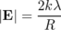

Field near a surface charge
As claimed earlier, the result E=2π kσ for the field near a charged surface is a special case of Gauss' law. We choose a Gaussian surface of the shape shown in figure j, known as a Gaussian pillbox. The exact shape of the flat end caps is unimportant.
The symmetry of the charge distribution tells us that the field points directly away from the surface, and is equally strong on both sides of the surface. This means that the end caps contribute equally to the flux, and the curved sides have zero flux through them. If the area of each end cap is A, then
4π k q_{in} = E₁⋅A₁+E₂⋅A₂ ,
where the subscripts 1 and 2 refer to the two end caps. We have A₂=-A₁, so
4π k q_{in} = E₁⋅A₁-E₂⋅A₁
and by symmetry the magnitudes of the two fields are equal, so
2|E|A = 4 π k σ A
|E| = 2π kσ
The symmetry between the two sides could be broken by the existence of other charges nearby, whose fields would add onto the field of the surface itself. Even then, Gauss's law still guarantees
|E_{⊥,1}-E_{⊥,2}| = 4π k σ ,
where the subscript ⊥ indicates the component of the field parallel to the surface (i.e., parallel to the area vectors). In other words, the electric field changes discontinuously when we pass through a charged surface; the discontinuity occurs in the component of the field perpendicular to the surface, and the amount of discontinuous change is 4π k σ. This is a completely general statement that is true near any charged surface, regardless of the existence of other charges nearby.

10.7 Gauss' Law in Differential Form
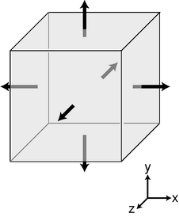
a / A tiny cubical Gaussian surface.
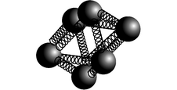
b / A meter for measuring .
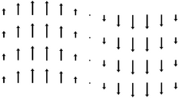
c / Example 33.
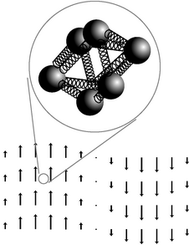
d / Discussion question A.
Gauss' law is a bit spooky. It relates the field on the Gaussian surface to the charges inside the surface. What if the charges have been moving around, and the field at the surface right now is the one that was created by the charges in their previous locations? Gauss' law --- unlike Coulomb's law --- still works in cases like these, but it's far from obvious how the flux and the charges can still stay in agreement if the charges have been moving around.
For this reason, it would be more physically attractive to restate Gauss' law in a different form, so that it related the behavior of the field at one point to the charges that were actually present at that point. This is essentially what we were doing in the fable of the flea named Gauss: the fleas' plan for surveying their planet was essentially one of dividing up the surface of their planet (which they believed was flat) into a patchwork, and then constructing small a Gaussian pillbox around each small patch. The equation E⊥=2π kσ then related a particular property of the local electric field to the local charge density.
In general, charge distributions need not be confined to a flat surface --- life is three-dimensional --- but the general approach of defining very small Gaussian surfaces is still a good one. Our strategy is to divide up space into tiny cubes, like the one on page 543. Each such cube constitutes a Gaussian surface, which may contain some charge. Again we approximate the field using its six values at the center of each of the six sides. Let the cube extend from x to x+d x, from y to y+d y, and from y to y+d y.
The sides at x and x+d x have area vectors and , respectively. The flux through the side at x is -E_{x}(x)d yd z, and the flux through the opposite side, at x+d x is E_{x}(x+d x)d yd z. The sum of these is (E_{x}(x+d x)-E_{x}(x))d yd z, and if the field was uniform, the flux through these two opposite sides would be zero. It will only be zero if the field's x component changes as a function of x. The difference E_{x}(x+d x)-E_{x}(x) can be rewritten as d E_{x}=(d E_{x})/(d x)d x, so the contribution to the flux from these two sides of the cube ends up being
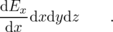
Doing the same for the other sides, we end up with a total flux
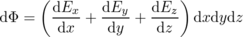
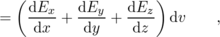
where d v is the volume of the cube. In evaluating each of these three derivatives, we are going to treat the other two variables as constants, to emphasize this we use the partial derivative notation ∂ introduced in chapter 3,
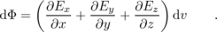
Using Gauss' law,
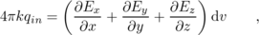
and we introduce the notation ρ (Greek letter rho) for the charge per unit volume, giving
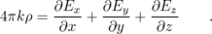
The quantity on the right is called the divergence of the electric field, written . Using this notation, we have
This equation has all the same physical implications as Gauss' law. After all, we proved Gauss' law by breaking down space into little cubes like this. We therefore refer to it as the differential form of Gauss' law, as opposed to Φ=4π kq_{in}, which is called the integral form.
Figure b shows an intuitive way of visualizing the meaning of the divergence. The meter consists of some electrically charged balls connected by springs. If the divergence is positive, then the whole cluster will expand, and it will contract its volume if it is placed at a point where the field has . What if the field is constant? We know based on the definition of the divergence that we should have in this case, and the meter does give the right result: all the balls will feel a force in the same direction, but they will neither expand nor contract.

Example 33: Divergence of a sine wave
◊ Figure c shows an electric field that varies as a sine wave. This is in fact what you'd see in a light wave: light is a wave pattern made of electric and magnetic fields. (The magnetic field would look similar, but would be in a plane perpendicular to the page.) What is the divergence of such a field, and what is the physical significance of the result?
◊ Intuitively, we can see that no matter where we put the div-meter in this field, it will neither expand nor contract. For instance, if we put it at the center of the figure, it will start spinning, but that's it.
Mathematically, let the x axis be to the right and let y be up. The field is of the form
where the constant K is not to be confused with Coulomb's constant. Since the field has only a y component, the only term in the divergence we need to evaluate is
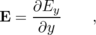
but this vanishes, because E_{y} depends only on x, not y : we treat y as a constant when evaluating the partial derivative ∂ E_{y}/∂ y, and the derivative of an expression containing only constants must be zero.
Physically this is a very important result: it tells us that a light wave can exist without any charges along the way to “keep it going.” In other words, light can travel through a vacuum, a region with no particles in it. If this wasn't true, we'd be dead, because the sun's light wouldn't be able to get to us through millions of kilometers of empty space!

Example 34: Electric field of a point charge
The case of a point charge is tricky, because the field behaves badly right on top of the charge, blowing up and becoming discontinuous. At this point, we cannot use the component form of the divergence, since none of the derivatives are well defined. However, a little visualization using the original definition of the divergence will quickly convince us that div E is infinite here, and that makes sense, because the density of charge has to be infinite at a point where there is a zero-size point of charge (finite charge in zero volume).
At all other points, we have
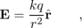
where is the unit vector pointing radially away from the charge. The field can therefore be written as
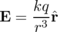
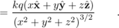
The three terms in the divergence are all similar, e.g.
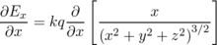
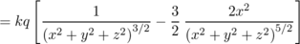
Straightforward algebra shows that adding in the other two terms results in zero, which makes sense, because there is no charge except at the origin.
Gauss' law in differential form lends itself most easily to finding the charge density when we are give the field. What if we want to find the field given the charge density? As demonstrated in the following example, one technique that often works is to guess the general form of the field based on experience or physical intuition, and then try to use Gauss' law to find what specific version of that general form will be a solution.

Example 35: The field inside a uniform sphere of charge
◊ Find the field inside a uniform sphere of charge whose charge density is ρ. (This is very much like finding the gravitational field at some depth below the surface of the earth.)
◊ By symmetry we know that the field must be purely radial (in and out). We guess that the solution might be of the form
where r is the distance from the center, and b and p are constants. A negative value of p would indicate a field that was strongest at the center, while a positive p would give zero field at the center and stronger fields farther out. Physically, we know by symmetry that the field is zero at the center, so we expect p to be positive.
As in the example 34, we rewrite as r/ r, and to simplify the writing we define n= p-1, so
E = br nr .
Gauss' law in differential form is
so we want a field whose divergence is constant. For a field of the form we guessed, the divergence has terms in it like
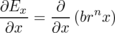
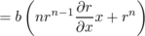
The partial derivative ∂ r/∂ x is easily calculated to be x/ r, so
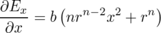
Adding in similar expressions for the other two terms in the divergence, and making use of x²+ y²+ z²= r², we have
This can indeed be constant, but only if n is 0 or -3, i.e. p is 1 or -2. The second solution gives a divergence which is constant and zero : this is the solution for the outside of the sphere! The first solution, which has the field directly proportional to r, must be the one that applies to the inside of the sphere, which is what we care about right now. Equating the coefficient in front to the one in Gauss' law, the field is
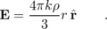
The field is zero at the center, and gets stronger and stronger as we approach the surface.

Discussion Questions
◊ As suggested by the figure, discuss the results you would get by inserting the div-meter at various locations in the sine-wave field.
\backofchapterboilerplate{efield}

Homework Problems
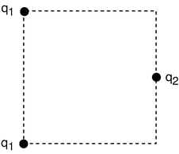
a / Problem 4.
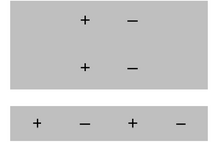
b / Problem 6.
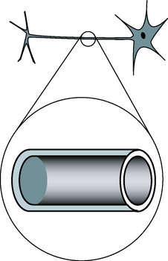
c / Problem 8.
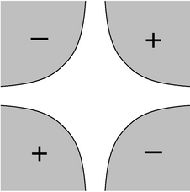
d / Problem 13.
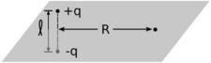
e / Problem 16.
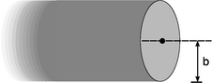
f / Problem 20.
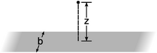
g / Problem 21.
h / Problem 24.
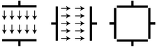
i / Problem 25.
1. [0]{chargemotioninfield} (a) At time t=0, a positively charged particle is placed, at rest, in a vacuum, in which there is a uniform electric field of magnitude E. Write an equation giving the particle's speed, v, in terms of t, E, and its mass and charge m and q.(answer check available at lightandmatter.com)
(b) If this is done with two different objects and they are observed to have the same motion, what can you conclude about their masses and charges? (For instance, when radioactivity was discovered, it was found that one form of it had the same motion as an electron in this type of experiment.)
2. [0]{altedefunits} Show that the alternative definition of the magnitude of the electric field, , has units that make sense.
3. The definition of the dipole moment, , involves the vector r_{i} stretching from the origin of our coordinate system out to the charge q_{i}. There are clearly cases where this causes the dipole moment to be dependent on the choice of coordinate system. For instance, if there is only one charge, then we could make the dipole moment equal zero if we chose the origin to be right on top of the charge, or nonzero if we put the origin somewhere else.
(a) Make up a numerical example with two charges of equal magnitude and opposite sign. Compute the dipole moment using two different coordinate systems that are oriented the same way, but differ in the choice of origin. Comment on the result.
(b) Generalize the result of part a to any pair of charges with equal magnitude and opposite sign. This is supposed to be a proof for any arrangement of the two charges, so don't assume any numbers.
(c) Generalize further, to n charges.
4. Three charges are arranged on a square as shown. All three charges are positive. What value of q₂/q₁ will produce zero electric field at the center of the square?(answer check available at lightandmatter.com)
5. [0]{dipolefarfield} This is a one-dimensional problem, with everything confined to the x axis. Dipole A consists of a -1.000 C charge at x=0.000 m and a 1.000 C charge at x=1.000 m. Dipole B has a -2.000 C charge at x=0.000 m and a 2.000 C charge at x=0.500 m.
(a) Compare the two dipole moments.
(b) Calculate the field created by dipole A at x=10.000 m, and compare with the field dipole B would make. Comment on the result.(answer check available at lightandmatter.com)
6. Compare the two dipole moments.
7. Find an arrangement of charges that has zero total charge and zero dipole moment, but that will make nonvanishing electric fields.
8. In our by-now-familiar neuron, the voltage difference between the inner and outer surfaces of the cell membrane is about V_{out}-V_{in}=-70 mV in the resting state, and the thickness of the membrane is about 6.0 nm (i.e. only about a hundred atoms thick). What is the electric field inside the membrane?(answer check available at lightandmatter.com)
9. [0]{sparkplug} The gap between the electrodes in an automobile engine's spark plug is 0.060 cm. To produce an electric spark in a gasoline-air mixture, an electric field of 3.0×10⁶ V/m must be achieved. On starting a car, what minimum voltage must be supplied by the ignition circuit? Assume the field is uniform.(answer check available at lightandmatter.com)
(b) The small size of the gap between the electrodes is inconvenient because it can get blocked easily, and special tools are needed to measure it. Why don't they design spark plugs with a wider gap?
10. A proton is in a region in which the electric field is given by E=a+bx³. If the proton starts at rest at x₁=0, find its speed, v, when it reaches position x₂. Give your answer in terms of a,b, x₂, and e and m, the charge and mass of the proton.(answer check available at lightandmatter.com)
11. (a) Given that the on-axis field of a dipole at large distances is proportional to D/r³, show that its voltage varies as D/r². (Ignore positive and negative signs and numerical constants of proportionality.)
(b) Write down an exact expression for the voltage of a two-charge dipole at an on-axis point, without assuming that the distance is large compared to the size of the dipole. Your expression will have to contain the actual charges and size of the dipole, not just its dipole moment. Now use approximations to show that, at large distances, this is consistent with your answer to part a.\hwhint{hwhint:dipolev}
12. A hydrogen atom is electrically neutral, so at large distances, we expect that it will create essentially zero electric field. This is not true, however, near the atom or inside it. Very close to the proton, for example, the field is very strong. To see this, think of the electron as a spherically symmetric cloud that surrounds the proton, getting thinner and thinner as we get farther away from the proton. (Quantum mechanics tells us that this is a more correct picture than trying to imagine the electron orbiting the proton.) Near the center of the atom, the electron cloud's field cancels out by symmetry, but the proton's field is strong, so the total field is very strong. The voltage in and around the hydrogen atom can be approximated using an expression of the form V=r⁻¹e^{-r}. (The units come out wrong, because I've left out some constants.) Find the electric field corresponding to this voltage, and comment on its behavior at very large and very small r. (solution in the pdf version of the book){hwsoln:screened}
13. [0]{hyperbolic} The figure shows a vacuum chamber surrounded by four metal electrodes shaped like hyperbolas. (Yes, physicists do sometimes ask their university machine shops for things machined in mathematical shapes like this. They have to be made on computer-controlled mills.) We assume that the electrodes extend far into and out of the page along the unseen z axis, so that by symmetry, the electric fields are the same for all z. The problem is therefore effectively two-dimensional. Two of the electrodes are at voltage +V_{o}, and the other two at -V_{o}, as shown. The equations of the hyperbolic surfaces are |xy|=b², where b is a constant. (We can interpret b as giving the locations x=± b, y=± b of the four points on the surfaces that are closest to the central axis.) There is no obvious, pedestrian way to determine the field or voltage in the central vacuum region, but there's a trick that works: with a little mathematical insight, we see that the voltage V=V_{o}b⁻²xy is consistent with all the given information. (Mathematicians could prove that this solution was unique, but a physicist knows it on physical grounds: if there were two different solutions, there would be no physical way for the system to decide which one to do!) (a) Use the techniques of subsection 10.2.2 to find the field in the vacuum region, and (b) sketch the field as a “sea of arrows.”(answer check available at lightandmatter.com)
14. [0]{carbondioxide} A carbon dioxide molecule is structured like O-C-O, with all three atoms along a line. The oxygen atoms grab a little bit of extra negative charge, leaving the carbon positive. The molecule's symmetry, however, means that it has no overall dipole moment, unlike a V-shaped water molecule, for instance. Whereas the voltage of a dipole of magnitude D is proportional to D/r² (see problem 11), it turns out that the voltage of a carbon dioxide molecule at a distant point along the molecule's axis equals b/r³, where r is the distance from the molecule and b is a constant (cf. problem 7). What would be the electric field of a carbon dioxide molecule at a point on the molecule's axis, at a distance r from the molecule?(answer check available at lightandmatter.com)
15. (a) A certain region of three-dimensional space has a voltage that varies as V=br², where r is the distance from the origin. Use the techniques of subsection 10.2.2 to find the field.(answer check available at lightandmatter.com)
(b) Write down another voltage that gives exactly the same field.
16. [2]{dipolemidplane} A dipole has a midplane, i.e., the plane that cuts through the dipole's center, and is perpendicular to the dipole's axis. Consider a two-charge dipole made of point charges ± q located at . Use approximations to find the field at a distant point in the midplane, and show that its magnitude comes out to be kD/R³ (half what it would be at a point on the axis lying an equal distance from the dipole).
17. (a) As suggested in example 9 on page 494, use approximations to show that the expression given for the electric field approaches kQ/d² for large d.
(b) Do the same for the result of example 12 on page 498.
18. [0]{ringve} As suggested in example 11 on page 496, show that you can get the same result for the on-axis field by differentiating the voltage
19. (a) Example 10 on page 495 gives the field of a charged rod in its midplane. Starting from this result, take the limit as the length of the rod approaches infinity. Note that λ is not changing, so as L gets bigger, the total charge Q increases. \hwans{hwans:estrips}
(b) In the text, I have shown (by several different methods) that the field of an infinite, uniformly charged plane is 2π kσ. Now you're going to rederive the same result by a different method. Suppose that it is the x-y plane that is charged, and we want to find the field at the point (0,0,z). (Since the plane is infinite, there is no loss of generality in assuming x=0 and y=0.) Imagine that we slice the plane into an infinite number of straight strips parallel to the y axis. Each strip has infinitesimal width d x, and extends from x to x+d x. The contribution any one of these strips to the field at our point has a magnitude which can be found from part a. By vector addition, prove the desired result for the field of the plane of charge.
20. Consider the electric field created by a uniformly charged cylindrical surface that extends to infinity in one direction.
(a) Show that the field at the center of the cylinder's mouth is 2π kσ, which happens to be the same as the field of an infinite flat sheet of charge!
(b) This expression is independent of the radius of the cylinder. Explain why this should be so. For example, what would happen if you doubled the cylinder's radius?
21. (a) Show that the field found in example 10 on page 495 reduces to E=2kλ/R in the limit of L→∞.
(b) An infinite strip of width b has a surface charge density σ. Find the field at a point at a distance z from the strip, lying in the plane perpendicularly bisecting the strip. (answer check available at lightandmatter.com)
(c) Show that this expression has the correct behavior in the limit where z approaches zero, and also in the limit of z>> b. For the latter, you'll need the result of problem 19a, which is given on page 760.
22. [2]{vedgedisk} Find the voltage at the edge of a uniformly charged disk. (Define V=0 to be infinitely far from the disk.) (answer check available at lightandmatter.com)\hwhint{hwhint:vedgedisk}
23. In an electrical storm, the cloud and the ground act like a parallel-plate capacitor, which typically charges up due to frictional electricity in collisions of ice particles in the cold upper atmosphere. Lightning occurs when the magnitude of the electric field builds up to a critical value, E_{c}, at which air is ionized.
(a) Treat the cloud as a flat square with sides of length L. If it is at a height h above the ground, find the amount of energy released in the lightning strike.(answer check available at lightandmatter.com)
(b) Based on your answer from part a, which is more dangerous, a lightning strike from a high-altitude cloud or a low-altitude one?
(c) Make an order-of-magnitude estimate of the energy released by a typical lightning bolt, assuming reasonable values for its size and altitude. E_{c} is about 10⁶ V/m.
24. The neuron in the figure has been drawn fairly short, but some neurons in your spinal cord have tails (axons) up to a meter long. The inner and outer surfaces of the membrane act as the “plates” of a capacitor. (The fact that it has been rolled up into a cylinder has very little effect.) In order to function, the neuron must create a voltage difference V between the inner and outer surfaces of the membrane. Let the membrane's thickness, radius, and length be t, r, and L. (a) Calculate the energy that must be stored in the electric field for the neuron to do its job. (In real life, the membrane is made out of a substance called a dielectric, whose electrical properties increase the amount of energy that must be stored. For the sake of this analysis, ignore this fact.) \hwhint{hwhint:neuronenergy}(answer check available at lightandmatter.com)
(b) An organism's evolutionary fitness should be better if it needs less energy to operate its nervous system. Based on your answer to part a, what would you expect evolution to do to the dimensions t and What other constraints would keep these evolutionary trends from going too far?
25. The figure shows cross-sectional views of two cubical capacitors, and a cross-sectional view of the same two capacitors put together so that their interiors coincide. A capacitor with the plates close together has a nearly uniform electric field between the plates, and almost zero field outside; these capacitors don't have their plates very close together compared to the dimensions of the plates, but for the purposes of this problem, assume that they still have approximately the kind of idealized field pattern shown in the figure. Each capacitor has an interior volume of 1.00 m³, and is charged up to the point where its internal field is 1.00 V/m.
(a) Calculate the energy stored in the electric field of each capacitor when they are separate. (answer check available at lightandmatter.com)
(b) Calculate the magnitude of the interior field when the two capacitors are put together in the manner shown. Ignore effects arising from the redistribution of each capacitor's charge under the influence of the other capacitor.(answer check available at lightandmatter.com)
(c) Calculate the energy of the put-together configuration. Does assembling them like this release energy, consume energy, or neither?(answer check available at lightandmatter.com)
26. (a) Show that the energy in the electric field of a point charge is infinite! Does the integral diverge at small distances, at large distances, or both? \hwhint{hwhint:epointinfty}
[4] (b) Now calculate the energy in the electric field of a uniformly charged sphere with radius b. Based on the shell theorem, it can be shown that the field for r>b is the same as for a point charge, while the field for r<b is kqr/b³. (Example 35 shows this using a different technique.)
The calculation in part a seems to show that infinite energy would be required in order to create a charged, pointlike particle. However, there are processes that, for example, create electron-positron pairs, and these processes don't require infinite energy. According to Einstein's famous equation E=mc², the energy required to create such a pair should only be 2mc², which is finite. One way out of this difficulty is to assume that no particle is really pointlike, and this is in fact the main motivation behind a speculative physical theory called string theory, which posits that charged particles are actually tiny loops, not points.
(answer check available at lightandmatter.com)
27. [0]{fmradiolrc} If an FM radio tuner consisting of an LRC circuit contains a 1.0 μH inductor, what range of capacitances should the variable capacitor be able to provide?(answer check available at lightandmatter.com)
28. [0]{lrcunits} (a) Show that the equation V_{L}=L d I/d t has the right units.
(b) Verify that RC has units of time.
(c) Verify that L/R has units of time.
29. [0]{capenergy} Find the energy stored in a capacitor in terms of its capacitance and the voltage difference across it.(answer check available at lightandmatter.com)
30. Find the inductance of two identical inductors in parallel.
31. [0]{strayimpedance} The wires themselves in a circuit can have resistance, inductance, and capacitance. Would “stray” inductance and capacitance be most important for low-frequency or for high-frequency circuits? For simplicity, assume that the wires act like they're in series with an inductor or capacitor.
32. (a) Find the capacitance of two identical capacitors in series.
(b) Based on this, how would you expect the capacitance of a parallel-plate capacitor to depend on the distance between the plates?
33. [0]{earthcap} Find the capacitance of the surface of the earth, assuming there is an outer spherical “plate” at infinity. (In reality, this outer plate would just represent some distant part of the universe to which we carried away some of the earth's charge in order to charge up the earth.)(answer check available at lightandmatter.com)
34. [0]{lomega} Starting from the relation V=Ld I/d t for the voltage difference across an inductor, show that an inductor has an impedance equal to Lω.
35. (a) Use complex number techniques to rewrite the function f(t)=4sinω t+3cosω t in the form Asin(ω t+δ).(answer check available at lightandmatter.com)
(b) Verify the result using the trigonometric identity sin(α+β)=sinαcosβ+sinβcosα.
36. A series LRC circuit consists of a 1.000 Ω resistor, a 1.000 F capacitor, and a 1.000 H inductor. (These are not particularly easy values to find on the shelf at Radio Shack!)
(a) Plot its impedance as a point in the complex plane for each of the following frequencies: ω=0.250, 0.500, 1.000, 2.000, and 4.000 Hz.
(b) What is the resonant angular frequency, ω_{res}, and how does this relate to your plot?(answer check available at lightandmatter.com)
(c) What is the resonant frequency f_{res} corresponding to your answer in part b?(answer check available at lightandmatter.com)
37. (a) Find the parallel impedance of a 37 kΩ resistor and a 1.0 nF capacitor at f=1.0×10⁴ Hz.(answer check available at lightandmatter.com)
(b) A voltage with an amplitude of 1.0 mV drives this impedance at this frequency. What is the amplitude of the current drawn from the voltage source, what is the current's phase angle with respect to the voltage, and does it lead the voltage, or lag behind it?(answer check available at lightandmatter.com)
38. (a) Use Gauss' law to find the fields inside and outside an infinite cylindrical surface with radius b and uniform surface charge density σ.(answer check available at lightandmatter.com)
(b) Show that there is a discontinuity in the electric field equal to 4π k σ between one side of the surface and the other, as there should be (see page 550).
(c) Reexpress your result in terms of the charge per unit length, and compare with the field of a line of charge.
(d) A coaxial cable has two conductors: a central conductor of radius a, and an outer conductor of radius b. These two conductors are separated by an insulator. Although such a cable is normally used for time-varying signals, assume throughout this problem that there is simply a DC voltage between the two conductors. The outer conductor is thin, as in part c. The inner conductor is solid, but, as is always the case with a conductor in electrostatics, the charge is concentrated on the surface. Thus, you can find all the fields in part b by superposing the fields due to each conductor, as found in part c. (Note that on a given length of the cable, the total charge of the inner and outer conductors is zero, so λ₁=-λ₂, but σ₁≠σ₂, since the areas are unequal.) Find the capacitance per unit length of such a cable.(answer check available at lightandmatter.com)
39. Use Gauss' law to find the field inside an infinite cylinder with radius b and uniform charge density ρ. (The external field has the same form as the one in problem 38.)(answer check available at lightandmatter.com)
40. This is an alternative approach to problem 39, using a different technique. Suppose that a long cylinder contains a uniform charge density ρ throughout its interior volume.
(a) Use the methods of section 10.7 to find the electric field inside the cylinder. (answer check available at lightandmatter.com)
(b) Extend your solution to the outside region, using the same technique. Once you find the general form of the solution, adjust it so that the inside and outside fields match up at the surface.(answer check available at lightandmatter.com)
41. The purpose of this homework problem is to prove that the divergence is invariant with respect to translations. That is, it doesn't matter where you choose to put the origin of your coordinate system. Suppose we have a field of the form . This is the most general field we need to consider in any small region as far as the divergence is concerned. (The dependence on x, y, and z is linear, but any smooth function looks linear close up. We also don't need to put in terms like , because they don't contribute to the divergence.) Define a new set of coordinates (u,v,w) related to (x,y,z) by
x = u + p
y = v + q
z = w + r ,
where p, q, and r are constants. Show that the field's divergence is the same in these new coordinates. Note that and are identical, and similarly for the other coordinates.
42. [2] Using a techniques similar to that of problem 41, show that the divergence is rotationally invariant, in the special case of rotations about the z axis. In such a rotation, we rotate to a new (u,v,z) coordinate system, whose axes are rotated by an angle θ with respect to those of the (x,y,z) system. The coordinates are related by
x = u cos θ + v sin θ
y = -u sin θ + v cos θ
Find how the u and v components the field E depend on u and v, and show that its divergence is the same in this new coordinate system.
43. [1]{gauss-const-e} In a certain region of space, the electric field is constant (i.e., the vector always has the same magnitude and direction). For simplicity, assume that the field points in the positive x direction. (a) Use Gauss's law to prove that there is no charge in this region of space. This is most easily done by considering a Gaussian surface consisting of a rectangular box, whose edges are parallel to the x, y, and z axes.
(b) If there are no charges in this region of space, what could be making this electric field?
44. [1]{gauss-simple-e} (a) In a certain region of space, the electric field is given by , where b is a constant. Find the amount of charge contained within a cubical volume extending from x=0 to x=a, from y=0 to y=a, and from z=0 to z=a.
(b) Repeat for .
(c) Repeat for .
(d) Repeat for .
45. [1]{gauss-em-wave} Light is a wave made of electric and magnetic fields, and the fields are perpendicular to the direction of the wave's motion, i.e., they're transverse. An example would be the electric field given by , where b and c are constants. (There would also be an associated magnetic field.) We observe that light can travel through a vacuum, so we expect that this wave pattern is consistent with the nonexistence of any charge in the space it's currently occupying. Use Gauss's law to prove that this is true.
46. [1]{charged-solid-cyl} A solid cylinder of radius b and length is uniformly charged with a total charge Q. Find the electric field at a point at the center of one of the flat ends.
47. [1]{charged-long-box} A rectangular box is uniformly charged with a charge density ρ. The box is extremely long and skinny, and its cross-section is a square with sides of length b. The length is so great in comparison to b that we can consider it as being infinite. Find the electric field at a point lying on the box's surface, at the midpoint between the two edges. Your answer will involve an integral that is most easily done using computer software.
48. [1]{charge-gun} A hollow cylindrical pipe has length and radius b. Its ends are open, but on the curved surface it has a charge density σ. A charge q with mass m is released at the center of the pipe, in unstable equilibrium. Because the equilibrium is unstable, the particle acclerates off in one direction or the other, along the axis of the pipe, and comes shooting out like a bullet from the barrel of a gun. Find the velocity of the particle when it's infinitely far from the “gun.” Your answer will involve an integral that is difficult to do by hand; you may want to look it up in a table of integrals, do it online at integrals.com, or download and install the free Maxima symbolic math software from maxima.sourceforge.net.
49. [1]{lc-e-sharing} (a) In a series LC circuit driven by a DC voltage (ω=0), compare the energy stored in the inductor to the energy stored in the capacitor.
(b) Carry out the same comparison for an LC circuit that is oscillating freely (without any driving voltage).
(c) Now consider the general case of a series LC circuit driven by an oscillating voltage at an arbitrary frequency. Let and be the average energy stored in the inductor, and similarly for . Define a quantity , which can be interpreted as the capacitor's average share of the energy, while 1-u is the inductor's average share. Find u in terms of L, C, and ω, and sketch a graph of u and 1-u versus ω. What happens at resonance? Make sure your result is consistent with your answer to part a.(answer check available at lightandmatter.com)
50. Astronomers believe that the mass distribution (mass per unit volume) of some galaxies may be approximated, in spherical coordinates, by ρ=ae^{-br}, for 0≤ r≤∞, where ρ is the density. Find the total mass.
51. A hydrogen atom in a particular state has the charge density (charge per unit volume) of the electron cloud given by ρ=ae^{-br}z², where r is the distance from the proton, and z is the coordinate measured along the z axis. Given that the total charge of the electron cloud must be -e, find a in terms of the other variables.
52. An electric field is given in cylindrical coordinates (R,φ,z) by E_{R}=ce^{-u|z|}R⁻¹cos²φ, where the notation E_{R} indicates the component of the field pointing directly away from the axis, and the components in the other directions are zero. (This isn't a completely impossible expression for the field near a radio transmitting antenna.) (a) Find the total charge enclosed within the infinitely long cylinder extending from the axis out to R=b. (b) Interpret the R-dependence of your answer to part a.
53. Redo the calculation of example 5 on page 487 using a different origin for the coordinate system, and show that you get the same result.
54. Calculate the quantity i^{i}.
\begin{exsection} \extitle{A}{Field Vectors}
Apparatus:
3 solenoids
DC power supply
compass
ruler
cut-off plastic cup
At this point you've studied the gravitational field, g, and the electric field, E, but not the magnetic field, B. However, they all have some of the same mathematical behavior: they act like vectors. Furthermore, magnetic fields are the easiest to manipulate in the lab. Manipulating gravitational fields directly would require futuristic technology capable of moving planet-sized masses around! Playing with electric fields is not as ridiculously difficult, but static electric charges tend to leak off through your body to ground, and static electricity effects are hard to measure numerically. Magnetic fields, on the other hand, are easy to make and control. Any moving charge, i.e. any current, makes a magnetic field.
A practical device for making a strong magnetic field is simply a coil of wire, formally known as a solenoid. The field pattern surrounding the solenoid gets stronger or weaker in proportion to the amount of current passing through the wire.
1. With a single solenoid connected to the power supply and laid with its axis horizontal, use a magnetic compass to explore the field pattern inside and outside it. The compass shows you the field vector's direction, but not its magnitude, at any point you choose. Note that the field the compass experiences is a combination (vector sum) of the solenoid's field and the earth's field.
2. What happens when you bring the compass extremely far away from the solenoid?
What does this tell you about the way the solenoid's field varies with distance?
Thus although the compass doesn't tell you the field vector's magnitude numerically, you can get at least some general feel for how it depends on distance.
3. Make a sea-of-arrows sketch of the magnetic field in the horizontal plane containing the solenoid's axis. The length of each arrow should at least approximately reflect the strength of the magnetic field at that point.

Does the field seem to have sources or sinks?
4. What do you think would happen to your sketch if you reversed the wires?
Try it.
5. Now hook up the two solenoids in parallel. You are going to measure what happens when their two fields combine in the at a certain point in space. As you've seen already, the solenoids' nearby fields are much stronger than the earth's field; so although we now theoretically have three fields involved (the earth's plus the two solenoids'), it will be safe to ignore the earth's field. The basic idea here is to place the solenoids with their axes at some angle to each other, and put the compass at the intersection of their axes, so that it is the same distance from each solenoid. Since the geometry doesn't favor either solenoid, the only factor that would make one solenoid influence the compass more than the other is current. You can use the cut-off plastic cup as a little platform to bring the compass up to the same level as the solenoids' axes.
a)What do you think will happen with the solenoids' axes at 90 degrees to each other, and equal currents? Try it. Now represent the vector addition of the two magnetic fields with a diagram. Check your diagram with your instructor to make sure you're on the right track.
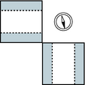
b) Now try to make a similar diagram of what would happen if you switched the wires on one of the solenoids.
After predicting what the compass will do, try it and see if you were right.
c)Now suppose you were to go back to the arrangement you had in part a, but you changed one of the currents to half its former value. Make a vector addition diagram, and use trig to predict the angle.
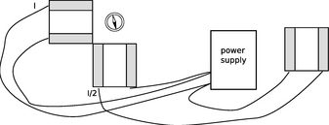
Try it. To cut the current to one of the solenoids in half, an easy and accurate method is simply to put the third solenoid in series with it, and put that third solenoid so far away that its magnetic field doesn't have any significant effect on the compass.
\end{exsection}

Footnotes
[1] In chapter 7, we saw that as a consequence of Einstein's theory of relativity, material objects can never move faster than the speed of light. Although we haven't explicitly shown that signals or information are subject to the same limit, the reasoning of homework problem 5 on page 362 can be extended to show that causality would be violated if signals could exceed the speed of light.
[2] rhymes with “mouse”
[3] Current is a scalar, since the definition I=d q/d t is the derivative of a scalar. However, there is a closely related quantity called the current density, J, which is a vector, and J is in fact the more fundamentally important quantity.
[4] As in chapter 2, we use the word “frequency” to mean either f or ω=2π f when the context makes it clear which is being referred to.
[5] I cheated a little. If z's argument is 30 degrees, then we could say 's was -30, but we could also call it 330. That's OK, because 330+30 gives 360, and an argument of 360 is the same as an argument of zero.
[6] A resistor always turns electrical energy into heat. It never turns heat into electrical energy!
[7] To many people, the word “radiation” implies nuclear contamination. Actually, the word simply means something that “radiates” outward. Natural sunlight is “radiation.” So is the light from a lightbulb, or the infrared light being emitted by your skin right now.
[8] Note that this time “frequency” means f, not ω! Physicists and engineers generally use ω because it simplifies the equations, but electricians and technicians always use f. The 60 Hz frequency is for the U.S.
[9] no relation to the human mathematician of the same name
[10] Newton's human namesake actually proved this for gravity, not electricity, but they're both 1/r² forces, so the proof works equally well in both cases.
[11] The math gets messy for the off-axis case. This part of the proof can be completed more easily and transparently using the techniques of section 10.7, and that is exactly we'll do in example 34 on page 553.

11. Electromagnetism
Table of Contents

Contents
Section 11.1 - More About the Magnetic Field
Section 11.2 - Magnetic Fields by Superposition
Section 11.3 - Magnetic Fields by Ampère's Law
Section 11.4 - Ampère's Law in Differential Form (optional)
Section 11.5 - Induced Electric Fields
Section 11.6 - Maxwell's Equations
Section 11.7 - Electromagnetic Properties of Materials

Chapter 11. Electromagnetism
Think not that I am come to destroy the law, or the prophets: I am not come to destroy, but to fulfill. -- Matthew 5:17

11.1 More About the Magnetic Field
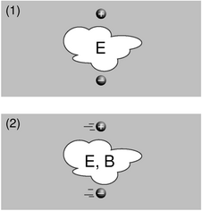
a / The pair of charged particles, as seen in two different frames of reference.
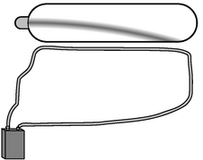
b / A large current is created by shorting across the leads of the battery. The moving charges in the wire attract the moving charges in the electron beam, causing the electrons to curve.
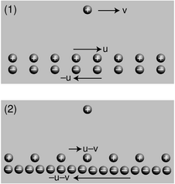
c / A charged particle and a current, seen in two different frames of reference. The second frame is moving at velocity v with respect to the first frame, so all the velocities have v subtracted from them. (As discussed in the main text, this is only approximately correct.)

Magnetic forces
In this chapter, I assume you know a few basic ideas about Einstein's theory of relativity, as described in section 7.1. Unless your typical workday involves rocket ships or particle accelerators, all this relativity stuff might sound like a description of some bizarre futuristic world that is completely hypothetical. There is, however, a relativistic effect that occurs in everyday life, and it is obvious and dramatic: magnetism. Magnetism, as we discussed previously, is an interaction between a moving charge and another moving charge, as opposed to electric forces, which act between any pair of charges, regardless of their motion. Relativistic effects are weak for speeds that are small compared to the speed of light, and the average speed at which electrons drift through a wire is quite low (centimeters per second, typically), so how can relativity be behind an impressive effect like a car being lifted by an electromagnet hanging from a crane? The key is that matter is almost perfectly electrically neutral, and electric forces therefore cancel out almost perfectly. Magnetic forces really aren't very strong, but electric forces are even weaker.
What about the word “relativity” in the name of the theory? It would seem problematic if moving charges interact differently than stationary charges, since motion is a matter of opinion, depending on your frame of reference. Magnetism, however, comes not to destroy relativity but to fulfill it. Magnetic interactions must exist according to the theory of relativity. To understand how this can be, consider how time and space behave in relativity. Observers in different frames of reference disagree about the lengths of measuring sticks and the speeds of clocks, but the laws of physics are valid and self-consistent in either frame of reference. Similarly, observers in different frames of reference disagree about what electric and magnetic fields and forces there are, but they agree about concrete physical events. For instance, figure a/1 shows two particles, with opposite charges, which are not moving at a particular moment in time. An observer in this frame of reference says there are electric fields around the particles, and predicts that as time goes on, the particles will begin to accelerate towards one another, eventually colliding. A different observer, a/2, says the particles are moving. This observer also predicts that the particles will collide, but explains their motion in terms of both an electric field, E, and a magnetic field, B. As we'll see shortly, the magnetic field is required in order to maintain consistency between the predictions made in the two frames of reference.
To see how this really works out, we need to find a nice simple example that is easy to calculate. An example like figure a is not easy to handle, because in the second frame of reference, the moving charges create fields that change over time at any given location. Examples like figure b are easier, because there is a steady flow of charges, and all the fields stay the same over time.¹ What is remarkable about this demonstration is that there can be no electric fields acting on the electron beam at all, since the total charge density throughout the wire is zero. Unlike figure a/2, figure b is purely magnetic.
To see why this must occur based on relativity, we make the mathematically idealized model shown in figure c. The charge by itself is like one of the electrons in the vacuum tube beam of figure b, and a pair of moving, infinitely long line charges has been substituted for the wire. The electrons in a real wire are in rapid thermal motion, and the current is created only by a slow drift superimposed on this chaos. A second deviation from reality is that in the real experiment, the protons are at rest with respect to the tabletop, and it is the electrons that are in motion, but in c/1 we have the positive charges moving in one direction and the negative ones moving the other way. If we wanted to, we could construct a third frame of reference in which the positive charges were at rest, which would be more like the frame of reference fixed to the tabletop in the real demonstration. However, as we'll see shortly, frames c/1 and c/2 are designed so that they are particularly easy to analyze. It's important to note that even though the two line charges are moving in opposite directions, their currents don't cancel. A negative charge moving to the left makes a current that goes to the right, so in frame c/1, the total current is twice that contributed by either line charge.
Frame 1 is easy to analyze because the charge densities of the two line charges cancel out, and the electric field experienced by the lone charge is therefore zero:
E₁ = 0
In frame 1, any force experienced by the lone charge must therefore be attributed solely to magnetism.
Frame 2 shows what we'd see if we were observing all this from a frame of reference moving along with the lone charge. Why don't the charge densities also cancel in this frame? Here's where the relativity comes in. Relativity tells us that moving objects appear contracted to an observer who is not moving along with them. Both line charges are in motion in both frames of reference, but in frame 1, the line charges were moving at equal speeds, so their contractions were equal, and their charge densities canceled out. In frame 2, however, their speeds are unequal. The positive charges are moving more slowly than in frame 1, so in frame 2 they are less contracted. The negative charges are moving more quickly, so their contraction is greater now. Since the charge densities don't cancel, there is an electric field in frame 2, which points into the wire, attracting the lone charge. Furthermore, the attraction felt by the lone charge must be purely electrical, since the lone charge is at rest in this frame of reference, and magnetic effects occur only between moving charges and other moving charges.²
To summarize, frame 1 displays a purely magnetic attraction, while in frame 2 it is purely electrical. Now we can calculate the force in frame 2, and equating it to the force in frame 1, we can find out how much magnetic force occurs. To keep the math simple, and to keep from assuming too much about your knowledge of relativity, we're going to carry out this whole calculation in the approximation where all the speeds are fairly small compared to the speed of light.³ For instance, if we find an expression such as (v/c)²+(v/c)⁴, we will assume that the fourth-order term is negligible by comparison. This is known as a calculation “to leading order in v/c.” In fact, I've already used the leading-order approximation twice without saying so! The first time I used it implicitly was in figure c, where I assumed that the velocities of the two line charges were u-v and -u-v. Relativistic velocities don't just combine by simple addition and subtraction like this, but this is an effect we can ignore in the present approximation. The second sleight of hand occurred when I stated that we could equate the forces in the two frames of reference. Force, like time and distance, is distorted relativistically when we change from one frame of reference to another. Again, however, this is an effect that we can ignore to the desired level of approximation.
Let ±λ be the charge per unit length of each line charge without relativistic contraction, i.e. in the frame moving with that line charge. Using the approximation γ=(1-v²/c²)^{-1/2}≈ 1+v²/2c² for v<< c, the total charge per unit length in frame 2 is
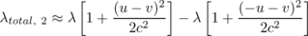
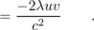
Let R be the distance from the line charge to the lone charge. Applying Gauss' law to a cylinder of radius R centered on the line charge, we find that the magnitude of the electric field experienced by the lone charge in frame 2 is
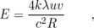
and the force acting on the lone charge q is
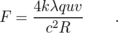
In frame 1, the current is I=2λ₁ u (see homework problem 9), which we can approximate as I=2λ u, since the current, unlike λ_{total, 2}, doesn't vanish completely without the relativistic effect. The magnetic force on the lone charge q due to the current I is
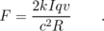
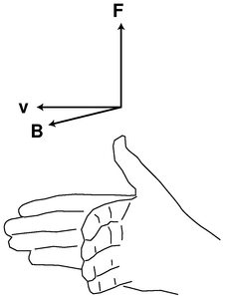
d / The right-hand relationship between the velocity of a positively charged particle, the magnetic field through which it is moving, and the magnetic force on it.
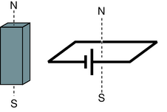
e / A standard dipole made from a square loop of wire shorting across a battery. It acts very much like a bar magnet, but its strength is more easily quantified.
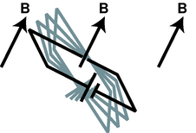
f / A dipole tends to align itself to the surrounding magnetic field.
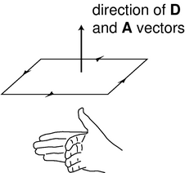
g / The m and A vectors.
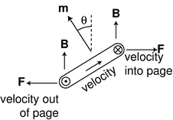
h / The torque on a current loop in a magnetic field. The current comes out of the page, goes across, goes back into the page, and then back across the other way in the hidden side of the loop.

i / A vector coming out of the page is shown with the tip of an arrowhead. A vector going into the page is represented using the tailfeathers of the arrow.
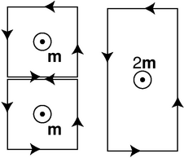
j / Dipole vectors can be added.
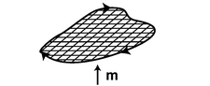
k / An irregular loop can be broken up into little squares.
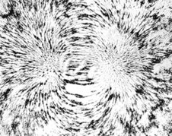
l / The magnetic field pattern around a bar magnet is created by the superposition of the dipole fields of the individual iron atoms. Roughly speaking, it looks like the field of one big dipole, especially farther away from the magnet. Closer in, however, you can see a hint of the magnet's rectangular shape. The picture was made by placing iron filings on a piece of paper, and then bringing a magnet up underneath.

The magnetic field

Definition in terms of the force on a moving particle
With electricity, it turned out to be useful to define an electric field rather than always working in terms of electric forces. Likewise, we want to define a magnetic field, B. Let's look at the result of the preceding subsection for insight. The equation
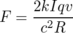
shows that when we put a moving charge near other moving charges, there is an extra magnetic force on it, in addition to any electric forces that may exist. Equations for electric forces always have a factor of k in front --- the Coulomb constant k is called the coupling constant for electric forces. Since magnetic effects are relativistic in origin, they end up having a factor of k/c² instead of just k. In a world where the speed of light was infinite, relativistic effects, including magnetism, would be absent, and the coupling constant for magnetism would be zero. A cute feature of the metric system is that we have k/c²=10⁻⁷ N⋅s²/C² exactly, as a matter of definition.
Naively, we could try to work by analogy with the electric field, and define the magnetic field as the magnetic force per unit charge. However, if we think of the lone charge in our example as the test charge, we'll find that this approach fails, because the force depends not just on the test particle's charge, but on its velocity, v, as well. Although we only carried out calculations for the case where the particle was moving parallel to the wire, in general this velocity is a vector, v, in three dimensions. We can also anticipate that the magnetic field will be a vector. The electric and gravitational fields are vectors, and we expect intuitively based on our experience with magnetic compasses that a magnetic field has a particular direction in space. Furthermore, reversing the current I in our example would have reversed the force, which would only make sense if the magnetic field had a direction in space that could be reversed. Summarizing, we think there must be a magnetic field vector B, and the force on a test particle moving through a magnetic field is proportional both to the B vector and to the particle's own v vector. In other words, the magnetic force vector F is found by some sort of vector multiplication of the vectors v and B. As proved on page 742, however, there is only one physically useful way of defining such a multiplication, which is the cross product.
We therefore define the magnetic field vector, B, as the vector that determines the force on a charged particle according to the following rule:
From this definition, we see that the magnetic field's units are N⋅s/C⋅m, which are usually abbreviated as teslas, 1 T=1 N⋅s/C⋅m. The definition implies a right-hand-rule relationship among the vectors, figure d, if the charge q is positive, and the opposite handedness if it is negative.
This is not just a definition but a bold prediction! Is it really true that for any point in space, we can always find a vector B that successfully predicts the force on any passing particle, regardless of its charge and velocity vector? Yes --- it's not obvious that it can be done, but experiments verify that it can. How? Well for example, the cross product of parallel vectors is zero, so we can try particles moving in various directions, and hunt for the direction that produces zero force; the B vector lies along that line, in either the same direction the particle was moving, or the opposite one. We can then go back to our data from one of the other cases, where the force was nonzero, and use it to choose between these two directions and find the magnitude of the B vector. We could then verify that this vector gave correct force predictions in a variety of other cases.
Even with this empirical reassurance, the meaning of this equation is not intuitively transparent, nor is it practical in most cases to measure a magnetic field this way. For these reasons, let's look at an alternative method of defining the magnetic field which, although not as fundamental or mathematically simple, may be more appealing.

Definition in terms of the torque on a dipole
A compass needle in a magnetic field experiences a torque which tends to align it with the field. This is just like the behavior of an electric dipole in an electric field, so we consider the compass needle to be a magnetic dipole. In subsection 10.1.3 on page 487, we gave an alternative definition of the electric field in terms of the torque on an electric dipole.
To define the strength of a magnetic field, however, we need some way of defining the strength of a test dipole, i.e. we need a definition of the magnetic dipole moment. We could use an iron permanent magnet constructed according to certain specifications, but such an object is really an extremely complex system consisting of many iron atoms, only some of which are aligned with each other. A more fundamental standard dipole is a square current loop. This could be little resistive circuit consisting of a square of wire shorting across a battery, e.
Applying F=v×B, we find that such a loop, when placed in a magnetic field, f, experiences a torque that tends to align plane so that its interior “face” points in a certain direction. Since the loop is symmetric, it doesn't care if we rotate it like a wheel without changing the plane in which it lies. It is this preferred facing direction that we will end up using as our alternative definition of the magnetic field.
If the loop is out of alignment with the field, the torque on it is proportional to the amount of current, and also to the interior area of the loop. The proportionality to current makes sense, since magnetic forces are interactions between moving charges, and current is a measure of the motion of charge. The proportionality to the loop's area is also not hard to understand, because increasing the length of the sides of the square increases both the amount of charge contained in this circular “river” and the amount of leverage supplied for making torque. Two separate physical reasons for a proportionality to length result in an overall proportionality to length squared, which is the same as the area of the loop. For these reasons, we define the magnetic dipole moment of a square current loop as
m = IA ,
where the direction of the vectors is defined as shown in figure g.
We can now give an alternative definition of the magnetic field:
The magnetic field vector, B, at any location in space is defined by observing the torque exerted on a magnetic test dipole m_{t} consisting of a square current loop. The field's magnitude is
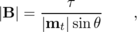
where θ is the angle between the dipole vector and the field. This is equivalent to the vector cross product .
Let's show that this is consistent with the previous definition, using the geometry shown in figure h. The velocity vector that point in and out of the page are shown using the convention defined in figure i. Let the mobile charge carriers in the wire have linear density λ, and let the sides of the loop have length h, so that we have I=λ v, and m=h²λ v. The only nonvanishing torque comes from the forces on the left and right sides. The currents in these sides are perpendicular to the field, so the magnitude of the cross product F=qv×B is simply |F|=qvB. The torque supplied by each of these forces is r×F, where the lever arm r has length h/2, and makes an angle θ with respect to the force vector. The magnitude of the total torque acting on the loop is therefore
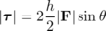
=h qvB sinθ ,
and substituting q=λ h and v=m/h²λ, we have
=m Bsinθ ,
which is consistent with the second definition of the field.
It undoubtedly seems artificial to you that we have discussed dipoles only in the form of a square loop of current. A permanent magnet, for example, is made out of atomic dipoles, and atoms aren't square! However, it turns out that the shape doesn't matter. To see why this is so, consider the additive property of areas and dipole moments, shown in figure j. Each of the square dipoles has a dipole moment that points out of the page. When they are placed side by side, the currents in the adjoining sides cancel out, so they are equivalent to a single rectangular loop with twice the area. We can break down any irregular shape into little squares, as shown in figure k, so the dipole moment of any planar current loop can be calculated based on its area, regardless of its shape.

Example 1: The magnetic dipole moment of an atom
Let's make an order-of-magnitude estimate of the magnetic dipole moment of an atom. A hydrogen atom is about 10⁻¹⁰ m in diameter, and the electron moves at speeds of about 10⁻² c. We don't know the shape of the orbit, and indeed it turns out that according to the principles of quantum mechanics, the electron doesn't even have a well-defined orbit, but if we're brave, we can still estimate the dipole moment using the cross-sectional area of the atom, which will be on the order of (10⁻¹⁰ m)²=10⁻²⁰ m². The electron is a single particle, not a steady current, but again we throw caution to the winds, and estimate the current it creates as e/Δ t, where Δ t, the time for one orbit, can be estimated by dividing the size of the atom by the electron's velocity. (This is only a rough estimate, and we don't know the shape of the orbit, so it would be silly, for instance, to bother with multiplying the diameter by π based on our intuitive visualization of the electron as moving around the circumference of a circle.) The result for the dipole moment is m∼10⁻²³ A⋅m².
Should we be impressed with how small this dipole moment is, or with how big it is, considering that it's being made by a single atom? Very large or very small numbers are never very interesting by themselves. To get a feeling for what they mean, we need to compare them to something else. An interesting comparison here is to think in terms of the total number of atoms in a typical object, which might be on the order of 10²⁶ (Avogadro's number). Suppose we had this many atoms, with their moments all aligned. The total dipole moment would be on the order of 10³ A⋅m², which is a pretty big number. To get a dipole moment this strong using human-scale devices, we'd have to send a thousand amps of current through a one-square meter loop of wire! The insight to be gained here is that, even in a permanent magnet, we must not have all the atoms perfectly aligned, because that would cause more spectacular magnetic effects than we really observe. Apparently, nearly all the atoms in such a magnet are oriented randomly, and do not contribute to the magnet's dipole moment.

Discussion Questions
◊ The physical situation shown in figure c on page 572 was analyzed entirely in terms of forces. Now let's go back and think about it in terms of fields. The charge by itself up above the wire is like a test charge, being used to determine the magnetic and electric fields created by the wire. In figures c/1 and c/2, are there fields that are purely electric or purely magnetic? Are there fields that are a mixture of E and B? How does this compare with the forces?
◊ Continuing the analysis begun in discussion question A, can we come up with a scenario involving some charged particles such that the fields are purely magnetic in one frame of reference but a mixture of E and B in another frame? How about an example where the fields are purely electric in one frame, but mixed in another? Or an example where the fields are purely electric in one frame, but purely magnetic in another?
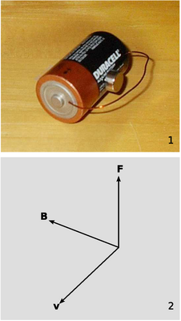
m / Example 2.
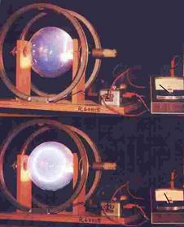
n / Magnetic forces cause a beam of electrons to move in a circle.
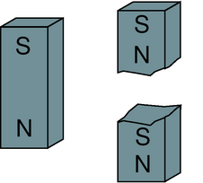
o / You can't isolate the poles of a magnet by breaking it in half.
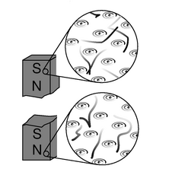
p / A magnetic dipole is made out of other dipoles, not out of monopoles.

Some applications

Example 2: Magnetic levitation
In figure m, a small, disk-shaped permanent magnet is stuck on the side of a battery, and a wire is clasped loosely around the battery, shorting it. A large current flows through the wire. The electrons moving through the wire feel a force from the magnetic field made by the permanent magnet, and this force levitates the wire.
From the photo, it's possible to find the direction of the magnetic field made by the permanent magnet. The electrons in the copper wire are negatively charged, so they flow from the negative (flat) terminal of the battery to the positive terminal (the one with the bump, in front). As the electrons pass by the permanent magnet, we can imagine that they would experience a field either toward the magnet, or away from it, depending on which way the magnet was flipped when it was stuck onto the battery. By the right-hand rule (figure d on page 575), the field must be toward the battery.

Example 3: Hallucinations during an MRI scan
During an MRI scan of the head, the patient's nervous system is exposed to intense magnetic fields. The average velocities of the charge-carrying ions in the nerve cells is fairly low, but if the patient moves her head suddenly, the velocity can be high enough that the magnetic field makes significant forces on the ions. This can result in visual and auditory hallucinations, e.g., frying bacon sounds.

Example 4: A circular orbit
The magnetic force is always perpendicular to the motion of the particle, so it can never do any work, and a charged particle moving through a magnetic field does not experience any change in its kinetic energy: its velocity vector can change its direction, but not its magnitude. If the velocity vector is initially perpendicular to the field, then the curve of its motion will remain in the plane perpendicular to the field, so the magnitude of the magnetic force on it will stay the same. When an object experiences a force with constant magnitude, which is always perpendicular to the direction of its motion, the result is that it travels in a circle.
Figure n shows a beam of electrons in a spherical vacuum tube. In the top photo, the beam is emitted near the right side of the tube, and travels straight up. In the bottom photo, a magnetic field has been imposed by an electromagnet surrounding the vacuum tube; the ammeter on the right shows that the current through the electromagnet is now nonzero. We observe that the beam is bent into a circle.
self-check: Infer the direction of the magnetic field. Don't forget that the beam is made of electrons, which are negatively charged! (answer in the back of the PDF version of the book)
Homework problem is a quantitative analysis of circular orbits.

Example 5: A velocity filter
Suppose you see the electron beam in figure n, and you want to determine how fast the electrons are going. You certainly can't do it with a stopwatch! Physicists may also encounter situations where they have a beam of unknown charged particles, and they don't even know their charges. This happened, for instance, when alpha and beta radiation were discovered. One solution to this problem relies on the fact that the force experienced by a charged particle in an electric field, F_{E}=qE, is independent of its velocity, but the force due to a magnetic field, F_{B}=qv×B, isn't. One can send a beam of charged particles through a space containing both an electric and a magnetic field, setting up the fields so that the two forces will cancel out perfectly for a certain velocity. Note that since both forces are proportional to the charge of the particles, the cancellation is independent of charge. Such a velocity filter can be used either to determine the velocity of an unknown beam or particles, or to select from a beam of particles only those having velocities within a certain desired range. Homework problem 14 is an analysis of this application.
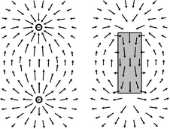
q / Magnetic fields have no sources or sinks.
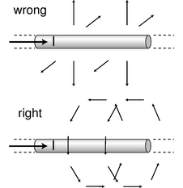
r / Example 6.

No magnetic monopoles
If you could play with a handful of electric dipoles and a handful of bar magnets, they would appear very similar. For instance, a pair of bar magnets wants to align themselves head-to-tail, and a pair of electric dipoles does the same thing. (It is unfortunately not that easy to make a permanent electric dipole that can be handled like this, since the charge tends to leak.)
You would eventually notice an important difference between the two types of objects, however. The electric dipoles can be broken apart to form isolated positive charges and negative charges. The two-ended device can be broken into parts that are not two-ended. But if you break a bar magnet in half, o, you will find that you have simply made two smaller two-ended objects.
The reason for this behavior is not hard to divine from our microscopic picture of permanent iron magnets. An electric dipole has extra positive “stuff” concentrated in one end and extra negative in the other. The bar magnet, on the other hand, gets its magnetic properties not from an imbalance of magnetic “stuff” at the two ends but from the orientation of the rotation of its electrons. One end is the one from which we could look down the axis and see the electrons rotating clockwise, and the other is the one from which they would appear to go counterclockwise. There is no difference between the “stuff” in one end of the magnet and the other, p.
Nobody has ever succeeded in isolating a single magnetic pole. In technical language, we say that magnetic monopoles not seem to exist. Electric monopoles do exist --- that's what charges are.
Electric and magnetic forces seem similar in many ways. Both act at a distance, both can be either attractive or repulsive, and both are intimately related to the property of matter called charge. (Recall that magnetism is an interaction between moving charges.) Physicists's aesthetic senses have been offended for a long time because this seeming symmetry is broken by the existence of electric monopoles and the absence of magnetic ones. Perhaps some exotic form of matter exists, composed of particles that are magnetic monopoles. If such particles could be found in cosmic rays or moon rocks, it would be evidence that the apparent asymmetry was only an asymmetry in the composition of the universe, not in the laws of physics. For these admittedly subjective reasons, there have been several searches for magnetic monopoles. Experiments have been performed, with negative results, to look for magnetic monopoles embedded in ordinary matter. Soviet physicists in the 1960s made exciting claims that they had created and detected magnetic monopoles in particle accelerators, but there was no success in attempts to reproduce the results there or at other accelerators. The most recent search for magnetic monopoles, done by reanalyzing data from the search for the top quark at Fermilab, turned up no candidates, which shows that either monopoles don't exist in nature or they are extremely massive and thus hard to create in accelerators.
The nonexistence of magnetic monopoles means that unlike an electric field, a magnetic one, can never have sources or sinks. The magnetic field vectors lead in paths that loop back on themselves, without ever converging or diverging at a point, as in the fields shown in figure q. Gauss' law for magnetism is therefore much simpler than Gauss' law for electric fields:
The magnetic flux through any closed surface is zero.
self-check: Draw a Gaussian surface on the electric dipole field of figure q that has nonzero electric flux through it, and then draw a similar surface on the magnetic field pattern. What happens? (answer in the back of the PDF version of the book)

Example 6: The field of a wire
◊ On page 574, we showed that a long, straight wire carrying current I exerts a magnetic force
on a particle with charge q moving parallel to the wire with velocity v. What, then, is the magnetic field of the wire?
◊ Comparing the equation above to the first definition of the magnetic field, F=v×B, it appears that the magnetic field is one that falls off like 1/ R, where R is the distance from the wire. However, it's not so easy to determine the direction of the field vector. There are two other axes along which the particle could have been moving, and the brute-force method would be to carry out relativistic calculations for these cases as well. Although this would probably be enough information to determine the field, we don't want to do that much work.
Instead, let's consider what the possibilities are. The field can't be parallel to the wire, because a cross product vanishes when the two vectors are parallel, and yet we know from the case we analyzed that the force doesn't vanish when the particle is moving parallel to the wire. The other two possibilities that are consistent with the symmetry of the problem are shown in figure r. One is like a bottle brush, and the other is like a spool of thread. The bottle brush pattern, however, violates Gauss' law for magnetism. If we made a cylindrical Gaussian surface with its axis coinciding with the wire, the flux through it would not be zero. We therefore conclude that the spool-of-thread pattern is the correct one.⁴ Since the particle in our example was moving perpendicular to the field, we have | F|=|q|| v|| B|, so
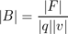
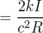

Symmetry and handedness
The physicist Richard Feynman helped to get me hooked on physics with an educational film containing the following puzzle. Imagine that you establish radio contact with an alien on another planet. Neither of you even knows where the other one's planet is, and you aren't able to establish any landmarks that you both recognize. You manage to learn quite a bit of each other's languages, but you're stumped when you try to establish the definitions of left and right (or, equivalently, clockwise and counterclockwise). Is there any way to do it?
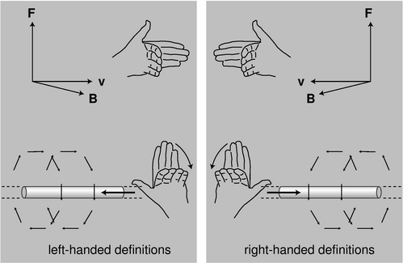
s / Left-handed and right-handed definitions.
If there was any way to do it without reference to external landmarks, then it would imply that the laws of physics themselves were asymmetric, which would be strange. Why should they distinguish left from right? The gravitational field pattern surrounding a star or planet looks the same in a mirror, and the same goes for electric fields. However, the magnetic field patterns shown in figure r seems to violate this principle. Could you use these patterns to explain left and right to the alien? No. If you look back at the definition of the magnetic field, it also contains a reference to handedness: the direction of the vector cross product. The aliens might have reversed their definition of the magnetic field, in which case their drawings of field patterns would look like mirror images of ours, as in the left panel of figure s.
Until the middle of the twentieth century, physicists assumed that any reasonable set of physical laws would have to have this kind of symmetry between left and right. An asymmetry would be grotesque. Whatever their aesthetic feelings, they had to change their opinions about reality when experiments showed that the weak nuclear force violates right-left symmetry! It is still a mystery why right-left symmetry is observed so scrupulously in general, but is violated by one particular type of physical process.

11.2 Magnetic Fields by Superposition
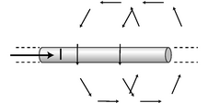
a / The magnetic field of a long, straight wire.
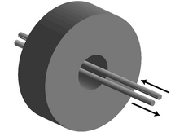
b / A ground fault interrupter.
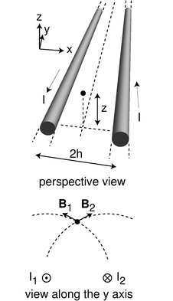
c / Example 8.
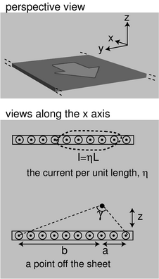
d / A sheet of charge.
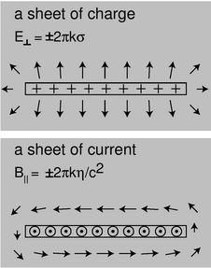
e / A sheet of charge and a sheet of current.

Superposition of straight wires
In chapter 10, one of the most important goals was to learn how to calculate the electric field for a given charge distribution. The corresponding problem for magnetism would be to calculate the magnetic field arising from a given set of currents. So far, however, we only know how to calculate the magnetic field of a long, straight wire,
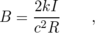
with the geometry shown in figure a. Whereas a charge distribution can be broken down into individual point charges, most currents cannot be broken down into a set of straight-line currents. Nevertheless, let's see what we can do with the tools that we have.

Example 7: A ground fault interrupter
Electric current in your home is supposed to flow out of one side of the outlet, through an appliance, and back into the wall through the other side of the outlet. If that's not what happens, then we have a problem --- the current must be finding its way to ground through some other path, perhaps through someone's body. If you have outlets in your home that have “test” and “reset” buttons on them, they have a safety device built into them that is meant to protect you in this situation. The ground fault interrupter (GFI) shown in figure b, routes the outgoing and returning currents through two wires that lie very close together. The clockwise and counterclockwise fields created by the two wires combine by vector addition, and normally cancel out almost exactly. However, if current is not coming back through the circuit, a magnetic field is produced. The doughnut-shaped collar detects this field (using an effect called induction, to be discussed in section 11.5), and sends a signal to a logic chip, which breaks the circuit within about 25 milliseconds.

Example 8: An example with vector addition
◊ Two long, straight wires each carry current I parallel to the y axis, but in opposite directions. They are separated by a gap 2 h in the x direction. Find the magnitude and direction of the magnetic field at a point located at a height z above the plane of the wires, directly above the center line.
◊ The magnetic fields contributed by the two wires add like vectors, which means we can add their x and z components. The x components cancel by symmetry. The magnitudes of the individual fields are equal,
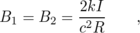
so the total field in the z direction is
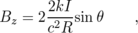
where θ is the angle the field vectors make above the x axis. The sine of this angle equals h/ R, so
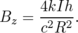
(Putting this explicitly in terms of z gives the less attractive form B_{z}=4 kIh/ c²( h²+ z²).)
At large distances from the wires, the individual fields are mostly in the ± x direction, so most of their strength cancels out. It's not surprising that the fields tend to cancel, since the currents are in opposite directions. What's more interesting is that not only is the field weaker than the field of one wire, it also falls off as R⁻² rather than R⁻¹. If the wires were right on top of each other, their currents would cancel each other out, and the field would be zero. From far away, the wires appear to be almost on top of each other, which is what leads to the more drastic R⁻² dependence on distance.
self-check: In example 8, what is the field right between the wires, at z=0, and how does this simpler result follow from vector addition? (answer in the back of the PDF version of the book)

An alarming infinity
An interesting aspect of the R⁻² dependence of the field in example 8 is the energy of the field. We've already established in the preceding chapter that the energy density of the magnetic field must be proportional to the square of the field strength, B², the same as for the gravitational and electric fields. Suppose we try to calculate the energy per unit length stored in the field of a single wire. We haven't yet found the proportionality factor that goes in front of the B², but that doesn't matter, because the energy per unit length turns out to be infinite! To see this, we can construct concentric cylindrical shells of length L, with each shell extending from R to R+d R. The volume of the shell equals its circumference times its thickness times its length, d v=(2π R)(d R)(L)=2π Ld R. For a single wire, we have B∼ R⁻¹, so the energy density is proportional to R⁻², and the energy contained in each shell varies as R⁻²d v∼ R⁻¹d r. Integrating this gives a logarithm, and as we let R approach infinity, we get the logarithm of infinity, which is infinite.
Taken at face value, this result would imply that electrical currents could never exist, since establishing one would require an infinite amount of energy per unit length! In reality, however, we would be dealing with an electric circuit, which would be more like the two wires of example 8: current goes out one wire, but comes back through the other. Since the field really falls off as R⁻², we have an energy density that varies as R⁻⁴, which does not give infinity when integrated out to infinity. (There is still an infinity at R=0, but this doesn't occur for a real wire, which has a finite diameter.)
Still, one might worry about the physical implications of the single-wire result. For instance, suppose we turn on an electron gun, like the one in a TV tube. It takes perhaps a microsecond for the beam to progress across the tube. After it hits the other side of the tube, a return current is established, but at least for the first microsecond, we have only a single current, not two. Do we have infinite energy in the resulting magnetic field? No. It takes time for electric and magnetic field disturbances to travel outward through space, so during that microsecond, the field spreads only to some finite value of R, not R=∞.
This reminds us of an important fact about our study of magnetism so far: we have only been considering situations where the currents and magnetic fields are constant over time. The equation B = 2kI/c²R was derived under this assumption. This equation is only valid if we assume the current has been established and flowing steadily for a long time, and if we are talking about the field at a point in space at which the field has been established for a long time. The generalization to time-varying fields is nontrivial, and qualitatively new effects will crop up. We have already seen one example of this on page 519, where we inferred that an inductor's time-varying magnetic field creates an electric field --- an electric field which is not created by any charges anywhere. Effects like these will be discussed in section 11.5

A sheet of current
There is a saying that in computer science, there are only three nice numbers: zero, one, and however many you please. In other words, computer software shouldn't have arbitrary limitations like a maximum of 16 open files, or 256 e-mail messages per mailbox. When superposing the fields of long, straight wires, the really interesting cases are one wire, two wires, and infinitely many wires. With an infinite number of wires, each carrying an infinitesimal current, we can create sheets of current, as in figure d. Such a sheet has a certain amount of current per unit length, which we notate η (Greek letter eta). The setup is similar to example 8, except that all the currents are in the same direction, and instead of adding up two fields, we add up an infinite number of them by doing an integral. For the y component, we have
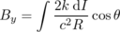
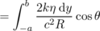
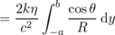
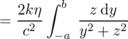
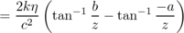
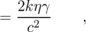
where in the last step we have used the identity tan⁻¹(-x)=-tan⁻¹x, combined with the relation tan⁻¹b/z+tan⁻¹a/z=γ, which can be verified with a little geometry and trigonometry. The calculation of B_{z} is left as an exercise (problem 17). More interesting is what happens underneath the sheet: by the right-hand rule, all the currents make rightward contributions to the field there, so B_{y} abruptly reverses itself as we pass through the sheet.
Close to the sheet, the angle γ approaches π, so we have
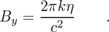
Figure e shows the similarity between this result and the result for a sheet of charge. In one case the sources are charges and the field is electric; in the other case we have currents and magnetic fields. In both cases we find that the field changes suddenly when we pass through a sheet of sources, and the amount of this change doesn't depend on the size of the sheet. It was this type of reasoning that eventually led us to Gauss' law in the case of electricity, and in section 11.3 we will see that a similar approach can be used with magnetism. The difference is that, whereas Gauss' law involves the flux, a measure of how much the field spreads out, the corresponding law for magnetism will measure how much the field curls.
Is it just dumb luck that the magnetic-field case came out so similar to the electric field case? Not at all. We've already seen that what one observer perceives as an electric field, another observer may perceive as a magnetic field. An observer flying along above a charged sheet will say that the charges are in motion, and will therefore say that it is both a sheet of current and a sheet of charge. Instead of a pure electric field, this observer will experience a combination of an electric field and a magnetic one. (We could also construct an example like the one in figure c on page 572, in which the field was purely magnetic.)

Energy in the magnetic field
In section 10.4, I've already argued that the energy density of the magnetic field must be proportional to |B|², which we can write as B² for convenience. To pin down the constant of proportionality, we now need to do something like the argument on page 502: find one example where we can calculate the mechanical work done by the magnetic field, and equate that to the amount of energy lost by the field itself. The easiest example is two parallel sheets of charge, with their currents in opposite directions. Homework problem is such a calculation, which gives the result
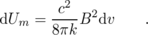
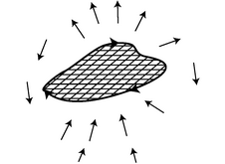
f / The field of any planar current loop can be found by breaking it down into square dipoles.
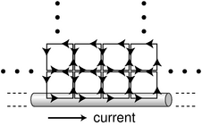
g / A long, straight current-carrying wire can be constructed by filling half of a plane with square dipoles.
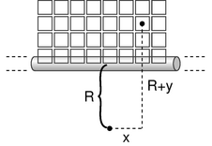
h / Setting up the integral.
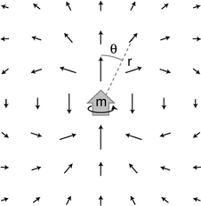
i / The field of a dipole.
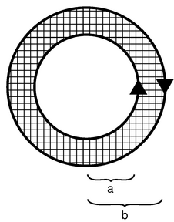
j / Example 9.

Superposition of dipoles
To understand this subsection, you'll have to have studied section 4.2.4, on iterated integrals.

The distant field of a dipole, in its midplane
Most current distributions cannot be broken down into long, straight wires, and subsection 11.2.1 has exhausted most of the interesting cases we can handle in this way. A much more useful building block is a square current loop. We have already seen how the dipole moment of an irregular current loop can be found by breaking the loop down into square dipoles (figure k on page 578), because the currents in adjoining squares cancel out on their shared edges. Likewise, as shown in figure f, if we could find the magnetic field of a square dipole, then we could find the field of any planar loop of current by adding the contributions to the field from all the squares.
The field of a square-loop dipole is very complicated close up, but luckily for us, we only need to know the current at distances that are large compared to the size of the loop, because we're free to make the squares on our grid as small as we like. The distant field of a square dipole turns out to be simple, and is no different from the distant field of any other dipole with the same dipole moment. We can also save ourselves some work if we only worry about finding the field of the dipole in its own plane, i.e. the plane perpendicular to its dipole moment. By symmetry, the field in this plane cannot have any component in the radial direction (inward toward the dipole, or outward away from it); it is perpendicular to the plane, and in the opposite direction compared to the dipole vector. (The field inside the loop is in the same direction as the dipole vector, but we're interested in the distant field.) Letting the dipole vector be along the z axis, we find that the field in the x-y plane is of the form B_{z}=f(r), where f(r) is some function that depends only on r, the distance from the dipole.
We can pin down the result even more without any math. We know that the magnetic field made by a current always contains a factor of k/c², which is the coupling constant for magnetism. We also know that the field must be proportional to the dipole moment, m=IA. Fields are always directly proportional to currents, and the proportionality to area follows because dipoles add according to their area. For instance, a square dipole that is 2 micrometers by 2 micrometers in size can be cut up into four dipoles that are 1 micrometer on a side. This tells us that our result must be of the form B_{z}=(k/c²)(IA)g(r). Now if we multiply the quantity (k/c²)(IA) by the function g(r), we have to get units of teslas, and this only works out if g(r) has units of m⁻³ (homework problem ), so our result must be of the form
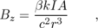
where β is a unitless constant. Thus our only task is to determine β, and we will have determined the field of the dipole (in the plane of its current, i.e., the midplane with respect to its dipole moment vector).
If we wanted to, we could simply build a dipole, measure its field, and determine β empirically. Better yet, we can get an exact result if we take a current loop whose field we know exactly, break it down into infinitesimally small squares, integrate to find the total field, set this result equal to the known expression for the field of the loop, and solve for β. There's just one problem here. We don't yet know an expression for the field of any current loop of any shape --- all we know is the field of a long, straight wire. Are we out of luck? No, because, as shown in figure g, we can make a long, straight wire by putting together square dipoles! Any square dipole away from the edge has all four of its currents canceled by its neighbors. The only currents that don't cancel are the ones on the edge, so by superimposing all the square dipoles, we get a straight-line current.
This might seem strange. If the squares on the interior have all their currents canceled out by their neighbors, why do we even need them? Well, we need the squares on the edge in order to make the straight-line current. We need the second row of squares to cancel out the currents at the top of the first row of squares, and so on.
Integrating as shown in figure h, we have
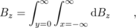
where d B_{z} is the contribution to the total magnetic field at our point of interest, which lies a distance R from the wire.
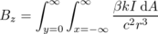
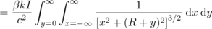
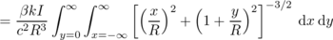
This can be simplified with the substitutions x=Ru, y=Rv, and d x d y=R² d u d v :
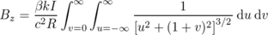
The u integral is of the form 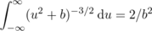, so
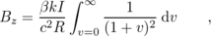
and the remaining v integral is equals 2, so
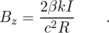
This is the field of a wire, which we already know equals 2kI/c²R, so we have β=1. Remember, the point of this whole calculation was not to find the field of a wire, which we already knew, but to find the unitless constant β in the expression for the field of a dipole. The distant field of a dipole, in its midplane, is therefore B_{z}=β kIA/c²r³= kIA/c²r³, or, in terms of the dipole moment,
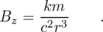

The distant field of a dipole, out of its midplane
What about the field of a magnetic dipole outside of the dipole's midplane? Let's compare with an electric dipole. An electric dipole, unlike a magnetic one, can be built out of two opposite monopoles, i.e., charges, separated by a certain distance, and it is then straightforward to show by vector addition that the field of an electric dipole is
where r is the distance from the dipole to the point of interest, θ is the angle between the dipole vector and the line connecting the dipole to this point, and E_{z} and E_{R} are, respectively, the components of the field parallel to and perpendicular to the dipole vector.
In the midplane, θ equals π/2, which produces E_{z}=-kDr⁻³ and E_{R}=0. This is the same as the field of a magnetic dipole in its midplane, except that the electric coupling constant k replaces the magnetic version k/c², and the electric dipole moment D is substituted for the magnetic dipole moment m. It is therefore reasonable to conjecture that by using the same presto-change-o recipe we can find the field of a magnetic dipole outside its midplane:
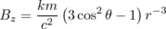
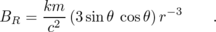
This turns out to be correct. ⁵

Example 9: Concentric, counterrotating currents
◊ Two concentric circular current loops, with radii a and b, carry the same amount of current I, but in opposite directions. What is the field at the center?
◊ We can produce these currents by tiling the region between the circles with square current loops, whose currents all cancel each other except at the inner and outer edges. The flavor of the calculation is the same as the one in which we made a line of current by filling a half-plane with square loops. The main difference is that this geometry has a different symmetry, so it will make more sense to use polar coordinates instead of x and y. The field at the center is
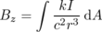
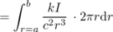
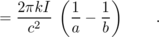
The positive sign indicates that the field is out of the page.

Example 10: Field at the center of a circular loop
◊ What is the magnetic field at the center of a circular current loop of radius a, which carries a current I?
◊ This is like example 9, but with the outer loop being very large, and therefore too distant to make a significant field at the center. Taking the limit of that result as b approaches infinity, we have
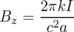
Comparing the results of examples 9 and 10, we see that the directions of the fields are both out of the page. In example 9, the outer loop has a current in the opposite direction, so it contributes a field that is into the page. This, however, is weaker than the field due to the inner loop, which dominates because it is less distant.
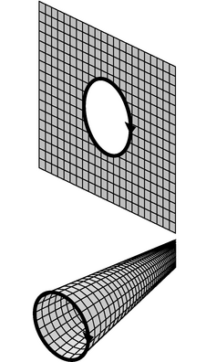
k / Two ways of making a current loop out of square dipoles.
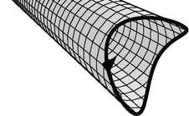
l / The new method can handle non-planar currents.
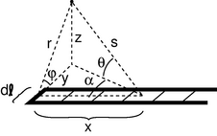
m / The field of an infinite U.
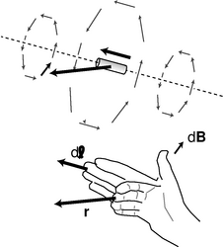
n / The geometry of the Biot-Savart law. The small arrows show the result of the Biot-Savart law at various positions relative to the current segment . The Biot-Savart law involves a cross product, and the right-hand rule for this cross product is demonstrated for one case.
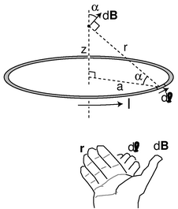
o / Example 12.

The Biot-Savart law (optional)
In section 11.2.3 we developed a method for finding the field due to a given current distribution by tiling a plane with square dipoles. This method has several disadvantages:
- The currents all have to lie in a single plane, and the point at which we're computing the field must be in that plane as well.
- We need to do integral over an area, which means one integral inside another, e.g. 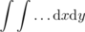. That can get messy.
- It's physically bizarre to have to construct square dipoles in places where there really aren't any currents.
Figure k shows the first step in eliminating these defects: instead of spreading our dipoles out in a plane, we bring them out along an axis. As shown in figure l, this eliminates the restriction to currents that lie in a plane. Now we have to use the general equations for a dipole field from page 593, rather than the simpler expression for the field in the midplane of a dipole. This increase in complication is more than compensated for by a fortunate feature of the new geometry, which is that the infinite tube can be broken down into strips, and we can find the field of such a strip for once and for all. This means that we no longer have to do one integral inside another. The derivation of the most general case is a little messy, so I'll just present the case shown in figure m, where the point of interest is assumed to lie in the y-z plane. Intuitively, what we're really finding is the field of the short piece of length on the end of the U; the two long parallel segments are going to be canceled out by their neighbors when we assemble all the strips to make the tube. We expect that the field of this end-piece will form a pattern that circulates around the y axis, so at the point of interest, it's really the x component of the field that we want to compute:
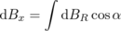
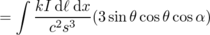
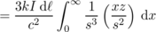
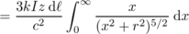
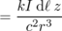
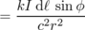
In the more general case, l, the current loop is not planar, the point of interest is not in the end-planes of the U's, and the U shapes have their ends staggered, so the end-piece is not the only part of each U whose current is not canceled. Without going into the gory details, the correct general result is as follows:
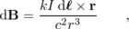
which is known as the Biot-Savart law. (It rhymes with “leo bazaar.” Both t's are silent.) The distances and r are now defined as vectors, and r, which point, respectively, in the direction of the current in the end-piece and the direction from the end-piece to the point of interest. The new equation looks different, but it is consistent with the old one. The vector cross product has a magnitude , which cancels one of r's in the denominator and makes the into a vector with magnitude .

Example 11: The field at the center of a circular loop
Previously we had to do quite a bit of work (examples 9 and 10), to calculate the field at the center of a circular loop of current of radius a. It's much easier now. Dividing the loop into many short segments, each is perpendicular to the r vector that goes from it to the center of the circle, and every r vector has magnitude a. Therefore every cross product has the same magnitude, , as well as the same direction along the axis perpendicular to the loop. The field is
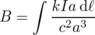
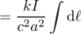
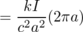
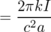

Example 12: Out-of-the-plane field of a circular loop
◊ What is the magnetic field of a circular loop of current at a point on the axis perpendicular to the loop, lying a distance z from the loop's center?
◊ Again, let's write a for the loop's radius. The r vector now has magnitude , but it is still perpendicular to the vector. By symmetry, the only nonvanishing component of the field is along the z axis,
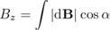
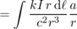
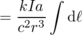
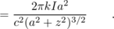

Is it the field of a particle?
We have a simple equation, based on Coulomb's law, for the electric field surrounding a charged particle. Looking at figure n, we can imagine that if the current segment was very short, then it might only contain one electron. It's tempting, then, to interpret the Biot-Savart law as a similar equation for the magnetic field surrounding a moving charged particle. Tempting but wrong! Suppose you stand at a certain point in space and watch a charged particle move by. It has an electric field, and since it's moving, you will also detect a magnetic field on top of that. Both of these fields change over time, however. Not only do they change their magnitudes and directions due to your changing geometric relationship to the particle, but they are also time-delayed, because disturbances in the electromagnetic field travel at the speed of light, which is finite. The fields you detect are the ones corresponding to where the particle used to be, not where it is now. Coulomb's law and the Biot-Savart law are both false in this situation, since neither equation includes time as a variable. It's valid to think of Coulomb's law as the equation for the field of a stationary charged particle, but not a moving one. The Biot-Savart law fails completely as a description of the field of a charged particle, since stationary particles don't make magnetic fields, and the Biot-Savart law fails in the case where the particle is moving.
If you look back at the long chain of reasoning that led to the Biot-Savart law, it all started from the relativistic arguments at the beginning of this chapter, where we assumed a steady current in an infinitely long wire. Everything that came later was built on this foundation, so all our reasoning depends on the assumption that the currents are steady. In a steady current, any charge that moves away from a certain spot is replaced by more charge coming up behind it, so even though the charges are all moving, the electric and magnetic fields they produce are constant. Problems of this type are called electrostatics and magnetostatics problems, and it is only for these problems that Coulomb's law and the Biot-Savart law are valid.
You might think that we could patch up Coulomb's law and the Biot-Savart law by inserting the appropriate time delays. However, we've already seen a clear example of a phenomenon that wouldn't be fixed by this patch: on page 519, we found that a changing magnetic field creates an electric field. Induction effects like these also lead to the existence of light, which is a wave disturbance in the electric and magnetic fields. We could try to apply another band-aid fix to Coulomb's law and the Biot-Savart law to make them deal with induction, but it won't work.
So what are the fundamental equations that describe how sources give rise to electromagnetic fields? We've already encountered two of them: Gauss' law for electricity and Gauss' law for magnetism. Experiments show that these are valid in all situations, not just static ones. But Gauss' law for magnetism merely says that the magnetic flux through a closed surface is zero. It doesn't tell us how to make magnetic fields using currents. It only tells us that we can't make them using magnetic monopoles. The following section develops a new equation, called Ampère's law, which is equivalent to the Biot-Savart law for magnetostatics, but which, unlike the Biot-Savart law, can easily be extended to nonstatic situations.

11.3 Magnetic Fields by Ampère's Law
a / The electric field of a sheet of charge, and the magnetic field of a sheet of current.
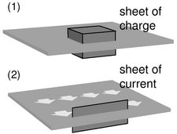
b / A Gaussian surface and an Ampèrian surface.
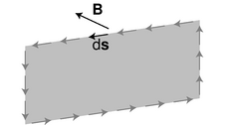
c / The definition of the circulation, Γ.
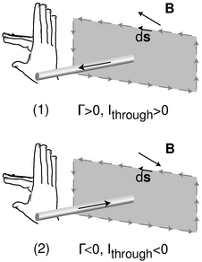
d / Positive and negative signs in Ampère's law.
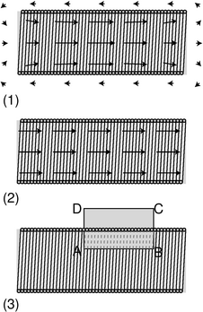
e / Example 13: a cutaway view of a solenoid.

Ampère's law
As discussed at the end of subsection 11.2.4, our goal now is to find an equation for magnetism that, unlike the Biot-Savart law, will not end up being a dead end when we try to extend it to nonstatic situations.⁶ Experiments show that Gauss' law is valid in both static and nonstatic situations, so it would be reasonable to look for an approach to magnetism that is similar to the way Gauss' law deals with electricity.
How can we do this? Figure a, reproduced from page , is our roadmap. Electric fields spread out from charges. Magnetic fields curl around currents. In figure b/1, we define a Gaussian surface, and we define the flux in terms of the electric field pointing out through this surface. In the magnetic case, b/2, we define a surface, called an Ampèrian surface, and we define a quantity called the circulation, Γ (uppercase Greek gamma), in terms of the magnetic field that points along the edge of the Ampèrian surface, c. We break the edge into tiny parts s_{j}, and for each of these parts, we define a contribution to the circulation using the dot product of ds with the magnetic field:
The circulation is a measure of how curly the field is. Like a Gaussian surface, an Ampèrian surface is purely a mathematical construction. It is not a physical object.
In figure b/2, the field is perpendicular to the edges on the ends, but parallel to the top and bottom edges. A dot product is zero when the vectors are perpendicular, so only the top and bottom edges contribute to Γ. Let these edges have length s. Since the field is constant along both of these edges, we don't actually have to break them into tiny parts; we can just have s₁ on the top edge, pointing to the left, and s₂ on the bottom edge, pointing to the right. The vector s₁ is in the same direction as the field B₁, and s₂ is in the same direction as B₂, so the dot products are simply equal to the products of the vectors' magnitudes. The resulting circulation is
Γ = |s₁||B₁|+|s₂||B₂|
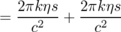
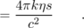
But η s is (current/length)(length), i.e. it is the amount of current that pierces the Ampèrian surface. We'll call this current I_{through}. We have found one specific example of the general law of nature known as Ampère's law:
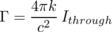

Positive and negative signs
Figures d/1 and d/2 show what happens to the circulation when we reverse the direction of the current I_{through}. Reversing the current causes the magnetic field to reverse itself as well. The dot products occurring in the circulation are all negative in d/2, so the total circulation is now negative. To preserve Ampère's law, we need to define the current in d/2 as a negative number. In general, determine these plus and minus signs using the right-hand rule shown in the figure. As the fingers of your hand sweep around in the direction of the s vectors, your thumb defines the direction of current which is positive. Choosing the direction of the thumb is like choosing which way to insert an ammeter in a circuit: on a digital meter, reversing the connections gives readings which are opposite in sign.

Example 13: A solenoid
◊ What is the field inside a long, straight solenoid of length and radius a, and having N loops of wire evenly wound along it, which carry a current I ?
◊ This is an interesting example, because it allows us to get a very good approximation to the field, but without some experimental input it wouldn't be obvious what approximation to use. Figure e/1 shows what we'd observe by measuring the field of a real solenoid. The field is nearly constant inside the tube, as long as we stay far away from the mouths. The field outside is much weaker. For the sake of an approximate calculation, we can idealize this field as shown in figure e/2. Of the edges of the Ampèrian surface shown in e/3, only AB contributes to the flux --- there is zero field along CD, and the field is perpendicular to edges BC and DA. Ampère's law gives
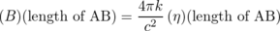
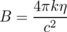
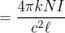
self-check: What direction is the current in figure e? (answer in the back of the PDF version of the book)
self-check: Based on how entered into the derivation in example 13, how should it be interpreted? Is it the total length of the wire? (answer in the back of the PDF version of the book)
self-check: Surprisingly, we never needed to know the radius of the solenoid in example 13. Why is it physically plausible that the answer would be independent of the radius? (answer in the back of the PDF version of the book)
Example 13 shows how much easier it can sometimes be to calculate a field using Ampère's law rather than the approaches developed previously in this chapter. However, if we hadn't already known something about the field, we wouldn't have been able to get started. In situations that lack symmetry, Ampère's law may make things harder, not easier. Anyhow, we will have no choice in nonstatic cases, where Ampère's law is true, and static equations like the Biot-Savart law are false.
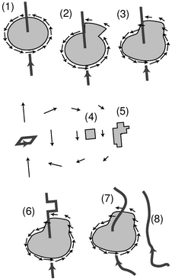
f / A proof of Ampère's law.

A quick and dirty proof
Here's an informal sketch for a proof of Ampère's law, with no pretensions to rigor. Even if you don't care much for proofs, it would be a good idea to read it, because it will help to build your ability to visualize how Ampère's law works.
First we establish by a direct computation (homework problem 31) that Ampère's law holds for the geometry shown in figure f/1, a circular Ampèrian surface with a wire passing perpendicularly through its center. If we then alter the surface as in figure f/2, Ampère's law still works, because the straight segments, being perpendicular to the field, don't contribute to the circulation, and the new arc makes the same contribution to the circulation as the old one it replaced, because the weaker field is compensated for by the greater length of the arc. It is clear that by a series of such modifications, we could mold the surface into any shape, f/3.
Next we prove Ampère's law in the case shown in figure f/4: a small, square Ampèrian surface subject to the field of a distant square dipole. This part of the proof can be most easily accomplished by the methods of section 11.4. It should, for example, be plausible in the case illustrated here. The field on the left edge is stronger than the field on the right, so the overall contribution of these two edges to the circulation is slightly counterclockwise. However, the field is not quite perpendicular to the top and bottoms edges, so they both make small clockwise contributions. The clockwise and counterclockwise parts of the circulation end up canceling each other out. Once Ampère's law is established for a square surface like f/4, it follows that it is true for an irregular surface like f/5, since we can build such a shape out of squares, and the circulations are additive when we paste the surfaces together this way.
By pasting a square dipole onto the wire, f/6, like a flag attached to a flagpole, we can cancel out a segment of the wire's current and create a detour. Ampère's law is still true because, as shown in the last step, the square dipole makes zero contribution to the circulation. We can make as many detours as we like in this manner, thereby morphing the wire into an arbitrary shape like f/7.
What about a wire like f/8? It doesn't pierce the Ampèrian surface, so it doesn't add anything to I_{through}, and we need to show that it likewise doesn't change the circulation. This wire, however, could be built by tiling the half-plane on its right with square dipoles, and we've already established that the field of a distant dipole doesn't contribute to the circulation. (Note that we couldn't have done this with a wire like f/7, because some of the dipoles would have been right on top of the Ampèrian surface.)
If Ampère's law holds for cases like f/7 and f/8, then it holds for any complex bundle of wires, including some that pass through the Ampèrian surface and some that don't. But we can build just about any static current distribution we like using such a bundle of wires, so it follows that Ampère's law is valid for any static current distribution.
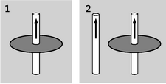
g / Discussion question A.
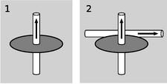
h / Discussion question B.
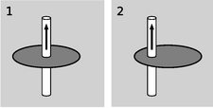
i / Discussion question C.
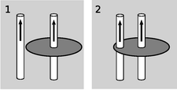
j / Discussion question D.
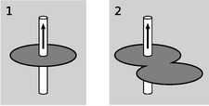
k / Discussion question E.

Maxwell's equations for static fields
Static electric fields don't curl the way magnetic fields do, so we can state a version of Ampère's law for electric fields, which is that the circulation of the electric field is zero. Summarizing what we know so far about static fields, we have
Φ_{E} = 4π kq_{in}
Φ_{B} = 0
Γ_{E} = 0
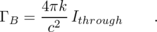
This set of equations is the static case of the more general relations known as Maxwell's equations. On the left side of each equation, we have information about a field. On the right is information about the field's sources.
It is vitally important to realize that these equations are only true for statics. They are incorrect if the distribution of charges or currents is changing over time. For example, we saw on page 519 that the changing magnetic field in an inductor gives rise to an electric field. Such an effect is completely inconsistent with the static version of Maxwell's equations; the equations don't even refer to time, so if the magnetic field is changing over time, they will not do anything special. The extension of Maxwell's equations to nonstatic fields is discussed in section 11.6.

Discussion Questions
◊ Figure g/1 shows a wire with a circular Ampèrian surface drawn around its waist; in this situation, Ampère's law can be verified easily based on the equation for the field of a wire. In panel 2, a second wire has been added. Explain why it's plausible that Ampère's law still holds.
◊ Figure h is like figure g, but now the second wire is perpendicular to the first, and lies in the plane of, and outside of, the Ampèrian surface. Carry out a similar analysis.
◊ This discussion question is similar to questions A and B, but now the Ampèrian surface has been moved off center.
◊ The left-hand wire has been nudged over a little. Analyze as before.
◊ You know what to do.

11.4 Ampère's Law in Differential Form (optional)
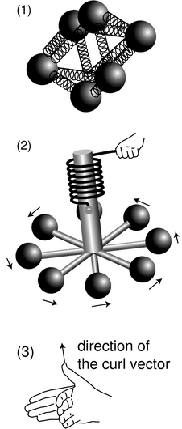
a / The div-meter, 1, and the curl-meter, 2 and 3.

The curl operator
The differential form of Gauss' law is more physically satisfying than the integral form, because it relates the charges that are present at some point to the properties of the electric field at the same point. Likewise, it would be more attractive to have a differential version of Ampère's law that would relate the currents to the magnetic field at a single point. intuitively, the divergence was based on the idea of the div-meter, a/1. The corresponding device for measuring the curliness of a field is the curl-meter, a/2. If the field is curly, then the torques on the charges will not cancel out, and the wheel will twist against the resistance of the spring. If your intuition tells you that the curlmeter will never do anything at all, then your intuition is doing a beautiful job on static fields; for nonstatic fields, however, it is perfectly possible to get a curly electric field.
Gauss' law in differential form relates , a scalar, to the charge density, another scalar. Ampère's law, however, deals with directions in space: if we reverse the directions of the currents, it makes a difference. We therefore expect that the differential form of Ampère's law will have vectors on both sides of the equal sign, and we should be thinking of the curl-meter's result as a vector. First we find the orientation of the curl-meter that gives the strongest torque, and then we define the direction of the curl vector using the right-hand rule shown in figure a/3.
To convert the div-meter concept to a mathematical definition, we found the infinitesimal flux, dΦ through a tiny cubical Gaussian surface containing a volume d v. By analogy, we imagine a tiny square Ampèrian surface with infinitesimal area dA. We assume this surface has been oriented in order to get the maximum circulation. The area vector dA will then be in the same direction as the one defined in figure a/3. Ampère's law is
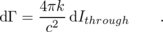
We define a current density per unit area, j, which is a vector pointing in the direction of the current and having magnitude j=d I/|dA|. In terms of this quantity, we have
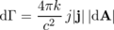
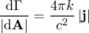
With this motivation, we define the magnitude of the curl as
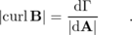
Note that the curl, just like a derivative, has a differential divided by another differential. In terms of this definition, we find Ampère's law in differential form:
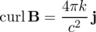
The complete set of Maxwell's equations in differential form is collected on page 747.

b / The coordinate system used in the following examples.
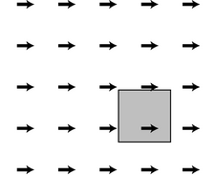
c / The field .
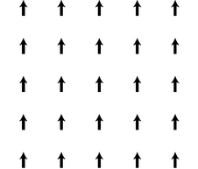
d / The field .
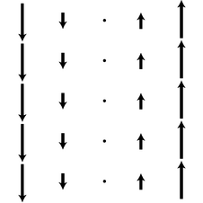
e / The field .
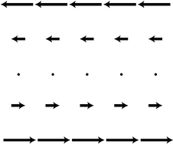
f / The field .
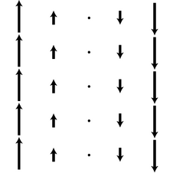
g / Example 14.
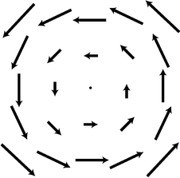
h / Example 15.
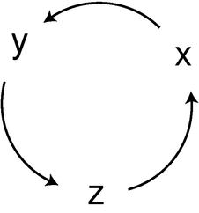
i / A cyclic permutation of x, y, and z.
j / Example 17.

Properties of the curl operator

The curl is a derivative.
As an example, let's calculate the curl of the field shown in figure c. For our present purposes, it doesn't really matter whether this is an electric or a magnetic field; we're just getting out feet wet with the curl as a mathematical definition. Applying the definition of the curl directly, we construct an Ampèrian surface in the shape of an infinitesimally small square. Actually, since the field is uniform, it doesn't even matter very much whether we make the square finite or infinitesimal. The right and left edges don't contribute to the circulation, since the field is perpendicular to these edges. The top and bottom do contribute, but the top's contribution is clockwise, i.e. into the page according to the right-hand rule, while the bottom contributes an equal amount in the counterclockwise direction, which corresponds to an out-of-the-page contribution to the curl. They cancel, and the circulation is zero. We could also have determined this by imagining a curl-meter inserted in this field: the torques on it would have canceled out.
It makes sense that the curl of a constant field is zero, because the curl is a kind of derivative. The derivative of a constant is zero.

The curl is rotationally invariant.
Figure c looks just like figure c, but rotated by 90 degrees. Physically, we could be viewing the same field from a point of view that was rotated. Since the laws of physics are the same regardless of rotation, the curl must be zero here as well. In other words, the curl is rotationally invariant. If a certain field has a certain curl vector, then viewed from some other angle, we simply see the same field and the same curl vector, viewed from a different angle. A zero vector viewed from a different angle is still a zero vector.
As a less trivial example, let's compute the curl of the field shown in figure e, at the point (x=0,y=0). The circulation around a square of side s centered on the origin can be approximated by evaluating the field at the midpoints of its sides, \begin{alignat*}{4} x=s/2 & y=0 & F=(s/2)\hat{y} & s_1\cdotF=s^2/2
x=0 & y=s/2 & F=0 & s_2\cdotF=0
x=-s/2 & y=0 & F=-(s/2)\hat{y} & s_3\cdotF=s^2/2
x=0 & y=-s/2 & F=0 & s_4\cdotF=0 ,
\end{alignat*} which gives a circulation of s², and a curl with a magnitude of s²/area=s²/s²=1. By the right-hand rule, the curl points out of the page, i.e. along the positive z axis, so we have
Now consider the field , shown in figure f. This is the same as the previous field, but with your book rotated by 90 degrees about the z axis. Rotating the result of the first calculation, , about the z axis doesn't change it, so the curl of this field is also .

Scaling
When you're taking an ordinary derivative, you have the rule
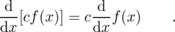
In other words, multiplying a function by a constant results in a derivative that is multiplied by that constant. The curl is a kind of derivative operator, and the same is true for a curl.

Example 14: Multiplying the field by -1.
◊ What is the curl of the field at the origin?
◊ Using the scaling property just discussed, we can make this into a curl that we've already calculated:
This is in agreement with the right-hand rule.

The curl is additive.
We have only calculated each field's curl at the origin, but each of these fields actually has the same curl everywhere. In example 14, for instance, it is obvious that the curl is constant along any vertical line. But even if we move along the x axis, there is still an imbalance between the torques on the left and right sides of the curl-meter. More formally, suppose we start from the origin and move to the left by one unit. We find ourselves in a region where the field is very much as it was before, except that all the field vectors have had one unit worth of added to them. But what do we get if we take the curl of ? The curl, like any god-fearing derivative operation, has the additive property
so
But the second term is zero, so we get the same result as at the origin.

Example 15: A field that goes in a circle
◊ What is the curl of the field ?
◊ Using the linearity of the curl, and recognizing each of the terms as one whose curl we have already computed, we find that this field's curl is a constant . This agrees with the right-hand rule.

Example 16: The field inside a long, straight wire
◊ What is the magnetic field inside a long, straight wire in which the current density is j?
◊ Let the wire be along the z axis, so . Ampère's law gives

In other words, we need a magnetic field whose curl is a constant. We've encountered several fields with constant curls, but the only one that has the same symmetry as the cylindrical wire is , so the answer must be this field or some constant multiplied by it,
The curl of this field is , so
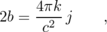
and thus
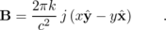

The curl in component form
Now consider the field
F_{x} = ax+by+c
F_{y} = dx+ey+f ,
i.e.
The only terms whose curls we haven't yet explicitly computed are the a, e, and f terms, and their curls turn out to be zero (homework problem 32). Only the b and d terms have nonvanishing curls. The curl of this field is
But any field in the x-y plane can be approximated with this type of field, as long as we only need to get a good approximation within a small region. The infinitesimal Ampèrian surface occurring in the definition of the curl is tiny enough to fit in a pretty small region, so we can get away with this here. The d and b coefficients can then be associated with the partial derivatives ∂ F_{y}/∂ x and ∂ F_{x}/∂ y. We therefore have
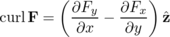
for any field in the x-y plane. In three dimensions, we just need to generate two more equations like this by doing a cyclic permutation of the variables x, y, and z:
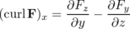
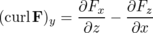
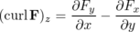

Example 17: A sine wave
◊ Find the curl of the following electric field
and interpret the result.
◊ The only nonvanishing partial derivative occurring in this curl is
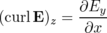
so
This is visually reasonable: the curl-meter would spin if we put its wheel in the plane of the page, with its axle poking out along the z axis. In some areas it would spin clockwise, in others counterclockwise, and this makes sense, because the cosine is positive in some placed and negative in others.
This is a perfectly reasonable field pattern: it the electric field pattern of a light wave! But Ampère's law for electric fields says the curl of E is supposed to be zero. What's going on? What's wrong is that we can't assume the static version of Ampère's law. All we've really proved is that this pattern is impossible as a static field: we can't have a light wave that stands still.
Figure k is a summary of the vector calculus presented in the optional sections of this book. The first column shows that one function is a related to another by a kind of differentiation. The second column states the fundamental theorem of calculus, which says that if you integrate the derivative over the interior of a region, you get some information about the original function at the boundary of that region.
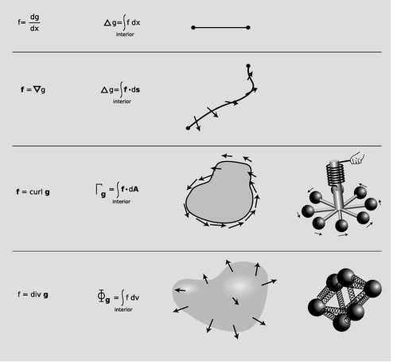
k / A summary of the derivative, gradient, curl, and divergence.

11.5 Induced Electric Fields

a / Faraday on a British banknote.
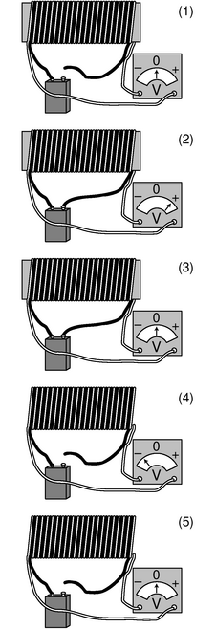
b / Faraday's experiment, simplified and shown with modern equipment.
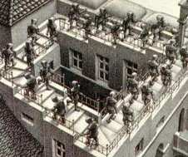
c / Detail from Ascending and Descending, M.C. Escher, 1960.
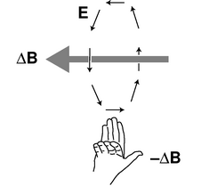
d / The relationship between the change in the magnetic field, and the electric field it produces.
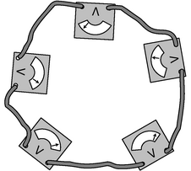
e / The electric circulation is the sum of the voltmeter readings.
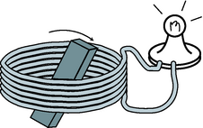
f / A generator.
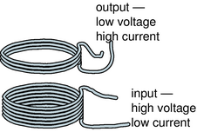
g / A transformer.

Faraday's experiment
Nature is simple, but the simplicity may not become evident until a hundred years after the discovery of some new piece of physics. We've already seen, on page 519, that the time-varying magnetic field in an inductor causes an electric field. This electric field is not created by charges. That argument, however, only seems clear with hindsight. The discovery of this phenomenon of induced electric fields --- fields that are not due to charges --- was a purely experimental accomplishment by Michael Faraday (1791-1867), the son of a blacksmith who had to struggle against the rigid class structure of 19th century England. Faraday, working in 1831, had only a vague and general idea that electricity and magnetism were related to each other, based on Oersted's demonstration, a decade before, that magnetic fields were caused by electric currents.
Figure b is a simplified drawing of the following experiment, as described in Faraday's original paper: “Two hundred and three feet of copper wire ... were passed round a large block of wood; [another] two hundred and three feet of similar wire were interposed as a spiral between the turns of the first, and metallic contact everywhere prevented by twine [insulation]. One of these [coils] was connected with a galvanometer [voltmeter], and the other with a battery... When the contact was made, there was a sudden and very slight effect at the galvanometer, and there was also a similar slight effect when the contact with the battery was broken. But whilst the ... current was continuing to pass through the one [coil], no ... effect ... upon the other [coil] could be perceived, although the active power of the battery was proved to be great, by its heating the whole of its own coil [through ordinary resistive heating] ...”
From Faraday's notes and publications, it appears that the situation in figure b/3 was a surprise to him, and he probably thought it would be a surprise to his readers, as well. That's why he offered evidence that the current was still flowing: to show that the battery hadn't just died. The induction effect occurred during the short time it took for the black coil's magnetic field to be established, b/2. Even more counterintuitively, we get an effect, equally strong but in the opposite direction, when the circuit is broken, b/4. The effect occurs only when the magnetic field is changing, and it appears to be proportional to the derivative ∂B/∂t, which is in one direction when the field is being established, and in the opposite direction when it collapses.
The effect is proportional to ∂B/∂t, but what is the effect? A voltmeter is nothing more than a resistor with an attachment for measuring the current through it. A current will not flow through a resistor unless there is some electric field pushing the electrons, so we conclude that the changing magnetic field has produced an electric field in the surrounding space. Since the white wire is not a perfect conductor, there must be electric fields in it as well. The remarkable thing about the circuit formed by the white wire is that as the electrons travel around and around, they are always being pushed forward by electric fields. This violates the loop rule, which says that when an electron makes a round trip, there is supposed to be just as much “uphill” (moving against the electric field) as “downhill” (moving with it). That's OK. The loop rule is only true for statics. Faraday's experiments show that an electron really can go around and around, and always be going “downhill,” as in the famous drawing by M.C. Escher shown in figure c. That's just what happens when you have a curly field.
When a field is curly, we can measure its curliness using a circulation. Unlike the magnetic circulation Γ_{B}, the electric circulation Γ_{E} is something we can measure directly using ordinary tools. A circulation is defined by breaking up a loop into tiny segments, ds, and adding up the dot products of these distance vectors with the field. But when we multiply electric field by distance, what we get is an indication of the amount of work per unit charge done on a test charge that has been moved through that distance. The work per unit charge has units of volts, and it can be measured using a voltmeter, as shown in figure e, where Γ_{E} equals the sum of the voltmeter readings. Since the electric circulation is directly measurable, most people who work with circuits are more familiar with it than they are with the magnetic circulation. They usually refer to Γ_{E} using the synonym “emf,” which stands for “electromotive force,” and notate it as . (This is an unfortunate piece of terminology, because its units are really volts, not newtons.) The term emf can also be used when the path is not a closed loop.
Faraday's experiment demonstrates a new relationship
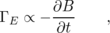
where the negative sign is a way of showing the observed left-handed relationship, d. This is similar to the structure of of Ampère's law:
Γ_{B} ∝ I_{through} ,
which also relates the curliness of a field to something that is going on nearby (a current, in this case).
It's important to note that even though the emf, Γ_{E}, has units of volts, it isn't a voltage. A voltage is a measure of the electrical energy a charge has when it is at a certain point in space. The curly nature of nonstatic fields means that this whole concept becomes nonsense. In a curly field, suppose one electron stays at home while its friend goes for a drive around the block. When they are reunited, the one that went around the block has picked up some kinetic energy, while the one who stayed at home hasn't. We simply can't define an electrical energy U_{e}=qV so that U_{e}+K stays the same for each electron. No voltage pattern, V, can do this, because then it would predict the same kinetic energies for the two electrons, which is incorrect. When we're dealing with nonstatic fields, we need to think of the electrical energy in terms of the energy density of the fields themselves.
It might sound as though an electron could get a free lunch by circling around and around in a curly electric field, resulting in a violation of conservation of energy. The following examples, in addition to their practical interest, both show that energy is in fact conserved.

Example 18: The generator
A basic generator, f, consists of a permanent magnet that rotates within a coil of wire. The magnet is turned by a motor or crank, (not shown). As it spins, the nearby magnetic field changes. This changing magnetic field results in an electric field, which has a curly pattern. This electric field pattern creates a current that whips around the coils of wire, and we can tap this current to light the lightbulb.
If the magnet was on a frictionless bearing, could we light the bulb for free indefinitely, thus violating conservation of energy? No. Mechanical work has to be done to crank the magnet, and that's where the energy comes from. If we break the light-bulb circuit, it suddenly gets easier to crank the magnet! This is because the current in the coil sets up its own magnetic field, and that field exerts a torque on the magnet. If we stopped cranking, this torque would quickly make the magnet stop turning.
self-check: When you're driving your car, the engine recharges the battery continuously using a device called an alternator, which is really just a generator. Why can't you use the alternator to start the engine if your car's battery is dead? (answer in the back of the PDF version of the book)

Example 19: The transformer
In example 17 on page 462, we discussed the advantages of transmitting power over electrical lines using high voltages and low currents. However, we don't want our wall sockets to operate at 10000 volts! For this reason, the electric company uses a device called a transformer, g, to convert everything to lower voltages and higher currents inside your house. The coil on the input side creates a magnetic field. Transformers work with alternating current, so the magnetic field surrounding the input coil is always changing. This induces an electric field, which drives a current around the output coil.
Since the electric field is curly, an electron can keep gaining more and more energy by circling through it again and again. Thus the output voltage can be controlled by changing the number of coils of wire on the output side. Changing the number of coils on the input side also has an effect (homework problem 33).
In any case, conservation of energy guarantees that the amount of power on the output side must equal the amount put in originally, I_{in}V_{in} = I_{out}V_{out}, so no matter what factor the voltage is reduced by, the current is increased by the same factor.

Discussion Questions
◊ Suppose the bar magnet in figure f on page 613 has a magnetic field pattern that emerges from its top, circling around and coming back in the bottom. This field is created by electrons orbiting atoms inside the magnet. Are these atomic currents clockwise or counterclockwise as seen from above? In what direction is the current flowing in the circuit?
We have a circling atomic current inside the circling current in the wires. When we have two circling currents like this, they will make torques on each other that will tend to align them in a certain way. Since currents in the same direction attract one another, which way is the torque made by the wires on the bar magnet? Verify that due to this torque, mechanical work has to be done in order to crank the generator.
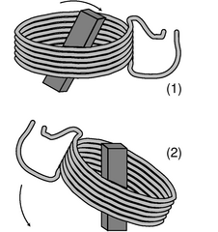
h / It doesn't matter whether it's the coil or the permanent magnet that spins. Either way, we get a functioning generator.
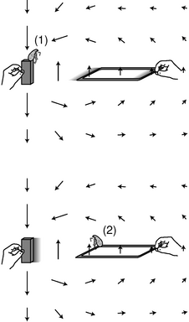
i / A generator that works with linear motion.

Why induction?
Faraday's results leave us in the dark about several things:
- They don't explain why induction effects occur.
- The relationship Γ_{E} ∝ -∂ B/∂ t tells us that a changing magnetic field creates an electric field in the surrounding region of space, but the phrase “surrounding region of space” is vague, and needs to be made mathematical.
- Suppose that we can make the “surrounding region of space” idea more well defined. We would then want to know the proportionality constant that has been hidden by the ∝ symbol. Although experiments like Faraday's could be used to find a numerical value for this constant, we would like to know why it should have that particular value.
We can get some guidance from the example of a car's alternator (which just means generator), referred to in the self-check on page 613. To keep things conceptually simple, I carefully avoided mentioning that in a real car's alternator, it isn't actually the permanent magnet that spins. The coil is what spins. The choice of design h/1 or h/2 is merely a matter of engineering convenience, not physics. All that matters is the relative motion of the two objects.
This is highly suggestive. As discussed at the beginning of this chapter, magnetism is a relativistic effect. From arguments about relative motion, we concluded that moving electric charges create magnetic fields. Now perhaps we can use reasoning with the same flavor to show that changing magnetic fields produce curly electric fields. Note that figure h/2 doesn't even require induction. The protons and electrons in the coil are moving through a magnetic field, so they experience forces. The protons can't flow, because the coil is a solid substance, but the electrons can, so a current is induced.⁷
Now if we're convinced that figure h/2 produces a current in the coil, then it seems very plausible that the same will happen in figure h/1, which implies the existence of induction effects. But this example involves circular motion, so it doesn't quite work as a way of proving that induction exists. When we say that motion is relative, we only mean straight-line motion, not circular motion.
A more ironclad relativistic argument comes from the arrangement shown in figure i. This is also a generator --- one that is impractical, but much easier to understand.
Flea 1 doesn't believe in this modern foolishness about induction. She's sitting on the bar magnet, which to her is obviously at rest. As the square wire loop is dragged away from her and the magnet, its protons experience a force out of the page, because the cross product F=qv×B is out of the page. The electrons, which are negatively charged, feel a force into the page. The conduction electrons are free to move, but the protons aren't. In the front and back sides of the loop, this force is perpendicular to the wire. In the right and left sides, however, the electrons are free to respond to the force. Note that the magnetic field is weaker on the right side. It's as though we had two pumps in a loop of pipe, with the weaker pump trying to push in the opposite direction; the weaker pump loses the argument.⁸ We get a current that circulates around the loop.⁹ There is no induction going on in this frame of reference; the forces that cause the current are just the ordinary magnetic forces experienced by any charged particle moving through a magnetic field.
Flea 2 is sitting on the loop, which she considers to be at rest. In her frame of reference, it's the bar magnet that is moving. Like flea 1, she observes a current circulating around the loop, but unlike flea 1, she cannot use magnetic forces to explain this current. As far as she is concerned, the electrons were initially at rest. Magnetic forces are forces between moving charges and other moving charges, so a magnetic field can never accelerate a charged particle starting from rest. A force that accelerates a charge from rest can only be an electric force, so she is forced to conclude that there is an electric field in her region of space. This field drives electrons around and around in circles, so it is apparently violating the loop rule --- it is a curly field. What reason can flea 2 offer for the existence of this electric field pattern? Well, she's been noticing that the magnetic field in her region of space has been changing, possibly because that bar magnet over there has been getting farther away. She observes that a changing magnetic field creates a curly electric field.
We therefore conclude that induction effects must exist based on the fact that motion is relative. If we didn't want to admit induction effects, we would have to outlaw flea 2's frame of reference, but the whole idea of relative motion is that all frames of reference are created equal, and there is no way to determine which one is really at rest.
This whole line of reasoning was not available to Faraday and his contemporaries, since they thought the relative nature of motion only applied to matter, not to electric and magnetic fields.¹⁰ But with the advantage of modern hindsight, we can understand in fundamental terms the facts that Faraday had to take simply as mysterious experimental observations. For example, the geometric relationship shown in figure d follows directly from the direction of the current we deduced in the story of the two fleas.
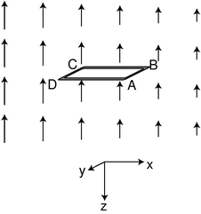
j / A new version of figure i with a tiny loop. The point of view is above the plane of the loop. In the frame of reference where the magnetic field is constant, the loop is moving to the right.
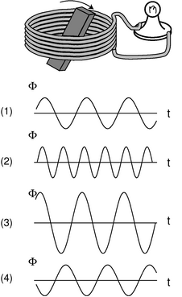
k / Example 21.
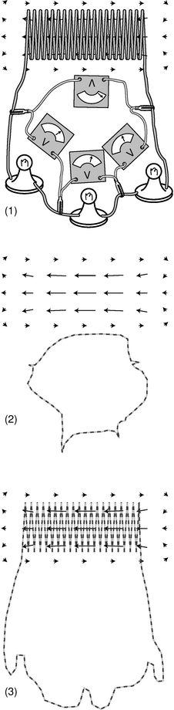
l / Example 22.

Faraday's law
We can also answer the other questions posed on page 615. The divide-and-conquer approach should be familiar by now. We first determine the circulation Γ_{E} in the case where the wire loop is very tiny, j. Then we can break down any big loop into a grid of small ones; we've already seen that when we make this kind of grid, the circulations add together. Although we'll continue to talk about a physical loop of wire, as in figure i, the tiny loop can really be just like the edges of an Ampèrian surface: a mathematical construct that doesn't necessarily correspond to a real object.
In the close-up view shown in figure j, the field looks simpler. Just as a tiny part of a curve looks straight, a tiny part of this magnetic field looks like the field vectors are just getting shorter by the same amount with each step to the right. Writing d x for the width of the loop, we therefore have
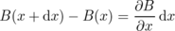
for the difference in the strength of the field between the left and right sides. In the frame of reference where the loop is moving, a charge q moving along with the loop at velocity v will experience a magnetic force . In the frame moving along with the loop, this is interpreted as an electrical force, . Observers in the two frames agree on how much force there is, so in the loop's frame, we have an electric field . This field is perpendicular to the front and back sides of the loop, BC and DA, so there is no contribution to the circulation along these sides, but there is a counterclockwise contribution to the circulation on CD, and smaller clockwise one on AB. The result is a circulation that is counterclockwise, and has an absolute value
|Γ_{E}| = |E(x)d y - E(x+d x)d y|
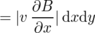
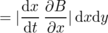
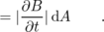
Using a right-hand rule, the counterclockwise circulation is represented by pointing one's thumb up, but the vector ∂ B/∂ t is down. This is just a rephrasing of the geometric relationship shown in figure d on page 612. We can represent the opposing directions using a minus sign,
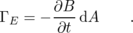
Although this derivation was carried out with everything aligned in a specific way along the coordinate axes, it turns out that this relationship can be generalized as a vector dot product,
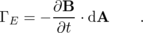
Finally, we can take a finite-sized loop and break down the circulation around its edges into a grid of tiny loops. The circulations add, so we have
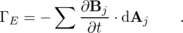
This is known as Faraday's law. (I don't recommend memorizing all these names.) Mathematically, Faraday's law is very similar to the structure of Ampère's law: the circulation of a field around the edges of a surface is equal to the sum of something that points through the
If the loop itself isn't moving, twisting, or changing shape, then the area vectors don't change over time, and we can move the derivative outside the sum, and rewrite Faraday's law in a slightly more transparent form:
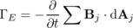
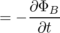
A changing magnetic flux makes a curly electric field. You might think based on Gauss' law for magnetic fields that Φ_{B} would be identically zero. However, Gauss' law only applies to surfaces that are closed, i.e. have no edges.
self-check: Check that the units in Faraday's law work out. An easy way to approach this is to use the fact that vB has the same units as E, which can be seen by comparing the equations for magnetic and electric forces used above. (answer in the back of the PDF version of the book)

Example 20: A pathetic generator
◊ The horizontal component of the earth's magnetic field varies from zero, at a magnetic pole, to about 10⁻⁴ T near the equator. Since the distance from the equator to a pole is about 10⁷ m, we can estimate, very roughly, that the horizontal component of the earth's magnetic field typically varies by about 10⁻¹¹ T/m as you go north or south. Suppose you connect the terminals of a one-ohm lightbulb to each other with a loop of wire having an area of 1 m². Holding the loop so that it lies in the east-west-up-down plane, you run straight north at a speed of 10 m/s, how much current will flow? Next, repeat the same calculation for the surface of a neutron star. The magnetic field on a neutron star is typically 10⁹ T, and the radius of an average neutron star is about 10⁴ m.
◊ Let's work in the frame of reference of the running person. In this frame of reference, the earth is moving, and therefore the local magnetic field is changing in strength by 10⁻⁹ T/s. This rate of change is almost exactly the same throughout the interior of the loop, so we can dispense with the summation, and simply write Faraday's law as
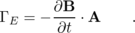
Since what we estimated was the rate of change of the horizontal component, and the vector A is horizontal (perpendicular to the loop), we can find this dot product simply by multiplying the two numbers:
Γ_{E} = (10⁻⁹ T/s)(1 m²)
= 10⁻⁹ T⋅m²/s
= 10⁻⁹ V
This is certainly not enough to light the bulb, and would not even be easy to measure using the most sensitive laboratory instruments.
Now what about the neutron star? We'll pretend you're tough enough that its gravity doesn't instantly crush you. The spatial variation of the magnetic field is on the order of (10⁹ T/10⁴ m)=10⁵ T/m. If you can run north at the same speed of 10 m/s, then in your frame of reference there is a temporal (time) variation of about 10⁶ T/s, and a calculation similar to the previous one results in an emf of 10⁶ V! This isn't just strong enough to light the bulb, it's sufficient to evaporate it, and kill you as well!
It might seem as though having access to a region of rapidly changing magnetic field would therefore give us an infinite supply of free energy. However, the energy that lights the bulb is actually coming from the mechanical work you do by running through the field. A tremendous force would be required to make the wire loop move through the neutron star's field at any significant speed.

Example 21: Speed and power in a generator
◊ Figure k shows three graphs of the magnetic flux through a generator's coils as a function of time. In graph 2, the generator is being cranked at twice the frequency. In 3, a permanent magnet with double the strength has been used. In 4, the generator is being cranked in the opposite direction. Compare the power generated in figures 2-4 with the the original case, 1.
◊ If the flux varies as Φ=Asinω t, then the time derivative occurring in Faraday's law is ∂Φ/∂ t=Aωcosω t. The absolute value of this is the same as the absolute value of the emf, Γ_{E}. The current through the lightbulb is proportional to this emf, and the power dissipated depends on the square of the current (P=I²R), so P∝ A²ω². Figures 2 and 3 both give four times the output power (and require four times the input power). Figure 4 gives the same result as figure 1; we can think of this as a negative amplitude, which gives the same result when squared.

Example 22: An approximate loop rule
Figure l/1 shows a simple RL circuit of the type discussed in the last chapter. A current has already been established in the coil, let's say by a battery. The battery was then unclipped from the coil, and we now see the circuit as the magnetic field in and around the inductor is beginning to collapse. I've already cautioned you that the loop rule doesn't apply in nonstatic situations, so we can't assume that the readings on the four voltmeters add up to zero. The interesting thing is that although they don't add up to exactly zero in this circuit, they very nearly do. Why is the loop rule even approximately valid in this situation?
The reason is that the voltmeters are measuring the emf Γ_{E} around the path shown in figure l/2, and the stray field of the solenoid is extremely weak out there. In the region where the meters are, the arrows representing the magnetic field would be too small to allow me to draw them to scale, so I have simply omitted them. Since the field is so weak in this region, the flux through the loop is nearly zero, and the rate of change of the flux, ∂Φ_{B}/∂ t, is also nearly zero. By Faraday's law, then, the emf around this loop is nearly zero.
Now consider figure l/3. The flux through the interior of this path is not zero, because the strong part of the field passes through it, and not just once but many times. To visualize this, imagine that we make a wire frame in this shape, dip it in a tank of soapy water, and pull it out, so that there is a soap-bubble film spanning its interior. Faraday's law refers to the rate of change of the flux through a surface such as this one. (The soap film tends to assume a certain special shape which results in the minimum possible surface area, but Faraday's law would be true for any surface that filled in the loop.) In the coiled part of the wire, the soap makes a three-dimensional screw shape, like the shape you would get if you took the steps of a spiral staircase and smoothed them into a ramp. The loop rule is going to be strongly violated for this path.
We can interpret this as follows. Since the wire in the solenoid has a very low resistance compared to the resistances of the light bulbs, we can expect that the electric field along the corkscrew part of loop l/3 will be very small. As an electron passes through the coil, the work done on it is therefore essentially zero, and the true emf along the coil is zero. In figure l/1, the meter on top is therefore not telling us the actual emf experienced by an electron that passes through the coil. It is telling us the emf experienced by an electron that passes through the meter itself, which is a different quantity entirely. The other three meters, however, really do tell us the emf through the bulbs, since there are no magnetic fields where they are, and therefore no funny induction effects.

11.6 Maxwell's Equations
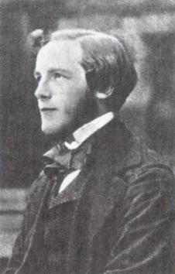
a / James Clerk Maxwell (1831-1879)
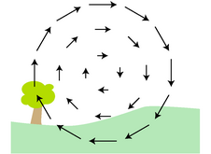
b / Where is the moving charge responsible for this magnetic field?
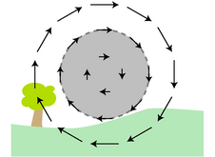
c / An Ampèrian surface superimposed on the landscape.
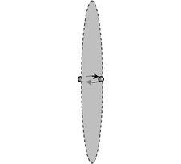
d / An electron jumps through a hoop.
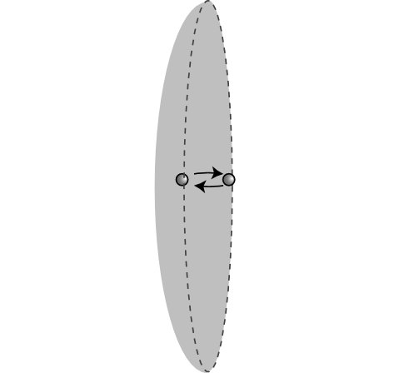
e / An alternative Ampèrian surface.

Induced magnetic fields
We have almost, but not quite, done figuring out the complete set of physical laws, called Maxwell's equations, governing electricity and magnetism. We are only missing one more term. For clarity, I'll state Maxwell's equations with the missing part included, and then discuss the physical motivation and experimental evidence for sticking it in:

Maxwell's equations
For any closed surface, the fluxes through the surface are
Φ_{E} = 4π kq_{in} and
Φ_{B} = 0 .
For any surface that is not closed, the circulations around the edges of the surface are given by
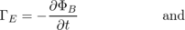
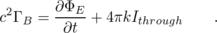
The Φ_{E} equation is Gauss' law: charges make diverging electric fields. The corresponding equation for Φ_{B} tells us that magnetic “charges” (monopoles) don't exist, so magnetic fields never diverge. The third equation says that changing magnetic fields induce curly electric fields, whose curliness we can measure using the emf, Γ_{E}, around a closed loop. The final equation, for Γ_{B}, is the only one where anything new has been added. Without the new time derivative term, this equation would simply be Ampère's law. (I've chosen to move the c² over to the left because it simplifies the writing, and also because it more clearly demonstrates the analogous roles played by charges and currents in the Φ_{E} and Γ_{B} equations.)
This new ∂Φ_{E}/∂ t term says that just as a changing magnetic field can induce a curly electric field, a changing electric field can induce a curly magnetic field. Why should this be so? The following examples show that Maxwell's equations would not make sense in general without it.
Figure b shows a mysterious curly magnetic field. Magnetic fields are supposed to be made by moving charges, but there don't seem to be any moving charges in this landscape. Where are they? One reasonable guess would be that they're behind your head, where you can't see them. Suppose there's a positively charged particle about to hit you in the back of the head. This particle is like a current going into the page. We're used to dealing with currents made by many charged particles, but logically we can't have some minimum number that would qualify as a current. This is not a static current, however, because the current at a given point in space is not staying the same over time. If the particle is pointlike, then it takes zero time to pass any particular location, and the current is then infinite at that point in space. A moment later, when the particle is passing by some other location, there will be an infinite current there, and zero current in the previous location. If this single particle qualifies as a current, then it should be surrounded by a curly magnetic field, just like any other current.¹¹
This explanation is simple and reasonable, but how do we know it's correct? Well, it makes another prediction, which is that the positively charged particle should be making an electric field as well. Not only that, but if it's headed for the back of your head, then it's getting closer and closer, so the electric field should be getting stronger over time. But this is exactly what Maxwell's equations require. There is no current I_{through} piercing the Ampèrian surface shown in figure c, so Maxwell's equation for Γ_{B} becomes c²Γ_{B} = ∂Φ_{E}/∂ t. The only reason for an electric field to change is if there are charged particles making it, and those charged particles are moving. When charged particles are moving, they make magnetic fields as well.
Note that the above example is also sufficient to prove the positive sign of the ∂Φ_{E}/∂ t term in Maxwell's equations, which is different from the negative sign of Faraday's -∂Φ_{B}/∂ t term.
The addition of the ∂Φ_{E}/∂ t term has an even deeper and more important physical meaning. With the inclusion of this term, Maxwell's equations can describe correctly the way in which disturbances in the electric and magnetic fields ripple outwards at the speed of light. Indeed, Maxwell was the first human to understand that light was in fact an electromagnetic wave. Legend has it that it was on a starry night that he first realized this implication of his equations. He went for a walk with his wife, and told her she was the only other person in the world who really knew what starlight was.
To see how the ∂Φ_{E}/∂ t term relates to electromagnetic waves, let's look at an example where we would get nonsense without it. Figure d shows an electron that sits just on one side of an imaginary Ampèrian surface, and then hops through it at some randomly chosen moment. Unadorned with the ∂Φ_{E}/∂ t term, Maxwell's equation for Γ_{B} reads as c²Γ_{B} = 4π k I_{through}, which is Ampère's law. If the electron is a pointlike particle, then we have an infinite current I_{through} at the moment when it pierces the imaginary surface, and zero current at all other times. An infinite magnetic circulation Γ_{B} can only be produced by an infinite magnetic field, so without the ∂Φ_{E}/∂ t term, Maxwell's equations predict nonsense: the edge of the surface would experience an infinite magnetic field at one instant, and zero magnetic field at all other times. Even if the infinity didn't upset us, it doesn't make sense that anything special would happen at the moment the electron passed through the surface, because the surface is an imaginary mathematical construct. We could just as well have chosen the curved surface shown in figure e, which the electron never crosses at all. We are already clearly getting nonsensical results by omitting the ∂Φ_{E}/∂ t term, and this shouldn't surprise us because Ampère's law only applies to statics. More to the point, Ampère's law doesn't have time in it, so it predicts that this effect is instantaneous. According to Ampère's law, we could send Morse code signals by wiggling the electron back and forth, and these signals would be received at distant locations instantly, without any time delay at all. This contradicts the theory of relativity, one of whose predictions is that information cannot be transmitted at speeds greater than the speed of light.

Discussion Questions
◊ Induced magnetic fields were introduced in the text via the imaginary landscape shown in figure b on page 623, and I argued that the magnetic field could have been produced by a positive charge coming from behind your head. This is a specific assumption about the number of charges (one), the direction of motion, and the sign of the charge. What are some other scenarios that could explain this field?
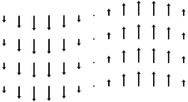
f / A magnetic field in the form of a sine wave.
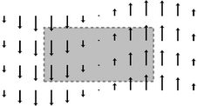
g / The wave pattern is curly. For example, the circulation around this reactangle is nonzero and counterclockwise.
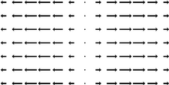
i / An impossible wave pattern.
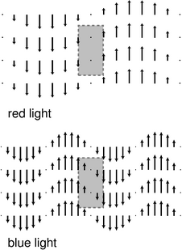
j / Red and blue light travel at the same speed.
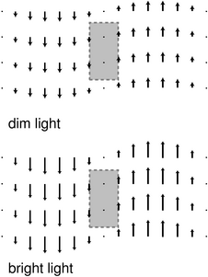
k / Bright and dim light travel at the same speed.
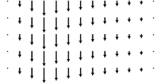
l / A nonsinusoidal wave.
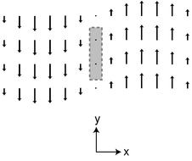
m / The magnetic field of the wave. The electric field, not shown, is perpendicular to the page.
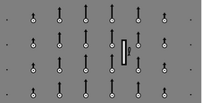
o / A classical calculation of the momentum of a light wave. An antenna of length is bathed in an electromagnetic wave. The black arrows represent the electric field, the white circles the magnetic field coming out of the page. The wave is traveling to the right.

Light waves
We could indeed send signals using this scheme, and the signals would be a form of light. A radio transmitting antenna, for instance, is simply a device for whipping electrons back and forth at megahertz frequencies. Radio waves are just like visible light, but with a lower frequency. With the addition of the ∂Φ_{E}/∂ t term, Maxwell's equations are capable of describing electromagnetic waves. It would be possible to use Maxwell's equations to calculate the pattern of the electric and magnetic fields rippling outward from a single electron that fidgets at irregular intervals, but let's pick a simpler example to analyze.
The simplest wave pattern is a sine wave like the one shown in figure f. Let's assume a magnetic field of this form, and see what Maxwell's equations tell us about it. If the wave is traveling through empty space, then there are no charges or currents present, and Maxwell's equations become
Φ_{E} = 0
Φ_{B} = 0
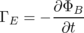
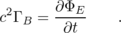
The equation Φ=0 has already been verified for this type of wave pattern in example 33 on page 552. Even if you haven't learned the techniques from that section, it should be visually plausible that this field pattern doesn't diverge or converge on any particular point.

Geometry of the electric and magnetic fields
The equation c²Γ_{B}=∂Φ_{E}/∂ t tells us that there can be no such thing as a purely magnetic wave. The wave pattern clearly does have a nonvanishing circulation around the edge of the surface suggested in figure g, so there must be an electric flux through the surface. This magnetic field pattern must be intertwined with an electric field pattern that fills the same space. There is also no way that the two sides of the equation could stay synchronized with each other unless the electric field pattern is also a sine wave, and one that has the same wavelength, frequency, and velocity. Since the electric field is making a flux through the indicated surface, it's plausible that the electric field vectors lie in a plane perpendicular to that of the magnetic field vectors. The resulting geometry is shown in figure h. Further justification for this geometry is given later in this subsection.
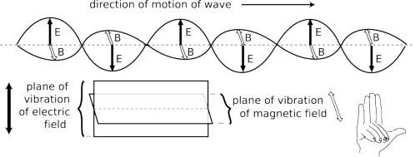
h / The geometry of an electromagnetic wave.
One feature of figure h that is easily justified is that the electric and magnetic fields are perpendicular not only to each other, but also to the direction of propagation of the wave. In other words, the vibration is sideways, like people in a stadium “doing the wave,” not lengthwise, like the accordion pattern in figure i. (In standard wave terminology, we say that the wave is transverse, not longitudinal.) The wave pattern in figure i is impossible, because it diverges from the middle. For virtually any choice of Gaussian surface, the magnetic and electric fluxes would be nonzero, contradicting the equations Φ_{B}=0 and Φ_{E}=0.¹²

Polarization
Two electromagnetic waves traveling in the same direction through space can differ by having their electric and magnetic fields in different directions, a property of the wave called its polarization.

The speed of light
What is the velocity of the waves described by Maxwell's equations? Maxwell convinced himself that light was an electromagnetic wave partly because his equations predicted waves moving at the velocity of light, c. The only velocity that appears in the equations is c, so this is fairly plausible, although a real calculation is required in order to prove that the velocity of the waves isn't something like 2c or c/π --- or zero, which is also c multiplied by a constant! The following discussion, leading up to a proof that electromagnetic waves travel at c, is meant to be understandable even if you're reading this book out of order, and haven't yet learned much about waves. As always with proofs in this book, the reason to read it isn't to convince yourself that it's true, but rather to build your intuition. The style will be visual. In all the following figures, the wave patterns are moving across the page (let's say to the right), and it usually doesn't matter whether you imagine them as representing the wave's magnetic field or its electric field, because Maxwell's equations in a vacuum have the same form for both fields. Whichever field we imagine the figures as representing, the other field is coming in and out of the page.
The velocity of the waves is not zero. If the wave pattern was standing still in space, then the right sides of the Γ equations would be zero, because there would be no change in the field over time at a particular point. But the left sides are not zero, so this is impossible.¹³
The velocity of the waves is a fixed number for a given wave pattern. Consider a typical sinusoidal wave of visible light, with a distance of half a micrometer from one peak to the next peak. Suppose this wave pattern provides a valid solution to Maxwell's equations when it is moving with a certain velocity. We then know, for instance, that there cannot be a valid solution to Maxwell's equations in which the same wave pattern moves with double that velocity. The time derivatives on the right sides of Maxwell's equations for Γ_{E} and Γ_{B} would be twice as big, since an observer at a certain point in space would see the wave pattern sweeping past at twice the rate. But the left sides would be the same, so the equations wouldn't equate.
The velocity is the same for all wave patterns. In other words, it isn't 0.878c for one wave pattern, and 1.067c for some other pattern. This is surprising, since, for example, water waves with different shapes do travel at different speeds. Similarly, even though we speak of “the speed of sound,” sound waves do travel at slightly different speeds depending on their pitch and loudness, although the differences are small unless you're talking about cannon blasts or extremely high frequency ultrasound. To see how Maxwell's equations give a consistent velocity, consider figure j. Along the right and left edges of the same Ampèrian surface, the more compressed wave pattern of blue light has twice as strong a field, so the circulations on the left sides of Maxwell's equations are twice as large.¹⁴ To satisfy Maxwell's equations, the time derivatives of the fields must also be twice as large for the blue light. But this is true only if the blue light's wave pattern is moving to the right at the same speed as the red light's: if the blue light pattern is sweeping over an observer with a given velocity, then the time between peaks is half as much, like the clicking of the wheels on a train whose cars are half the length.¹⁵
We can also check that bright and dim light, as shown in figure k, have the same velocity. If you haven't yet learned much about waves, then this might be surprising. A material object with more energy goes faster, but that's not the case for waves. The circulation around the edge of the Ampèrian surface shown in the figure is twice as strong for the light whose fields are doubled in strength, so the left sides of Maxwell's Γ equations are doubled. The right sides are also doubled, because the derivative of twice a function is twice the derivative of the original function. Thus if dim light moving with a particular velocity is a solution, then so is bright light, provided that it has the same velocity.
We can now see that all sinusoidal waves have the same velocity. What about nonsinusoidal waves like the one in figure l? There is a mathematical theorem, due to Fourier, that says any function can be made by adding together sinusoidal functions. For instance, 3sin x-7cos 3x can be made by adding together the functions 3sin x and -7cos 3x, but Fourier proved that this can be done even for functions, like figure l, that aren't obviously built out of sines and cosines in the first place. Therefore our proof that sinusoidal waves all have the same velocity is sufficient to demonstrate that other waves also have this same velocity.
We're now ready to prove that this universal speed for all electromagnetic waves is indeed c. Since we've already convinced ourselves that all such waves travel at the same speed, it's sufficient to find the velocity of one wave in particular. Let's pick the wave whose fields have magnitudes
which is about as simple as we can get. The peak electric field of this wave has a strength , and the peak magnetic field is . The sine functions go through one complete cycle as x increases by 2π=6.28…, so the distance from one peak of this wave to the next --- its wavelength --- is 6.28... meters. This means that it is not a wave of visible light but rather a radio wave (its wavelength is on the same order of magnitude as the size of a radio antenna). That's OK. What was glorious about Maxwell's work was that it unified the whole electromagnetic spectrum. Light is simple. Radio waves aren't fundamentally any different than light waves, x-rays, or gamma rays. ¹⁶
The justification for putting x+vt inside the sine functions is as follows. As the wave travels through space, the whole pattern just shifts over. The fields are zero at x=0, t=0, since the sine of zero is zero. This zero-point of the wave pattern shifts over as time goes by; at any time t its location is given by x+vt=0. After one second, the zero-point is located at x=-(1 s)v. The distance it travels in one second is therefore numerically equal to v, and this is exactly the concept of velocity: how far something goes per unit time.
The wave has to satisfy Maxwell's equations for Γ_{E} and Γ_{B} regardless of what Ampèrian surfaces we pick, and by applying them to any surface, we could determine the speed of the wave. The surface shown in figure m turns out to result in an easy calculation: a narrow strip of width and height h, coinciding with the position of the zero-point of the field at t=0.
Now let's apply the equation c²Γ_{B}=∂Φ_{E}/∂ t at t=0. Since the strip is narrow, we can approximate the magnetic field using sin x≈ x, which is valid for small x. The magnetic field on the right edge of the strip, at , is then , so the right edge of the strip contributes to the circulation. The left edge contributes the same amount, so the left side of Maxwell's equation is
The other side of the equation is
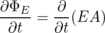
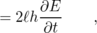
where we can dispense with the usual sum because the strip is narrow and there is no variation in the field as we go up and down the strip. The derivative equals , and evaluating the cosine at x=0, t=0 gives
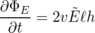
Maxwell's equation for Γ_{B} therefore results in
An application of Γ_{E}=-∂Φ_{B}/∂ t gives a similar result, except that there is no factor of c²
(The minus sign simply represents the right-handed relationship of the fields relative to their direction of propagation.)
Multiplying these last two equations by each other, we get
c² = v²
v = ± c .
This is the desired result. (The plus or minus sign shows that the wave can travel in either direction.)
As a byproduct of this calculation, we can find the relationship between the strengths of the electric and magnetic fields in an electromagnetic wave. If, instead of multiplying the equations and , we divide them, we can easily show that .
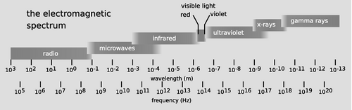
n / The electromagnetic spectrum.
Figure n shows the complete spectrum of light waves. The wavelength λ (number of meters per cycle) and frequency f (number of cycles per second) are related by the equation c=fλ. Maxwell's equations predict that all light waves have the same structure, regardless of wavelength and frequency, so even though radio and x-rays, for example, hadn't been discovered, Maxwell predicted that such waves would have to exist. Maxwell's 1865 prediction passed an important test in 1888, when Heinrich Hertz published the results of experiments in which he showed that radio waves could be manipulated in the same ways as visible light waves. Hertz showed, for example, that radio waves could be reflected from a flat surface, and that the directions of the reflected and incoming waves were related in the same way as with light waves, forming equal angles with the surface. Likewise, light waves can be focused with a curved, dish-shaped mirror, and Hertz demonstrated the same thing with a dish-shaped radio antenna.

Momentum of light waves
A light wave consists of electric and magnetic fields, and fields contain energy. Thus a light wave carries energy with it when it travels from one place to another. If a material object has kinetic energy and moves from one place to another, it must also have momentum, so it is logical to ask whether light waves have momentum as well. It can be proved based on relativity that it does, and that the momentum and energy are related by the equation U=p/c, where p is the magnitude of the momentum vector, and U=U_{e}+U_{m} is the sum of the energy of the electric and magnetic fields (see homework problem 11 on page 363). We can now demonstrate this without explicitly referring to relativity, and connect it to the specific structure of a light wave.
The energy density of a light wave is related to the magnitudes of the fields in a specific way --- it depends on the squares of their magnitudes, E² and B², which are the same as the dot products E⋅E and B⋅B. We argued on page 502 that since energy is a scalar, the only possible expressions for the energy densities of the fields are dot products like these, multiplied by some constants. This is because the dot product is the only mathematically sensible way of multiplying two vectors to get a scalar result. (Any other way violates the symmetry of space itself.)
How does this relate to momentum? Well, we know that if we double the strengths of the fields in a light beam, it will have four times the energy, because the energy depends on the square of the fields. But we then know that this quadruple-energy light beam must have quadruple the momentum as well. If there wasn't this kind of consistency between the momentum and the energy, then we could violate conservation of momentum by combining light beams or splitting them up. We therefore know that the momentum density of a light beam must depend on a field multiplied by a field. Momentum, however, is a vector, and there is only one physically meaningful way of multiplying two vectors to get a vector result, which is the cross product (see page 742). The momentum density can therefore only depend on the cross products E×E, B×B, and E×B. But the first two of these are zero, since the cross product vanishes when there is a zero angle between the vectors. Thus the momentum per unit volume must equal E×B multiplied by some constant,
dp = (constant)E×B d v
This predicts something specific about the direction of propagation of a light wave: it must be along the line perpendicular to the electric and magnetic fields. We've already seen that this is correct, and also that the electric and magnetic fields are perpendicular to each other. Therefore this cross product has a magnitude
|E×B| =|E||B|sin 90°
=|E||B|
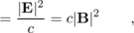
where in the last step the relation |E|=c|B| has been used.
We now only need to find one physical example in order to fix the constant of proportionality. Indeed, if we didn't know relativity, it would be possible to believe that the constant of proportionality was zero! The simplest example of which I know is as follows. Suppose a piece of wire of length is bathed in electromagnetic waves coming in sideways, and let's say for convenience that this is a radio wave, with a wavelength that is large compared to , so that the fields don't change significantly across the length of the wire. Let's say the electric field of the wave happens to be aligned with the wire. Then there is an emf between the ends of the wire which equals , and since the wire is small compared to the wavelength, we can pretend that the field is uniform, not curly, in which case voltage is a well-defined concept, and this is equivalent to a voltage difference between the ends of the wire. The wire obeys Ohm's law, and a current flows in response to the wave.¹⁷ Equating the expressions d U/d t and IΔ V for the power dissipated by ohmic heating, we have
for the energy the wave transfers to the wire in a time interval d t.
Note that although some electrons have been set in motion in the wire, we haven't yet seen any momentum transfer, since the protons are experiencing the same amount of electric force in the opposite direction. However, the electromagnetic wave also has a magnetic field, and a magnetic field transfers momentum to (exerts a force on) a current. This is only a force on the electrons, because they're what make the current. The magnitude of this force equals (homework problem ), and using the definition of force, dp/d t, we find for the magnitude of the momentum transferred:
We now know both the amount of energy and the amount of momentum that the wave has lost by interacting with the wire. Dividing these two equations, we find
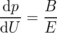
which is what we expected based on relativity. This can now be restated in the form dp = (constant)E×B d v (homework problem 37).
Note that although the equations p=U/c and dp = (constant)E×B d v are consistent with each other for a sine wave, they are not consistent with each other in general. The relativistic argument leading up to p=U/c assumed that we were only talking about a single thing traveling in a single direction, whereas no such assumption was made in arguing for the E×B form. For instance, if two light beams of equal strength are traveling through one another, going in opposite directions, their total momentum is zero, which is consistent with the E×B form, but not with U/c.
Some examples were given in chapter 3 of situations where it actually matters that light has momentum.

Angular momentum of light waves
For completeness, we note that since light carries momentum, it must also be possible for it to have angular momentum. If you've studied chemistry, here's an example of why this can be important. You know that electrons in atoms can exist in states labeled s, p, d, f, and so on. What you might not have realized is that these are angular momentum labels. The s state, for example, has zero angular momentum. If light didn't have angular momentum, then, for example, it wouldn't be possible for a hydrogen atom in a p state to change to the lower-energy s state by emitting light. Conservation of angular momentum requires that the light wave carry away all the angular momentum originally possessed by the electron in the p state, since in the s state it has none.

11.7 Electromagnetic Properties of Materials
Different types of matter have a variety of useful electrical and magnetic properties. Some are conductors, and some are insulators. Some, like iron and nickel, can be magnetized, while others have useful electrical properties, e.g., dielectrics, discussed qualitatively in the discussion question on page 512, which allow us to make capacitors with much higher values of capacitance than would otherwise be possible. We need to organize our knowledge about the properties that materials can possess, and see whether this knowledge allows us to calculate anything useful with Maxwell's equations.
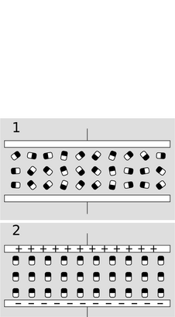
a / A capacitor with a dielectric between the plates.

Conductors
A perfect conductor, such as a superconductor, has no DC electrical resistance. It is not possible to have a static electric field inside it, because then charges would move in response to that field, and the motion of the charges would tend to reduce the field, contrary to the assumption that the field was static. Things are a little different at the surface of a perfect conductor than on the interior. We expect that any net charges that exist on the conductor will spread out under the influence of their mutual repulsion, and settle on the surface. As we saw in chapter 10, Gauss's law requires that the fields on the two sides of a sheet of charge have |E_{⊥,1}-E_{⊥,2}| proportional to the surface charge density, and since the field inside the conductor is zero, we infer that there can be a field on or immediately outside the conductor, with a nonvanishing component perpendicular to the surface. The component of the field parallel to the surface must vanish, however, since otherwise it would cause the charges to move along the surface.
On a hot summer day, the reason the sun feels warm on your skin is that the oscillating fields of the light waves excite currents in your skin, and these currents dissipate energy by ohmic heating. In a perfect conductor, however, this could never happen, because there is no such thing as ohmic heating. Since electric fields can't penetrate a perfect conductor, we also know that an electromagnetic wave can never pass into one. By conservation of energy, we know that the wave can't just vanish, and if the energy can't be dissipated as heat, then the only remaining possibility is that all of the wave's energy is reflected. This is why metals, which are good electrical conductors, are also highly reflective. They are not perfect electrical conductors, however, so they are not perfectly reflective. The wave enters the conductor, but immediately excites oscillating currents, and these oscillating currents dissipate the energy both by ohmic heating and by reradiating the reflected wave. Since the parts of Maxwell's equations describing radiation have time derivatives in them, the efficiency of this reradiation process depends strongly on frequency. When the frequency is high and the material is a good conductor, reflection predominates, and is so efficient that the wave only penetrates to a very small depth, called the skin depth. In the limit of poor conduction and low frequencies, absorption predominates, and the skin depth becomes much greater. In a high-frequency AC circuit, the skin depth in a copper wire is very small, and therefore the signals in such a circuit are propagated entirely at the surfaces of the wires. In the limit of low frequencies, i.e., DC, the skin depth approaches infinity, so currents are carried uniformly over the wires' cross-sections.
We can quantify how well a particular material conducts electricity. We know that the resistance of a wire is proportional to its length, and inversely proportional to its cross-sectional area. The constant of proportionality is 1/σ, where σ (not the same σ as the surface charge density) is called the electrical conductivity. Exposed to an electric field E, a conductor responds with a current per unit cross-sectional area J=σE. The skin depth is proportional to , where f is the frequency of the wave.

b / A stud finder is used to locate the wooden beams, or studs, that form the frame behind the wallboard. It is a capacitor whose capacitance changes when it is brought close to a substance with a particular permittivity. Although the wall is external to the capacitor, a change in capacitance is still observed, because the capacitor has “fringing fields” that extend outside the region between its plates.

Dielectrics
A material with a very low conductivity is an insulator. Such materials are usually composed of atoms or molecules whose electrons are strongly bound to them; since the atoms or molecules have zero total charge, their motion cannot create an electric current. But even though they have zero charge, they may not have zero dipole moment. Imagine such a substance filling in the space between the plates of a capacitor, as in figure a. For simplicity, we assume that the molecules are oriented randomly at first, a/1, and then become completely aligned when a field is applied, a/2. The effect has been to take all of the negatively charged black ands of the molecules and shift them upward, and the opposite for the positively charged white ends. Where the black and white charges overlap, there is still zero net charge, but we have a strip of negative charge at the top, and a strip of positive charge at the bottom, a/3. The effect has been to cancel out part of the charge that was deposited on the plates of the capacitor. Now this is very subtle, because Maxwell's equations treat these charges on an equal basis, but in terms of practical measurements, they are completely different. The charge on the plates can be measured be inserting an ammeter in the circuit, and integrating the current over time. But the charges in the layers at the top and bottom of the dielectric never flowed through any wires, and cannot be detected by an ammeter. In other words, the total charge, q, appearing in Maxwell's equartions is actualy q=q_{free}-q_{bound}, where q_{free} is the charge that moves freely through wires, and can be detected in an ammeter, while q_{bound} is the charge bound onto the individual molecules, which can't. We will, however, detect the presence of the bound charges via their electric fields. Since their electric fields partially cancel the fields of the free charges, a voltmeter will register a smaller than expected voltage difference between the plates. If we measure q_{free}/V, we have a result that is larger than the capacitance we would have expected.
Although the relationship E≤ftrightarrow q between electric fields and their sources is unalterably locked in by Gauss's law, that's not what we see in practical measurements. In this example, we can measure the voltage difference between the plates of the capacitor and divide by the distance between them to find E, and then integrate an ammeter reading to find q_{free}, and we will find that Gauss's law appears not to hold. We have E≤ftrightarrow q_{free}/(constant), where the constant fudge factor is greater than one. This constant is a property of the dielectric material, and tells us how many dipoles there are, how strong they are, and how easily they can be reoriented. The conventional notation is to incorporate this fudge factor into Gauss's law by defining an altered version of the electric field,
D=ε E ,
and to rewrite Gauss's law as
The constant ε is a property of the material, known as its permittivity. In a vacuum, ε takes on a value known as ε_{o}, defined as 1/(4π k). In a dielectric, ε is greater than ε_{o}. When a dielectric is present between the plates of a capacitor, its capacitance is proportional to ε (problem 49). The following table gives some sample values of the permittivities of a few substances.
substance | epsilonepsilonzuo at zero frequency
vacuum | 1
air | 1.00054
water | 80
barium titanate | 1250
A capacitor with a very high capacitance is potentially a superior replacement for a battery, but until the 1990's this was impractical because capacitors with high enough values couldn't be made, even with dielectrics having the largest known permittivities. Such supercapactors, some with values in the kilofarad range, are now available. Most of them do not use dielectric at all; the very high capacitance values are instead obtained by using electrodes that are not parallel metal plates at all, but exotic materials such as aerogels, which allow the spacing between the “electrodes” to be very small.
Although figure a/2 shows the dipoles in the dielectric being completely aligned, this is not a situation commonly encountered in practice. In such a situation, the material would be as polarized as it could possibly be, and if the field was increased further, it would not respond. In reality, a capacitor, for example, would normally be operated with fields that produced quite a small amount of alignment, and it would be under these conditions that the linear relationship D=εE would actually be a good approximation. Before a material's maximum polarization is reached, it may actually spark or burn up.
self-check: Suppose a parallel-plate capacitor is built so that a slab of dielectric material can be slid in or out. (This is similar to the way the stud finder in figure b works.) We insert the dielectric, hook the capacitor up to a battery to charge it, and then use an ammeter and a voltmeter to observe what happens when the dielectric is withdrawn. Predict the changes observed on the meters, and correlate them with the expected change in capacitance. Discuss the energy transformations involved, and determine whether positive or negative work is done in removing the dielectric. (answer in the back of the PDF version of the book)
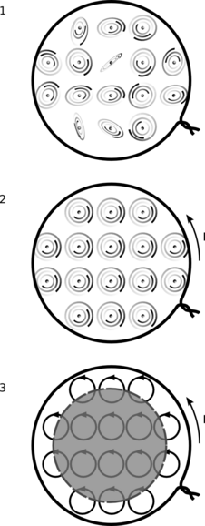
c / The magnetic version of figure a. A magnetically permeable material is placed at the center of a solenoid.
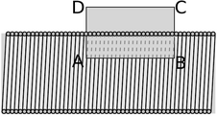
d / Example 23: a cutaway view of a solenoid.
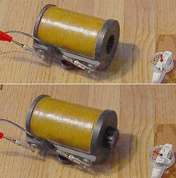
e / Example 23: without the iron core, the field is so weak that it barely deflects the compass. With it, the deflection is nearly 90°.

f / Example 24: ferrite beads. The top panel shows a clip-on type, while the bottom shows one built into a cable.

g / A frog is levitated diamagnetically inside a powerful magnet. Evidently frog has μ<μ_{o}.
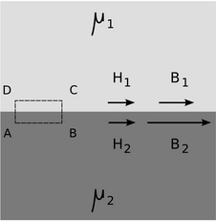
h / At a boundary between two substances with μ₂>μ₁, the H field has a continuous component parallel to the surface, which implies a discontinuity in the parallel component of the magnetic field B.
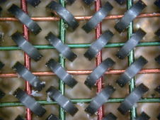
k / Magnetic core memory.
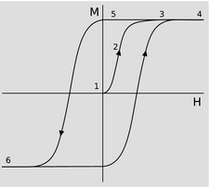
l / A hysteresis curve.
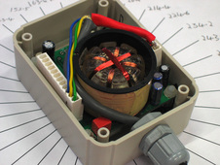
m / A fluxgate compass.

Magnetic materials
Atoms and molecules may have magnetic dipole moments as well as electric dipole moments. Just as an electric dipole contains bound charges, a magnetic dipole has bound currents, which come from the motion of the electrons as they orbit the nucleus, c/1. Such a substance, subjected to a magnetic field, tends to align itself, c/2, so that a sheet of current circulates around the externally applied field. Figure c/3 is closely analogous to figure a/3; in the central gray area, the atomic currents cancel out, but the atoms at the outer surface form a sheet of bound current. However, whereas like charges repel and opposite charges attract, it works the other way around for currents: currents in the same direction attract, and currents in opposite directions repel. Therefore the bound currents in a material inserted inside a solenoid tend to reinforce the free currents, and the result is to strengthen the field. The total current is I=I_{free}+I_{bound}, and we define an altered version of the magnetic field,
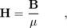
and rewrite Ampère's law as
The constant μ is the permeability, with a vacuum value of μ_{o}=4π k/c². Here are the magnetic permeabilities of some substances:
substance | mumuzuo
vacuum | 1
aluminum | 1.00002
steel | 700
transformer iron | 4,000
mu-metal | 20,000

Example 23: An iron-core electromagnet
◊ A solenoid has 1000 turns of wire wound along a cylindrical core with a length of 10 cm. If a current of 1.0 A is used, find the magnetic field inside the solenoid if the core is air, and if the core is made of iron with μ/μ_{o}=4,000.
◊ Air has essentially the same permability as vacuum, so using the result of example 13 on page 600, we find that the field is 0.013 T.
We now consider the case where the core is filled with iron. The original derivation in example 13 started from Ampère's law, which we now rewrite as . As argued previously, the only significant contributions to the circulation come from line segment AB. This segment lies inside the iron, where H=B/μ. The H field is the same as in the air-core case, since the new form of Ampère's law only relates H to the current in the wires (the free current). This means that B=μH is greater by a factor of 4,000 than in the air-core case, or 52 T. This is an extremely intense field --- so intense, in fact, that the iron's magnetic polarization would probably become saturated before we could actually get the field that high.

Example 24: A ferrite bead
Cables designed to carry audio signals are typically made with two adjacent conductors, such that the current flowing out through one conductor comes back through the other one. Computer cables are similar, but usually have several such pairs bundled inside the insulator. This paired arrangement is known as differential mode, and has the advantage of cutting down on the reception and transmission of interference. In terms of transmission, the magnetic field created by the outgoing current is almost exactly canceled by the field from the return current, so electromagnetic waves are only weakly induced. In reception, both conductors are bathed in the same electric and magnetic fields, so an emf that adds current on one side subtracts current from the other side, resulting in cancellation.
The opposite of differential mode is called common mode. In common mode, all conductors have currents flowing in the same direction. Even when a circuit is designed to operate in differential mode, it may not have exactly equal currents in the two conductors with I₁+I₂=0, meaning that current is leaking off to ground at one end of the circuit or the other. Although paired cables are relatively immune to differential-mode interference, they do not have any automatic protection from common-mode interference.
Figure f shows a device for reducing common-mode interference called a ferrite bead, which surrounds the cable like a bead on a string. Ferrite is a magnetically permeable alloy. Let's consider common-mode transmission of interference. The bare cable has some DC resistance, but is also surrounded by a magnetic field, so it has inductance as well. This means that it behaves like a series L-R circuit, with an impedance that varies as R+iω L, where both R and L are very small. When we add the ferrite bead, the inductance is increased by orders of magnitude. In addition, a common-mode AC current will excite eddy currents in the ferrite, and these currents dissipate energy as heat. This behaves like an increase in the resistance. Since the magnetic and ohmic properties of the ferrite both vary with frequency, neither R nor L is actually constant with respect to frequency, but both are much greater than for the bare cable.
Suppose, for example, that a signal is being transmitted from a digital camera to a computer via a USB cable. The camera has an internal impedance that is on the order of 10 Ω, the computer's input also has a ∼10 Ω impedance, and in differential mode the ferrite bead has no effect, so the cable's impedance has its low, designed value (probably also about 10 Ω, for good impedance matching). The signal is transmitted unattenuated from the camera to the computer, and there is almost no radiation from the cable.
But in reality there will be a certain amount of common-mode current as well. With respect to common mode, the ferrite bead has a large impedance, with the exact value depending on frequency, but typically on the order of 100 Ω for frequencies in the MHz range. We now have a series circuit consisting of three impedances: 10, 100, and 10 Ω. For a given emf applied by an external radio wave, the current induced in the circuit has been attenuated by an order of magnitude, relative to its value without the ferrite bead.
Why is the ferrite is necessary at all? Why not just insert ordinary air-core inductors in the circuit? We could, for example, have two solenoidal coils, one in the outgoing line and one in the return line, interwound with one another with their windings oriented so that their differential-mode fields would cancel. There are two good reasons to prefer the ferrite bead design. One is that it allows a clip-on device like the one in the top panel of figure f, which can be added without breaking the circuit. The other is that our circuit will inevitably have some stray capacitance, and will therefore act like an LRC circuit, with a resonance at some frequency. At frequencies close to the resonant frequency, the circuit would absorb and transmit common-mode interference very strongly, which is exactly the opposite of the effect we were hoping to produce. The resonance peak could be made low and broad by adding resistance in series, but this extra resistance would attenuate the differential-mode signals as well as the common-mode ones. The ferrite's resistance, however, is actually a purely magnetic effect, so it vanishes in differential mode.
Surprisingly, some materials have magnetic permeabilities less than μ_{o}. This cannot be accounted for in the model above, and although there are semiclassical arguments that can explain it to some extent, it is fundamentally a quantum mechanical effect. Materials with μ>μ_{o} are called paramagnetic, while those with μ<μ_{o} are referred to as diamagnetic. Diamagnetism is generally a much weaker effect than paramagnetism, and is easily masked if there is any trace of contamination from a paramagnetic material. Diamagnetic materials have the interesting property that they are repelled from regions of strong magnetic field, and it is therefore possible to levitate a diamagnetic object above a magnet, as in figure g.
A complete statement of Maxwell's equations in the presence of electric and magnetic materials is as follows:
Φ_{D} = q_{T}EXTu0004free
Φ_{B} = 0
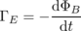
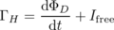
Comparison with the vacuum case shows that the speed of an electromagnetic wave moving through a substance described by permittivity and permeability ε and μ is . For most substances, μ≈μ_{o}, and ε is highly frequency-dependent.
Suppose we have a boundary between two substances. By constructing a Gaussian or Ampèrian surface that extends across the boundary, we can arrive at various constraints on how the fields must behave as me move from one substance into the other, when there are no free currents or charges present, and the fields are static. An interesting example is the application of Faraday's law, Γ_{H}=0, to the case where one medium --- let's say it's air --- has a low permeability, while the other one has a very high one. We will violate Faraday's law unless the component of the H field parallel to the boundary is a continuous function, H_{||,1}=H_{||,2}. This means that if μ/μ_{o} is very high, the component of B=μH parallel to the surface will have an abrupt discontinuity, being much stronger inside the high-permeability material. The result is that when a magnetic field enters a high-permeability material, it tends to twist abruptly to one side, and the pattern of the field tends to be channeled through the material like water through a funnel. Figure i shows an example, in which the effect is to shield the interior of the sphere from the externally imposed field. Special high-permeability alloys, with trade names like Mu-Metal, are sold for this purpose. 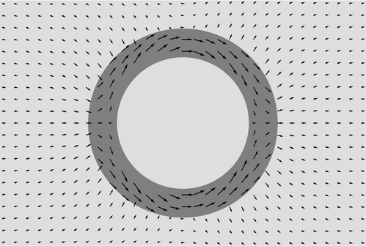
i / A hollow sphere with μ/μ_{o}=10, is immersed in a uniform, externally imposed magnetic field. The interior of the sphere is shielded from the field. The arrows map the magnetic field B. (See homework problem 52 on page 657.
The very last magnetic phenomenon we'll discuss is probably the very first experience you ever had of magnetism. Ferromagnetism is a phenomenon in which a material tends to organize itself so that it has a nonvanishing magnetic field. It is exhibited strongly by iron and nickel, which explains the origin of the name. 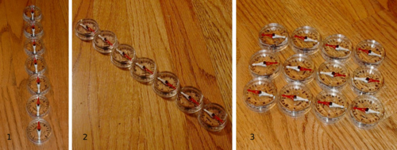
j / A model of ferromagnetism.
Figure j/1 is a simple one-dimensional model of ferromagnetism. Each magnetic compass needle represents an atom. The compasses in the chain are stable when aligned with one another, because each one's north end is attracted to its neighbor's south end. The chain can be turned around, j/2, without disrupting its organization, and the compasses do not realign themselves with the Earth's field, because their torques on one another are stronger than the Earth's torques on them. The system has a memory. For example, if I want to remind myself that my friend's address is 137 Coupling Ct., I can align the chain at an angle of 137 degrees. The model fails, however, as an explanation of real ferromagnetism, because in two or more dimensions, the most stable arrangement of a set of interacting magnetic dipoles is something more like j/3, in which alternating rows point in opposite directions. In this two-dimensional pattern, every compass is aligned in the most stable way with all four of its neighbors. This shows that ferromagnetism, like diamagnetism, has no purely classical explanation; a full explanation requires quantum mechanics.
Because ferromagnetic substances “remember” the history of how they were prepared, they are commonly used to store information in computers. Figure k shows 16 bits from an ancient (ca. 1970) 4-kilobyte random-access memory, in which each doughnut-shaped iron “core” can be magnetized in one of two possible directions, so that it stores one bit of information. Today, RAM is made of transistors rather than magnetic cores, but a remnant of the old technology remains in the term “core dump,” meaning “memory dump,” as in “my girlfriend gave me a total core dump about her mom's divorce.” Most computer hard drives today do store their information on rotating magnetic platters, but the platter technology may be obsoleted by flash memory in the near future.
The memory property of ferromagnets can be depicted on the type of graph shown in figure l, known as a hysteresis curve. The y axis is the magnetization of a sample of the material --- a measure of the extent to which its atomic dipoles are aligned with one another. If the sample is initially unmagnetized, 1, and a field H is externally applied, the magnetization increases, 2, but eventually becomes saturated, 3, so that higher fields do not result in any further magnetization, 4. The external field can then be reduced, 5, and even eliminated completely, but the material will retain its magnetization. It is a permanent magnet. To eliminate its magnetization completely, a substantial field must be applied in the opposite direction. If this reversed field is made stronger, then the substance will eventually become magnetized just as strongly in the opposite direction. Since the hysteresis curve is nonlinear, and is not a function (it has more than one value of M for a particular value of B), a ferromagnetic material does not have a single, well-defined value of the permeability μ; a value like 4,000 for transformer iron represents some kind of a rough average.

Example 25: The fluxgate compass
The fluxgate compass is a type of magnetic compass without moving parts, commonly used on ships and aircraft. An AC current is applied in a coil wound around a ferromagnetic core, driving the core repeatedly around a hysteresis loop. Because the hysteresis curve is highly nonlinear, the addition of an external field such as the Earth's alters the core's behavior. Suppose, for example, that the axis of the coil is aligned with the magnetic north-south. The core will reach saturation more quickly when the coil's field is in the same direction as the Earth's, but will not saturate as early in the next half-cycle, when the two fields are in opposite directions. With the use of multiple coils, the components of the Earth's field can be measured along two or three axes, permitting the compass's orientation to be determined in two or (for aircraft) three dimensions.
\backofchapterboilerplate{em}

Homework Problems
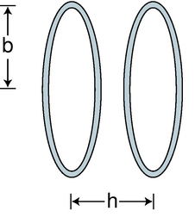
b / Problem 21.
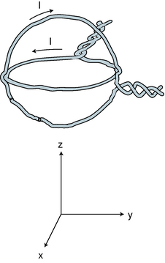
c / Problem 24.
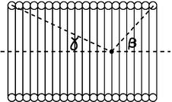
e / Problem .
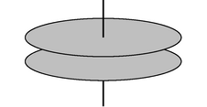
f / Problem 39.
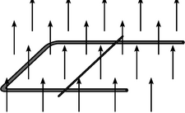
g / Problem 44.
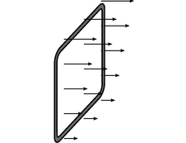
h / Problem 45.
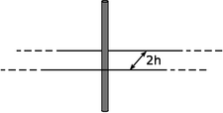
i / Problem 46.
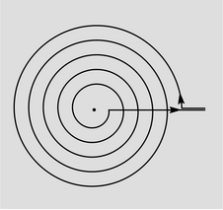
j / Problem 53.
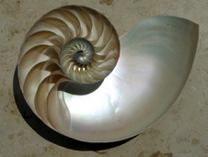
k / A nautilus shell is approximately a logarithmic spiral, of the type in problem 54.
1. [0]{righthandmodel} For a positively charged particle moving through a magnetic field, the directions of the v, B, and F vectors are related by a right-hand rule:
Make a three-dimensional model of the three vectors using pencils or rolled-up pieces of paper to represent the vectors assembled with their tails together. Make all three vectors perpendicular to each other. Now write down every possible way in which the rule could be rewritten by scrambling up the three symbols v, B, and F. Referring to your model, which are correct and which are incorrect?
2. [0]{ebforce} A particle with a charge of 1.0 C and a mass of 1.0 kg is observed moving past point P with a velocity . The electric field at point P is , and the magnetic field is . Find the force experienced by the particle.(answer check available at lightandmatter.com)
3. [0]{moveandcurve} A charged particle is released from rest. We see it start to move, and as it gets going, we notice that its path starts to curve. Can we tell whether this region of space has E≠q 0, or B≠q 0, or both? Assume that no other forces are present besides the possible electrical and magnetic ones, and that the fields, if they are present, are uniform.
4. [0]{describemotioninb} A charged particle is in a region of space in which there is a uniform magnetic field . There is no electric field, and no other forces act on the particle. In each case, describe the future motion of the particle, given its initial velocity.
(a) v_{o}=0
(b)
(c)
5. The following data give the results of two experiments in which charged particles were released from the same point in space, and the forces on them were measured:
q11 muzuC | mathbfv11 munitsunithatmathbfx | mathbfF11 zumNhatmathbfy
q22 muzuC | mathbfv21 munitsunithatmathbfx | mathbfF22 zumNhatmathbfy
The data are insufficient to determine the magnetic field vector; demonstrate this by giving two different magnetic field vectors, both of which are consistent with the data.
6. The following data give the results of two experiments in which charged particles were released from the same point in space, and the forces on them were measured:
q11 zunC | mathbfv11 munitsunithatmathbfz | mathbfF15 zupNhatmathbfx2 zupNhatmathbfy
q21 zunC | mathbfv23 munitsunithatmathbfz | mathbfF210 zupNhatmathbfx4 zupNhatmathbfy
Is there a nonzero electric field at this point? A nonzero magnetic field?
7. The following data give the results of three experiments in which charged particles were released from the same point in space, and the forces on them were measured:
q11 zuC | mathbfv10 | mathbfF11 zuNhatmathbfy
q21 zuC | mathbfv21 munitsunithatmathbfx | mathbfF21 zuNhatmathbfy
q31 zuC | mathbfv31 munitsunithatmathbfz | mathbfF30
Determine the electric and magnetic fields.(answer check available at lightandmatter.com)
8. [2]{ebexperiment} In problem , the three experiments gave enough information to determine both fields. Is it possible to design a procedure so that, using only two such experiments, we can always find E and B? If so, design it. If not, why not?
9. [0]{linechargecurrent} (a) A line charge, with charge per unit length λ, moves at velocity v along its own length. How much charge passes a given point in time d t? What is the resulting current? \hwans{hwans:linechargecurrent}
(b) Show that the units of your answer in part a work out correctly.
This constitutes a physical model of an electric current, and it would be a physically realistic model of a beam of particles moving in a vacuum, such as the electron beam in a television tube. It is not a physically realistic model of the motion of the electrons in a current-carrying wire, or of the ions in your nervous system; the motion of the charge carriers in these systems is much more complicated and chaotic, and there are charges of both signs, so that the total charge is zero. But even when the model is physically unrealistic, it still gives the right answers when you use it to compute magnetic effects. This is a remarkable fact, which we will not prove. The interested reader is referred to E.M. Purcell, Electricity and Magnetism, McGraw Hill, 1963.
10. Two parallel wires of length L carry currents I₁ and I₂. They are separated by a distance R, and we assume R is much less than L, so that our results for long, straight wires are accurate. The goal of this problem is to compute the magnetic forces acting between the wires.
(a) Neither wire can make a force on itself. Therefore, our first step in computing wire 1's force on wire 2 is to find the magnetic field made only by wire 1, in the space occupied by wire 2. Express this field in terms of the given quantities.(answer check available at lightandmatter.com)
(b) Let's model the current in wire 2 by pretending that there is a line charge inside it, possessing density per unit length λ₂ and moving at velocity v₂. Relate λ₂ and v₂ to the current I₂, using the result of problem 9a. Now find the magnetic force wire 1 makes on wire 2, in terms of I₁, I₂, L, and R. \hwans{hwans:bforcewire}
(c) Show that the units of the answer to part b work out to be newtons.
11. This problem is a continuation of problem . Note that the answer to problem b is given on page 761.
(a) Interchanging the 1's and 2's in the answer to problem b, what is the magnitude of the magnetic force from wire 2 acting on wire 1? Is this consistent with Newton's third law?
(b) Suppose the currents are in the same direction. Make a sketch, and use the right-hand rule to determine whether wire 1 pulls wire 2 towards it, or pushes it away.
(c) Apply the right-hand rule again to find the direction of wire 2's force on wire 1. Does this agree with Newton's third law?
(d) What would happen if wire 1's current was in the opposite direction compared to wire 2's?
12. [0]{circularorbitphoto} (a) In the photo of the vacuum tube apparatus in figure n on page 581, infer the direction of the magnetic field from the motion of the electron beam. (The answer is given in the answer to the self-check on that page.)
(b) Based on your answer to part a, find the direction of the currents in the coils.
(c) What direction are the electrons in the coils going?
(d) Are the currents in the coils repelling the currents consisting of the beam inside the tube, or attracting them? Check your answer by comparing with the result of problem .
13. [0]{cyclotron} A charged particle of mass m and charge q moves in a circle due to a uniform magnetic field of magnitude B, which points perpendicular to the plane of the circle.
(a) Assume the particle is positively charged. Make a sketch showing the direction of motion and the direction of the field, and show that the resulting force is in the right direction to produce circular motion.
(b) Find the radius, r, of the circle, in terms of m, q, v, and B.(answer check available at lightandmatter.com)
(c) Show that your result from part b has the right units.
(d) Discuss all four variables occurring on the right-hand side of your answer from part b. Do they make sense? For instance, what should happen to the radius when the magnetic field is made stronger? Does your equation behave this way?
(e) Restate your result so that it gives the particle's angular frequency, ω, in terms of the other variables, and show that v drops out.(answer check available at lightandmatter.com)
A charged particle can be accelerated in a circular device called a cyclotron, in which a magnetic field is what keeps them from going off straight. This frequency is therefore known as the cyclotron frequency. The particles are accelerated by other forces (electric forces), which are AC. As long as the electric field is operated at the correct cyclotron frequency for the type of particles being manipulated, it will stay in sync with the particles, giving them a shove in the right direction each time they pass by. The particles are speeding up, so this only works because the cyclotron frequency is independent of velocity.
14. [0]{vfilter} Suppose a charged particle is moving through a region of space in which there is an electric field perpendicular to its velocity vector, and also a magnetic field perpendicular to both the particle's velocity vector and the electric field. Show that there will be one particular velocity at which the particle can be moving that results in a total force of zero on it. Relate this velocity to the magnitudes of the electric and magnetic fields. (Such an arrangement, called a velocity filter, is one way of determining the speed of an unknown particle.)
15. Each figure represents the motion of a positively charged particle. The dots give the particles' positions at equal time intervals. In each case, determine whether the motion was caused by an electric force, a magnetic force, or a frictional force, and explain your reasoning. If possible, determine the direction of the magnetic or electric field. All fields are uniform. In (a), the particle stops for an instant at the upper right, but then comes back down and to the left, retracing the same dots. In (b), it stops on the upper right and stays there.
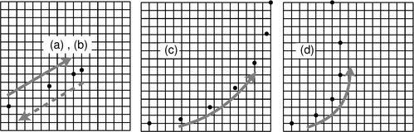
a / Problem 15.
16. Use the Biot-Savart law to derive the magnetic field of a long, straight wire, and show that this reproduces the result of example 6 on page 583.
17. (a) Modify the calculation on page 588 to determine the component of the magnetic field of a sheet of charge that is perpendicular to the sheet.(answer check available at lightandmatter.com)
(b) Show that your answer has the right units.
(c) Show that your answer approaches zero as z approaches infinity.
(d) What happens to your answer in the case of a=b? Explain why this makes sense.
18. One model of the hydrogen atom has the electron circling around the proton at a speed of 2.2×10⁶ m/s, in an orbit with a radius of 0.05 nm. (Although the electron and proton really orbit around their common center of mass, the center of mass is very close to the proton, since it is 2000 times more massive. For this problem, assume the proton is stationary.)
(a) Treat the circling electron as a current loop, and calculate the current.
(b) Estimate the magnetic field created at the center of the atom by the electron.(answer check available at lightandmatter.com)
(c) Does the proton experience a nonzero force from the electron's magnetic field? Explain.
(d) Does the electron experience a magnetic field from the proton? Explain.
(e) Does the electron experience a magnetic field created by its own current? Explain.
(f) Is there an electric force acting between the proton and electron? If so, calculate it.(answer check available at lightandmatter.com)
(g) Is there a gravitational force acting between the proton and electron? If so, calculate it.
(h) An inward force is required to keep the electron in its orbit -- otherwise it would obey Newton's first law and go straight, leaving the atom. Based on your answers to the previous parts, which force or forces (electric, magnetic and gravitational) contributes significantly to this inward force? (Based on a problem by Arnold Arons.)
19. Two long, parallel strips of thin metal foil form a configuration like a long, narrow sandwich. The air gap between them has height h, the width of each strip is w, and their length is . Each strip carries current I, and we assume for concreteness that the currents are in opposite directions, so that the magnetic force, F, between the strips is repulsive.
(a) Find the force in the limit of w>> h.(answer check available at lightandmatter.com)
(b) Find the force in the limit of w<< h, which is like two ordinary wires.
(c) Discuss the relationship between the two results.
20. [0]{solenoid-u-quadruple-i} If you put four times more current through a solenoid, how many times more energy is stored in its magnetic field?(answer check available at lightandmatter.com)
21. A Helmholtz coil is defined as a pair of identical circular coils lying in parallel planes and separated by a distance, h, equal to their radius, b. (Each coil may have more than one turn of wire.) Current circulates in the same direction in each coil, so the fields tend to reinforce each other in the interior region. This configuration has the advantage of being fairly open, so that other apparatus can be easily placed inside and subjected to the field while remaining visible from the outside. The choice of h=b results in the most uniform possible field near the center. A photograph of a Helmholtz coil was shown in figure n on page 581.
(a) Find the percentage drop in the field at the center of one coil, compared to the full strength at the center of the whole apparatus. (answer check available at lightandmatter.com)
(b) What value of h (not equal to b) would make this percentage difference equal to zero?(answer check available at lightandmatter.com)
22. [0]{dipole-units-proof} The equation B_{z}=β kIA/c²r³ was found on page 592 for the distant field of a dipole. Show, as asserted there, that the constant β must be unitless.
23. Consider two solenoids, one of which is smaller so that it can be put inside the other. Assume they are long enough so that each one only contributes significantly to the field inside itself, and the interior fields are nearly uniform. Consider the configuration where the small one is inside the big one with their currents circulating in the same direction, and a second configuration in which the currents circulate in opposite directions. Compare the energies of these configurations with the energy when the solenoids are far apart. Based on this reasoning, which configuration is stable, and in which configuration will the little solenoid tend to get twisted around or spit out? \hwhint{hwhint:nestedsolenoids}
24. The figure shows a nested pair of circular wire loops used to create magnetic fields. (The twisting of the leads is a practical trick for reducing the magnetic fields they contribute, so the fields are very nearly what we would expect for an ideal circular current loop.) The coordinate system below is to make it easier to discuss directions in space. One loop is in the y-z plane, the other in the x-y plane. Each of the loops has a radius of 1.0 cm, and carries 1.0 A in the direction indicated by the arrow.
(a) Calculate the magnetic field that would be produced by one such loop, at its center. (answer check available at lightandmatter.com)
(b) Describe the direction of the magnetic field that would be produced, at its center, by the loop in the x-y plane alone.
(c) Do the same for the other loop.
(d) Calculate the magnitude of the magnetic field produced by the two loops in combination, at their common center. Describe its direction.(answer check available at lightandmatter.com)
25. [2]{unknown-field} Suppose we are given a permanent magnet with a complicated, asymmetric shape. Describe how a series of measurements with a magnetic compass could be used to determine the strength and direction of its magnetic field at some point of interest. Assume that you are only able to see the direction to which the compass needle settles; you cannot measure the torque acting on it.
26. Consider two solenoids, one of which is smaller so that it can be put inside the other. Assume they are long enough to act like ideal solenoids, so that each one only contributes significantly to the field inside itself, and the interior fields are nearly uniform. Consider the configuration where the small one is partly inside and partly hanging out of the big one, with their currents circulating in the same direction. Their axes are constrained to coincide.
(a) Find the difference in the magnetic energy between the configuration where the solenoids are separate and the configuration where the small one is inserted into the big one. Your equation will include the length x of the part of the small solenoid that is inside the big one, as well as other relevant variables describing the two solenoids.(answer check available at lightandmatter.com)
(b) Based on your answer to part a, find the force acting between the solenoids.(answer check available at lightandmatter.com)
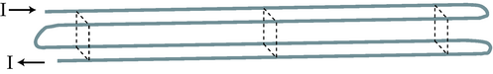
d / Problem 27.
27. Four long wires are arranged, as shown, so that their cross-section forms a square, with connections at the ends so that current flows through all four before exiting. Note that the current is to the right in the two back wires, but to the left in the front wires. If the dimensions of the cross-sectional square (height and front-to-back) are b, find the magnetic field (magnitude and direction) along the long central axis.(answer check available at lightandmatter.com)
28. (a) For the geometry described in example 8 on page 586, find the field at a point the lies in the plane of the wires, but not between the wires, at a distance b from the center line. Use the same technique as in that example.
(b) Now redo the calculation using the technique demonstrated on page 592. The integrals are nearly the same, but now the reasoning is reversed: you already know β=1, and you want to find an unknown field. The only difference in the integrals is that you are tiling a different region of the plane in order to mock up the currents in the two wires. Note that you can't tile a region that contains a point of interest, since the technique uses the field of a distant dipole.(answer check available at lightandmatter.com)
29. (a) A long, skinny solenoid consists of N turns of wire wrapped uniformly around a hollow cylinder of length and cross-sectional area A. Find its inductance.(answer check available at lightandmatter.com)
(b) Show that your answer has the right units to be an inductance.
30. (a) A solenoid can be imagined as a series of circular current loops that are spaced along their common axis. Integrate the result of example 12 on page 596 to show that the field on the axis of a solenoid can be written as B=(2π kη/c²)(cosβ+cosγ), where the angles β and γ are defined in the figure.
(b) Show that in the limit where the solenoid is very long, this exact result agrees with the approximate one derived in example 13 on page 600 using Ampère's law.
(c) Note that, unlike the calculation using Ampère's law, this one is valid at points that are near the mouths of the solenoid, or even outside it entirely. If the solenoid is long, at what point on the axis is the field equal to one half of its value at the center of the solenoid?
(d) What happens to your result when you apply it to points that are very far away from the solenoid? Does this make sense?
31. The first step in the proof of Ampère's law on page 601 is to show that Ampère's law holds in the case shown in figure f/1, where a circular Ampèrian loop is centered on a long, straight wire that is perpendicular to the plane of the loop. Carry out this calculation, using the result for the field of a wire that was established without using Ampère's law.
32. On page 606, the curl of was computed. Now consider the fields and .
(a) Sketch these fields.
(b) Using the same technique of explicitly constructing a small square, prove that their curls are both zero. Do not use the component form of the curl; this was one step in deriving the component form of the curl.
33. The purpose of this problem is to find how the gain of a transformer depends on its construction.
(a) The number of loops of wire, N, in a solenoid is changed, while keeping the length constant. How does the impedance depend on N? State your answer as a proportionality, e.g., Z∝ N³ or Z∝ N⁻⁵.
(b) For a given AC voltage applied across the inductor, how does the magnetic field depend on N? You need to take into account both the dependence of a solenoid's field on N for a given current and your answer to part a, which affects the current.
(c) Now consider a transformer consisting of two solenoids. The input side has N₁ loops, and the output N₂. We wish to find how the output voltage V₂ depends on N₁, N₂, and the input voltage V₁. The text has already established V₂∝ V₁N₂, so it only remains to find the dependence on N₁. Use your result from part b to accomplish this. The ratio V₂/V₁ is called the voltage gain.
34. Problem 33 dealt with the dependence of a transformer's gain on the number of loops of wire in the input solenoid. Carry out a similar analysis of how the gain depends on the frequency at which the circuit is operated.
35. A charged particle is in motion at speed v, in a region of vacuum through which an electromagnetic wave is passing. In what direction should the particle be moving in order to minimize the total force acting on it? Consider both possibilities for the sign of the charge. (Based on a problem by David J. Raymond.)
36. (a) For each term appearing on the right side of Maxwell's equations, give an example of an everyday situation it describes.
(b) Most people doing calculations in the SI system of units don't use k and k/c². Instead, they express everything in terms of the constants
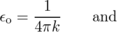
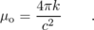
Rewrite Maxwell's equations in terms of these constants, eliminating k and c everywhere.
37. (a) Prove that in an electromagnetic wave, half the energy is in the electric field and half in the magnetic field.
(b) Based on your result from part a, find the proportionality constant in the relation dp∝E×B d v, where d p is the momentum of the part of a plane light wave contained in the volume d v. The vector E×B is known as the Poynting vector. (To do this problem, you need to know the relativistic relationship between the energy and momentum of a beam of light.)(answer check available at lightandmatter.com)
38. (a) A beam of light has cross-sectional area A and power P, i.e. P is the number of joules per second that enter a window through which the beam passes. Find the energy density U/v in terms of P, A, and universal constants.
(b) Find and , the amplitudes of the electric and magnetic fields, in terms of P, A, and universal constants (i.e., your answer should not include U or v). You will need the result of problem 37a. A real beam of light usually consists of many short wavetrains, not one big sine wave, but don't worry about that.(answer check available at lightandmatter.com)\hwhint{hwhint:solarconstant}
(c) A beam of sunlight has an intensity of P/A=1.35×10³ W/m², assuming no clouds or atmospheric absorption. This is known as the solar constant. Compute and , and compare with the strengths of static fields you experience in everyday life: E ∼ 10⁶ V/m in a thunderstorm, and B ∼ 10⁻³ T for the Earth's magnetic field.(answer check available at lightandmatter.com)
39. The circular parallel-plate capacitor shown in the figure is being charged up over time, with the voltage difference across the plates varying as V=st, where s is a constant. The plates have radius b, and the distance between them is d. We assume d << b, so that the electric field between the plates is uniform, and parallel to the axis. Find the induced magnetic field at a point between the plates, at a distance R from the axis. \hwhint{hwhint:circularcap}(answer check available at lightandmatter.com)
40. If you watch a movie played backwards, some vectors reverse their direction. For instance, people walk backwards, with their velocity vectors flipped around. Other vectors, such as forces, keep the same direction, e.g. gravity still pulls down. An electric field is another example of a vector that doesn't turn around: positive charges are still positive in the time-reversed universe, so they still make diverging electric fields, and likewise for the converging fields around negative charges.
(a) How does the momentum of a material object behave under time-reversal?(solution in the pdf version of the book){hwsoln:timereversalem}
(b) The laws of physics are still valid in the time-reversed universe. For example, show that if two material objects are interacting, and momentum is conserved, then momentum is still conserved in the time-reversed universe.(solution in the pdf version of the book){hwsoln:timereversalem}
(c) Discuss how currents and magnetic fields would behave under time reversal. \hwhint{hwhint:timereversalem}
(d) Similarly, show that the equation dp∝E×B is still valid under time reversal.
41. [2]{timereversalem2} This problem is a more advanced exploration of the time-reversal ideas introduced in problem 40.
(a) In that problem, we assumed that charge did not flip its sign under time reversal. Suppose we make the opposite assumption, that charge does change its sign. This is an idea introduced by Richard Feynman: that antimatter is really matter traveling backward in time! Determine the time-reversal properties of E and B under this new assumption, and show that dp∝E×B is still valid under time-reversal.
(b) Show that Maxwell's equations are time-reversal symmetric, i.e. that if the fields E(x,y,z,t) and B(x,y,z,t) satisfy Maxwell's equations, then so do E(x,y,z,-t) and B(x,y,z,-t). Demonstrate this under both possible assumptions about charge, q→ q and q→ -q.
42. [2]{bwork} The purpose of this problem is to prove that the constant of proportionality a in the equation d U_{m}=aB² d v, for the energy density of the magnetic field, is given by a=c²/8π k as asserted on page 590. The geometry we'll use consists of two sheets of current, like a sandwich with nothing in between but some vacuum in which there is a magnetic field. The currents are in opposite directions, and we can imagine them as being joined together at the ends to form a complete circuit, like a tube made of paper that has been squashed almost flat. The sheets have lengths L in the direction parallel to the current, and widths w. They are separated by a distance d, which, for convenience, we assume is small compared to L and w. Thus each sheet's contribution to the field is uniform, and can be approximated by the expression 2π kη/c².
(a) Make a drawing similar to the one in figure 11.2.1 on page 589, and show that in this opposite-current configuration, the magnetic fields of the two sheets reinforce in the region between them, producing double the field, but cancel on the outside.
(b) By analogy with the case of a single strand of wire, one sheet's force on the other is ILB₁, were I=η w is the total current in one sheet, and B₁=B/2 is the field contributed by only one of the sheets, since the sheet can't make any net force on itself. Based on your drawing and the right-hand rule, show that this force is repulsive.
For the rest of the problem, consider a process in which the sheets start out touching, and are then separated to a distance d. Since the force between the sheets is repulsive, they do mechanical work on the outside world as they are separated, in much the same way that the piston in an engine does work as the gases inside the cylinder expand. At the same time, however, there is an induced emf which would tend to extinguish the current, so in order to maintain a constant current, energy will have to be drained from a battery. There are three types of energy involved: the increase in the magnetic field energy, the increase in the energy of the outside world, and the decrease in energy as the battery is drained. (We assume the sheets have very little resistance, so there is no ohmic heating involved.)(answer check available at lightandmatter.com)
(c) Find the mechanical work done by the sheets, which equals the increase in the energy of the outside world. Show that your result can be stated in terms of η, the final volume v=wLd, and nothing else but numerical and physical constants.(answer check available at lightandmatter.com)
(d) The power supplied by the battery is P=IΓ_{E} (like P=IΔ V, but with an emf instead of a voltage difference), and the circulation is given by Γ=-dΦ_{B}/d t. The negative sign indicates that the battery is being drained. Calculate the energy supplied by the battery, and, as in part c, show that the result can be stated in terms of η, v, and universal constants.(answer check available at lightandmatter.com)
(e) Find the increase in the magnetic-field energy, in terms of η, v, and the unknown constant a.(answer check available at lightandmatter.com)
(f) Use conservation of energy to relate your answers from parts c, d, and e, and solve for a.(answer check available at lightandmatter.com)
43. [2]{surfing} A positively charged particle is released from rest at the origin at t=0, in a region of vacuum through which an electromagnetic wave is passing. The particle accelerates in response to the wave. In this region of space, the wave varies as , , and we assume that the particle has a relatively large value of m/q, so that its response to the wave is sluggish, and it never ends up moving at any speed comparable to the speed of light. Therefore we don't have to worry about the spatial variation of the wave; we can just imagine that these are uniform fields imposed by some external mechanism on this region of space.
(a) Find the particle's coordinates as functions of time.(answer check available at lightandmatter.com)
(b) Show that the motion is confined to -z_{max}≤ z ≤ z_{max}, where .
44. A U-shaped wire makes electrical contact with a second, straight wire, which rolls along it to the right, as shown in the figure. The whole thing is immersed in a uniform magnetic field, which is perpendicular to the plane of the circuit. The resistance of the rolling wire is much greater than that of the U.
(a) Find the direction of the force on the wire based on conservation of energy.
(b) Verify the direction of the force using right-hand rules.
(c) Find magnitude of the force acting on the wire. There is more than one way to do this, but please do it using Faraday's law (which works even though it's the Ampèrian surface itself that is changing, rather than the field).(answer check available at lightandmatter.com)
(d) Consider how the answer to part a would have changed if the direction of the field had been reversed, and also do the case where the direction of the rolling wire's motion is reversed. Verify that this is in agreement with your answer to part c.
45. A wire loop of resistance R and area A, lying in the y-z plane, falls through a nonuniform magnetic field , where k is a constant. The z axis is vertical.
(a) Find the direction of the force on the wire based on conservation of energy.
(b) Verify the direction of the force using right-hand rules.
(c) Find the magnetic force on the wire.(answer check available at lightandmatter.com)
46. Verify Ampère's law in the case shown in the figure, assuming the known equation for the field of a wire. A wire carrying current I passes perpendicularly through the center of the rectangular Ampèrian surface. The length of the rectangle is infinite, so it's not necessary to compute the contributions of the ends.
47. Electromagnetic waves are supposed to have their electric and magnetic fields perpendicular to each other. (Throughout this problem, assume we're talking about waves traveling through a vacuum, and that there is only a single sine wave traveling in a single direction, not a superposition of sine waves passing through each other.) Suppose someone claims they can make an electromagnetic wave in which the electric and magnetic fields lie in the same plane. Prove that this is impossible based on Maxwell's equations.
48. A certain region of space has a magnetic field given by . Find the electric current flowing through the square defined by z=0, 0≤ x ≤ a, and 0≤ y ≤ a.(answer check available at lightandmatter.com)
49. A capacitor has parallel plates of area A, separated by a distance h. If there is a vacuum between the plates, then Gauss's law gives E=4π kσ=4π kq/A for the field between the plates, and combining this with E=V/h, we find C=q/V=(1/4π k)A/h. (a) Generalize this derivation to the case where there is a dielectric between the plates. (b) Suppose we have a list of possible materials we could choose as dielectrics, and we wish to construct a capacitor that will have the highest possible energy density, U_{e}/v, where v is the volume. For each dielectric, we know its permittivity ε, and also the maximum electric field E it can sustain without breaking down and allowing sparks to cross between the plates. Write the maximum energy density in terms of these two variables, and determine a figure of merit that could be used to decide which material would be the best choice.
50. Repeat the self-check on page 638, but with one change in the procedure: after we charge the capacitor, we open the circuit, and then continue with the observations.
51. On page 641, I proved that H_{||,1}=H_{||,2} at the boundary between two substances if there is no free current and the fields are static. In fact, each of Maxwell's four equations implies a constraint with a similar structure. Some are constraints on the field components parallel to the boundary, while others are constraints on the perpendicular parts. Since some of the fields referred to in Maxwell's equations are the electric and magnetic fields E and B, while others are the auxiliary fields D and H, some of the constraints deal with E and B, others with D and H. Find the other three constraints.
52. [3]{spherical-shielding} (a) Figure i on page 642 shows a hollow sphere with μ/μ_{o}=x, inner radius a, and outer radius b, which has been subjected to an external field B_{o}. Finding the fields on the exterior, in the shell, and on the interior requires finding a set of fields that satisfies five boundary conditions: (1) far from the sphere, the field must approach the constant B_{o}; (2) at the outer surface of the sphere, the field must have H_{||,1}=H_{||,2}, as discussed on page 641; (3) the same constraint applies at the inner surface of the sphere; (4) and (5) there is an additional constraint on the fields at the inner and outer surfaces, as found in problem 51. The goal of this problem is to find the solution for the fields, and from it, to prove that the interior field is uniform, and given by
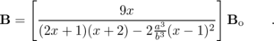
This is a very difficult problem to solve from first principles, because it's not obvious what form the fields should have, and if you hadn't been told, you probably wouldn't have guessed that the interior field would be uniform. We could, however, guess that once the sphere becomes polarized by the external field, it would become a dipole, and at r>> b, the field would be a uniform field superimposed on the field of a dipole. It turns out that even close to the sphere, the solution has exactly this form. In order to complete the solution, we need to find the field in the shell (a<r<b), but the only way this field could match up with the detailed angular variation of the interior and exterior fields would be if it was also a superposition of a uniform field with a dipole field. The final result is that we have four unknowns: the strength of the dipole component of the external field, the strength of the uniform and dipole components of the field within the shell, and the strength of the uniform interior field. These four unknowns are to be determined by imposing constraints (2) through (5) above.
(b) Show that the expression from part a has physically reasonable behavior in its dependence on x and a/b.
53. Magnet coils are often wrapped in multiple layers. The figure shows the special case where the layers are all confined to a single plane, forming a spiral. Since the thickness of the wires (plus their insulation) is fixed, the spiral that results is a mathematical type known as an Archimedean spiral, in which the turns are evenly spaced. The equation of the spiral is r=wθ, where w is a constant. For a spiral that starts from r=a and ends at r=b, show that the field at the center is given by (kI/c²w)ln b/a.(solution in the pdf version of the book){hwsoln:biot-savart-spiral}
54. Perform a calculation similar to the one in problem 53, but for a logarithmic spiral, defined by r=we^{uθ}, and show that the field is B=(kI/c²u)(1/a-1/b). Note that the solution to problem 53 is given in the back of the book.
\begin{exsection} \extitle{B}{Polarization}
Apparatus:
calcite (Iceland spar) crystal
polaroid film
1. Lay the crystal on a piece of paper that has print on it. You will observe a double image. See what happens if you rotate the crystal.
Evidently the crystal does something to the light that passes through it on the way from the page to your eye. One beam of light enters the crystal from underneath, but two emerge from the top; by conservation of energy the energy of the original beam must be shared between them. Consider the following three possible interpretations of what you have observed:
(a) The two new beams differ from each other, and from the original beam, only in energy. Their other properties are the same.
(b) The crystal adds to the light some mysterious new property (not energy), which comes in two flavors, X and Y. Ordinary light doesn't have any of either. One beam that emerges from the crystal has some X added to it, and the other beam has Y.
(c) There is some mysterious new property that is possessed by all light. It comes in two flavors, X and Y, and most ordinary light sources make an equal mixture of type X and type Y light. The original beam is an even mixture of both types, and this mixture is then split up by the crystal into the two purified forms.
In parts 2 and 3 you'll make observations that will allow you to figure out which of these is correct.
2. Now place a polaroid film over the crystal and see what you observe. What happens when you rotate the film in the horizontal plane? Does this observation allow you to rule out any of the three interpretations?
3. Now put the polaroid film under the crystal and try the same thing. Putting together all your observations, which interpretation do you think is correct?
4. Look at an overhead light fixture through the polaroid, and try rotating it. What do you observe? What does this tell you about the light emitted by the lightbulb?
5. Now position yourself with your head under a light fixture and directly over a shiny surface, such as a glossy tabletop. You'll see the lamp's reflection, and the light coming from the lamp to your eye will have undergone a reflection through roughly a 180-degree angle (i.e. it very nearly reversed its direction). Observe this reflection through the polaroid, and try rotating it. Finally, position yourself so that you are seeing glancing reflections, and try the same thing. Summarize what happens to light with properties X and Y when it is reflected. (This is the principle behind polarizing sunglasses.) \end{exsection}

Footnotes
[1] For a more practical demonstration of this effect, you can put an ordinary magnet near a computer monitor. The picture will be distorted. Make sure that the monitor has a demagnetizing (“degaussing”) button, however! Otherwise you may permanently damage it. Don't use a television tube, because TV tubes don't have demagnetizing buttons.
[2] One could object that this is circular reasoning, since the whole purpose of this argument is to prove from first principles that magnetic effects follow from the theory of relativity. Could there be some extra interaction which occurs between a moving charge and any other charge, regardless of whether the other charge is moving or not? We can argue, however, that such a theory would lack self-consistency, since we have to define the electric field somehow, and the only way to define it is in terms of F/q, where F is the force on a test charge q which is at rest. In other words, we'd have to say that there was some extra contribution to the electric field if the charge making it was in motion. This would, however, violate Gauss' law, and Gauss' law is amply supported by experiment, even when the sources of the electric field are moving. It would also violate the time-reversal symmetry of the laws of physics.
[3] The reader who wants to see the full relativistic treatment is referred to chapter 5 of E.M. Purcell, Electricity and Magnetism, McGraw Hill, 1963.
[4] Strictly speaking, there is a hole in this logic, since I've only ruled out a field that is purely along one of these three perpendicular directions. What if it has components along more than one of them? A little more work is required to eliminate these mixed possibilities. For example, we can rule out a field with a nonzero component parallel to the wire based on the following symmetry argument. Suppose a charged particle is moving in the plane of the page directly toward the wire. If the field had a component parallel to the wire, then the particle would feel a force into or out of the page, but such a force is impossible based on symmetry, since the whole arrangement is symmetric with respect to mirror-reflection across the plane of the page.
[5] If you've taken a course in differential equations, this won't seem like a very surprising assertion. The differential form of Gauss' law is a differential equation, and by giving the value of the field in the midplane, we've specified a boundary condition for the differential equation. Normally if you specify the boundary conditions, then there is a unique solution to the differential equation. In this particular case, it turns out that to ensure uniqueness, we also need to demand that the solution satisfy the differential form of Ampère's law, which is discussed in section 11.4.
[6] If you didn't read this optional subsection, don't worry, because the point is that we need to try a whole new approach anyway.
[7] Note that the magnetic field never does work on a charged particle, because its force is perpendicular to the motion; the electric power is actually coming from the mechanical work that had to be done to spin the coil. Spinning the coil is more difficult due to the presence of the magnet.
[8] If the pump analogy makes you uneasy, consider what would happen if all the electrons moved into the page on both sides of the loop. We'd end up with a net negative charge at the back side, and a net positive charge on the front. This actually would happen in the first nanosecond after the loop was set in motion. This buildup of charge would start to quench both currents due to electrical forces, but the current in the right side of the wire, which is driven by the weaker magnetic field, would be the first to stop. Eventually, an equilibrium will be reached in which the same amount of current is flowing at every point around the loop, and no more charge is being piled up.
[9] The wire is not a perfect conductor, so this current produces heat. The energy required to produce this heat comes from the hands, which are doing mechanical work as they separate the magnet from the loop.
[10] They can't be blamed too much for this. As a consequence of Faraday's work, it soon became apparent that light was an electromagnetic wave, and to reconcile this with the relative nature of motion requires Einstein's version of relativity, with all its subversive ideas how space and time are not absolute.
[11] One way to prove this rigorously is that in a frame of reference where the particle is at rest, it has an electric field that surrounds it on all sides. If the particle has been moving with constant velocity for a long time, then this is just an ordinary Coulomb's-law field, extending off to very large distances, since disturbances in the field ripple outward at the speed of light. In a frame where the particle is moving, this pure electric field is experienced instead as a combination of an electric field and a magnetic field, so the magnetic field must exist throughout the same vast region of space.
[12] Even if the fields can't be parallel to the direction of propagation, one might wonder whether they could form some angle other than 90 degrees with it. No. One proof is given on page 631. A alternative argument, which is simpler but more esoteric, is that if there was such a pattern, then there would be some other frame of reference in which it would look like figure i.
[13] A young Einstein worried about what would happen if you rode a motorcycle alongside a light wave, traveling at the speed of light. Would the light wave have a zero velocity in this frame of reference? The only solution lies in the theory of relativity, one of whose consequences is that a material object like a student or a motorcycle cannot move at the speed of light.
[14] Actually, this is only exactly true of the rectangular strip is made infinitesimally thin.
[15] You may know already that different colors of light have different speeds when they pass through a material substance, such as the glass or water. This is not in contradiction with what I'm saying here, since this whole analysis is for light in a vacuum.
[16] What makes them appear to be unrelated phenomena is that we experience them through their interaction with atoms, and atoms are complicated, so they respond to various kinds of electromagnetic waves in complicated ways.
[17] This current will soon come to a grinding halt, because we don't have a complete circuit, but let's say we're talking about the first picosecond during which the radio wave encounters the wire. This is why real radio antennas are not very short compared to a wavelength!

12. Quantum Physics
Table of Contents

Contents
Section 12.1 - Rules of Randomness
Section 12.2 - Light as a Particle
Section 12.3 - Matter as a Wave
Section 12.4 - The Atom

Chapter 12. Quantum Physics

12.1 Rules of Randomness
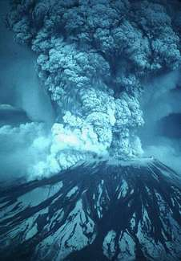
a / In 1980, the continental U.S. got its first taste of active volcanism in recent memory with the eruption of Mount St. Helens.
Given for one instant an intelligence which could comprehend all the forces by which nature is animated and the respective positions of the things which compose it...nothing would be uncertain, and the future as the past would be laid out before its eyes. -- Pierre Simon de Laplace, 1776
The energy produced by the atom is a very poor kind of thing. Anyone who expects a source of power from the transformation of these atoms is talking moonshine. -- Ernest Rutherford, 1933
The Quantum Mechanics is very imposing. But an inner voice tells me that it is still not the final truth. The theory yields much, but it hardly brings us nearer to the secret of the Old One. In any case, I am convinced that He does not play dice. -- Albert Einstein
However radical Newton's clockwork universe seemed to his contemporaries, by the early twentieth century it had become a sort of smugly accepted dogma. Luckily for us, this deterministic picture of the universe breaks down at the atomic level. The clearest demonstration that the laws of physics contain elements of randomness is in the behavior of radioactive atoms. Pick two identical atoms of a radioactive isotope, say the naturally occurring uranium 238, and watch them carefully. They will decay at different times, even though there was no difference in their initial behavior.
We would be in big trouble if these atoms' behavior was as predictable as expected in the Newtonian world-view, because radioactivity is an important source of heat for our planet. In reality, each atom chooses a random moment at which to release its energy, resulting in a nice steady heating effect. The earth would be a much colder planet if only sunlight heated it and not radioactivity. Probably there would be no volcanoes, and the oceans would never have been liquid. The deep-sea geothermal vents in which life first evolved would never have existed. But there would be an even worse consequence if radioactivity was deterministic: after a few billion years of peace, all the uranium 238 atoms in our planet would presumably pick the same moment to decay. The huge amount of stored nuclear energy, instead of being spread out over eons, would all be released at one instant, blowing our whole planet to Kingdom Come.¹
The new version of physics, incorporating certain kinds of randomness, is called quantum physics (for reasons that will become clear later). It represented such a dramatic break with the previous, deterministic tradition that everything that came before is considered “classical,” even the theory of relativity. This chapter is a basic introduction to quantum physics.

Discussion Question
◊ I said “Pick two identical atoms of a radioactive isotope.” Are two atoms really identical? If their electrons are orbiting the nucleus, can we distinguish each atom by the particular arrangement of its electrons at some instant in time?

Randomness isn't random.
Einstein's distaste for randomness, and his association of determinism with divinity, goes back to the Enlightenment conception of the universe as a gigantic piece of clockwork that only had to be set in motion initially by the Builder. Many of the founders of quantum mechanics were interested in possible links between physics and Eastern and Western religious and philosophical thought, but every educated person has a different concept of religion and philosophy. Bertrand Russell remarked, “Sir Arthur Eddington deduces religion from the fact that atoms do not obey the laws of mathematics. Sir James Jeans deduces it from the fact that they do.”
Russell's witticism, which implies incorrectly that mathematics cannot describe randomness, remind us how important it is not to oversimplify this question of randomness. You should not simply surmise, “Well, it's all random, anything can happen.” For one thing, certain things simply cannot happen, either in classical physics or quantum physics. The conservation laws of mass, energy, momentum, and angular momentum are still valid, so for instance processes that create energy out of nothing are not just unlikely according to quantum physics, they are impossible.
A useful analogy can be made with the role of randomness in evolution. Darwin was not the first biologist to suggest that species changed over long periods of time. His two new fundamental ideas were that (1) the changes arose through random genetic variation, and (2) changes that enhanced the organism's ability to survive and reproduce would be preserved, while maladaptive changes would be eliminated by natural selection. Doubters of evolution often consider only the first point, about the randomness of natural variation, but not the second point, about the systematic action of natural selection. They make statements such as, “the development of a complex organism like Homo sapiens via random chance would be like a whirlwind blowing through a junkyard and spontaneously assembling a jumbo jet out of the scrap metal.” The flaw in this type of reasoning is that it ignores the deterministic constraints on the results of random processes. For an atom to violate conservation of energy is no more likely than the conquest of the world by chimpanzees next year.

Discussion Question
◊ Economists often behave like wannabe physicists, probably because it seems prestigious to make numerical calculations instead of talking about human relationships and organizations like other social scientists. Their striving to make economics work like Newtonian physics extends to a parallel use of mechanical metaphors, as in the concept of a market's supply and demand acting like a self-adjusting machine, and the idealization of people as economic automatons who consistently strive to maximize their own wealth. What evidence is there for randomness rather than mechanical determinism in economics?
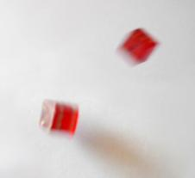
b / Why are dice random?

Calculating randomness
You should also realize that even if something is random, we can still understand it, and we can still calculate probabilities numerically. In other words, physicists are good bookmakers. A good bookmaker can calculate the odds that a horse will win a race much more accurately that an inexperienced one, but nevertheless cannot predict what will happen in any particular race.

Statistical independence
As an illustration of a general technique for calculating odds, suppose you are playing a 25-cent slot machine. Each of the three wheels has one chance in ten of coming up with a cherry. If all three wheels come up cherries, you win $100. Even though the results of any particular trial are random, you can make certain quantitative predictions. First, you can calculate that your odds of winning on any given trial are 1/10×1/10×1/10=1/1000=0.001. Here, I am representing the probabilities as numbers from 0 to 1, which is clearer than statements like “The odds are 999 to 1,” and makes the calculations easier. A probability of 0 represents something impossible, and a probability of 1 represents something that will definitely happen.
Also, you can say that any given trial is equally likely to result in a win, and it doesn't matter whether you have won or lost in prior games. Mathematically, we say that each trial is statistically independent, or that separate games are uncorrelated. Most gamblers are mistakenly convinced that, to the contrary, games of chance are correlated. If they have been playing a slot machine all day, they are convinced that it is “getting ready to pay,” and they do not want anyone else playing the machine and “using up” the jackpot that they “have coming.” In other words, they are claiming that a series of trials at the slot machine is negatively correlated, that losing now makes you more likely to win later. Craps players claim that you should go to a table where the person rolling the dice is “hot,” because she is likely to keep on rolling good numbers. Craps players, then, believe that rolls of the dice are positively correlated, that winning now makes you more likely to win later.
My method of calculating the probability of winning on the slot machine was an example of the following important rule for calculations based on independent probabilities:
\lessimportant[The Law of Independent Probabilities]

Chapter 12. If the probability of one event happening is P_{A}, and the probability of a second statistically independent event happening is P_{B}, then the probability that they will both occur is the product of the probabilities, P_{A}P_{B}. If there are more than two events involved, you simply keep on multiplying.
Note that this only applies to independent probabilities. For instance, if you have a nickel and a dime in your pocket, and you randomly pull one out, there is a probability of 0.5 that it will be the nickel. If you then replace the coin and again pull one out randomly, there is again a probability of 0.5 of coming up with the nickel, because the probabilities are independent. Thus, there is a probability of 0.25 that you will get the nickel both times.
Suppose instead that you do not replace the first coin before pulling out the second one. Then you are bound to pull out the other coin the second time, and there is no way you could pull the nickel out twice. In this situation, the two trials are not independent, because the result of the first trial has an effect on the second trial. The law of independent probabilities does not apply, and the probability of getting the nickel twice is zero, not 0.25.
Experiments have shown that in the case of radioactive decay, the probability that any nucleus will decay during a given time interval is unaffected by what is happening to the other nuclei, and is also unrelated to how long it has gone without decaying. The first observation makes sense, because nuclei are isolated from each other at the centers of their respective atoms, and therefore have no physical way of influencing each other. The second fact is also reasonable, since all atoms are identical. Suppose we wanted to believe that certain atoms were “extra tough,” as demonstrated by their history of going an unusually long time without decaying. Those atoms would have to be different in some physical way, but nobody has ever succeeded in detecting differences among atoms. There is no way for an atom to be changed by the experiences it has in its lifetime.

Addition of probabilities
The law of independent probabilities tells us to use multiplication to calculate the probability that both A and B will happen, assuming the probabilities are independent. What about the probability of an “or” rather than an “and”? If two events A and B are mutually exclusive, then the probability of one or the other occurring is the sum P_{A}+P_{B}. For instance, a bowler might have a 30% chance of getting a strike (knocking down all ten pins) and a 20% chance of knocking down nine of them. The bowler's chance of knocking down either nine pins or ten pins is therefore 50%.
It does not make sense to add probabilities of things that are not mutually exclusive, i.e. that could both happen. Say I have a 90% chance of eating lunch on any given day, and a 90% chance of eating dinner. The probability that I will eat either lunch or dinner is not 180%.

Normalization
If I spin a globe and randomly pick a point on it, I have about a 70% chance of picking a point that's in an ocean and a 30% chance of picking a point on land. The probability of picking either water or land is . Water and land are mutually exclusive, and there are no other possibilities, so the probabilities had to add up to 100%. It works the same if there are more than two possibilities --- if you can classify all possible outcomes into a list of mutually exclusive results, then all the probabilities have to add up to 1, or 100%. This property of probabilities is known as normalization.

Averages
Another way of dealing with randomness is to take averages. The casino knows that in the long run, the number of times you win will approximately equal the number of times you play multiplied by the probability of winning. In the game mentioned above, where the probability of winning is 0.001, if you spend a week playing, and pay $2500 to play 10,000 times, you are likely to win about 10 times (10,000×0.001=10), and collect $1000. On the average, the casino will make a profit of $1500 from you. This is an example of the following rule.
\lessimportant[Rule for Calculating Averages]{If you conduct N identical, statistically independent trials, and the probability of success in each trial is P, then on the average, the total number of successful trials will be NP. If N is large enough, the relative error in this estimate will become small.}
The statement that the rule for calculating averages gets more and more accurate for larger and larger N(known popularly as the “law of averages”) often provides a correspondence principle that connects classical and quantum physics. For instance, the amount of power produced by a nuclear power plant is not random at any detectable level, because the number of atoms in the reactor is so large. In general, random behavior at the atomic level tends to average out when we consider large numbers of atoms, which is why physics seemed deterministic before physicists learned techniques for studying atoms individually.
We can achieve great precision with averages in quantum physics because we can use identical atoms to reproduce exactly the same situation many times. If we were betting on horses or dice, we would be much more limited in our precision. After a thousand races, the horse would be ready to retire. After a million rolls, the dice would be worn out.
self-check:
Which of the following things must have independent, which could be independent, and which definitely are not independent? (1) the probability of successfully making two free-throws in a row in basketball; (2) the probability that it will rain in London tomorrow and the probability that it will rain on the same day in a certain city in a distant galaxy; (3) your probability of dying today and of dying tomorrow. (answer in the back of the PDF version of the book)

Discussion Questions
◊ Newtonian physics is an essentially perfect approximation for describing the motion of a pair of dice. If Newtonian physics is deterministic, why do we consider the result of rolling dice to be random?
◊ Why isn't it valid to define randomness by saying that randomness is when all the outcomes are equally likely?
◊ The sequence of digits 121212121212121212 seems clearly nonrandom, and 41592653589793 seems random. The latter sequence, however, is the decimal form of pi, starting with the third digit. There is a story about the Indian mathematician Ramanujan, a self-taught prodigy, that a friend came to visit him in a cab, and remarked that the number of the cab, 1729, seemed relatively uninteresting. Ramanujan replied that on the contrary, it was very interesting because it was the smallest number that could be represented in two different ways as the sum of two cubes. The Argentine author Jorge Luis Borges wrote a short story called “The Library of Babel,” in which he imagined a library containing every book that could possibly be written using the letters of the alphabet. It would include a book containing only the repeated letter “a;” all the ancient Greek tragedies known today, all the lost Greek tragedies, and millions of Greek tragedies that were never actually written; your own life story, and various incorrect versions of your own life story; and countless anthologies containing a short story called “The Library of Babel.” Of course, if you picked a book from the shelves of the library, it would almost certainly look like a nonsensical sequence of letters and punctuation, but it's always possible that the seemingly meaningless book would be a science-fiction screenplay written in the language of a Neanderthal tribe, or the lyrics to a set of incomparably beautiful love songs written in a language that never existed. In view of these examples, what does it really mean to say that something is random?
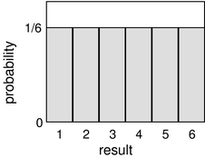
c / Probability distribution for the result of rolling a single die.
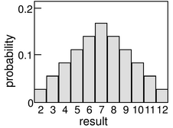
d / Rolling two dice and adding them up.
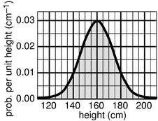
e / A probability distribution for height of human adults (not real data).
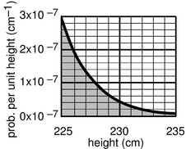
f / Example 1.
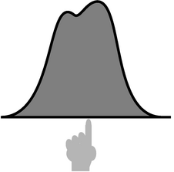
g / The average of a probability distribution.
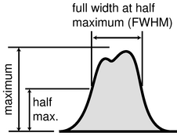
h / The full width at half maximum (FWHM) of a probability distribution.

Probability distributions
So far we've discussed random processes having only two possible outcomes: yes or no, win or lose, on or off. More generally, a random process could have a result that is a number. Some processes yield integers, as when you roll a die and get a result from one to six, but some are not restricted to whole numbers, for example the number of seconds that a uranium-238 atom will exist before undergoing radioactive decay.
Consider a throw of a die. If the die is “honest,” then we expect all six values to be equally likely. Since all six probabilities must add up to 1, then probability of any particular value coming up must be 1/6. We can summarize this in a graph, c. Areas under the curve can be interpreted as total probabilities. For instance, the area under the curve from 1 to 3 is 1/6+1/6+1/6=1/2, so the probability of getting a result from 1 to 3 is 1/2. The function shown on the graph is called the probability distribution.
Figure d shows the probabilities of various results obtained by rolling two dice and adding them together, as in the game of craps. The probabilities are not all the same. There is a small probability of getting a two, for example, because there is only one way to do it, by rolling a one and then another one. The probability of rolling a seven is high because there are six different ways to do it: 1+6, 2+5, etc.
If the number of possible outcomes is large but finite, for example the number of hairs on a dog, the graph would start to look like a smooth curve rather than a ziggurat.
What about probability distributions for random numbers that are not integers? We can no longer make a graph with probability on the y axis, because the probability of getting a given exact number is typically zero. For instance, there is zero probability that a radioactive atom will last for exactly 3 seconds, since there is are infinitely many possible results that are close to 3 but not exactly three: 2.999999999999999996876876587658465436, for example. It doesn't usually make sense, therefore, to talk about the probability of a single numerical result, but it does make sense to talk about the probability of a certain range of results. For instance, the probability that an atom will last more than 3 and less than 4 seconds is a perfectly reasonable thing to discuss. We can still summarize the probability information on a graph, and we can still interpret areas under the curve as probabilities.
But the y axis can no longer be a unitless probability scale. In radioactive decay, for example, we want the x axis to have units of time, and we want areas under the curve to be unitless probabilities. The area of a single square on the graph paper is then
If the units are to cancel out, then the height of the square must evidently be a quantity with units of inverse time. In other words, the y axis of the graph is to be interpreted as probability per unit time, not probability.
Figure e shows another example, a probability distribution for people's height. This kind of bell-shaped curve is quite common.
self-check:
Compare the number of people with heights in the range of 130-135 cm to the number in the range 135-140. (answer in the back of the PDF version of the book)

Example 1: Looking for tall basketball players
◊ A certain country with a large population wants to find very tall people to be on its Olympic basketball team and strike a blow against western imperialism. Out of a pool of 10⁸ people who are the right age and gender, how many are they likely to find who are over 225 cm (7 feet 4 inches) in height? Figure (d) gives a close-up of the “tails” of the distribution shown previously.
◊ The shaded area under the curve represents the probability that a given person is tall enough. Each rectangle represents a probability of 0.2×10⁻⁷ cm⁻¹ × 1 cm =2×10⁻⁹. There are about 35 rectangles covered by the shaded area, so the probability of having a height greater than 230 cm is 7×10⁻⁸ , or just under one in ten million. Using the rule for calculating averages, the average, or expected number of people this tall is (10⁸)×(7×10⁻⁸ )=7.

Average and width of a probability distribution
If the next Martian you meet asks you, “How tall is an adult human?,” you will probably reply with a statement about the average human height, such as “Oh, about 5 feet 6 inches.” If you wanted to explain a little more, you could say, “But that's only an average. Most people are somewhere between 5 feet and 6 feet tall.” Without bothering to draw the relevant bell curve for your new extraterrestrial acquaintance, you've summarized the relevant information by giving an average and a typical range of variation.
The average of a probability distribution can be defined geometrically as the horizontal position at which it could be balanced if it was constructed out of cardboard. A convenient numerical measure of the amount of variation about the average, or amount of uncertainty, is the full width at half maximum, or FWHM, shown in figure h.
A great deal more could be said about this topic, and indeed an introductory statistics course could spend months on ways of defining the center and width of a distribution. Rather than force-feeding you on mathematical detail or techniques for calculating these things, it is perhaps more relevant to point out simply that there are various ways of defining them, and to inoculate you against the misuse of certain definitions.
The average is not the only possible way to say what is a typical value for a quantity that can vary randomly; another possible definition is the median, defined as the value that is exceeded with 50% probability. When discussing incomes of people living in a certain town, the average could be very misleading, since it can be affected massively if a single resident of the town is Bill Gates. Nor is the FWHM the only possible way of stating the amount of random variation; another possible way of measuring it is the standard deviation (defined as the square root of the average squared deviation from the average value).

Exponential decay and half-life

Half-life
Most people know that radioactivity “lasts a certain amount of time,” but that simple statement leaves out a lot. As an example, consider the following medical procedure used to diagnose thyroid function. A very small quantity of the isotope ¹³¹I, produced in a nuclear reactor, is fed to or injected into the patient. The body's biochemical systems treat this artificial, radioactive isotope exactly the same as ¹²⁷I, which is the only naturally occurring type. (Nutritionally, iodine is a necessary trace element. Iodine taken into the body is partly excreted, but the rest becomes concentrated in the thyroid gland. Iodized salt has had iodine added to it to prevent the nutritional deficiency known as goiters, in which the iodine-starved thyroid becomes swollen.) As the ¹³¹I undergoes beta decay, it emits electrons, neutrinos, and gamma rays. The gamma rays can be measured by a detector passed over the patient's body. As the radioactive iodine becomes concentrated in the thyroid, the amount of gamma radiation coming from the thyroid becomes greater, and that emitted by the rest of the body is reduced. The rate at which the iodine concentrates in the thyroid tells the doctor about the health of the thyroid.
If you ever undergo this procedure, someone will presumably explain a little about radioactivity to you, to allay your fears that you will turn into the Incredible Hulk, or that your next child will have an unusual number of limbs. Since iodine stays in your thyroid for a long time once it gets there, one thing you'll want to know is whether your thyroid is going to become radioactive forever. They may just tell you that the radioactivity “only lasts a certain amount of time,” but we can now carry out a quantitative derivation of how the radioactivity really will die out.
Let P_{surv}(t) be the probability that an iodine atom will survive without decaying for a period of at least t. It has been experimentally measured that half all ¹³¹I atoms decay in 8 hours, so we have
P_{surv}(8 hr) = 0.5 .
Now using the law of independent probabilities, the probability of surviving for 16 hours equals the probability of surviving for the first 8 hours multiplied by the probability of surviving for the second 8 hours,
P_{surv}(16 hr) = 0.50×0.50
= 0.25 .
Similarly we have
P_{surv}(24 hr) = 0.50×0.5×0.5
= 0.125 .
Generalizing from this pattern, the probability of surviving for any time t that is a multiple of 8 hours is
P_{surv}(t) = 0.5^{t/8 hr} .
We now know how to find the probability of survival at intervals of 8 hours, but what about the points in time in between? What would be the probability of surviving for 4 hours? Well, using the law of independent probabilities again, we have
P_{surv}(8 hr) = P_{surv}(4 hr) × P_{surv}(4 hr) ,
which can be rearranged to give
= 0.707 .
This is exactly what we would have found simply by plugging in P_{surv}(t)=0.5^{t/8 hr} and ignoring the restriction to multiples of 8 hours. Since 8 hours is the amount of time required for half of the atoms to decay, it is known as the half-life, written t_{1/2}. The general rule is as follows:
\lessimportant{Exponential Decay Equation}{
P_{surv}(t) = 0.5^{t/t}_{1/2}
}
Using the rule for calculating averages, we can also find the number of atoms, N(t), remaining in a sample at time :
N(t) = N(0) × 0.5^{t/t}_{1/2}
Both of these equations have graphs that look like dying-out exponentials, as in the example below.

Example 2: Radioactive contamination at Chernobyl
◊ One of the most dangerous radioactive isotopes released by the Chernobyl disaster in 1986 was ⁹⁰Sr, whose half-life is 28 years. (a) How long will it be before the contamination is reduced to one tenth of its original level? (b) If a total of 10²⁷ atoms was released, about how long would it be before not a single atom was left?
◊ (a) We want to know the amount of time that a ⁹⁰Sr nucleus has a probability of 0.1 of surviving. Starting with the exponential decay formula,
P_{surv} = 0.5^{t/t}_{1/2} ,
we want to solve for t. Taking natural logarithms of both sides,
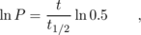
so
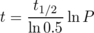
Plugging in P=0.1 and t_{1/2}=28 years, we get t=93 years.
(b) This is just like the first part, but P=10⁻²⁷ . The result is about 2500 years.
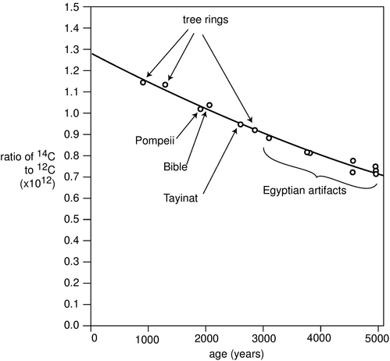
i / Calibration of the ¹⁴C dating method using tree rings and artifacts whose ages were known from other methods. Redrawn from Emilio Segrè, Nuclei and Particles, 1965.

Example 3: ¹⁴C Dating
\zu{C}Dating}^{12}\zu{C}, but not quite.^{14}\zu{C}, with a half-life of 5600 years, is^{14}\zu{C}in the atmosphere remains constant, at1.3\times10^{-12}. Living plants and animals take in both^{12}\zu{C}and^{14}\zu{C}from the atmosphere and incorporate^{14}\zu{C}gradually falls off as it undergoes^{14}\zu{C}$ in various objects. Similar methods, using longer-lived isotopes, provided the first firm proof that the earth was billions of years old, not a few thousand as some had claimed on religious grounds.

Rate of decay
If you want to find how many radioactive decays occur within a time interval lasting from time t to time t+Δ t, the most straightforward approach is to calculate it like this:
= N(t) - N(t+Δ t)
A problem arises when Δ t is small compared to t_{1/2}. For instance, suppose you have a hunk of 10²² atoms of ²³⁵U, with a half-life of 700 million years, which is 2.2×10¹⁶ s. You want to know how many decays will occur in Δ t=1 s. Since we're specifying the current number of atoms, t=0. As you plug in to the formula above on your calculator, the quantity 0.5^{Δ t/t}_{1/2} comes out on your calculator to equal one, so the final result is zero. That's incorrect, though. In reality, 0.5^{Δ t/t}_{1/2} should equal 0.999999999999999968, but your calculator only gives eight digits of precision, so it rounded it off to one. In other words, the probability that a ²³⁵U atom will survive for 1 s is very close to one, but not equal to one. The number of decays in one second is therefore 3.2×10⁵, not zero.
Well, my calculator only does eight digits of precision, just like yours, so how did I know the right answer? The way to do it is to use the following approximation:
(The symbol << means “is much less than.”) Using it, we can find the following approximation:
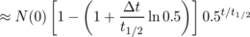
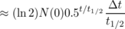
This also gives us a way to calculate the rate of decay, i.e. the number of decays per unit time. Dividing by Δ t on both sides, we have

Example 4: The hot potato
◊ A nuclear physicist with a demented sense of humor tosses you a cigar box, yelling “hot potato.” The label on the box says “contains 10²⁰ atoms of ¹⁷F, half-life of 66 s, produced today in our reactor at 1 p.m.” It takes you two seconds to read the label, after which you toss it behind some lead bricks and run away. The time is 1:40 p.m. Will you die?
◊ The time elapsed since the radioactive fluorine was produced in the reactor was 40 minutes, or 2400 s. The number of elapsed half-lives is therefore t/t_{1/2}= 36. The initial number of atoms was N(0)=10²⁰ . The number of decays per second is now about 10⁷ s⁻¹, so it produced about 2×10⁷ high-energy electrons while you held it in your hands. Although twenty million electrons sounds like a lot, it is not really enough to be dangerous.
By the way, none of the equations we've derived so far was the actual probability distribution for the time at which a particular radioactive atom will decay. That probability distribution would be found by substituting N(0)=1 into the equation for the rate of decay.
If the sheer number of equations is starting to seem formidable, let's pause and think for a second. The simple equation for P_{surv} is something you can derive easily from the law of independent probabilities any time you need it. From that, you can quickly find the exact equation for the rate of decay. The derivation of the approximate equations for Δ t<< t is a little hairier, but note that except for the factors of ln 2, everything in these equations can be found simply from considerations of logic and units. For instance, a longer half-life will obviously lead to a slower rate of decays, so it makes sense that we divide by it. As for the ln 2 factors, they are exactly the kind of thing that one looks up in a book when one needs to know them.

Discussion Questions
◊ In the medical procedure involving ¹³¹I, why is it the gamma rays that are detected, not the electrons or neutrinos that are also emitted?
◊ For 1 s, Fred holds in his hands 1 kg of radioactive stuff with a half-life of 1000 years. Ginger holds 1 kg of a different substance, with a half-life of 1 min, for the same amount of time. Did they place themselves in equal danger, or not?
◊ How would you interpret it if you calculated N(t), and found it was less than one?
◊ Does the half-life depend on how much of the substance you have? Does the expected time until the sample decays completely depend on how much of the substance you have?

Applications of calculus
The area under the probability distribution is of course an integral. If we call the random number x and the probability distribution D(x), then the probability that x lies in a certain range is given by
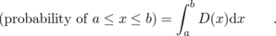
What about averages? If x had a finite number of equally probable values, we would simply add them up and divide by how many we had. If they weren't equally likely, we'd make the weighted average x₁P₁+x₂P₂+... But we need to generalize this to a variable x that can take on any of a continuum of values. The continuous version of a sum is an integral, so the average is

where the integral is over all possible values of x.

Example 5: Probability distribution for radioactive decay
Here is a rigorous justification for the statement in subsection 12.1.4 that the probability distribution for radioactive decay is found by substituting N(0)=1 into the equation for the rate of decay. We know that the probability distribution must be of the form
D(t) = k 0.5^{t/t}_{1/2} ,
where k is a constant that we need to determine. The atom is guaranteed to decay eventually, so normalization gives us
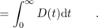
The integral is most easily evaluated by converting the function into an exponential with e as the base
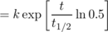
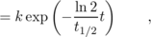
which gives an integral of the familiar form 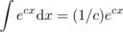. We thus have
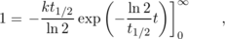
which gives the desired result:
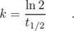

Example 6: Average lifetime
You might think that the half-life would also be the average lifetime of an atom, since half the atoms' lives are shorter and half longer. But the half whose lives are longer include some that survive for many half-lives, and these rare long-lived atoms skew the average. We can calculate the average lifetime as follows:
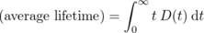
Using the convenient base-e form again, we have
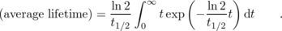
This integral is of a form that can either be attacked with integration by parts or by looking it up in a table. The result is 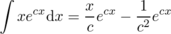, and the first term can be ignored for our purposes because it equals zero at both limits of integration. We end up with
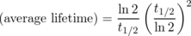
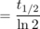
= 1.443 t_{1/2} ,
which is, as expected, longer than one half-life.
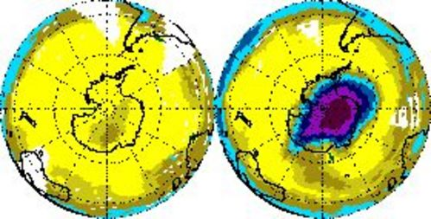
j / In recent decades, a huge hole in the ozone layer has spread out from Antarctica. Left: November 1978. Right: November 1992

12.2 Light as a Particle
The only thing that interferes with my learning is my education. -- Albert Einstein
Radioactivity is random, but do the laws of physics exhibit randomness in other contexts besides radioactivity? Yes. Radioactive decay was just a good playpen to get us started with concepts of randomness, because all atoms of a given isotope are identical. By stocking the playpen with an unlimited supply of identical atom-toys, nature helped us to realize that their future behavior could be different regardless of their original identicality. We are now ready to leave the playpen, and see how randomness fits into the structure of physics at the most fundamental level.
The laws of physics describe light and matter, and the quantum revolution rewrote both descriptions. Radioactivity was a good example of matter's behaving in a way that was inconsistent with classical physics, but if we want to get under the hood and understand how nonclassical things happen, it will be easier to focus on light rather than matter. A radioactive atom such as uranium-235 is after all an extremely complex system, consisting of 92 protons, 143 neutrons, and 92 electrons. Light, however, can be a simple sine wave.
However successful the classical wave theory of light had been --- allowing the creation of radio and radar, for example --- it still failed to describe many important phenomena. An example that is currently of great interest is the way the ozone layer protects us from the dangerous short-wavelength ultraviolet part of the sun's spectrum. In the classical description, light is a wave. When a wave passes into and back out of a medium, its frequency is unchanged, and although its wavelength is altered while it is in the medium, it returns to its original value when the wave reemerges. Luckily for us, this is not at all what ultraviolet light does when it passes through the ozone layer, or the layer would offer no protection at all!
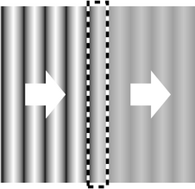
b / A wave is partially absorbed.
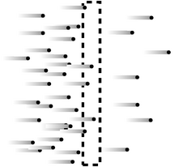
c / A stream of particles is partially absorbed.
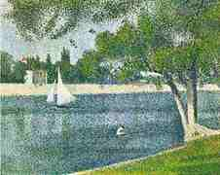
d / Einstein and Seurat: twins separated at birth? Seine Grande Jatte by Georges Seurat (19th century).

Evidence for light as a particle
For a long time, physicists tried to explain away the problems with the classical theory of light as arising from an imperfect understanding of atoms and the interaction of light with individual atoms and molecules. The ozone paradox, for example, could have been attributed to the incorrect assumption that one could think of the ozone layer as a smooth, continuous substance, when in reality it was made of individual ozone molecules. It wasn't until 1905 that Albert Einstein threw down the gauntlet, proposing that the problem had nothing to do with the details of light's interaction with atoms and everything to do with the fundamental nature of light itself.
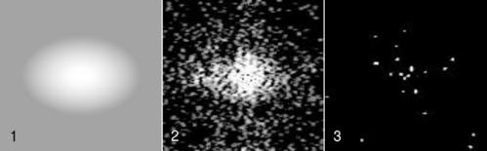
a / Digital camera images of dimmer and dimmer sources of light. The dots are records of individual photons.
In those days the data were sketchy, the ideas vague, and the experiments difficult to interpret; it took a genius like Einstein to cut through the thicket of confusion and find a simple solution. Today, however, we can get right to the heart of the matter with a piece of ordinary consumer electronics, the digital camera. Instead of film, a digital camera has a computer chip with its surface divided up into a grid of light-sensitive squares, called “pixels.” Compared to a grain of the silver compound used to make regular photographic film, a digital camera pixel is activated by an amount of light energy orders of magnitude smaller. We can learn something new about light by using a digital camera to detect smaller and smaller amounts of light, as shown in figure a. Figure a/1 is fake, but a/2 and a/3 are real digital-camera images made by Prof. Lyman Page of Princeton University as a classroom demonstration. Figure a/1 is what we would see if we used the digital camera to take a picture of a fairly dim source of light. In figures a/2 and a/3, the intensity of the light was drastically reduced by inserting semitransparent absorbers like the tinted plastic used in sunglasses. Going from a/1 to a/2 to a/3, more and more light energy is being thrown away by the absorbers.
The results are drastically different from what we would expect based on the wave theory of light. If light was a wave and nothing but a wave, b, then the absorbers would simply cut down the wave's amplitude across the whole wavefront. The digital camera's entire chip would be illuminated uniformly, and weakening the wave with an absorber would just mean that every pixel would take a long time to soak up enough energy to register a signal.
But figures a/2 and a/3 show that some pixels take strong hits while others pick up no energy at all. Instead of the wave picture, the image that is naturally evoked by the data is something more like a hail of bullets from a machine gun, c. Each “bullet” of light apparently carries only a tiny amount of energy, which is why detecting them individually requires a sensitive digital camera rather than an eye or a piece of film.
Although Einstein was interpreting different observations, this is the conclusion he reached in his 1905 paper: that the pure wave theory of light is an oversimplification, and that the energy of a beam of light comes in finite chunks rather than being spread smoothly throughout a region of space.
We now think of these chunks as particles of light, and call them “photons,” although Einstein avoided the word “particle,” and the word “photon” was invented later. Regardless of words, the trouble was that waves and particles seemed like inconsistent categories. The reaction to Einstein's paper could be kindly described as vigorously skeptical. Even twenty years later, Einstein wrote, “There are therefore now two theories of light, both indispensable, and --- as one must admit today despite twenty years of tremendous effort on the part of theoretical physicists --- without any logical connection.” In the remainder of this chapter we will learn how the seeming paradox was eventually resolved.

Discussion Questions
◊ Suppose someone rebuts the digital camera data in figure a, claiming that the random pattern of dots occurs not because of anything fundamental about the nature of light but simply because the camera's pixels are not all exactly the same. How could we test this interpretation?
◊ Discuss how the correspondence principle applies to the observations and concepts discussed in this section.
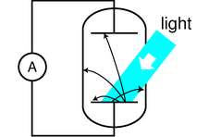
e / Apparatus for observing the photoelectric effect. A beam of light strikes a capacitor plate inside a vacuum tube, and electrons are ejected (black arrows).
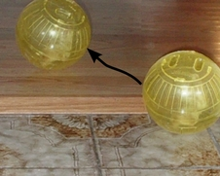
f / The hamster in her hamster ball is like an electron emerging from the metal (tiled kitchen floor) into the surrounding vacuum (wood floor). The wood floor is higher than the tiled floor, so as she rolls up the step, the hamster will lose a certain amount of kinetic energy, analogous to E_{s}. If her kinetic energy is too small, she won't even make it up the step.
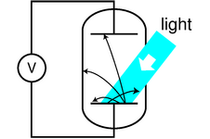
g / A different way of studying the photoelectric effect.
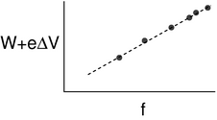
h / The quantity E_{s}+eΔ V indicates the energy of one photon. It is found to be proportional to the frequency of the light.

How much light is one photon?

The photoelectric effect
We have seen evidence that light energy comes in little chunks, so the next question to be asked is naturally how much energy is in one chunk. The most straightforward experimental avenue for addressing this question is a phenomenon known as the photoelectric effect. The photoelectric effect occurs when a photon strikes the surface of a solid object and knocks out an electron. It occurs continually all around you. It is happening right now at the surface of your skin and on the paper or computer screen from which you are reading these words. It does not ordinarily lead to any observable electrical effect, however, because on the average free electrons are wandering back in just as frequently as they are being ejected. (If an object did somehow lose a significant number of electrons, its growing net positive charge would begin attracting the electrons back more and more strongly.)
Figure e shows a practical method for detecting the photoelectric effect. Two very clean parallel metal plates (the electrodes of a capacitor) are sealed inside a vacuum tube, and only one plate is exposed to light. Because there is a good vacuum between the plates, any ejected electron that happens to be headed in the right direction will almost certainly reach the other capacitor plate without colliding with any air molecules.
The illuminated (bottom) plate is left with a net positive charge, and the unilluminated (top) plate acquires a negative charge from the electrons deposited on it. There is thus an electric field between the plates, and it is because of this field that the electrons' paths are curved, as shown in the diagram. However, since vacuum is a good insulator, any electrons that reach the top plate are prevented from responding to the electrical attraction by jumping back across the gap. Instead they are forced to make their way around the circuit, passing through an ammeter. The ammeter allows a measurement of the strength of the photoelectric effect.

An unexpected dependence on frequency
The photoelectric effect was discovered serendipitously by Heinrich Hertz in 1887, as he was experimenting with radio waves. He was not particularly interested in the phenomenon, but he did notice that the effect was produced strongly by ultraviolet light and more weakly by lower frequencies. Light whose frequency was lower than a certain critical value did not eject any electrons at all. (In fact this was all prior to Thomson's discovery of the electron, so Hertz would not have described the effect in terms of electrons --- we are discussing everything with the benefit of hindsight.) This dependence on frequency didn't make any sense in terms of the classical wave theory of light. A light wave consists of electric and magnetic fields. The stronger the fields, i.e. the greater the wave's amplitude, the greater the forces that would be exerted on electrons that found themselves bathed in the light. It should have been amplitude (brightness) that was relevant, not frequency. The dependence on frequency not only proves that the wave model of light needs modifying, but with the proper interpretation it allows us to determine how much energy is in one photon, and it also leads to a connection between the wave and particle models that we need in order to reconcile them.
To make any progress, we need to consider the physical process by which a photon would eject an electron from the metal electrode. A metal contains electrons that are free to move around. Ordinarily, in the interior of the metal, such an electron feels attractive forces from atoms in every direction around it. The forces cancel out. But if the electron happens to find itself at the surface of the metal, the attraction from the interior side is not balanced out by any attraction from outside. In popping out through the surface the electron therefore loses some amount of energy E_{s}, which depends on the type of metal used.
Suppose a photon strikes an electron, annihilating itself and giving up all its energy to the electron. (We now know that this is what always happens in the photoelectric effect, although it had not yet been established in 1905 whether or not the photon was completely annihilated.) The electron will (1) lose kinetic energy through collisions with other electrons as it plows through the metal on its way to the surface; (2) lose an amount of kinetic energy equal to E_{s} as it emerges through the surface; and (3) lose more energy on its way across the gap between the plates, due to the electric field between the plates. Even if the electron happens to be right at the surface of the metal when it absorbs the photon, and even if the electric field between the plates has not yet built up very much, E_{s} is the bare minimum amount of energy that it must receive from the photon if it is to contribute to a measurable current. The reason for using very clean electrodes is to minimize E_{s} and make it have a definite value characteristic of the metal surface, not a mixture of values due to the various types of dirt and crud that are present in tiny amounts on all surfaces in everyday life.
We can now interpret the frequency dependence of the photoelectric effect in a simple way: apparently the amount of energy possessed by a photon is related to its frequency. A low-frequency red or infrared photon has an energy less than E_{s}, so a beam of them will not produce any current. A high-frequency blue or violet photon, on the other hand, packs enough of a punch to allow an electron to make it to the other plate. At frequencies higher than the minimum, the photoelectric current continues to increase with the frequency of the light because of effects (1) and (3).

Numerical relationship between energy and frequency
Prompted by Einstein's photon paper, Robert Millikan (whom we first encountered in chapter 8) figured out how to use the photoelectric effect to probe precisely the link between frequency and photon energy. Rather than going into the historical details of Millikan's actual experiments (a lengthy experimental program that occupied a large part of his professional career) we will describe a simple version, shown in figure g, that is used sometimes in college laboratory courses.² The idea is simply to illuminate one plate of the vacuum tube with light of a single wavelength and monitor the voltage difference between the two plates as they charge up. Since the resistance of a voltmeter is very high (much higher than the resistance of an ammeter), we can assume to a good approximation that electrons reaching the top plate are stuck there permanently, so the voltage will keep on increasing for as long as electrons are making it across the vacuum tube.
At a moment when the voltage difference has a reached a value ΔV, the minimum energy required by an electron to make it out of the bottom plate and across the gap to the other plate is E_{s}+eΔV. As Δ V increases, we eventually reach a point at which E_{s}+eΔ V equals the energy of one photon. No more electrons can cross the gap, and the reading on the voltmeter stops rising. The quantity E_{s}+eΔ V now tells us the energy of one photon. If we determine this energy for a variety of wavelengths, h, we find the following simple relationship between the energy of a photon and the frequency of the light:
E = hf ,
where h is a constant with the value 6.63×10⁻³⁴ J⋅s. Note how the equation brings the wave and particle models of light under the same roof: the left side is the energy of one particle of light, while the right side is the frequency of the same light, interpreted as a wave. The constant h is known as Planck's constant, for historical reasons explained in the footnote beginning on the preceding page.
self-check:
How would you extract h from the graph in figure h? What if you didn't even know E_{s} in advance, and could only graph eΔ V versus f? (answer in the back of the PDF version of the book)
Since the energy of a photon is hf, a beam of light can only have energies of hf, 2hf, 3hf, etc. Its energy is quantized --- there is no such thing as a fraction of a photon. Quantum physics gets its name from the fact that it quantizes quantities like energy, momentum, and angular momentum that had previously been thought to be smooth, continuous and infinitely divisible.

Example 7: Number of photons emitted by a lightbulb per second
◊ Roughly how many photons are emitted by a 100-W lightbulb in 1 second?
◊ People tend to remember wavelengths rather than frequencies for visible light. The bulb emits photons with a range of frequencies and wavelengths, but let's take 600 nm as a typical wavelength for purposes of estimation. The energy of a single photon is
E_{photon} = hf
= hc/λ
A power of 100 W means 100 joules per second, so the number of photons is
(100 J)/E_{photon}

Example 8: Momentum of a photon
◊ According to the theory of relativity, the momentum of a beam of light is given by p=E/c (see homework problem 11 on page 363). Apply this to find the momentum of a single photon in terms of its frequency, and in terms of its wavelength.
◊ Combining the equations p=E/c and E=hf, we find
p = E/c
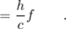
To reexpress this in terms of wavelength, we use c=fλ:
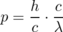
The second form turns out to be simpler.

Discussion Questions
◊ The photoelectric effect only ever ejects a very tiny percentage of the electrons available near the surface of an object. How well does this agree with the wave model of light, and how well with the particle model? Consider the two different distance scales involved: the wavelength of the light, and the size of an atom, which is on the order of 10⁻¹⁰ or 10⁻⁹ m.
◊ What is the significance of the fact that Planck's constant is numerically very small? How would our everyday experience of light be different if it was not so small?
◊ How would the experiments described above be affected if a single electron was likely to get hit by more than one photon?
◊ Draw some representative trajectories of electrons for Δ V=0, Δ V less than the maximum value, and Δ V greater than the maximum value.
◊ Explain based on the photon theory of light why ultraviolet light would be more likely than visible or infrared light to cause cancer by damaging DNA molecules. How does this relate to discussion question C?
◊ Does E=hf imply that a photon changes its energy when it passes from one transparent material into another substance with a different index of refraction?
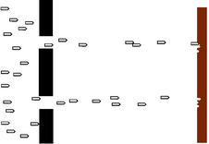
j / Bullets pass through a double slit.
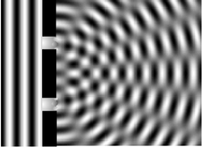
k / A water wave passes through a double slit.
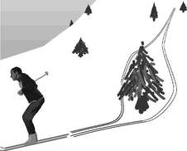
l / A single photon can go through both slits.
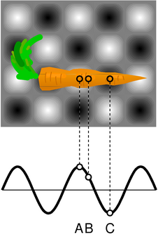
m / Example 9.

Wave-particle duality
How can light be both a particle and a wave? We are now ready to resolve this seeming contradiction. Often in science when something seems paradoxical, it's because we (1) don't define our terms carefully, or (2) don't test our ideas against any specific real-world situation. Let's define particles and waves as follows:
- Waves exhibit superposition, and specifically interference phenomena.
- Particles can only exist in whole numbers, not fractions
As a real-world check on our philosophizing, there is one particular experiment that works perfectly. We set up a double-slit interference experiment that we know will produce a diffraction pattern if light is an honest-to-goodness wave, but we detect the light with a detector that is capable of sensing individual photons, e.g. a digital camera. To make it possible to pick out individual dots due to individual photons, we must use filters to cut down the intensity of the light to a very low level, just as in the photos by Prof. Page on page 679. The whole thing is sealed inside a light-tight box. The results are shown in figure i. (In fact, the similar figures in on page 679 are simply cutouts from these figures.)
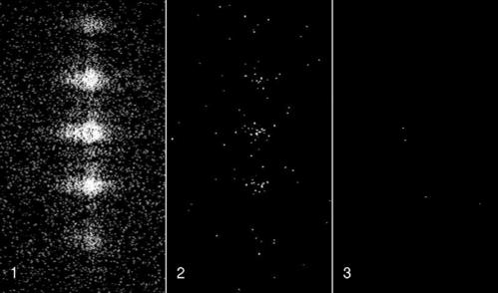
i / Wave interference patterns photographed by Prof. Lyman Page with a digital camera. Laser light with a single well-defined wavelength passed through a series of absorbers to cut down its intensity, then through a set of slits to produce interference, and finally into a digital camera chip. (A triple slit was actually used, but for conceptual simplicity we discuss the results in the main text as if it was a double slit.) In panel 2 the intensity has been reduced relative to 1, and even more so for panel 3.
Neither the pure wave theory nor the pure particle theory can explain the results. If light was only a particle and not a wave, there would be no interference effect. The result of the experiment would be like firing a hail of bullets through a double slit, j. Only two spots directly behind the slits would be hit.
If, on the other hand, light was only a wave and not a particle, we would get the same kind of diffraction pattern that would happen with a water wave, k. There would be no discrete dots in the photo, only a diffraction pattern that shaded smoothly between light and dark.
Applying the definitions to this experiment, light must be both a particle and a wave. It is a wave because it exhibits interference effects. At the same time, the fact that the photographs contain discrete dots is a direct demonstration that light refuses to be split into units of less than a single photon. There can only be whole numbers of photons: four photons in figure i/3, for example.

A wrong interpretation: photons interfering with each other
One possible interpretation of wave-particle duality that occurred to physicists early in the game was that perhaps the interference effects came from photons interacting with each other. By analogy, a water wave consists of moving water molecules, and interference of water waves results ultimately from all the mutual pushes and pulls of the molecules. This interpretation was conclusively disproved by G.I. Taylor, a student at Cambridge. The demonstration by Prof. Page that we've just been discussing is essentially a modernized version of Taylor's work. Taylor reasoned that if interference effects came from photons interacting with each other, a bare minimum of two photons would have to be present at the same time to produce interference. By making the light source extremely dim, we can be virtually certain that there are never two photons in the box at the same time. In figure i/3, however, the intensity of the light has been cut down so much by the absorbers that if it was in the open, the average separation between photons would be on the order of a kilometer! At any given moment, the number of photons in the box is most likely to be zero. It is virtually certain that there were never two photons in the box at once.

The concept of a photon's path is undefined.
If a single photon can demonstrate double-slit interference, then which slit did it pass through? The unavoidable answer must be that it passes through both! This might not seem so strange if we think of the photon as a wave, but it is highly counterintuitive if we try to visualize it as a particle. The moral is that we should not think in terms of the path of a photon. Like the fully human and fully divine Jesus of Christian theology, a photon is supposed to be 100% wave and 100% particle. If a photon had a well defined path, then it would not demonstrate wave superposition and interference effects, contradicting its wave nature. (In subsection 12.3.4 we will discuss the Heisenberg uncertainty principle, which gives a numerical way of approaching this issue.)

Another wrong interpretation: the pilot wave hypothesis
A second possible explanation of wave-particle duality was taken seriously in the early history of quantum mechanics. What if the photon particle is like a surfer riding on top of its accompanying wave? As the wave travels along, the particle is pushed, or “piloted” by it. Imagining the particle and the wave as two separate entities allows us to avoid the seemingly paradoxical idea that a photon is both at once. The wave happily does its wave tricks, like superposition and interference, and the particle acts like a respectable particle, resolutely refusing to be in two different places at once. If the wave, for instance, undergoes destructive interference, becoming nearly zero in a particular region of space, then the particle simply is not guided into that region.
The problem with the pilot wave interpretation is that the only way it can be experimentally tested or verified is if someone manages to detach the particle from the wave, and show that there really are two entities involved, not just one. Part of the scientific method is that hypotheses are supposed to be experimentally testable. Since nobody has ever managed to separate the wavelike part of a photon from the particle part, the interpretation is not useful or meaningful in a scientific sense.

The probability interpretation
The correct interpretation of wave-particle duality is suggested by the random nature of the experiment we've been discussing: even though every photon wave/particle is prepared and released in the same way, the location at which it is eventually detected by the digital camera is different every time. The idea of the probability interpretation of wave-particle duality is that the location of the photon-particle is random, but the probability that it is in a certain location is higher where the photon-wave's amplitude is greater.
More specifically, the probability distribution of the particle must be proportional to the square of the wave's amplitude,
∝ (amplitude)² .
This follows from the correspondence principle and from the fact that a wave's energy density is proportional to the square of its amplitude. If we run the double-slit experiment for a long enough time, the pattern of dots fills in and becomes very smooth as would have been expected in classical physics. To preserve the correspondence between classical and quantum physics, the amount of energy deposited in a given region of the picture over the long run must be proportional to the square of the wave's amplitude. The amount of energy deposited in a certain area depends on the number of photons picked up, which is proportional to the probability of finding any given photon there.

Example 9: A microwave oven
◊ The figure shows two-dimensional (top) and one-dimensional (bottom) representations of the standing wave inside a microwave oven. Gray represents zero field, and white and black signify the strongest fields, with white being a field that is in the opposite direction compared to black. Compare the probabilities of detecting a microwave photon at points A, B, and C.
◊ A and C are both extremes of the wave, so the probabilities of detecting a photon at A and C are equal. It doesn't matter that we have represented C as negative and A as positive, because it is the square of the amplitude that is relevant. The amplitude at B is about 1/2 as much as the others, so the probability of detecting a photon there is about 1/4 as much.
The probability interpretation was disturbing to physicists who had spent their previous careers working in the deterministic world of classical physics, and ironically the most strenuous objections against it were raised by Einstein, who had invented the photon concept in the first place. The probability interpretation has nevertheless passed every experimental test, and is now as well established as any part of physics.
An aspect of the probability interpretation that has made many people uneasy is that the process of detecting and recording the photon's position seems to have a magical ability to get rid of the wavelike side of the photon's personality and force it to decide for once and for all where it really wants to be. But detection or measurement is after all only a physical process like any other, governed by the same laws of physics. We will postpone a detailed discussion of this issue until the following chapter, since a measuring device like a digital camera is made of matter, but we have so far only discussed how quantum mechanics relates to light.

Example 10: What is the proportionality constant?
◊ What is the proportionality constant that would make an actual equation out of ?
◊ The probability that the photon is in a certain small region of volume v should equal the fraction of the wave's energy that is within that volume:
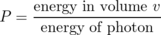
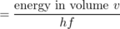
We assume v is small enough so that the electric and magnetic fields are nearly constant throughout it. We then have
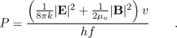
We can simplify this formidable looking expression by recognizing that in an electromagnetic wave, |E| and |B| are related by |E|=c|B|. With some algebra, it turns out that the electric and magnetic fields each contribute half the total energy, so we can simplify this to
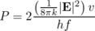
As advertised, the probability is proportional to the square of the wave's amplitude.

Discussion Questions
◊ Referring back to the example of the carrot in the microwave oven, show that it would be nonsensical to have probability be proportional to the field itself, rather than the square of the field.
◊ Einstein did not try to reconcile the wave and particle theories of light, and did not say much about their apparent inconsistency. Einstein basically visualized a beam of light as a stream of bullets coming from a machine gun. In the photoelectric effect, a photon “bullet” would only hit one atom, just as a real bullet would only hit one person. Suppose someone reading his 1905 paper wanted to interpret it by saying that Einstein's so-called particles of light are simply short wave-trains that only occupy a small region of space. Comparing the wavelength of visible light (a few hundred nm) to the size of an atom (on the order of 0.1 nm), explain why this poses a difficulty for reconciling the particle and wave theories.
◊ Can a white photon exist?
◊ In double-slit diffraction of photons, would you get the same pattern of dots on the digital camera image if you covered one slit? Why should it matter whether you give the photon two choices or only one?
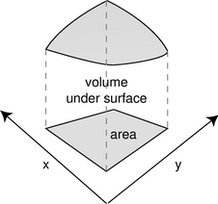
n / Probability is the volume under a surface defined by D(x,y).

Photons in three dimensions
Up until now I've been sneaky and avoided a full discussion of the three-dimensional aspects of the probability interpretation. The example of the carrot in the microwave oven, for example, reduced to a one-dimensional situation because we were considering three points along the same line and because we were only comparing ratios of probabilities. The purpose of bringing it up now is to head off any feeling that you've been cheated conceptually rather than to prepare you for mathematical problem solving in three dimensions, which would not be appropriate for the level of this course.
A typical example of a probability distribution in section 12.1 was the distribution of heights of human beings. The thing that varied randomly, height, h, had units of meters, and the probability distribution was a graph of a function D(h). The units of the probability distribution had to be m⁻¹ (inverse meters) so that areas under the curve, interpreted as probabilities, would be unitless: (area)=(height)(width)=m⁻¹⋅m.
Now suppose we have a two-dimensional problem, e.g. the probability distribution for the place on the surface of a digital camera chip where a photon will be detected. The point where it is detected would be described with two variables, x and y, each having units of meters. The probability distribution will be a function of both variables, D(x,y). A probability is now visualized as the volume under the surface described by the function D(x,y), as shown in figure n. The units of D must be m⁻² so that probabilities will be unitless: (probability)=(depth)(length)(width). In terms of calculus, we have 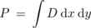.
Generalizing finally to three dimensions, we find by analogy that the probability distribution will be a function of all three coordinates, D(x,y,z), and will have units of m⁻³. It is unfortunately impossible to visualize the graph unless you are a mutant with a natural feel for life in four dimensions. If the probability distribution is nearly constant within a certain volume of space v, the probability that the photon is in that volume is simply vD. If not, then we can use an integral, 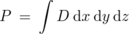.
\inlinefignocaption{melting-witch}

12.3 Matter as a Wave
[In] a few minutes I shall be all melted... I have been wicked in my day, but I never thought a little girl like you would ever be able to melt me and end my wicked deeds. Look out --- here I go! -- The Wicked Witch of the West
As the Wicked Witch learned the hard way, losing molecular cohesion can be unpleasant. That's why we should be very grateful that the concepts of quantum physics apply to matter as well as light. If matter obeyed the laws of classical physics, molecules wouldn't exist.
Consider, for example, the simplest atom, hydrogen. Why does one hydrogen atom form a chemical bond with another hydrogen atom? Roughly speaking, we'd expect a neighboring pair of hydrogen atoms, A and B, to exert no force on each other at all, attractive or repulsive: there are two repulsive interactions (proton A with proton B and electron A with electron B) and two attractive interactions (proton A with electron B and electron A with proton B). Thinking a little more precisely, we should even expect that once the two atoms got close enough, the interaction would be repulsive. For instance, if you squeezed them so close together that the two protons were almost on top of each other, there would be a tremendously strong repulsion between them due to the 1/r² nature of the electrical force. The repulsion between the electrons would not be as strong, because each electron ranges over a large area, and is not likely to be found right on top of the other electron. Thus hydrogen molecules should not exist according to classical physics.
Quantum physics to the rescue! As we'll see shortly, the whole problem is solved by applying the same quantum concepts to electrons that we have already used for photons.
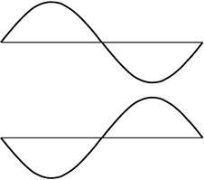
b / These two electron waves are not distinguishable by any measuring device.

Electrons as waves
We started our journey into quantum physics by studying the random behavior of matter in radioactive decay, and then asked how randomness could be linked to the basic laws of nature governing light. The probability interpretation of wave-particle duality was strange and hard to accept, but it provided such a link. It is now natural to ask whether the same explanation could be applied to matter. If the fundamental building block of light, the photon, is a particle as well as a wave, is it possible that the basic units of matter, such as electrons, are waves as well as particles?
A young French aristocrat studying physics, Louis de Broglie (pronounced “broylee”), made exactly this suggestion in his 1923 Ph.D. thesis. His idea had seemed so farfetched that there was serious doubt about whether to grant him the degree. Einstein was asked for his opinion, and with his strong support, de Broglie got his degree.
Only two years later, American physicists C.J. Davisson and L. Germer confirmed de Broglie's idea by accident. They had been studying the scattering of electrons from the surface of a sample of nickel, made of many small crystals. (One can often see such a crystalline pattern on a brass doorknob that has been polished by repeated handling.) An accidental explosion occurred, and when they put their apparatus back together they observed something entirely different: the scattered electrons were now creating an interference pattern! This dramatic proof of the wave nature of matter came about because the nickel sample had been melted by the explosion and then resolidified as a single crystal. The nickel atoms, now nicely arranged in the regular rows and columns of a crystalline lattice, were acting as the lines of a diffraction grating. The new crystal was analogous to the type of ordinary diffraction grating in which the lines are etched on the surface of a mirror (a reflection grating) rather than the kind in which the light passes through the transparent gaps between the lines (a transmission grating).
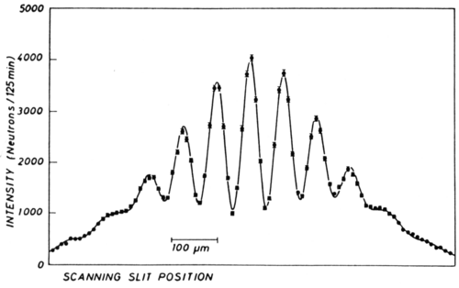
a / A double-slit interference pattern made with neutrons. (A. Zeilinger, R. G\"{a}hler, C.G. Shull, W. Treimer, and W. Mampe, Reviews of Modern Physics, Vol. 60, 1988.)
Although we will concentrate on the wave-particle duality of electrons because it is important in chemistry and the physics of atoms, all the other “particles” of matter you've learned about show wave properties as well. Figure a, for instance, shows a wave interference pattern of neutrons.
It might seem as though all our work was already done for us, and there would be nothing new to understand about electrons: they have the same kind of funny wave-particle duality as photons. That's almost true, but not quite. There are some important ways in which electrons differ significantly from photons:
- Electrons have mass, and photons don't.
- Photons always move at the speed of light, but electrons can move at any speed less than c.
- Photons don't have electric charge, but electrons do, so electric forces can act on them. The most important example is the atom, in which the electrons are held by the electric force of the nucleus.
- Electrons cannot be absorbed or emitted as photons are. Destroying an electron or creating one out of nothing would violate conservation of charge.
(In section 12.4 we will learn of one more fundamental way in which electrons differ from photons, for a total of five.)
Because electrons are different from photons, it is not immediately obvious which of the photon equations from the previous chapter can be applied to electrons as well. A particle property, the energy of one photon, is related to its wave properties via E=hf or, equivalently, E=hc/λ. The momentum of a photon was given by p=hf/c or p=h/λ. Ultimately it was a matter of experiment to determine which of these equations, if any, would work for electrons, but we can make a quick and dirty guess simply by noting that some of the equations involve c, the speed of light, and some do not. Since c is irrelevant in the case of an electron, we might guess that the equations of general validity are those that do not have c in them:
E = hf
p = h/λ
This is essentially the reasoning that de Broglie went through, and experiments have confirmed these two equations for all the fundamental building blocks of light and matter, not just for photons and electrons.
The second equation, which I soft-pedaled in the previous chapter, takes on a greater important for electrons. This is first of all because the momentum of matter is more likely to be significant than the momentum of light under ordinary conditions, and also because force is the transfer of momentum, and electrons are affected by electrical forces.

Example 11: The wavelength of an elephant
◊ What is the wavelength of a trotting elephant?
◊ One may doubt whether the equation should be applied to an elephant, which is not just a single particle but a rather large collection of them. Throwing caution to the wind, however, we estimate the elephant's mass at 10³ kg and its trotting speed at 10 m/s. Its wavelength is therefore roughly
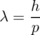
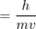
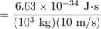
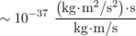
= 10⁻³⁷ m
The wavelength found in this example is so fantastically small that we can be sure we will never observe any measurable wave phenomena with elephants or any other human-scale objects. The result is numerically small because Planck's constant is so small, and as in some examples encountered previously, this smallness is in accord with the correspondence principle.
Although a smaller mass in the equation λ =h/mv does result in a longer wavelength, the wavelength is still quite short even for individual electrons under typical conditions, as shown in the following example.

Example 12: The typical wavelength of an electron
◊ Electrons in circuits and in atoms are typically moving through voltage differences on the order of 1 V, so that a typical energy is (e)(1 V), which is on the order of 10⁻¹⁹ J. What is the wavelength of an electron with this amount of kinetic energy?
◊ This energy is nonrelativistic, since it is much less than mc². Momentum and energy are therefore related by the nonrelativistic equation K=p²/2m. Solving for p and substituting in to the equation for the wavelength, we find
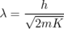
= 1.6×10⁻⁹ m .
This is on the same order of magnitude as the size of an atom, which is no accident: as we will discuss in the next chapter in more detail, an electron in an atom can be interpreted as a standing wave. The smallness of the wavelength of a typical electron also helps to explain why the wave nature of electrons wasn't discovered until a hundred years after the wave nature of light. To scale the usual wave-optics devices such as diffraction gratings down to the size needed to work with electrons at ordinary energies, we need to make them so small that their parts are comparable in size to individual atoms. This is essentially what Davisson and Germer did with their nickel crystal.
self-check:
These remarks about the inconvenient smallness of electron wavelengths apply only under the assumption that the electrons have typical energies. What kind of energy would an electron have to have in order to have a longer wavelength that might be more convenient to work with? (answer in the back of the PDF version of the book)

What kind of wave is it?
If a sound wave is a vibration of matter, and a photon is a vibration of electric and magnetic fields, what kind of a wave is an electron made of? The disconcerting answer is that there is no experimental “observable,” i.e. directly measurable quantity, to correspond to the electron wave itself. In other words, there are devices like microphones that detect the oscillations of air pressure in a sound wave, and devices such as radio receivers that measure the oscillation of the electric and magnetic fields in a light wave, but nobody has ever found any way to measure the electron wave directly.
We can of course detect the energy (or momentum) possessed by an electron just as we could detect the energy of a photon using a digital camera. (In fact I'd imagine that an unmodified digital camera chip placed in a vacuum chamber would detect electrons just as handily as photons.) But this only allows us to determine where the wave carries high probability and where it carries low probability. Probability is proportional to the square of the wave's amplitude, but measuring its square is not the same as measuring the wave itself. In particular, we get the same result by squaring either a positive number or its negative, so there is no way to determine the positive or negative sign of an electron wave.
Most physicists tend toward the school of philosophy known as operationalism, which says that a concept is only meaningful if we can define some set of operations for observing, measuring, or testing it. According to a strict operationalist, then, the electron wave itself is a meaningless concept. Nevertheless, it turns out to be one of those concepts like love or humor that is impossible to measure and yet very useful to have around. We therefore give it a symbol, Ψ (the capital Greek letter psi), and a special name, the electron wavefunction (because it is a function of the coordinates x, y, and z that specify where you are in space). It would be impossible, for example, to calculate the shape of the electron wave in a hydrogen atom without having some symbol for the wave. But when the calculation produces a result that can be compared directly to experiment, the final algebraic result will turn out to involve only Ψ², which is what is observable, not Ψ itself.
Since Ψ, unlike E and B, is not directly measurable, we are free to make the probability equations have a simple form: instead of having the probability density equal to some funny constant multiplied by Ψ², we simply define Ψ so that the constant of proportionality is one:
Since the probability distribution has units of m⁻³, the units of Ψ must be m^{-3/2}.

Discussion Question
◊ Frequency is oscillations per second, whereas wavelength is meters per oscillation. How could the equations E=hf and p=h/λ be made to look more alike by using quantities that were more closely analogous? (This more symmetric treatment makes it easier to incorporate relativity into quantum mechanics, since relativity says that space and time are not entirely separate.)
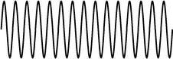
c / Part of an infinite sine wave.
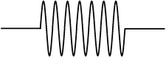
d / A finite-length sine wave.
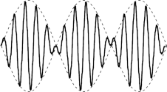
e / A beat pattern created by superimposing two sine waves with slightly different wavelengths.

Dispersive waves
A colleague of mine who teaches chemistry loves to tell the story about an exceptionally bright student who, when told of the equation p=h/λ, protested, “But when I derived it, it had a factor of 2!” The issue that's involved is a real one, albeit one that could be glossed over (and is, in most textbooks) without raising any alarms in the mind of the average student. The present optional section addresses this point; it is intended for the student who wishes to delve a little deeper.
Here's how the now-legendary student was presumably reasoning. We start with the equation v=fλ, which is valid for any sine wave, whether it's quantum or classical. Let's assume we already know E=hf, and are trying to derive the relationship between wavelength and momentum:
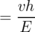
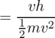
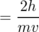
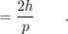
The reasoning seems valid, but the result does contradict the accepted one, which is after all solidly based on experiment.
The mistaken assumption is that we can figure everything out in terms of pure sine waves. Mathematically, the only wave that has a perfectly well defined wavelength and frequency is a sine wave, and not just any sine wave but an infinitely long sine wave, c. The unphysical thing about such a wave is that it has no leading or trailing edge, so it can never be said to enter or leave any particular region of space. Our derivation made use of the velocity, v, and if velocity is to be a meaningful concept, it must tell us how quickly stuff (mass, energy, momentum, ...) is transported from one region of space to another. Since an infinitely long sine wave doesn't remove any stuff from one region and take it to another, the “velocity of its stuff” is not a well defined concept.
Of course the individual wave peaks do travel through space, and one might think that it would make sense to associate their speed with the “speed of stuff,” but as we will see, the two velocities are in general unequal when a wave's velocity depends on wavelength. Such a wave is called a dispersive wave, because a wave pulse consisting of a superposition of waves of different wavelengths will separate (disperse) into its separate wavelengths as the waves move through space at different speeds. Nearly all the waves we have encountered have been nondispersive. For instance, sound waves and light waves (in a vacuum) have speeds independent of wavelength. A water wave is one good example of a dispersive wave. Long-wavelength water waves travel faster, so a ship at sea that encounters a storm typically sees the long-wavelength parts of the wave first. When dealing with dispersive waves, we need symbols and words to distinguish the two speeds. The speed at which wave peaks move is called the phase velocity, v_{p}, and the speed at which “stuff” moves is called the group velocity, v_{g}.
An infinite sine wave can only tell us about the phase velocity, not the group velocity, which is really what we would be talking about when we refer to the speed of an electron. If an infinite sine wave is the simplest possible wave, what's the next best thing? We might think the runner up in simplicity would be a wave train consisting of a chopped-off segment of a sine wave, d. However, this kind of wave has kinks in it at the end. A simple wave should be one that we can build by superposing a small number of infinite sine waves, but a kink can never be produced by superposing any number of infinitely long sine waves.
Actually the simplest wave that transports stuff from place to place is the pattern shown in figure e. Called a beat pattern, it is formed by superposing two sine waves whose wavelengths are similar but not quite the same. If you have ever heard the pulsating howling sound of musicians in the process of tuning their instruments to each other, you have heard a beat pattern. The beat pattern gets stronger and weaker as the two sine waves go in and out of phase with each other. The beat pattern has more “stuff” (energy, for example) in the areas where constructive interference occurs, and less in the regions of cancellation. As the whole pattern moves through space, stuff is transported from some regions and into other ones.
If the frequency of the two sine waves differs by 10%, for instance, then ten periods will be occur between times when they are in phase. Another way of saying it is that the sinusoidal “envelope” (the dashed lines in figure e) has a frequency equal to the difference in frequency between the two waves. For instance, if the waves had frequencies of 100 Hz and 110 Hz, the frequency of the envelope would be 10 Hz.
To apply similar reasoning to the wavelength, we must define a quantity z=1/λ that relates to wavelength in the same way that frequency relates to period. In terms of this new variable, the z of the envelope equals the difference between the z's of the two sine waves.
The group velocity is the speed at which the envelope moves through space. Let Δ f and Δ z be the differences between the frequencies and z's of the two sine waves, which means that they equal the frequency and z of the envelope. The group velocity is v_{g}=f_{envelope}λ_{envelope}=Δz. If Δ f and Δ z are sufficiently small, we can approximate this expression as a derivative,
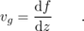
This expression is usually taken as the definition of the group velocity for wave patterns that consist of a superposition of sine waves having a narrow range of frequencies and wavelengths. In quantum mechanics, with f=E/h and z=p/h, we have v_{g}=d E/d p. In the case of a nonrelativistic electron the relationship between energy and momentum is E=p²/2m, so the group velocity is d E/d p=p/m=v, exactly what it should be. It is only the phase velocity that differs by a factor of two from what we would have expected, but the phase velocity is not the physically important thing.
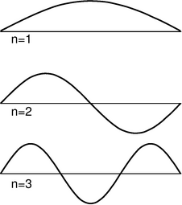
f / Three possible standing-wave patterns for a particle in a box.

g / The spectrum of the light from the star Sirius.
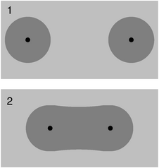
h / Two hydrogen atoms bond to form an H₂ molecule. In the molecule, the two electrons' wave patterns overlap , and are about twice as wide.

Bound states
Electrons are at their most interesting when they're in atoms, that is, when they are bound within a small region of space. We can understand a great deal about atoms and molecules based on simple arguments about such bound states, without going into any of the realistic details of atom. The simplest model of a bound state is known as the particle in a box: like a ball on a pool table, the electron feels zero force while in the interior, but when it reaches an edge it encounters a wall that pushes back inward on it with a large force. In particle language, we would describe the electron as bouncing off of the wall, but this incorrectly assumes that the electron has a certain path through space. It is more correct to describe the electron as a wave that undergoes 100% reflection at the boundaries of the box.
Like a generation of physics students before me, I rolled my eyes when initially introduced to the unrealistic idea of putting a particle in a box. It seemed completely impractical, an artificial textbook invention. Today, however, it has become routine to study electrons in rectangular boxes in actual laboratory experiments. The “box” is actually just an empty cavity within a solid piece of silicon, amounting in volume to a few hundred atoms. The methods for creating these electron-in-a-box setups (known as “quantum dots”) were a by-product of the development of technologies for fabricating computer chips.
For simplicity let's imagine a one-dimensional electron in a box, i.e. we assume that the electron is only free to move along a line. The resulting standing wave patterns, of which the first three are shown in the figure, are just like some of the patterns we encountered with sound waves in musical instruments. The wave patterns must be zero at the ends of the box, because we are assuming the walls are impenetrable, and there should therefore be zero probability of finding the electron outside the box. Each wave pattern is labeled according to n, the number of peaks and valleys it has. In quantum physics, these wave patterns are referred to as “states” of the particle-in-the-box system.
The following seemingly innocuous observations about the particle in the box lead us directly to the solutions to some of the most vexing failures of classical physics:
The particle's energy is quantized (can only have certain values). Each wavelength corresponds to a certain momentum, and a given momentum implies a definite kinetic energy, E=p²/2m. (This is the second type of energy quantization we have encountered. The type we studied previously had to do with restricting the number of particles to a whole number, while assuming some specific wavelength and energy for each particle. This type of quantization refers to the energies that a single particle can have. Both photons and matter particles demonstrate both types of quantization under the appropriate circumstances.)
The particle has a minimum kinetic energy. Long wavelengths correspond to low momenta and low energies. There can be no state with an energy lower than that of the n=1 state, called the ground state.
The smaller the space in which the particle is confined, the higher its kinetic energy must be. Again, this is because long wavelengths give lower energies.

Example 13: Spectra of thin gases
A fact that was inexplicable by classical physics was that thin gases absorb and emit light only at certain wavelengths. This was observed both in earthbound laboratories and in the spectra of stars. The figure on the left shows the example of the spectrum of the star Sirius, in which there are “gap teeth” at certain wavelengths. Taking this spectrum as an example, we can give a straightforward explanation using quantum physics.
Energy is released in the dense interior of the star, but the outer layers of the star are thin, so the atoms are far apart and electrons are confined within individual atoms. Although their standing-wave patterns are not as simple as those of the particle in the box, their energies are quantized.
When a photon is on its way out through the outer layers, it can be absorbed by an electron in an atom, but only if the amount of energy it carries happens to be the right amount to kick the electron from one of the allowed energy levels to one of the higher levels. The photon energies that are missing from the spectrum are the ones that equal the difference in energy between two electron energy levels. (The most prominent of the absorption lines in Sirius's spectrum are absorption lines of the hydrogen atom.)

Example 14: The stability of atoms
In many Star Trek episodes the Enterprise, in orbit around a planet, suddenly lost engine power and began spiraling down toward the planet's surface. This was utter nonsense, of course, due to conservation of energy: the ship had no way of getting rid of energy, so it did not need the engines to replenish it.
Consider, however, the electron in an atom as it orbits the nucleus. The electron does have a way to release energy: it has an acceleration due to its continuously changing direction of motion, and according to classical physics, any accelerating charged particle emits electromagnetic waves. According to classical physics, atoms should collapse!
The solution lies in the observation that a bound state has a minimum energy. An electron in one of the higher-energy atomic states can and does emit photons and hop down step by step in energy. But once it is in the ground state, it cannot emit a photon because there is no lower-energy state for it to go to.

Example 15: Chemical bonds
I began this section with a classical argument that chemical bonds, as in an H₂ molecule, should not exist. Quantum physics explains why this type of bonding does in fact occur. When the atoms are next to each other, the electrons are shared between them. The “box” is about twice as wide, and a larger box allows a smaller energy. Energy is required in order to separate the atoms. (A qualitatively different type of bonding is discussed on page 727.)

Discussion Questions
◊ Neutrons attract each other via the strong nuclear force, so according to classical physics it should be possible to form nuclei out of clusters of two or more neutrons, with no protons at all. Experimental searches, however, have failed to turn up evidence of a stable two-neutron system (dineutron) or larger stable clusters. Explain based on quantum physics why a dineutron might spontaneously fly apart.
◊ The following table shows the energy gap between the ground state and the first excited state for four nuclei, in units of picojoules. (The nuclei were chosen to be ones that have similar structures, e.g., they are all spherical in shape.)
nucleus | energy gap (picojoules)
4zuHe | 3.234
16zuO | 0.968
40zuCa | 0.536
208zuPb | 0.418
Explain the trend in the data.

The uncertainty principle and measurement

Eliminating randomness through measurement?
A common reaction to quantum physics, among both early-twentieth-century physicists and modern students, is that we should be able to get rid of randomness through accurate measurement. If I say, for example, that it is meaningless to discuss the path of a photon or an electron, one might suggest that we simply measure the particle's position and velocity many times in a row. This series of snapshots would amount to a description of its path.
A practical objection to this plan is that the process of measurement will have an effect on the thing we are trying to measure. This may not be of much concern, for example, when a traffic cop measure's your car's motion with a radar gun, because the energy and momentum of the radar pulses are insufficient to change the car's motion significantly. But on the subatomic scale it is a very real problem. Making a videotape through a microscope of an electron orbiting a nucleus is not just difficult, it is theoretically impossible. The video camera makes pictures of things using light that has bounced off them and come into the camera. If even a single photon of visible light was to bounce off of the electron we were trying to study, the electron's recoil would be enough to change its behavior significantly.

The Heisenberg uncertainty principle
This insight, that measurement changes the thing being measured, is the kind of idea that clove-cigarette-smoking intellectuals outside of the physical sciences like to claim they knew all along. If only, they say, the physicists had made more of a habit of reading literary journals, they could have saved a lot of work. The anthropologist Margaret Mead has recently been accused of inadvertently encouraging her teenaged Samoan informants to exaggerate the freedom of youthful sexual experimentation in their society. If this is considered a damning critique of her work, it is because she could have done better: other anthropologists claim to have been able to eliminate the observer-as-participant problem and collect untainted data.
The German physicist Werner Heisenberg, however, showed that in quantum physics, any measuring technique runs into a brick wall when we try to improve its accuracy beyond a certain point. Heisenberg showed that the limitation is a question of what there is to be known, even in principle, about the system itself, not of the ability or inability of a specific measuring device to ferret out information that is knowable but not previously hidden.
Suppose, for example, that we have constructed an electron in a box (quantum dot) setup in our laboratory, and we are able adjust the length L of the box as desired. All the standing wave patterns pretty much fill the box, so our knowledge of the electron's position is of limited accuracy. If we write Δ x for the range of uncertainty in our knowledge of its position, then Δ x is roughly the same as the length of the box:
Δ x ≈ L
If we wish to know its position more accurately, we can certainly squeeze it into a smaller space by reducing L, but this has an unintended side-effect. A standing wave is really a superposition of two traveling waves going in opposite directions. The equation p=h/λ really only gives the magnitude of the momentum vector, not its direction, so we should really interpret the wave as a 50/50 mixture of a right-going wave with momentum p=h/λ and a left-going one with momentum p=-h/λ. The uncertainty in our knowledge of the electron's momentum is Δ p=2h/λ, covering the range between these two values. Even if we make sure the electron is in the ground state, whose wavelength λ =2L is the longest possible, we have an uncertainty in momentum of Δ p=h/L. In general, we find
Δ p >rsim h/L ,
with equality for the ground state and inequality for the higher-energy states. Thus if we reduce L to improve our knowledge of the electron's position, we do so at the cost of knowing less about its momentum. This trade-off is neatly summarized by multiplying the two equations to give
Δ pΔ x >rsim h .
Although we have derived this in the special case of a particle in a box, it is an example of a principle of more general validity:

The Heisenberg uncertainty principle
It is not possible, even in principle, to know the momentum and the position of a particle simultaneously and with perfect accuracy. The uncertainties in these two quantities are always such that Δ pΔ x >rsim h.
(This approximation can be made into a strict inequality, Δ pΔ x>h/4π, but only with more careful definitions, which we will not bother with.)
Note that although I encouraged you to think of this derivation in terms of a specific real-world system, the quantum dot, no reference was ever made to any specific laboratory equipment or procedures. The argument is simply that we cannot know the particle's position very accurately unless it has a very well defined position, it cannot have a very well defined position unless its wave-pattern covers only a very small amount of space, and its wave-pattern cannot be thus compressed without giving it a short wavelength and a correspondingly uncertain momentum. The uncertainty principle is therefore a restriction on how much there is to know about a particle, not just on what we can know about it with a certain technique.

Example 16: An estimate for electrons in atoms
◊ A typical energy for an electron in an atom is on the order of , which corresponds to a speed of about 1% of the speed of light. If a typical atom has a size on the order of 0.1 nm, how close are the electrons to the limit imposed by the uncertainty principle?
◊ If we assume the electron moves in all directions with equal probability, the uncertainty in its momentum is roughly twice its typical momentum. This only an order-of-magnitude estimate, so we take Δ p to be the same as a typical momentum:
Δ p Δ x = p_{typical} Δ x
= (m_{electron}) (0.01c) (0.1×10⁻⁹ m)
= 3× 10⁻³⁴ J⋅s
This is on the same order of magnitude as Planck's constant, so evidently the electron is “right up against the wall.” (The fact that it is somewhat less than h is of no concern since this was only an estimate, and we have not stated the uncertainty principle in its most exact form.)
self-check:
If we were to apply the uncertainty principle to human-scale objects, what would be the significance of the small numerical value of Planck's constant? (answer in the back of the PDF version of the book)

Optional topic: Historical Note
The true nature of Heisenberg's role in the Nazi atomic bomb effort is a fascinating question, and dramatic enough to have inspired a well-received 1998 theatrical play, “Copenhagen.” The real story, however, may never be completely unraveled. Heisenberg was the scientific leader of the German bomb program up until its cancellation in 1942, when the German military decided that it was too ambitious a project to undertake in wartime, and too unlikely to produce results.
Some historians believe that Heisenberg intentionally delayed and obstructed the project because he secretly did not want the Nazis to get the bomb. Heisenberg's apologists point out that he never joined the Nazi party, and was not anti-Semitic. He actively resisted the government's Deutsche-Physik policy of eliminating supposed Jewish influences from physics, and as a result was denounced by the S.S. as a traitor, escaping punishment only because Himmler personally declared him innocent. One strong piece of evidence for this view is a secret message carried to the U.S. in 1941, by one of the last Jews to escape from Berlin, and eventually delivered to the chairman of the Uranium Committee, which was then studying the feasibility of a bomb. The message states “...that a large number of German physicists are working intensively on the problem of the uranium bomb under the direction of Heisenberg, [and] that Heisenberg himself tries to delay the work as much as possible, fearing the catastrophic results of success. But he cannot help fulfilling the orders given to him, and if the problem can be solved, it will be solved probably in the near future. So he gave the advice to us to hurry up if U.S.A. will not come too late.” The message supports the view that Heisenberg intentionally misled his government about the bomb's technical feasibility; Nazi Minister of Armaments Albert Speer wrote that he was convinced to drop the project after a 1942 meeting with Heisenber because “the physicists themselves didn't want to put too much into it.” Heisenberg also may have warned Danish physicist Niels Bohr personally in September 1941 about the existence of the Nazi bomb effort.
On the other side of the debate, critics of Heisenberg say that he clearly wanted Germany to win the war, that he visited German-occupied territories in a semi-official role, and that he may simply have not been very good at his job directing the bomb project. On a visit to the occupied Netherlands in 1943, he told a colleague, “Democracy cannot develop sufficient energy to rule Europe. There are, therefore, only two alternatives: Germany and Russia. And then a Europe under German leadership would be the lesser evil.” Some historians³ argue that the real point of Heisenberg's meeting with Bohr was to try to convince the U.S. not to try to build a bomb, so that Germany, possessing a nuclear monopoly, would defeat the Soviets --- this was after the June 1941 entry of the U.S.S.R. into the war, but before the December 1941 Pearl Harbor attack brought the U.S. in. Bohr apparently considered Heisenberg's account of the meeting, published after the war was over, to be inaccurate.⁴ The secret 1941 message also has a curious moral passivity to it, as if Heisenberg was saying “I hope you stop me before I do something bad,” but we should also consider the great risk Heisenberg would have been running if he actually originated the message.

Measurement and Schr\"{o}dinger's cat
In the previous chapter I briefly mentioned an issue concerning measurement that we are now ready to address carefully. If you hang around a laboratory where quantum-physics experiments are being done and secretly record the physicists' conversations, you'll hear them say many things that assume the probability interpretation of quantum mechanics. Usually they will speak as though the randomness of quantum mechanics enters the picture when something is measured. In the digital camera experiments of the previous chapter, for example, they would casually describe the detection of a photon at one of the pixels as if the moment of detection was when the photon was forced to “make up its mind.” Although this mental cartoon usually works fairly well as a description of things they experience in the lab, it cannot ultimately be correct, because it attributes a special role to measurement, which is really just a physical process like all other physical processes.
If we are to find an interpretation that avoids giving any special role to measurement processes, then we must think of the entire laboratory, including the measuring devices and the physicists themselves, as one big quantum-mechanical system made out of protons, neutrons, electrons, and photons. In other words, we should take quantum physics seriously as a description not just of microscopic objects like atoms but of human-scale (“macroscopic”) things like the apparatus, the furniture, and the people.
The most celebrated example is called the Schr\"odinger's cat experiment. Luckily for the cat, there probably was no actual experiment --- it was simply a “thought experiment” that the physicist the German theorist Schr\"odinger discussed with his colleagues. Schr\"odinger wrote:
One can even construct quite burlesque cases. A cat is shut up in a steel container, together with the following diabolical apparatus (which one must keep out of the direct clutches of the cat): In a Geiger tube [radiation detector] there is a tiny mass of radioactive substance, so little that in the course of an hour perhaps one atom of it disintegrates, but also with equal probability not even one; if it does happen, the counter [detector] responds and ... activates a hammer that shatters a little flask of prussic acid [filling the chamber with poison gas]. If one has left this entire system to itself for an hour, then one will say to himself that the cat is still living, if in that time no atom has disintegrated. The first atomic disintegration would have poisoned it.
Now comes the strange part. Quantum mechanics describes the particles the cat is made of as having wave properties, including the property of superposition. Schr\"odinger describes the wavefunction of the box's contents at the end of the hour:
The wavefunction of the entire system would express this situation by having the living and the dead cat mixed ... in equal parts [50/50 proportions]. The uncertainty originally restricted to the atomic domain has been transformed into a macroscopic uncertainty...
At first Schr\"odinger's description seems like nonsense. When you opened the box, would you see two ghostlike cats, as in a doubly exposed photograph, one dead and one alive? Obviously not. You would have a single, fully material cat, which would either be dead or very, very upset. But Schr\"odinger has an equally strange and logical answer for that objection. In the same way that the quantum randomness of the radioactive atom spread to the cat and made its wavefunction a random mixture of life and death, the randomness spreads wider once you open the box, and your own wavefunction becomes a mixture of a person who has just killed a cat and a person who hasn't.

Discussion Questions
◊ Compare Δ p and Δ x for the two lowest energy levels of the one-dimensional particle in a box, and discuss how this relates to the uncertainty principle.
◊ On a graph of Δ p versus Δx, sketch the regions that are allowed and forbidden by the Heisenberg uncertainty principle. Interpret the graph: Where does an atom lie on it? An elephant? Can either p or x be measured with perfect accuracy if we don't care about the other?
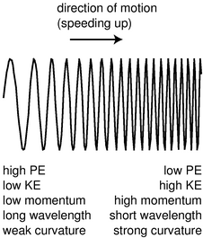
i / An electron in a gentle electric field gradually shortens its wavelength as it gains energy.
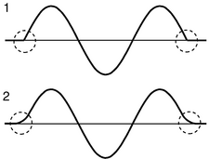
j / The wavefunction's tails go where classical physics says they shouldn't.

Electrons in electric fields
So far the only electron wave patterns we've considered have been simple sine waves, but whenever an electron finds itself in an electric field, it must have a more complicated wave pattern. Let's consider the example of an electron being accelerated by the electron gun at the back of a TV tube. Newton's laws are not useful, because they implicitly assume that the path taken by the particle is a meaningful concept. Conservation of energy is still valid in quantum physics, however. In terms of energy, the electron is moving from a region of low voltage into a region of higher voltage. Since its charge is negative, it loses electrical energy by moving to a higher voltage, so its kinetic energy increases. As its electrical energy goes down, its kinetic energy goes up by an equal amount, keeping the total energy constant. Increasing kinetic energy implies a growing momentum, and therefore a shortening wavelength, i
The wavefunction as a whole does not have a single well-defined wavelength, but the wave changes so gradually that if you only look at a small part of it you can still pick out a wavelength and relate it to the momentum and energy. (The picture actually exaggerates by many orders of magnitude the rate at which the wavelength changes.)
But what if the electric field was stronger? The electric field in a TV is only ∼10⁵ N/C, but the electric field within an atom is more like 10¹² N/C. In figure k, the wavelength changes so rapidly that there is nothing that looks like a sine wave at all. We could get a rough idea of the wavelength in a given region by measuring the distance between two peaks, but that would only be a rough approximation. Suppose we want to know the wavelength at point P. The trick is to construct a sine wave, like the one shown with the dashed line, which matches the curvature of the actual wavefunction as closely as possible near P. The sine wave that matches as well as possible is called the “osculating” curve, from a Latin word meaning “to kiss.” The wavelength of the osculating curve is the wavelength that will relate correctly to conservation of energy.
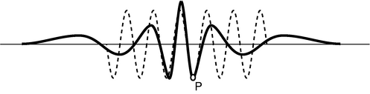
k / A typical wavefunction of an electron in an atom (heavy curve) and the osculating sine wave (dashed curve) that matches its curvature at point P.

Tunneling
We implicitly assumed that the particle-in-a-box wavefunction would cut off abruptly at the sides of the box, j/1, but that would be unphysical. A kink has infinite curvature, and curvature is related to energy, so it can't be infinite. A physically realistic wavefunction must always “tail off” gradually, j/2. In classical physics, a particle can never enter a region in which its interaction energy U would be greater than the amount of energy it has available. But in quantum physics the wavefunction will always have a tail that reaches into the classically forbidden region. If it was not for this effect, called tunneling, the fusion reactions that power the sun would not occur due to the high electrical energy nuclei need in order to get close together! Tunneling is discussed in more detail in the following subsection.
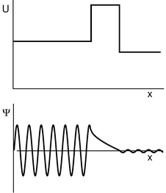
l / Tunneling through a barrier.

The Schr\"odinger equation
In subsection 12.3.5 we were able to apply conservation of energy to an electron's wavefunction, but only by using the clumsy graphical technique of osculating sine waves as a measure of the wave's curvature. You have learned a more convenient measure of curvature in calculus: the second derivative. To relate the two approaches, we take the second derivative of a sine wave:
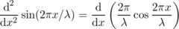
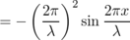
Taking the second derivative gives us back the same function, but with a minus sign and a constant out in front that is related to the wavelength. We can thus relate the second derivative to the osculating wavelength:
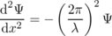
This could be solved for λ in terms of Ψ, but it will turn out below to be more convenient to leave it in this form.
Applying this to conservation of energy, we have
E = K + U
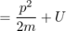
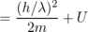
Note that both equation \eqref{eq:schreqna} and equation \eqref{eq:schreqnb} have λ² in the denominator. We can simplify our algebra by multiplying both sides of equation \eqref{eq:schreqnb} by Ψ to make it look more like equation \eqref{eq:schreqna}:
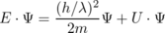
+ U ⋅ Ψ
+ U ⋅ Ψ
Further simplification is achieved by using the symbol (h with a slash through it, read “h-bar”) as an abbreviation for h/2π. We then have the important result known as the \labelimportantintext{Schr\"odinger equation}:
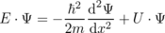
(Actually this is a simplified version of the Schr\"odinger equation, applying only to standing waves in one dimension.) Physically it is a statement of conservation of energy. The total energy E must be constant, so the equation tells us that a change in interaction energy U must be accompanied by a change in the curvature of the wavefunction. This change in curvature relates to a change in wavelength, which corresponds to a change in momentum and kinetic energy.
self-check:
Considering the assumptions that were made in deriving the Schr\"odinger equation, would it be correct to apply it to a photon? To an electron moving at relativistic speeds? (answer in the back of the PDF version of the book)
Usually we know right off the bat how U depends on x, so the basic mathematical problem of quantum physics is to find a function Ψ (x) that satisfies the Schr\"odinger equation for a given interaction-energy function U(x). An equation, such as the Schr\"odinger equation, that specifies a relationship between a function and its derivatives is known as a differential equation.
The study of differential equations in general is beyond the mathematical level of this book, but we can gain some important insights by considering the easiest version of the Schr\"odinger equation, in which the interaction energy U is constant. We can then rearrange the Schr\"odinger equation as follows:
where, according to our assumptions, a is independent of x. We need to find a function whose second derivative is the same as the original function except for a multiplicative constant. The only functions with this property are sine waves and exponentials:
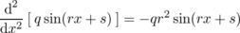
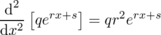
The sine wave gives negative values of a, a=-r², and the exponential gives positive ones, a=r². The former applies to the classically allowed region with U<E.
This leads us to a quantitative calculation of the tunneling effect discussed briefly in the preceding subsection. The wavefunction evidently tails off exponentially in the classically forbidden region. Suppose, as shown in figure l, a wave-particle traveling to the right encounters a barrier that it is classically forbidden to enter. Although the form of the Schr\"odinger equation we're using technically does not apply to traveling waves (because it makes no reference to time), it turns out that we can still use it to make a reasonable calculation of the probability that the particle will make it through the barrier. If we let the barrier's width be w, then the ratio of the wavefunction on the left side of the barrier to the wavefunction on the right is
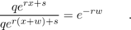
Probabilities are proportional to the squares of wavefunctions, so the probability of making it through the barrier is
P = e^{-2rw}
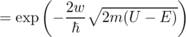
self-check:
If we were to apply this equation to find the probability that a person can walk through a wall, what would the small value of Planck's constant imply? (answer in the back of the PDF version of the book)

Use of complex numbers
In a classically forbidden region, a particle's total energy, U+K, is less than its U, so its K must be negative. If we want to keep believing in the equation K=p²/2m, then apparently the momentum of the particle is the square root of a negative number. This is a symptom of the fact that the Schr\"odinger equation fails to describe all of nature unless the wavefunction and various other quantities are allowed to be complex numbers. In particular it is not possible to describe traveling waves correctly without using complex wavefunctions.
This may seem like nonsense, since real numbers are the only ones that are, well, real! Quantum mechanics can always be related to the real world, however, because its structure is such that the results of measurements always come out to be real numbers. For example, we may describe an electron as having non-real momentum in classically forbidden regions, but its average momentum will always come out to be real (the imaginary parts average out to zero), and it can never transfer a non-real quantity of momentum to another particle.
A complete investigation of these issues is beyond the scope of this book, and this is why we have normally limited ourselves to standing waves, which can be described with real-valued wavefunctions.
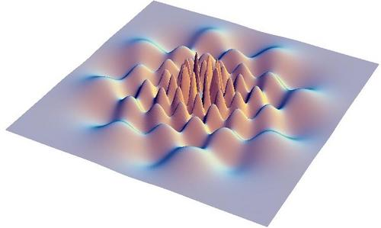

12.4 The Atom
You can learn a lot by taking a car engine apart, but you will have learned a lot more if you can put it all back together again and make it run. Half the job of reductionism is to break nature down into its smallest parts and understand the rules those parts obey. The second half is to show how those parts go together, and that is our goal in this chapter. We have seen how certain features of all atoms can be explained on a generic basis in terms of the properties of bound states, but this kind of argument clearly cannot tell us any details of the behavior of an atom or explain why one atom acts differently from another.
The biggest embarrassment for reductionists is that the job of putting things back together job is usually much harder than the taking them apart. Seventy years after the fundamentals of atomic physics were solved, it is only beginning to be possible to calculate accurately the properties of atoms that have many electrons. Systems consisting of many atoms are even harder. Supercomputer manufacturers point to the folding of large protein molecules as a process whose calculation is just barely feasible with their fastest machines. The goal of this chapter is to give a gentle and visually oriented guide to some of the simpler results about atoms.
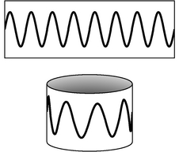
a / Eight wavelengths fit around this circle ().

Classifying states
We'll focus our attention first on the simplest atom, hydrogen, with one proton and one electron. We know in advance a little of what we should expect for the structure of this atom. Since the electron is bound to the proton by electrical forces, it should display a set of discrete energy states, each corresponding to a certain standing wave pattern. We need to understand what states there are and what their properties are.
What properties should we use to classify the states? The most sensible approach is to used conserved quantities. Energy is one conserved quantity, and we already know to expect each state to have a specific energy. It turns out, however, that energy alone is not sufficient. Different standing wave patterns of the atom can have the same energy.
Momentum is also a conserved quantity, but it is not particularly appropriate for classifying the states of the electron in a hydrogen atom. The reason is that the force between the electron and the proton results in the continual exchange of momentum between them. (Why wasn't this a problem for energy as well? Kinetic energy and momentum are related by K=p²/2m, so the much more massive proton never has very much kinetic energy. We are making an approximation by assuming all the kinetic energy is in the electron, but it is quite a good approximation.)
Angular momentum does help with classification. There is no transfer of angular momentum between the proton and the electron, since the force between them is a center-to-center force, producing no torque.
Like energy, angular momentum is quantized in quantum physics. As an example, consider a quantum wave-particle confined to a circle, like a wave in a circular moat surrounding a castle. A sine wave in such a “quantum moat” cannot have any old wavelength, because an integer number of wavelengths must fit around the circumference, C, of the moat. The larger this integer is, the shorter the wavelength, and a shorter wavelength relates to greater momentum and angular momentum. Since this integer is related to angular momentum, we use the symbol for it:
The angular momentum is
L = rp .
Here, r=C/2π, and , so
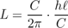
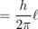
In the example of the quantum moat, angular momentum is quantized in units of h/2π. This makes h/2π a pretty important number, so we define the abbreviation . This symbol is read “h-bar.”
In fact, this is a completely general fact in quantum physics, not just a fact about the quantum moat:

Quantization of angular momentum
The angular momentum of a particle due to its motion through space is quantized in units of .
self-check:
What is the angular momentum of the wavefunction shown at the beginning of the section? (answer in the back of the PDF version of the book)
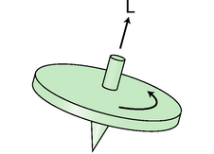
b / The angular momentum vector of a spinning top.
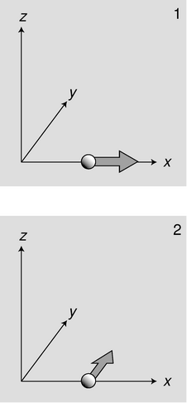
c / Reconciling the uncertainty principle with the definition of angular momentum.

Angular momentum in three dimensions
Up until now we've only worked with angular momentum in the context of rotation in a plane, for which we could simply use positive and negative signs to indicate clockwise and counterclockwise directions of rotation. A hydrogen atom, however, is unavoidably three-dimensional. Before we worry about three-dimensional angular momentum in quantum mechanics, we need to understand how it works in classical mechanics; the following discussion is a summary of the most important facts from optional section 4.3.

Three-dimensional angular momentum in classical physics
If we are to completely specify the angular momentum of a classical object like a top, b, in three dimensions, it's not enough to say whether the rotation is clockwise or counterclockwise. We must also give the orientation of the plane of rotation or, equivalently, the direction of the top's axis. The convention is to specify the direction of the axis. There are two possible directions along the axis, and as a matter of convention we use the direction such that if we sight along it, the rotation appears clockwise.
Angular momentum can, in fact, be defined as a vector pointing along this direction. This might seem like a strange definition, since nothing actually moves in that direction, but it wouldn't make sense to define the angular momentum vector as being in the direction of motion, because every part of the top has a different direction of motion. Ultimately it's not just a matter of picking a definition that is convenient and unambiguous: the definition we're using is the only one that makes the total angular momentum of a system a conserved quantity if we let “total” mean the vector sum.
As with rotation in one dimension, we cannot define what we mean by angular momentum in a particular situation unless we pick a point as an axis. This is really a different use of the word “axis” than the one in the previous paragraphs. Here we simply mean a point from which we measure the distance r. In the hydrogen atom, the nearly immobile proton provides a natural choice of axis.

Three-dimensional angular momentum in quantum physics
Once we start to think more carefully about the role of angular momentum in quantum physics, it may seem that there is a basic problem: the angular momentum of the electron in a hydrogen atom depends on both its distance from the proton and its momentum, so in order to know its angular momentum precisely it would seem we would need to know both its position and its momentum simultaneously with good accuracy. This, however, might seem to be forbidden by the Heisenberg uncertainty principle.
Actually the uncertainty principle does place limits on what can be known about a particle's angular momentum vector, but it does not prevent us from knowing its magnitude as an exact integer multiple of . The reason is that in three dimensions, there are really three separate uncertainty principles:
Now consider a particle, c/1, that is moving along the x axis at position x and with momentum p_{x}. We may not be able to know both x and p_{x} with unlimited accurately, but we can still know the particle's angular momentum about the origin exactly: it is zero, because the particle is moving directly away from the origin.
Suppose, on the other hand, a particle finds itself, c/2, at a position x along the x axis, and it is moving parallel to the y axis with momentum p_{y}. It has angular momentum xp_{y} about the z axis, and again we can know its angular momentum with unlimited accuracy, because the uncertainty principle on relates x to p_{x} and y to p_{y}. It does not relate x to p_{y}.
As shown by these examples, the uncertainty principle does not restrict the accuracy of our knowledge of angular momenta as severely as might be imagined. However, it does prevent us from knowing all three components of an angular momentum vector simultaneously. The most general statement about this is the following theorem, which we present without proof:

The angular momentum vector in quantum physics
The most the can be known about an angular momentum vector is its magnitude and one of its three vector components. Both are quantized in units of .
d / A cross-section of a hydrogen wavefunction.
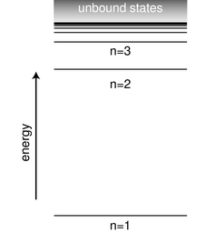
e / The energy of a state in the hydrogen atom depends only on its n quantum number.

The hydrogen atom
Deriving the wavefunctions of the states of the hydrogen atom from first principles would be mathematically too complex for this book, but it's not hard to understand the logic behind such a wavefunction in visual terms. Consider the wavefunction from the beginning of the section, which is reproduced in figure d. Although the graph looks three-dimensional, it is really only a representation of the part of the wavefunction lying within a two-dimensional plane. The third (up-down) dimension of the plot represents the value of the wavefunction at a given point, not the third dimension of space. The plane chosen for the graph is the one perpendicular to the angular momentum vector.
Each ring of peaks and valleys has eight wavelengths going around in a circle, so this state has , i.e. we label it . The wavelength is shorter near the center, and this makes sense because when the electron is close to the nucleus it has a lower electrical energy, a higher kinetic energy, and a higher momentum.
Between each ring of peaks in this wavefunction is a nodal circle, i.e. a circle on which the wavefunction is zero. The full three-dimensional wavefunction has nodal spheres: a series of nested spherical surfaces on which it is zero. The number of radii at which nodes occur, including r=∞, is called n, and n turns out to be closely related to energy. The ground state has n=1 (a single node only at r=∞), and higher-energy states have higher n values. There is a simple equation relating n to energy, which we will discuss in subsection 12.4.4.
The numbers n and , which identify the state, are called its quantum numbers. A state of a given n and can be oriented in a variety of directions in space. We might try to indicate the orientation using the three quantum numbers , , and . But we have already seen that it is impossible to know all three of these simultaneously. To give the most complete possible description of a state, we choose an arbitrary axis, say the z axis, and label the state according to n, , and .⁵
Angular momentum requires motion, and motion implies kinetic energy. Thus it is not possible to have a given amount of angular momentum without having a certain amount of kinetic energy as well. Since energy relates to the n quantum number, this means that for a given n value there will be a maximum possible . It turns out that this maximum value of equals n-1.
In general, we can list the possible combinations of quantum numbers as follows:
n can equal 1, 2, 3, …
ell can range from 0 ton − 1, in steps of 1
ellz can range fromell toell, in steps of 1
Applying these rules, we have the following list of states:
n = 1, | ell0, | ellz0 | one state
n = 2, | ell0, | ellz0 | one state
n = 2, | ell1, | ellz1, 0, or 1 | three states
…
self-check: Continue the list for n=3. (answer in the back of the PDF version of the book)
Figure f on page 721 shows the lowest-energy states of the hydrogen atom. The left-hand column of graphs displays the wavefunctions in the x-y plane, and the right-hand column shows the probability distribution in a three-dimensional representation.
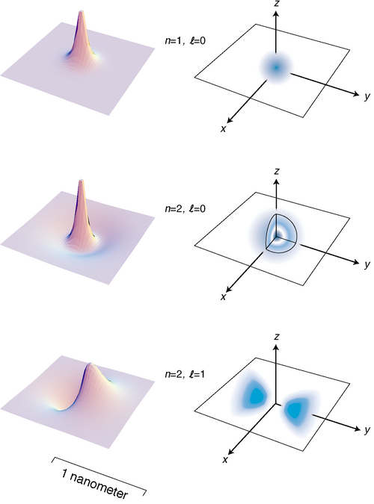
f / The three states of the hydrogen atom having the lowest energies.

Discussion Questions
◊ The quantum number n is defined as the number of radii at which the wavefunction is zero, including r=∞. Relate this to the features of the figures on the facing page.
◊ Based on the definition of n, why can't there be any such thing as an n=0 state?
◊ Relate the features of the wavefunction plots in figure f to the corresponding features of the probability distribution pictures.
◊ How can you tell from the wavefunction plots in figure f which ones have which angular momenta?
◊ Criticize the following incorrect statement: “The wavefunction in figure d has a shorter wavelength in the center because in the center the electron is in a higher energy level.”
◊ Discuss the implications of the fact that the probability cloud in of the n=2, state is split into two parts.

Energies of states in hydrogen
The experimental technique for measuring the energy levels of an atom accurately is spectroscopy: the study of the spectrum of light emitted (or absorbed) by the atom. Only photons with certain energies can be emitted or absorbed by a hydrogen atom, for example, since the amount of energy gained or lost by the atom must equal the difference in energy between the atom's initial and final states. Spectroscopy had actually become a highly developed art several decades before Einstein even proposed the photon, and the Swiss spectroscopist Johann Balmer determined in 1885 that there was a simple equation that gave all the wavelengths emitted by hydrogen. In modern terms, we think of the photon wavelengths merely as indirect evidence about the underlying energy levels of the atom, and we rework Balmer's result into an equation for these atomic energy levels:
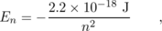
This energy includes both the kinetic energy of the electron and the electrical energy. The zero-level of the electrical energy scale is chosen to be the energy of an electron and a proton that are infinitely far apart. With this choice, negative energies correspond to bound states and positive energies to unbound ones.
Where does the mysterious numerical factor of 2.2×10⁻¹⁸ J come from? In 1913 the Danish theorist Niels Bohr realized that it was exactly numerically equal to a certain combination of fundamental physical constants:
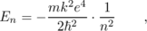
where m is the mass of the electron, and k is the Coulomb force constant for electric forces.
Bohr was able to cook up a derivation of this equation based on the incomplete version of quantum physics that had been developed by that time, but his derivation is today mainly of historical interest. It assumes that the electron follows a circular path, whereas the whole concept of a path for a particle is considered meaningless in our more complete modern version of quantum physics. Although Bohr was able to produce the right equation for the energy levels, his model also gave various wrong results, such as predicting that the atom would be flat, and that the ground state would have rather than the correct .
A full and correct treatment is impossible at the mathematical level of this book, but we can provide a straightforward explanation for the form of the equation using approximate arguments. A typical standing-wave pattern for the electron consists of a central oscillating area surrounded by a region in which the wavefunction tails off. As discussed in subsection 12.3.6, the oscillating type of pattern is typically encountered in the classically allowed region, while the tailing off occurs in the classically forbidden region where the electron has insufficient kinetic energy to penetrate according to classical physics. We use the symbol r for the radius of the spherical boundary between the classically allowed and classically forbidden regions.
When the electron is at the distance r from the proton, it has zero kinetic energy --- in classical terms, this would be the distance at which the electron would have to stop, turn around, and head back toward the proton. Thus when the electron is at distance r, its energy is purely electrical:
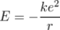
Now comes the approximation. In reality, the electron's wavelength cannot be constant in the classically allowed region, but we pretend that it is. Since n is the number of nodes in the wavefunction, we can interpret it approximately as the number of wavelengths that fit across the diameter 2r. We are not even attempting a derivation that would produce all the correct numerical factors like 2 and π and so on, so we simply make the approximation
Finally we assume that the typical kinetic energy of the electron is on the same order of magnitude as the absolute value of its total energy. (This is true to within a factor of two for a typical classical system like a planet in a circular orbit around the sun.) We then have \begin{subequations} \renewcommand{\theequation}{\theparentequation}
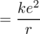
\end{subequations} We now solve the equation ke²/r ∼ hn² / 2mr² for r and throw away numerical factors we can't hope to have gotten right, yielding
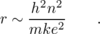
Plugging n=1 into this equation gives r=2 nm, which is indeed on the right order of magnitude. Finally we combine equations [4] and [1] to find
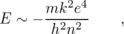
which is correct except for the numerical factors we never aimed to find.

Discussion Questions
◊ States of hydrogen with n greater than about 10 are never observed in the sun. Why might this be?
◊ Sketch graphs of r and E versus n for the hydrogen, and compare with analogous graphs for the one-dimensional particle in a box.
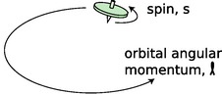
g / The top has angular momentum both because of the motion of its center of mass through space and due to its internal rotation. Electron spin is roughly analogous to the intrinsic spin of the top.

Electron spin
It's disconcerting to the novice ping-pong player to encounter for the first time a more skilled player who can put spin on the ball. Even though you can't see that the ball is spinning, you can tell something is going on by the way it interacts with other objects in its environment. In the same way, we can tell from the way electrons interact with other things that they have an intrinsic spin of their own. Experiments show that even when an electron is not moving through space, it still has angular momentum amounting to .
This may seem paradoxical because the quantum moat, for instance, gave only angular momenta that were integer multiples of , not half-units, and I claimed that angular momentum was always quantized in units of , not just in the case of the quantum moat. That whole discussion, however, assumed that the angular momentum would come from the motion of a particle through space. The angular momentum of the electron is simply a property of the particle, like its charge or its mass. It has nothing to do with whether the electron is moving or not, and it does not come from any internal motion within the electron. Nobody has ever succeeded in finding any internal structure inside the electron, and even if there was internal structure, it would be mathematically impossible for it to result in a half-unit of angular momentum.
We simply have to accept this angular momentum, called the “spin” of the electron --- Mother Nature rubs our noses in it as an observed fact.
Protons and neutrons have the same spin, while photons have an intrinsic spin of . In general, half-integer spins are typical of material particles. Integral values are found for the particles that carry forces: photons, which embody the electric and magnetic fields of force, as well as the more exotic messengers of the nuclear and gravitational forces.
As was the case with ordinary angular momentum, we can describe spin angular momentum in terms of its magnitude, and its component along a given axis. We write s and s_{z} for these quantities, expressed in units of , so an electron has s=1/2 and s_{z}=+1/2 or -1/2.
Taking electron spin into account, we need a total of four quantum numbers to label a state of an electron in the hydrogen atom: n, , , and s_{z}. (We omit s because it always has the same value.) The symbols and include only the angular momentum the electron has because it is moving through space, not its spin angular momentum. The availability of two possible spin states of the electron leads to a doubling of the numbers of states:
n = 1, | ell0, | ellz0, | s_{z} = + 1 / 2 or − 1 / 2 | two states
n = 2, | ell0, | ellz0, | s_{z} = + 1 / 2 or − 1 / 2 | two states
n = 2, | ell1, | ellz1, 0, or 1, | s_{z} = + 1 / 2 or − 1 / 2 | six states
…

A note about notation
There are unfortunately two inconsistent systems of notation for the quantum numbers we've been discussing. The notation I've been using is the one that is used in nuclear physics, but there is a different one that is used in atomic physics.
nuclear physics | atomic physics
n | same
ell | same
ellx | no notation
elly | no notation
ellz | m
s = 1 / 2 | no notation (sometimesσ)
s_{x} | no notation
s_{y} | no notation
s_{z} | s
{}The nuclear physics notation is more logical (not giving special status to the z axis) and more memorable ( rather than the obscure m), which is why I use it consistently in this book, even though nearly all the applications we'll consider are atomic ones.
We are further encumbered with the following historically derived letter labels, which deserve to be eliminated in favor of the simpler numerical ones:
ell0 |  | ell1 |  | ell2 |  | ell3
s |  | p |  | d |  | f
n = 1 | n = 2 |  | n = 3 |  | n = 4 |  | n = 5 | n = 6 | n = 7
K | L |  | M |  | N |  | O | P | Q
{}The spdf labels are used in both nuclear⁶ and atomic physics, while the KLMNOPQ letters are used only to refer to states of electrons.
And finally, there is a piece of notation that is good and useful, but which I simply haven't mentioned yet. The vector stands for the total angular momentum of a particle in units of , including both orbital and spin parts. This quantum number turns out to be very useful in nuclear physics, because nuclear forces tend to exchange orbital and spin angular momentum, so a given energy level often contains a mixture of and s values, while remaining fairly pure in terms of j.
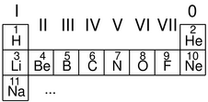
h / The beginning of the periodic table.
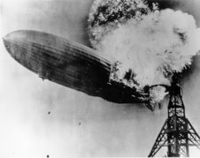
i / Hydrogen is highly reactive.

Atoms with more than one electron
What about other atoms besides hydrogen? It would seem that things would get much more complex with the addition of a second electron. A hydrogen atom only has one particle that moves around much, since the nucleus is so heavy and nearly immobile. Helium, with two, would be a mess. Instead of a wavefunction whose square tells us the probability of finding a single electron at any given location in space, a helium atom would need to have a wavefunction whose square would tell us the probability of finding two electrons at any given combination of points. Ouch! In addition, we would have the extra complication of the electrical interaction between the two electrons, rather than being able to imagine everything in terms of an electron moving in a static field of force created by the nucleus alone.
Despite all this, it turns out that we can get a surprisingly good description of many-electron atoms simply by assuming the electrons can occupy the same standing-wave patterns that exist in a hydrogen atom. The ground state of helium, for example, would have both electrons in states that are very similar to the n=1 states of hydrogen. The second-lowest-energy state of helium would have one electron in an n=1 state, and the other in an n=2 states. The relatively complex spectra of elements heavier than hydrogen can be understood as arising from the great number of possible combinations of states for the electrons.
A surprising thing happens, however, with lithium, the three-electron atom. We would expect the ground state of this atom to be one in which all three electrons settle down into n=1 states. What really happens is that two electrons go into n=1 states, but the third stays up in an n=2 state. This is a consequence of a new principle of physics:

The Pauli Exclusion Principle
Only one electron can ever occupy a given state.
There are two n=1 states, one with s_{z}=+1/2 and one with s_{z}=-1/2, but there is no third n=1 state for lithium's third electron to occupy, so it is forced to go into an n=2 state.
It can be proved mathematically that the Pauli exclusion principle applies to any type of particle that has half-integer spin. Thus two neutrons can never occupy the same state, and likewise for two protons. Photons, however, are immune to the exclusion principle because their spin is an integer.

Deriving the periodic table
We can now account for the structure of the periodic table, which seemed so mysterious even to its inventor Mendeleev. The first row consists of atoms with electrons only in the n=1 states:
H | 1 electron in ann = 1 state
He | 2 electrons in the twon = 1 states
The next row is built by filling the n=2 energy levels:
Li | 2 electrons inn = 1 states, 1 electron in ann = 2 state
Be | 2 electrons inn = 1 states, 2 electrons inn = 2 states
…
O | 2 electrons inn = 1 states, 6 electrons inn = 2 states
F | 2 electrons inn = 1 states, 7 electrons inn = 2 states
Ne | 2 electrons inn = 1 states, 8 electrons inn = 2 states
In the third row we start in on the n=3 levels:
Na | 2 electrons inn = 1 states, 8 electrons inn = 2 states, 1 electron in ann = 3 state
...
We can now see a logical link between the filling of the energy levels and the structure of the periodic table. Column 0, for example, consists of atoms with the right number of electrons to fill all the available states up to a certain value of n. Column I contains atoms like lithium that have just one electron more than that.
This shows that the columns relate to the filling of energy levels, but why does that have anything to do with chemistry? Why, for example, are the elements in columns I and VII dangerously reactive? Consider, for example, the element sodium (Na), which is so reactive that it may burst into flames when exposed to air. The electron in the n=3 state has an unusually high energy. If we let a sodium atom come in contact with an oxygen atom, energy can be released by transferring the n=3 electron from the sodium to one of the vacant lower-energy n=2 states in the oxygen. This energy is transformed into heat. Any atom in column I is highly reactive for the same reason: it can release energy by giving away the electron that has an unusually high energy.
Column VII is spectacularly reactive for the opposite reason: these atoms have a single vacancy in a low-energy state, so energy is released when these atoms steal an electron from another atom.
It might seem as though these arguments would only explain reactions of atoms that are in different rows of the periodic table, because only in these reactions can a transferred electron move from a higher-n state to a lower-n state. This is incorrect. An n=2 electron in fluorine (F), for example, would have a different energy than an n=2 electron in lithium (Li), due to the different number of protons and electrons with which it is interacting. Roughly speaking, the n=2 electron in fluorine is more tightly bound (lower in energy) because of the larger number of protons attracting it. The effect of the increased number of attracting protons is only partly counteracted by the increase in the number of repelling electrons, because the forces exerted on an electron by the other electrons are in many different directions and cancel out partially.

Homework Problems
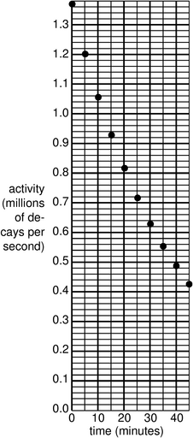
a / Problem 9.
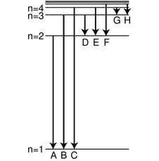
b / Problem 26.
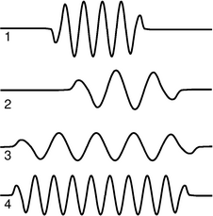
c / Problem 35.
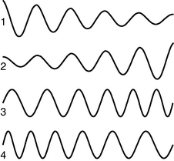
d / Problem 36.
1. If a radioactive substance has a half-life of one year, does this mean that it will be completely decayed after two years? Explain.
2. What is the probability of rolling a pair of dice and getting “snake eyes,” i.e. both dice come up with ones?
3. Use a calculator to check the approximation that a^{b}≈ 1+bln a, if b << 1, using some arbitrary numbers. See how good the approximation is for values of b that are not quite as small compared to one.
4. Make up an example of a numerical problem involving a rate of decay where Δ t << t_{1/2}, but the exact expression for the rate of decay on page 674 can still be evaluated on a calculator without getting something that rounds off to zero. Check that you get approximately the same result using both methods from subsection 12.1.4 to calculate the number of decays between t and t+Δ t. Keep plenty of significant figures in your results, in order to show the difference between them.
5. Refer to the probability distribution for people's heights in figure e on page 669.
(a) Show that the graph is properly normalized.
(b) Estimate the fraction of the population having heights between 140 and 150 cm.(answer check available at lightandmatter.com)
6. A blindfolded person fires a gun at a circular target of radius b, and is allowed to continue firing until a shot actually hits it. Any part of the target is equally likely to get hit. We measure the random distance r from the center of the circle to where the bullet went in.
(a) Show that the probability distribution of r must be of the form D(r)=kr, where k is some constant. (Of course we have D(r)=0 for r>b.)
(b) Determine k by requiring D to be properly normalized.(answer check available at lightandmatter.com)
(c) Find the average value of r.(answer check available at lightandmatter.com)
(d) Interpreting your result from part c, how does it compare with b/2? Does this make sense? Explain.
7. We are given some atoms of a certain radioactive isotope, with half-life t_{1/2}. We pick one atom at random, and observe it for one half-life, starting at time zero. If it decays during that one-half-life period, we record the time t at which the decay occurred. If it doesn't, we reset our clock to zero and keep trying until we get an atom that cooperates. The final result is a time 0≤ t≤ t_{1/2}, with a distribution that looks like the usual exponential decay curve, but with its tail chopped off.
(a) Find the distribution D(t), with the proper normalization.(answer check available at lightandmatter.com)
(b) Find the average value of t.(answer check available at lightandmatter.com)
(c) Interpreting your result from part b, how does it compare with t_{1/2}/2? Does this make sense? Explain.
8. The speed, v, of an atom in an ideal gas has a probability distribution of the form
D(v) = bve^{-cv2} ,
where 0≤ v < ∞, c relates to the temperature, and b is determined by normalization.
(a) Sketch the distribution.
(b) Find b in terms of c.(answer check available at lightandmatter.com)
(c) Find the average speed in terms of c, eliminating b. (Don't try to do the indefinite integral, because it can't be done in closed form. The relevant definite integral can be found in tables or done with computer software.)(answer check available at lightandmatter.com)
9. (a) A nuclear physicist is studying a nuclear reaction caused in an accelerator experiment, with a beam of ions from the accelerator striking a thin metal foil and causing nuclear reactions when a nucleus from one of the beam ions happens to hit one of the nuclei in the target. After the experiment has been running for a few hours, a few billion radioactive atoms have been produced, embedded in the target. She does not know what nuclei are being produced, but she suspects they are an isotope of some heavy element such as Pb, Bi, Fr or U. Following one such experiment, she takes the target foil out of the accelerator, sticks it in front of a detector, measures the activity every 5 min, and makes a graph (figure). The isotopes she thinks may have been produced are:
isotope | half-life (minutes)
211zuPb | 36.1
214zuPb | 26.8
214zuBi | 19.7
223zuFr | 21.8
239zuU | 23.5
Which one is it?
(b) Having decided that the original experimental conditions produced one specific isotope, she now tries using beams of ions traveling at several different speeds, which may cause different reactions. The following table gives the activity of the target 10, 20 and 30 minutes after the end of the experiment, for three different ion speeds.
 | activity (millions of decays/s) after…
 | 10 min | 20 min | 30 min
first ion speed | 1.933 | 0.832 | 0.382
second ion speed | 1.200 | 0.545 | 0.248
third ion speed | 6.544 | 1.296 | 0.248
Since such a large number of decays is being counted, assume that the data are only inaccurate due to rounding off when writing down the table. Which are consistent with the production of a single isotope, and which imply that more than one isotope was being created?
10. Devise a method for testing experimentally the hypothesis that a gambler's chance of winning at craps is independent of her previous record of wins and losses.
11. All helium on earth is from the decay of naturally occurring heavy radioactive elements such as uranium. Each alpha particle that is emitted ends up claiming two electrons, which makes it a helium atom. If the original ²³⁸U atom is in solid rock (as opposed to the earth's molten regions), the He atoms are unable to diffuse out of the rock. This problem involves dating a rock using the known decay properties of uranium 238. Suppose a geologist finds a sample of hardened lava, melts it in a furnace, and finds that it contains 1230 mg of uranium and 2.3 mg of helium. ²³⁸U decays by alpha emission, with a half-life of 4.5×10⁹ years. The subsequent chain of alpha and electron (beta) decays involves much shorter half-lives, and terminates in the stable nucleus ²⁰⁶Pb. Almost all natural uranium is ²³⁸U, and the chemical composition of this rock indicates that there were no decay chains involved other than that of ²³⁸U.
(a) How many alphas are emitted per decay chain? [Hint: Use conservation of mass.]
(b) How many electrons are emitted per decay chain? [Hint: Use conservation of charge.]
(c) How long has it been since the lava originally hardened?(answer check available at lightandmatter.com)
12. When light is reflected from a mirror, perhaps only 80% of the energy comes back. One could try to explain this in two different ways: (1) 80% of the photons are reflected, or (2) all the photons are reflected, but each loses 20% of its energy. Based on your everyday knowledge about mirrors, how can you tell which interpretation is correct? [Based on a problem from PSSC Physics.]
13. Suppose we want to build an electronic light sensor using an apparatus like the one described in the section on the photoelectric effect. How would its ability to detect different parts of the spectrum depend on the type of metal used in the capacitor plates?
14. [0] The photoelectric effect can occur not just for metal cathodes but for any substance, including living tissue. Ionization of DNA molecules can cause cancer or birth defects. If the energy required to ionize DNA is on the same order of magnitude as the energy required to produce the photoelectric effect in a metal, which of the following types of electromagnetic waves might pose such a hazard? Explain.
60 Hz waves from power lines
100 MHz FM radio
microwaves from a microwave oven
visible light
ultraviolet light
x-rays
15. The beam of a 100-W overhead projector covers an area of 1 m×1 m when it hits the screen 3 m away. Estimate the number of photons that are in flight at any given time. (Since this is only an estimate, we can ignore the fact that the beam is not parallel.)(answer check available at lightandmatter.com)
16. In the photoelectric effect, electrons are observed with virtually no time delay (∼10 ns), even when the light source is very weak. (A weak light source does however only produce a small number of ejected electrons.) The purpose of this problem is to show that the lack of a significant time delay contradicted the classical wave theory of light, so throughout this problem you should put yourself in the shoes of a classical physicist and pretend you don't know about photons at all. At that time, it was thought that the electron might have a radius on the order of 10⁻¹⁵ m. (Recent experiments have shown that if the electron has any finite size at all, it is far smaller.)
(a) Estimate the power that would be soaked up by a single electron in a beam of light with an intensity of 1 mW/m².(answer check available at lightandmatter.com)
(b) The energy, E_{s}, required for the electron to escape through the surface of the cathode is on the order of 10⁻¹⁹ J. Find how long it would take the electron to absorb this amount of energy, and explain why your result constitutes strong evidence that there is something wrong with the classical theory.(answer check available at lightandmatter.com)
17. A photon collides with an electron and rebounds from the collision at 180 degrees, i.e. going back along the path on which it came. The rebounding photon has a different energy, and therefore a different frequency and wavelength. Show that, based on conservation of energy and momentum, the difference between the photon's initial and final wavelengths must be 2h/mc, where m is the mass of the electron. The experimental verification of this type of “pool-ball” behavior by Arthur Compton in 1923 was taken as definitive proof of the particle nature of light. Note that we're not making any nonrelativistic approximations. To keep the algebra simple, you should use natural units --- in fact, it's a good idea to use even-more-natural-than-natural units, in which we have not just c=1 but also h=1, and m=1 for the mass of the electron. You'll also probably want to use the relativistic relationship E²-p²=m², which becomes E²-p²=1 for the energy and momentum of the electron in these units.
18. Generalize the result of problem 17 to the case where the photon bounces off at an angle other than 180° with respect to its initial direction of motion.
19. In a television, suppose the electrons are accelerated from rest through a voltage difference of 10⁴ V. What is their final wavelength?(answer check available at lightandmatter.com)
20. Use the Heisenberg uncertainty principle to estimate the minimum velocity of a proton or neutron in a ²⁰⁸Pb nucleus, which has a diameter of about 13 fm (1 fm=10⁻¹⁵ m). Assume that the speed is nonrelativistic, and then check at the end whether this assumption was warranted.(answer check available at lightandmatter.com)
21. Find the energy of a particle in a one-dimensional box of length L, expressing your result in terms of L, the particle's mass m, the number of peaks and valleys n in the wavefunction, and fundamental constants.(answer check available at lightandmatter.com)
22. A free electron that contributes to the current in an ohmic material typically has a speed of 10⁵ m/s (much greater than the drift velocity).
(a) Estimate its de Broglie wavelength, in nm.(answer check available at lightandmatter.com)
(b) If a computer memory chip contains 10⁸ electric circuits in a 1 cm² area, estimate the linear size, in nm, of one such circuit.(answer check available at lightandmatter.com)
(c) Based on your answers from parts a and b, does an electrical engineer designing such a chip need to worry about wave effects such as diffraction?
(d) Estimate the maximum number of electric circuits that can fit on a 1 cm² computer chip before quantum-mechanical effects become important.
23. In classical mechanics, an interaction energy of the form gives a harmonic oscillator: the particle moves back and forth at a frequency . This form for U(x) is often a good approximation for an individual atom in a solid, which can vibrate around its equilibrium position at x=0. (For simplicity, we restrict our treatment to one dimension, and we treat the atom as a single particle rather than as a nucleus surrounded by electrons). The atom, however, should be treated quantum-mechanically, not clasically. It will have a wave function. We expect this wave function to have one or more peaks in the classically allowed region, and we expect it to tail off in the classically forbidden regions to the right and left. Since the shape of U(x) is a parabola, not a series of flat steps as in figure l on page 713, the wavy part in the middle will not be a sine wave, and the tails will not be exponentials.
(a) Show that there is a solution to the Schr\"{o}dinger equation of the form
Ψ(x)=e^{-bx2} ,
and relate b to k, m, and . To do this, calculate the second derivative, plug the result into the Schr\"{o}dinger equation, and then find what value of b would make the equation valid for all values of x. This wavefunction turns out to be the ground state. Note that this wavefunction is not properly normalized --- don't worry about that.(answer check available at lightandmatter.com)
(b) Sketch a graph showing what this wavefunction looks like.
(c) Let's interpret b. If you changed b, how would the wavefunction look different? Demonstrate by sketching two graphs, one for a smaller value of b, and one for a larger value.
(d) Making k greater means making the atom more tightly bound. Mathematically, what happens to the value of b in your result from part a if you make k greater? Does this make sense physically when you compare with part c?
24. [2] On page 713 we derived an expression for the probability that a particle would tunnel through a rectangular barrier, i.e. a region in which the interaction energy U(x) has a graph that looks like a rectangle. Generalize this to a barrier of any shape. [Hints: First try generalizing to two rectangular barriers in a row, and then use a series of rectangular barriers to approximate the actual curve of an arbitrary function U(x). Note that the width and height of the barrier in the original equation occur in such a way that all that matters is the area under the U-versus-x curve. Show that this is still true for a series of rectangular barriers, and generalize using an integral.] If you had done this calculation in the 1930's you could have become a famous physicist.
25. (a) A distance scale is shown below the wavefunctions and probability densities illustrated in figure f on page 721. Compare this with the order-of-magnitude estimate derived in subsection 12.4.4 for the radius r at which the wavefunction begins tailing off. Was the estimate on the right order of magnitude?
(b) Although we normally say the moon orbits the earth, actually they both orbit around their common center of mass, which is below the earth's surface but not at its center. The same is true of the hydrogen atom. Does the center of mass lie inside the proton, or outside it?
26. The figure shows eight of the possible ways in which an electron in a hydrogen atom could drop from a higher energy state to a state of lower energy, releasing the difference in energy as a photon. Of these eight transitions, only D, E, and F produce photons with wavelengths in the visible spectrum.
(a) Which of the visible transitions would be closest to the violet end of the spectrum, and which would be closest to the red end? Explain.
(b) In what part of the electromagnetic spectrum would the photons from transitions A, B, and C lie? What about G and H? Explain.
(c) Is there an upper limit to the wavelengths that could be emitted by a hydrogen atom going from one bound state to another bound state? Is there a lower limit? Explain.
27. Before the quantum theory, experimentalists noted that in many cases, they would find three lines in the spectrum of the same atom that satisfied the following mysterious rule: 1/λ₁=1/λ₂+1/λ₃. Explain why this would occur. Do not use reasoning that only works for hydrogen --- such combinations occur in the spectra of all elements. [Hint: Restate the equation in terms of the energies of photons.]
28. Find an equation for the wavelength of the photon emitted when the electron in a hydrogen atom makes a transition from energy level n₁ to level n₂.(answer check available at lightandmatter.com)
29. (a) Verify that Planck's constant has the same units as angular momentum.
(b) Estimate the angular momentum of a spinning basketball, in units of .
30. Assume that the kinetic energy of an electron the n=1 state of a hydrogen atom is on the same order of magnitude as the absolute value of its total energy, and estimate a typical speed at which it would be moving. (It cannot really have a single, definite speed, because its kinetic and interaction energy trade off at different distances from the proton, but this is just a rough estimate of a typical speed.) Based on this speed, were we justified in assuming that the electron could be described nonrelativistically?
31. The wavefunction of the electron in the ground state of a hydrogen atom is
Ψ = π^{-1/2} a^{-3/2} e^{-r/a} ,
where r is the distance from the proton, and a=5.3×10⁻¹¹ m is a constant that sets the size of the wave.
(a) Calculate symbolically, without plugging in numbers, the probability that at any moment, the electron is inside the proton. Assume the proton is a sphere with a radius of b=0.5 fm. [Hint: Does it matter if you plug in r=0 or r=b in the equation for the wavefunction?](answer check available at lightandmatter.com)
(b) Calculate the probability numerically.(answer check available at lightandmatter.com)
(c) Based on the equation for the wavefunction, is it valid to think of a hydrogen atom as having a finite size? Can a be interpreted as the size of the atom, beyond which there is nothing? Or is there any limit on how far the electron can be from the proton?
32. Use physical reasoning to explain how the equation for the energy levels of hydrogen,
should be generalized to the case of a heavier atom with atomic number Z that has had all its electrons stripped away except for one.
33. A muon is a subatomic particle that acts exactly like an electron except that its mass is 207 times greater. Muons can be created by cosmic rays, and it can happen that one of an atom's electrons is displaced by a muon, forming a muonic atom. If this happens to a hydrogen atom, the resulting system consists simply of a proton plus a muon.
(a) Based on the results of section 12.4.4, how would the size of a muonic hydrogen atom in its ground state compare with the size of the normal atom?
(b) If you were searching for muonic atoms in the sun or in the earth's atmosphere by spectroscopy, in what part of the electromagnetic spectrum would you expect to find the absorption lines?
34. Show that the wavefunction given in problem 31 is properly normalized.
35. (a) Rank-order the photons according to their wavelengths, frequencies, and energies. If two are equal, say so. Explain all your answers.
(b) Photon 3 was emitted by a xenon atom going from its second-lowest-energy state to its lowest-energy state. Which of photons 1, 2, and 4 are capable of exciting a xenon atom from its lowest-energy state to its second-lowest-energy state? Explain.
36. Which figure could be an electron speeding up as it moves to the right? Explain.
\begin{exsection}
\extitle{A}{Quantum Versus Classical Randomness}
1. Imagine the classical version of the particle in a one-dimensional box. Suppose you insert the particle in the box and give it a known, predetermined energy, but a random initial position and a random direction of motion. You then pick a random later moment in time to see where it is. Sketch the resulting probability distribution by shading on top of a line segment. Does the probability distribution depend on energy?
2. Do similar sketches for the first few energy levels of the quantum mechanical particle in a box, and compare with 1.
3. Do the same thing as in 1, but for a classical hydrogen atom in two dimensions, which acts just like a miniature solar system. Assume you're always starting out with the same fixed values of energy and angular momentum, but a position and direction of motion that are otherwise random. Do this for L=0, and compare with a real L=0 probability distribution for the hydrogen atom.
4. Repeat 3 for a nonzero value of L, say L=.
5. Summarize: Are the classical probability distributions accurate? What qualitative features are possessed by the classical diagrams but not by the quantum mechanical ones, or vice-versa?
\end{exsection}

Footnotes
[1] This is under the assumption that all the uranium atoms were created at the same time. In reality, we have only a general idea of the processes that might have created the heavy elements in the nebula from which our solar system condensed. Some portion of them may have come from nuclear reactions in supernova explosions in that particular nebula, but some may have come from previous supernova explosions throughout our galaxy, or from exotic events like collisions of white dwarf stars.
[2] What I'm presenting in this chapter is a simplified explanation of how the photon could have been discovered. The actual history is more complex. Max Planck (1858-1947) began the photon saga with a theoretical investigation of the spectrum of light emitted by a hot, glowing object. He introduced quantization of the energy of light waves, in multiples of hf, purely as a mathematical trick that happened to produce the right results. Planck did not believe that his procedure could have any physical significance. In his 1905 paper Einstein took Planck's quantization as a description of reality, and applied it to various theoretical and experimental puzzles, including the photoelectric effect. Millikan then subjected Einstein's ideas to a series of rigorous experimental tests. Although his results matched Einstein's predictions perfectly, Millikan was skeptical about photons, and his papers conspicuously omit any reference to them. Only in his autobiography did Millikan rewrite history and claim that he had given experimental proof for photons.
[3] A Historical Perspective on Copenhagen, David C. Cassidy, Physics Today, July 2000, p. 28, http://www.aip.org/pt/vol-53/iss-7/p28.html
[4] Bohr drafted several replies, but never published them for fear of hurting Heisenberg and his family. Bohr's papers were to be sealed for 50 years after his death, but his family released them early, in February 2002. The texts, including English translations, are available at http://www.nbi.dk/NBA/papers/docs/cover.html.
[5] See page 725 for a note about the two different systems of notations that are used for quantum numbers.
[6] After f, the series continues in alphabetical order. In nuclei that are spinning rapidly enough that they are almost breaking apart, individual protons and neutrons can be stirred up to values as high as 7, which is j.

http://www.lightandmatter.com/area1sn.html
http://www.lightandmatter.com/html_books/0sn/
http://www.lightandmatter.com/html_books/0sn/ch03/ch03.html
http://www.lightandmatter.com/simpleb.pdf
http://www.lightandmatter.com/simpleb.pdf
http://www.lightandmatter.com/simplec.pdf
http://www.lightandmatter.com/simpled.pdf
http://www.lightandmatter.com/simplee.pdf
http://www.lightandmatter.com/simplef.pdf
http://www.lightandmatter.com/simpleg.pdf
http://www.lightandmatter.com/simpleh.pdf
http://www.lightandmatter.com/simplei.pdf
http://www.lightandmatter.com/simplej.pdf
http://www.lightandmatter.com/simplek.pdf
http://www.lightandmatter.com/simplel.pdf
http://www.lightandmatter.com/simplem.pdf
http://www.lightandmatter.com/simplen.pdf
http://www.lightandmatter.com/simpleo.pdf
http://www.lightandmatter.com/simplep.pdf
http://www.lightandmatter.com/simple.pdf

